fgf

gfg

[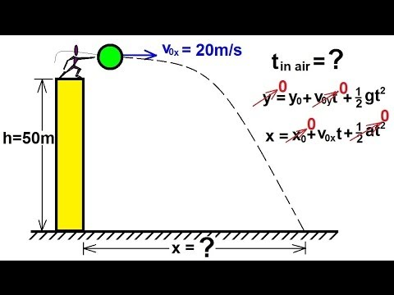](https://www.youtube.com/watch?v=zJb-Q49vD3A)

g