Boston Housing Data

debabrata bhattacharya

boston housing data

DEBABRATA BHATTACHARYA

Contents

Boston Housing Data 5

About the Dataset 5

Dataset Properties 6

Dataset Summarization 7

Visualizations 10

Histogram 10

Density Plot 11

Box and Whisker Plot 12

Correlation 13

Scatter Plot 13

Correlation Matrix 14

Project Techniques 15

Algorithms Considered 15

LinearRegression 15

Lasso 15

ElasticNet 15

DecisionTreeRegressor 15

SVR 15

KNeighborsRegressor 15

Ensembles Considered 16

AdaBoostRegressor 16

GradientBoostingRegressor 16

RandomForestRegressor 16

ExtraTreesRegressor 16

Results 17

Algorithms 17

Visualization 17

Conclusion 17

Scaling 18

Results 18

Visualization 18

Conclusion 18

Ensembles 19

Results 19

Visualization 19

Conclusion 19

Parameter Tuning 20

Results 20

Visualization 20

Conclusion 20

Project Code 21

Project Output 22

Tests 24

Conclusion 25

Learning Outcomes 26

# Boston Housing Data

## About the Dataset

The repository is hosted at [UCI Machine Learning Repository](https://archive.ics.uci.edu/ml/machine-learning-databases/housing/). It concerns housing values in suburbs of Boston.

The data describes the conditions in all the sub-divisions of the City of Boston. The target variable is the medv(median value of homes) variable.

The data set is multivariate and contains ratio(numerical) and nominal data.

There are 506 instances and 14 attributes.

The shape of the dataset is (506, 14). We can see that there are 506 instances or rows and 11 attributes or columns.

The datatpes of the attributes are:

CRIM float64

ZN float64

INDUS float64

CHAS int64

NOX float64

RM float64

AGE float64

DIS float64

RAD int64

TAX float64

PTRATIO float64

B float64

LSTAT float64

MEDV float64

dtype: object.

Most of them are float types, with 2 integer types mixed in.

## Dataset Properties

The Boston data frame has 506 rows and 14 columns.

This data frame contains the following columns:

*crim*  
per capita crime rate by town.

*zn*  
proportion of residential land zoned for lots over 25,000 sq. ft.

*indus*  
proportion of non-retail business acres per town.

*chas*  
Charles River dummy variable (= 1 if tract bounds river; 0 otherwise).

*nox*  
nitrogen oxides concentration (parts per 10 million).

*rm*  
average number of rooms per dwelling.

*age*  
proportion of owner-occupied units built prior to 1940.

*dis*  
weighted mean of distances to five Boston employment centers.

*rad*  
index of accessibility to radial highways.

*tax*  
full-value property-tax rate per $10,000.

*ptratio*  
pupil-teacher ratio by town.

*black*  
1000(Bk - 0.63)^2 where Bk is the proportion of blacks by town.

*lstat*  
lower status of the population (percent).

*medv*  
median value of owner-occupied homes in $1000s.

## Dataset Summarization

Let’s take a look at the first 20 rows of the data:

CRIM ZN INDUS CHAS NOX RM AGE DIS RAD TAX PTRATIO B LSTAT MEDV

0 6.32e-03 18.0 2.31 0 0.54 6.58 65.2 4.09 1 296.0 15.3 396.90 4.98 24.0

1 2.73e-02 0.0 7.07 0 0.47 6.42 78.9 4.97 2 242.0 17.8 396.90 9.14 21.6

2 2.73e-02 0.0 7.07 0 0.47 7.18 61.1 4.97 2 242.0 17.8 392.83 4.03 34.7

3 3.24e-02 0.0 2.18 0 0.46 7.00 45.8 6.06 3 222.0 18.7 394.63 2.94 33.4

4 6.91e-02 0.0 2.18 0 0.46 7.15 54.2 6.06 3 222.0 18.7 396.90 5.33 36.2

5 2.99e-02 0.0 2.18 0 0.46 6.43 58.7 6.06 3 222.0 18.7 394.12 5.21 28.7

6 8.83e-02 12.5 7.87 0 0.52 6.01 66.6 5.56 5 311.0 15.2 395.60 12.43 22.9

7 1.45e-01 12.5 7.87 0 0.52 6.17 96.1 5.95 5 311.0 15.2 396.90 19.15 27.1

8 2.11e-01 12.5 7.87 0 0.52 5.63 100.0 6.08 5 311.0 15.2 386.63 29.93 16.5

9 1.70e-01 12.5 7.87 0 0.52 6.00 85.9 6.59 5 311.0 15.2 386.71 17.10 18.9

10 2.25e-01 12.5 7.87 0 0.52 6.38 94.3 6.35 5 311.0 15.2 392.52 20.45 15.0

11 1.17e-01 12.5 7.87 0 0.52 6.01 82.9 6.23 5 311.0 15.2 396.90 13.27 18.9

12 9.38e-02 12.5 7.87 0 0.52 5.89 39.0 5.45 5 311.0 15.2 390.50 15.71 21.7

13 6.30e-01 0.0 8.14 0 0.54 5.95 61.8 4.71 4 307.0 21.0 396.90 8.26 20.4

14 6.38e-01 0.0 8.14 0 0.54 6.10 84.5 4.46 4 307.0 21.0 380.02 10.26 18.2

15 6.27e-01 0.0 8.14 0 0.54 5.83 56.5 4.50 4 307.0 21.0 395.62 8.47 19.9

16 1.05e+00 0.0 8.14 0 0.54 5.93 29.3 4.50 4 307.0 21.0 386.85 6.58 23.1

17 7.84e-01 0.0 8.14 0 0.54 5.99 81.7 4.26 4 307.0 21.0 386.75 14.67 17.5

18 8.03e-01 0.0 8.14 0 0.54 5.46 36.6 3.80 4 307.0 21.0 288.99 11.69 20.2

19 7.26e-01 0.0 8.14 0 0.54 5.73 69.5 3.80 4 307.0 21.0 390.95 11.28 18.2.

We can see that all the data is disparate from each other, with dissimilar ranges. Some attributes are binary(0 & 1). Some have a lot of 0s in them.

Dataset description:

CRIM ZN INDUS CHAS NOX RM ... RAD TAX PTRATIO B LSTAT MEDV

count 5.06e+02 506.00 506.00 506.00 506.00 506.00 ... 506.00 506.00 506.00 506.00 506.00 506.00

mean 3.61e+00 11.36 11.14 0.07 0.55 6.28 ... 9.55 408.24 18.46 356.67 12.65 22.53

std 8.60e+00 23.32 6.86 0.25 0.12 0.70 ... 8.71 168.54 2.16 91.29 7.14 9.20

min 6.32e-03 0.00 0.46 0.00 0.39 3.56 ... 1.00 187.00 12.60 0.32 1.73 5.00

25% 8.20e-02 0.00 5.19 0.00 0.45 5.89 ... 4.00 279.00 17.40 375.38 6.95 17.02

50% 2.57e-01 0.00 9.69 0.00 0.54 6.21 ... 5.00 330.00 19.05 391.44 11.36 21.20

75% 3.68e+00 12.50 18.10 0.00 0.62 6.62 ... 24.00 666.00 20.20 396.23 16.96 25.00

max 8.90e+01 100.00 27.74 1.00 0.87 8.78 ... 24.00 711.00 22.00 396.90 37.97 50.00

We can see that the attributes have wildly varying ranges, means and min and max values. The data needs to be brought to scale. Also, the ZN attribute might be significant.

Correlation between the different attributes:

CRIM ZN INDUS CHAS NOX RM AGE DIS RAD TAX PTRATIO B LSTAT MEDV

CRIM 1.00 -0.20 0.41 -5.59e-02 0.42 -0.22 0.35 -0.38 6.26e-01 0.58 0.29 -0.39 0.46 -0.39

ZN -0.20 1.00 -0.53 -4.27e-02 -0.52 0.31 -0.57 0.66 -3.12e-01 -0.31 -0.39 0.18 -0.41 0.36

INDUS 0.41 -0.53 1.00 6.29e-02 0.76 -0.39 0.64 -0.71 5.95e-01 0.72 0.38 -0.36 0.60 -0.48

CHAS -0.06 -0.04 0.06 1.00e+00 0.09 0.09 0.09 -0.10 -7.37e-03 -0.04 -0.12 0.05 -0.05 0.18

NOX 0.42 -0.52 0.76 9.12e-02 1.00 -0.30 0.73 -0.77 6.11e-01 0.67 0.19 -0.38 0.59 -0.43

RM -0.22 0.31 -0.39 9.13e-02 -0.30 1.00 -0.24 0.21 -2.10e-01 -0.29 -0.36 0.13 -0.61 0.70

AGE 0.35 -0.57 0.64 8.65e-02 0.73 -0.24 1.00 -0.75 4.56e-01 0.51 0.26 -0.27 0.60 -0.38

DIS -0.38 0.66 -0.71 -9.92e-02 -0.77 0.21 -0.75 1.00 -4.95e-01 -0.53 -0.23 0.29 -0.50 0.25

RAD 0.63 -0.31 0.60 -7.37e-03 0.61 -0.21 0.46 -0.49 1.00e+00 0.91 0.46 -0.44 0.49 -0.38

TAX 0.58 -0.31 0.72 -3.56e-02 0.67 -0.29 0.51 -0.53 9.10e-01 1.00 0.46 -0.44 0.54 -0.47

PTRATIO 0.29 -0.39 0.38 -1.22e-01 0.19 -0.36 0.26 -0.23 4.65e-01 0.46 1.00 -0.18 0.37 -0.51

B -0.39 0.18 -0.36 4.88e-02 -0.38 0.13 -0.27 0.29 -4.44e-01 -0.44 -0.18 1.00 -0.37 0.33

LSTAT 0.46 -0.41 0.60 -5.39e-02 0.59 -0.61 0.60 -0.50 4.89e-01 0.54 0.37 -0.37 1.00 -0.74

MEDV -0.39 0.36 -0.48 1.75e-01 -0.43 0.70 -0.38 0.25 -3.82e-01 -0.47 -0.51 0.33 -0.74 1.00

We can see that many of the attributes have high correlation among them.

DIS and NOX at 0.77 and RAD and TAX with 0.91 certainly jump out. CHAS seems the least correlated to other attributes.

# Visualizations

## Histogram

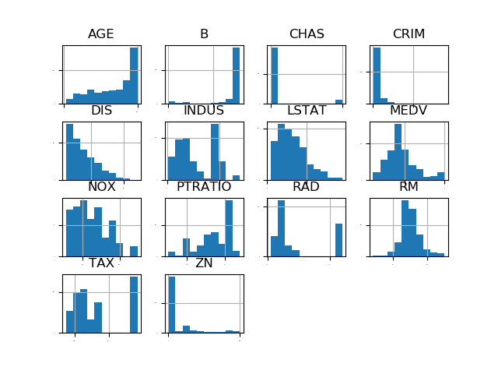

The histogram depicts each of the attributes in a separate histogram.

I think we can see that almost all of the attributes except 'RM' are heavily skewed. The data would probably benefit from scaling and transformation.

A lot of the attributes might be bimodal.

## Density Plot

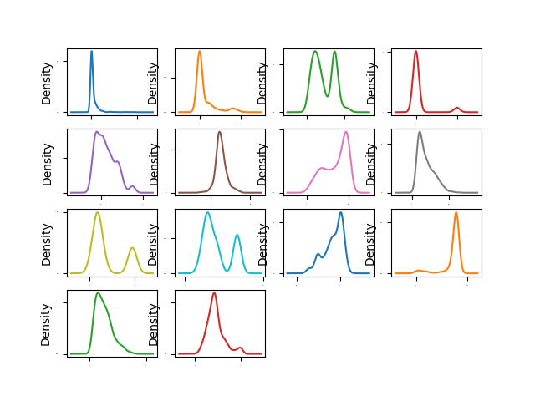

The density plot shows a clearer picture of the distributions. Clearly there is a lot of skew and there are a lot of bimodal distributions.

## Box and Whisker Plot

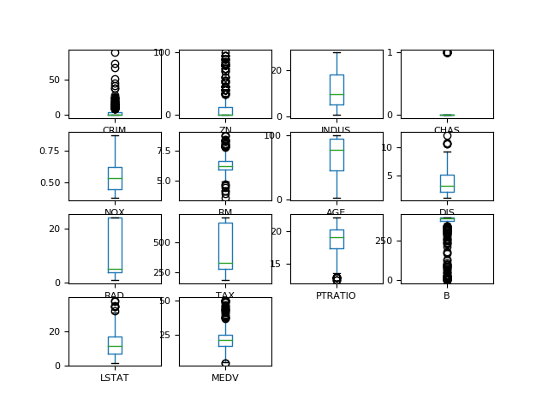

The box and whisker plots paint a very clear picture of skewness of the data, as well as of the bimodal distributions.

## Correlation

### Scatter Plot

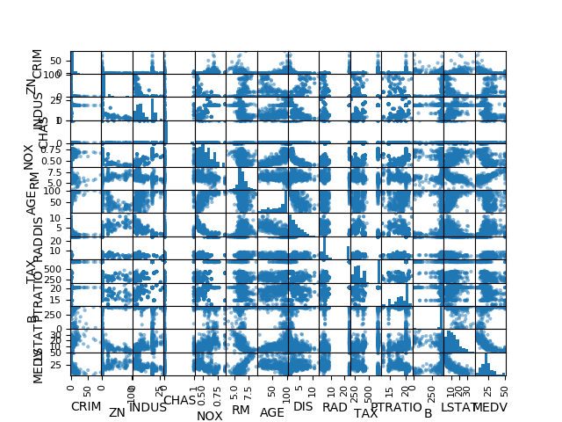

We can see a lot of negative and positive correlation in the form of nice and smooth curves in the scatter plot.

### Correlation Matrix

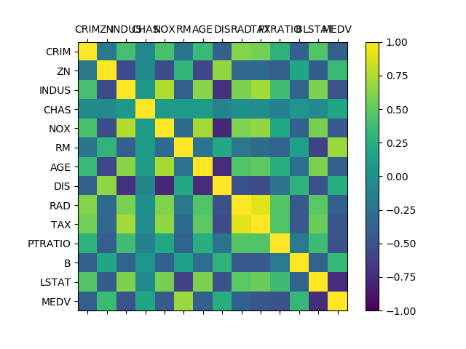

The correlation matrix confirms the correlation evident in the scatter plot. DIS seems to be highly correlated with no less than 4 variables. AGE is also correlated, and this dataset would benefit from being standardized and perhaps some PCA.

# Project Techniques

## Algorithms Considered

### LinearRegression

LinearRegression fits a linear model with coefficients w = (w1, …, wp) to minimize the residual sum of squares between the observed targets in the dataset, and the targets predicted by the linear approximation.

### Lasso

Linear Model trained with L1 prior as regularizer (aka the Lasso)

### ElasticNet

Linear regression with combined L1 and L2 priors as regularizer.

### DecisionTreeRegressor

A decision tree regressor.

### SVR

Epsilon-Support Vector Regression. The free parameters in the model are C and epsilon. The implementation is based on libsvm.

### KNeighborsRegressor

Regression based on k-nearest neighbors. The target is predicted by local interpolation of the targets associated of the nearest neighbors in the training set.

## Ensembles Considered

### AdaBoostRegressor

An AdaBoost [1] regressor is a meta-estimator that begins by fitting a regressor on the original dataset and then fits additional copies of the regressor on the same dataset but where the weights of instances are adjusted according to the error of the current prediction. As such, subsequent regressors focus more on difficult cases.

### GradientBoostingRegressor

Gradient Boosting for regression.

GB builds an additive model in a forward stage-wise fashion; it allows for the optimization of arbitrary differentiable loss functions. In each stage a regression tree is fit on the negative gradient of the given loss function.

### RandomForestRegressor

A random forest regressor. A random forest is a meta estimator that fits a number of classifying decision trees on various sub-samples of the dataset and uses averaging to improve the predictive accuracy and control over-fitting. The sub-sample size is always the same as the original input sample size but the samples are drawn with replacement if bootstrap=True (default).

### ExtraTreesRegressor

An extra-trees regressor. This class implements a meta estimator that fits a number of randomized decision trees (a.k.a. extra-trees) on various sub-samples of the dataset and uses averaging to improve the predictive accuracy and control over-fitting.

# Results

## Algorithms

Name Mean Std

lr:-21.379855726678706(9.414263656984769)

lasso:-26.423561108409654(11.651109915777914)

en:-27.50225935066171(12.3050222641127)

cart:-24.710840243902442(10.322473181739754)

svm:-85.51834183929131(31.99479823184288)

knn:-41.89648839024391(13.901688149849864)

### Visualization

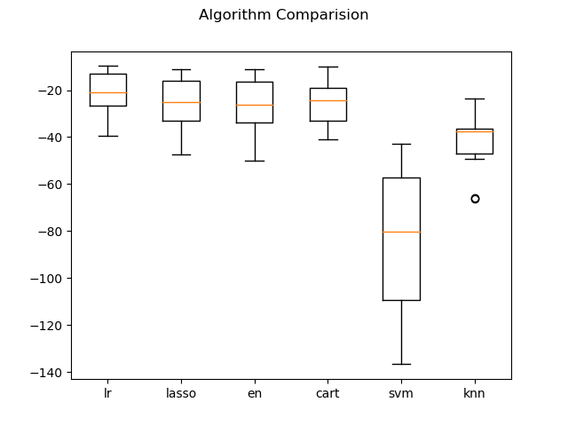

### Conclusion

We can see that Linear Regression has the lowest error, followed by lasso and CART. To understand this further, we will visualize the results.

As we can see from the boxplot, lr has the lowest error, and it seems to be evenly distributed. CART does have 2 outliers, but otherwise it performs second-best.

CART does seem to have a tighter distribution against others. I think we need to standardize the data to get a better picture.

## Scaling

### Results

Name Mean Std

ScaledLR : -21.379855726678564 (9.414263656984708)

ScaledEN : -27.932372158135514 (10.587490490139405)

ScaledLASSO : -26.607313557676616 (8.978761485890262)

ScaledCART : -25.763937804878047 (14.516292461177029)

ScaledSVR : -29.633085500303213 (17.009186052351556)

ScaledKNN : -20.107620487804876 (12.376949150820472)

### Visualization

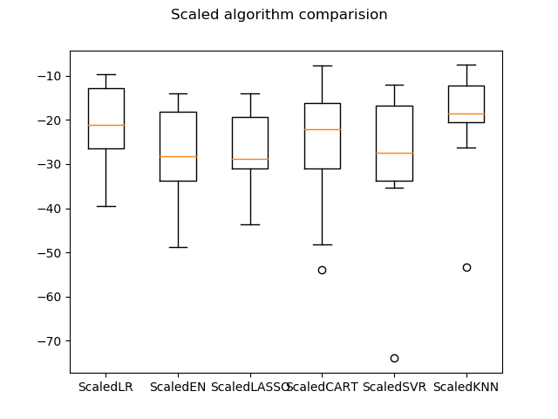

### Conclusion

We can see that scaling the data improved the performance for KNN. It performed the best out of all models.

From the boxplot, KNN emerges strongly as a good candidate with the lowest score and a tight bound.

## Ensembles

### Results

ScaledAR: -15.570136781522445 (7.226508004326689)

ScaledGBM: -10.386519807726451 (4.584945303632313)

ScakedRF: -14.107018420731709 (6.93372242026274)

ScaledET: -10.68477058536585 (5.263157650864247)

### Visualization

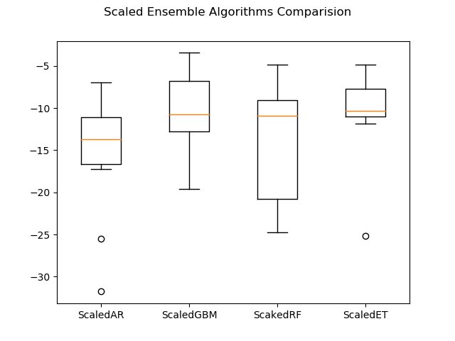

### Conclusion

We can see that GBM has a slightly better mean score than ET, and ET has a tighter bound. We shall proceed with GBM and aim to tune it further.

# Parameter Tuning

## Results

Best: -9.3538696600702 using {'n_estimators': 400}

-10.812166656847484 (4.724393636557874) with: {'n_estimators': 50}

-10.040856533581554 (4.441757611922483) with: {'n_estimators': 100}

-9.694044578095989 (4.275652713871717) with: {'n_estimators': 150}

-9.539480800040016 (4.270152744263775) with: {'n_estimators': 200}

-9.449041675378322 (4.261930249819678) with: {'n_estimators': 250}

-9.426909455124738 (4.271398576035022) with: {'n_estimators': 300}

-9.366779386673732 (4.251668915728572) with: {'n_estimators': 350}

-9.3538696600702 (4.26581630222825) with: {'n_estimators': 400}

### Visualization

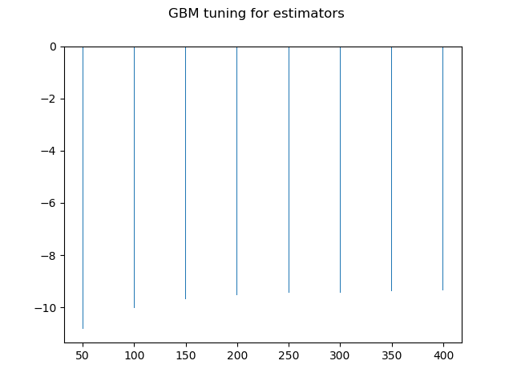

### Conclusion

The best performance was for n_estimators = 400. Thus, we will be using GBM and expect a low error rate.

# Project Code

def model_finalization(self):

        seed = 7

        scaler = StandardScaler().fit(self.x_train)

        rescaled_x = scaler.transform(self.x_train)

        model = GradientBoostingRegressor(random_state=seed, n_estimators=400)

        model.fit(rescaled_x, self.y_train)

        # a) Predictions on validation dataset

        # transform the validation dataset

        rescaledValidation_x = scaler.transform(self.x_validation)

        predictions = model.predict(rescaledValidation_x)

        print("The predictons for the validation set are: {} in terms of mean squared error".format(mean_squared_error(self.y_validation, predictions)))

        # b) Create standalone model on entire training dataset

        self.model = GradientBoostingRegressor(random_state=seed, n_estimators=400)

        scaler = StandardScaler().fit(self.x)

        self.rescaled_x = scaler.transform(self.x)

        self.rescaledValidation_x = scaler.transform(self.x_validation)

        self.model.fit(self.rescaled_x, self.y)

        self.predictions = self.model.predict(self.rescaledValidation_x)

        print("The predictons for the entire set are: {} in terms of mean squared error".format(mean_squared_error(self.y_validation, self.predictions)))

        # c) Save model for later use

        from joblib import dump

        filename = self.filename

        dump(self.model, filename)

# Project Output

The shape of the dataset is (506, 14). We can see that there are 506 instances or rows and 11 attributes or columns.

The datatpes of the attributes are:

CRIM float64

ZN float64

INDUS float64

CHAS int64

NOX float64

RM float64

AGE float64

DIS float64

RAD int64

TAX float64

PTRATIO float64

B float64

LSTAT float64

MEDV float64

dtype: object.

Most of them are float types, with 2 integer types mixed in.

Lets take a look at the first 20 rows of the data:

CRIM ZN INDUS CHAS NOX RM AGE DIS RAD TAX PTRATIO B LSTAT MEDV

0 6.32e-03 18.0 2.31 0 0.54 6.58 65.2 4.09 1 296.0 15.3 396.90 4.98 24.0

1 2.73e-02 0.0 7.07 0 0.47 6.42 78.9 4.97 2 242.0 17.8 396.90 9.14 21.6

2 2.73e-02 0.0 7.07 0 0.47 7.18 61.1 4.97 2 242.0 17.8 392.83 4.03 34.7

3 3.24e-02 0.0 2.18 0 0.46 7.00 45.8 6.06 3 222.0 18.7 394.63 2.94 33.4

4 6.91e-02 0.0 2.18 0 0.46 7.15 54.2 6.06 3 222.0 18.7 396.90 5.33 36.2

5 2.99e-02 0.0 2.18 0 0.46 6.43 58.7 6.06 3 222.0 18.7 394.12 5.21 28.7

6 8.83e-02 12.5 7.87 0 0.52 6.01 66.6 5.56 5 311.0 15.2 395.60 12.43 22.9

7 1.45e-01 12.5 7.87 0 0.52 6.17 96.1 5.95 5 311.0 15.2 396.90 19.15 27.1

8 2.11e-01 12.5 7.87 0 0.52 5.63 100.0 6.08 5 311.0 15.2 386.63 29.93 16.5

9 1.70e-01 12.5 7.87 0 0.52 6.00 85.9 6.59 5 311.0 15.2 386.71 17.10 18.9

10 2.25e-01 12.5 7.87 0 0.52 6.38 94.3 6.35 5 311.0 15.2 392.52 20.45 15.0

11 1.17e-01 12.5 7.87 0 0.52 6.01 82.9 6.23 5 311.0 15.2 396.90 13.27 18.9

12 9.38e-02 12.5 7.87 0 0.52 5.89 39.0 5.45 5 311.0 15.2 390.50 15.71 21.7

13 6.30e-01 0.0 8.14 0 0.54 5.95 61.8 4.71 4 307.0 21.0 396.90 8.26 20.4

14 6.38e-01 0.0 8.14 0 0.54 6.10 84.5 4.46 4 307.0 21.0 380.02 10.26 18.2

15 6.27e-01 0.0 8.14 0 0.54 5.83 56.5 4.50 4 307.0 21.0 395.62 8.47 19.9

16 1.05e+00 0.0 8.14 0 0.54 5.93 29.3 4.50 4 307.0 21.0 386.85 6.58 23.1

17 7.84e-01 0.0 8.14 0 0.54 5.99 81.7 4.26 4 307.0 21.0 386.75 14.67 17.5

18 8.03e-01 0.0 8.14 0 0.54 5.46 36.6 3.80 4 307.0 21.0 288.99 11.69 20.2

19 7.26e-01 0.0 8.14 0 0.54 5.73 69.5 3.80 4 307.0 21.0 390.95 11.28 18.2.

We can see that all the data is disparate from each other, with dissimilar ranges. Some attributes are binary(0 & 1). Some have a lot of 0s in them.

Dataset description:

CRIM ZN INDUS CHAS NOX RM ... RAD TAX PTRATIO B LSTAT MEDV

count 5.06e+02 506.00 506.00 506.00 506.00 506.00 ... 506.00 506.00 506.00 506.00 506.00 506.00

mean 3.61e+00 11.36 11.14 0.07 0.55 6.28 ... 9.55 408.24 18.46 356.67 12.65 22.53

std 8.60e+00 23.32 6.86 0.25 0.12 0.70 ... 8.71 168.54 2.16 91.29 7.14 9.20

min 6.32e-03 0.00 0.46 0.00 0.39 3.56 ... 1.00 187.00 12.60 0.32 1.73 5.00

25% 8.20e-02 0.00 5.19 0.00 0.45 5.89 ... 4.00 279.00 17.40 375.38 6.95 17.02

50% 2.57e-01 0.00 9.69 0.00 0.54 6.21 ... 5.00 330.00 19.05 391.44 11.36 21.20

75% 3.68e+00 12.50 18.10 0.00 0.62 6.62 ... 24.00 666.00 20.20 396.23 16.96 25.00

max 8.90e+01 100.00 27.74 1.00 0.87 8.78 ... 24.00 711.00 22.00 396.90 37.97 50.00

[8 rows x 14 columns]

We can see that the attributes have wildly varying ranges, means and min and max values. The data needs to be brought to scale. Also, the ZN attribute might be significant.

Correlation between the different attributes:

CRIM ZN INDUS CHAS NOX RM AGE DIS RAD TAX PTRATIO B LSTAT MEDV

CRIM 1.00 -0.20 0.41 -5.59e-02 0.42 -0.22 0.35 -0.38 6.26e-01 0.58 0.29 -0.39 0.46 -0.39

ZN -0.20 1.00 -0.53 -4.27e-02 -0.52 0.31 -0.57 0.66 -3.12e-01 -0.31 -0.39 0.18 -0.41 0.36

INDUS 0.41 -0.53 1.00 6.29e-02 0.76 -0.39 0.64 -0.71 5.95e-01 0.72 0.38 -0.36 0.60 -0.48

CHAS -0.06 -0.04 0.06 1.00e+00 0.09 0.09 0.09 -0.10 -7.37e-03 -0.04 -0.12 0.05 -0.05 0.18

NOX 0.42 -0.52 0.76 9.12e-02 1.00 -0.30 0.73 -0.77 6.11e-01 0.67 0.19 -0.38 0.59 -0.43

RM -0.22 0.31 -0.39 9.13e-02 -0.30 1.00 -0.24 0.21 -2.10e-01 -0.29 -0.36 0.13 -0.61 0.70

AGE 0.35 -0.57 0.64 8.65e-02 0.73 -0.24 1.00 -0.75 4.56e-01 0.51 0.26 -0.27 0.60 -0.38

DIS -0.38 0.66 -0.71 -9.92e-02 -0.77 0.21 -0.75 1.00 -4.95e-01 -0.53 -0.23 0.29 -0.50 0.25

RAD 0.63 -0.31 0.60 -7.37e-03 0.61 -0.21 0.46 -0.49 1.00e+00 0.91 0.46 -0.44 0.49 -0.38

TAX 0.58 -0.31 0.72 -3.56e-02 0.67 -0.29 0.51 -0.53 9.10e-01 1.00 0.46 -0.44 0.54 -0.47

PTRATIO 0.29 -0.39 0.38 -1.22e-01 0.19 -0.36 0.26 -0.23 4.65e-01 0.46 1.00 -0.18 0.37 -0.51

B -0.39 0.18 -0.36 4.88e-02 -0.38 0.13 -0.27 0.29 -4.44e-01 -0.44 -0.18 1.00 -0.37 0.33

LSTAT 0.46 -0.41 0.60 -5.39e-02 0.59 -0.61 0.60 -0.50 4.89e-01 0.54 0.37 -0.37 1.00 -0.74

MEDV -0.39 0.36 -0.48 1.75e-01 -0.43 0.70 -0.38 0.25 -3.82e-01 -0.47 -0.51 0.33 -0.74 1.00

We can see that many of the attributes have high correlation among them.

DIS and NOX at 0.77 and RAD and TAX with 0.91 certainly jump out. CHAS seems the least correlated to other attributes.

Data Visualization:

The histogram depicts each of the attributes in a separate histogram.

I think we can see that almost all of the attbutes except 'RM' are heavily skewed. The data would probably benefit from scaling anf transformation.

A lot of the attributes might be bimodal.

The density plot shows a clearer picture of the distributions. Clearly there is a lot of skew and there are a lot of bimodal distributions.

The box and whisker plots paint a very clear picture of skewness of the data, as well as of the bimodial distributions.

Correlation:

We can see a lot of negative and positive correlation in the form of nice and smooth curves in the scatter plot.

The correlation matrix confirms the correlation evident in the scatter plot. DIS seems to be highly correlated with no less than 4 variables. AGE is also correlated, and this dataset would benefit from being standardized and perhaps some PCA.

Name Mean Std

lr:-21.379855726678706(9.414263656984769)

lasso:-26.423561108409654(11.651109915777914)

en:-27.50225935066171(12.3050222641127)

cart:-24.710840243902442(10.322473181739754)

svm:-85.51834183929131(31.99479823184288)

knn:-41.89648839024391(13.901688149849864)

We can see that Linear Regression has the lowest error, followed by lasso and CART. To understand this further, we will visualize the results.

As we can see from the boxplot, lr has the lowest error, and it seems to be evenly distributed. CART does have 2 outliers, but oherwise it performs second-best.

CART does seem to have a tighter distribution against others. I think we need to standardize the data to get a better picture.

Results of spotchecking models on different algorithms.

Name Mean Std

ScaledLR : -21.379855726678564 (9.414263656984708)

ScaledEN : -27.932372158135514 (10.587490490139405)

ScaledLASSO : -26.607313557676616 (8.978761485890262)

ScaledCART : -25.763937804878047 (14.516292461177029)

ScaledSVR : -29.633085500303213 (17.009186052351556)

ScaledKNN : -20.107620487804876 (12.376949150820472)

We can see that scaling the data improved the performance for KNN. It performed the best out of all models.

From the boxplot, KNN emerges strongly as a good candidate with the lowest score and a tight bound.

C:\ProgramData\Anaconda3\lib\site-packages\sklearn\model_selection\_search.py:813: DeprecationWarning: The default of the `iid` parameter will change from True to False in version 0.22 and will be removed in 0.24. This will change numeric results when test-set sizes are unequal.

DeprecationWarning)

Results are:

Best: -18.172136963696367 using {'n_neighbors': 3}

-20.208663366336634 (15.029651571426534) with:{'n_neighbors': 1}

-18.172136963696367 (12.950569939457809) with:{'n_neighbors': 3}

-20.131163366336633 (12.203696929311104) with:{'n_neighbors': 5}

-20.575845120226305 (12.345886317622917) with:{'n_neighbors': 7}

-20.368263659699302 (11.621737918716054) with:{'n_neighbors': 9}

-21.009204238605676 (11.610012219014179) with:{'n_neighbors': 11}

-21.15180854180092 (11.943317892509251) with:{'n_neighbors': 13}

-21.557399669966998 (11.536338523667055) with:{'n_neighbors': 15}

-22.789938161636233 (11.56686063504654) with:{'n_neighbors': 17}

-23.871872960149197 (11.340388662548046) with:{'n_neighbors': 19}

-24.361362115803416 (11.9147857079963) with:{'n_neighbors': 21}

We can see from the figure that k = 3 had the lowest error.

ScaledAR: -15.570136781522445 (7.226508004326689)

ScaledGBM: -10.386519807726451 (4.584945303632313)

ScakedRF: -14.107018420731709 (6.93372242026274)

ScaledET: -10.68477058536585 (5.263157650864247)

We can see that GBM has a lsightly better mean score than ET, and ET has a tighter bound. We shall proceed with GBM and aim to tune it further.

C:\ProgramData\Anaconda3\lib\site-packages\sklearn\model_selection\_search.py:813: DeprecationWarning: The default of the `iid` parameter will change from True to False in version 0.22 and will be removed in 0.24. This will change numeric results when test-set sizes are unequal.

DeprecationWarning)

Results are:

Best: -9.3538696600702 using {'n_estimators': 400}

-10.812166656847484 (4.724393636557874) with: {'n_estimators': 50}

-10.040856533581554 (4.441757611922483) with: {'n_estimators': 100}

-9.694044578095989 (4.275652713871717) with: {'n_estimators': 150}

-9.539480800040016 (4.270152744263775) with: {'n_estimators': 200}

-9.449041675378322 (4.261930249819678) with: {'n_estimators': 250}

-9.426909455124738 (4.271398576035022) with: {'n_estimators': 300}

-9.366779386673732 (4.251668915728572) with: {'n_estimators': 350}

-9.3538696600702 (4.26581630222825) with: {'n_estimators': 400}

The best performance was for n_estimators = 400. Thus, we will be using GBM and expect a low error rate.

The predictons for the validation set are: 11.878916447820348 in terms of mean squared error

The predictons for the entire set are: 0.2618166772801396 in terms of mean squared error

Model is accurate

# Tests

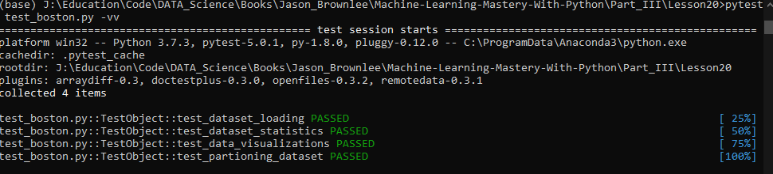

# Conclusion

The predictions for the validation set are: 11.878916447820348 in terms of mean squared error

The predictions for the entire set are: 0.2618166772801396 in terms of mean squared error

Model is accurate.

# Learning Outcomes

* Problem Definition (Boston house price data).
* Loading the Dataset.
* Analyze Data (some skewed distributions and correlated attributes).
* Evaluate Algorithms (Linear Regression looked good).
* Evaluate Algorithms with Standardization (KNN looked good).
* Algorithm Tuning (K=3 for KNN was best).
* Ensemble Methods (Bagging and Boosting, Gradient Boosting looked good).
* Tuning Ensemble Methods (getting the most from Gradient Boosting).
* Finalize Model (use all training data and confirm using validation dataset).