# Loading调研

Loading调研  
 1 概览  
 2 文件结构  
 3 CommonStartupLoadingScreen Module  
 3.1 CommonStartupLoadingScreen.Build.cs  
 3.1.1 源码  
 3.1.2 关键依赖模块  
 3.1.3 模块依赖图  
 3.2 核心模块  
 3.2.1 流程图  
 3.2.2 时序图  
 4 CommonLoadingScreen Module  
 4.1 CommonLoadingScreen.Build.cs  
 4.1.1 源码  
 4.1.2 关键依赖模块  
 4.1.3 模块依赖图  
 4.2 核心模块  
 4.2.1 类图  
 4.2.2 数据图  
 4.2.3 流程图  
 4.2.4 时序图

## 1 概览

* **插件名称:** CommonLoadingScreen
* **模块**
  + CommonLoadingScreen
  + CommonStartupLoadingScreen
* **功能描述:**

加载屏幕管理器处理项目指定的加载屏幕UI的创建和显示 .该模块主要用于在游戏加载阶段显示过渡画面或加载动画，提供一个灵活的、可自定义的加载屏幕解决方案。

* **核心功能**
  + LoadingScreenManager 加载界面管理器
  + CommonLoadingScreenSettings 加载界面配置
  + LoadingProcessInterface 加载界面处理接口

## 2 文件结构

CommonLoadingScreen/  
├── Source/  
│ ├── CommonLoadingScreen/  
│ │ ├── Private/ # 私有实现文件  
│ │ │ ├── CommonLoadingScreenModule.cpp  
│ │ │ ├── CommonLoadingScreenSettings.cpp  
│ │ │ ├── CommonLoadingScreenSettings.h  
│ │ │ ├── LoadingScreenManager.cpp  
│ │ ├── Public/ # 公共头文件  
│ │ │ ├── LoadingProcessInterface.h  
│ │ │ ├── LoadingProcessTask.cpp  
│ │ │ ├── LoadingProcessTask.h  
│ │ │ ├── LoadingScreenManager.h  
│ │ ├── CommonLoadingScreen.Build.cs # 构建配置  
│ ├── CommonStartupLoadingScreen/ # 启动加载屏幕模块  
│ │ ├── Private/  
│ │ │ ├── CommonPreLoadScreen.cpp  
│ │ │ ├── CommonPreLoadScreen.h  
│ │ │ ├── CommonStartupLoadingScreen.cpp  
│ │ │ ├── SCommonPreLoadScreenWidget.cpp  
│ │ │ ├── SCommonPreLoadScreenWidget.h  
│ │ ├── CommonStartupLoadingScreen.Build.cs  
├── CommonLoadingScreen.uplugin # 插件配置文件

## 3 CommonStartupLoadingScreen Module

### 3.1 CommonStartupLoadingScreen.Build.cs

#### 3.1.1 源码

PublicDependencyModuleNames.AddRange(  
 new string[]  
 {  
 "Core",  
 // ... add other public dependencies that you statically link with here ...  
 }  
 );  
   
 PrivateDependencyModuleNames.AddRange(  
 new string[]  
 {  
 "CoreUObject",  
 "Engine",  
 "Slate",  
 "SlateCore",  
 "MoviePlayer",  
 "PreLoadScreen",  
 "DeveloperSettings"  
 }  
 );

#### 3.1.2 关键依赖模块

1. MoviePlayer
2. PreLoadScreen
3. DeveloperSettings

#### 3.1.3 模块依赖图

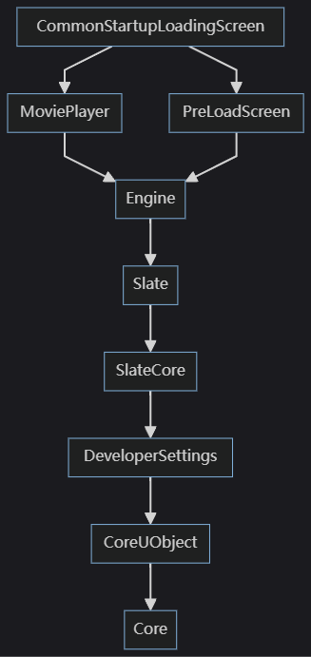

### 3.2 核心模块

#### 3.2.1 流程图

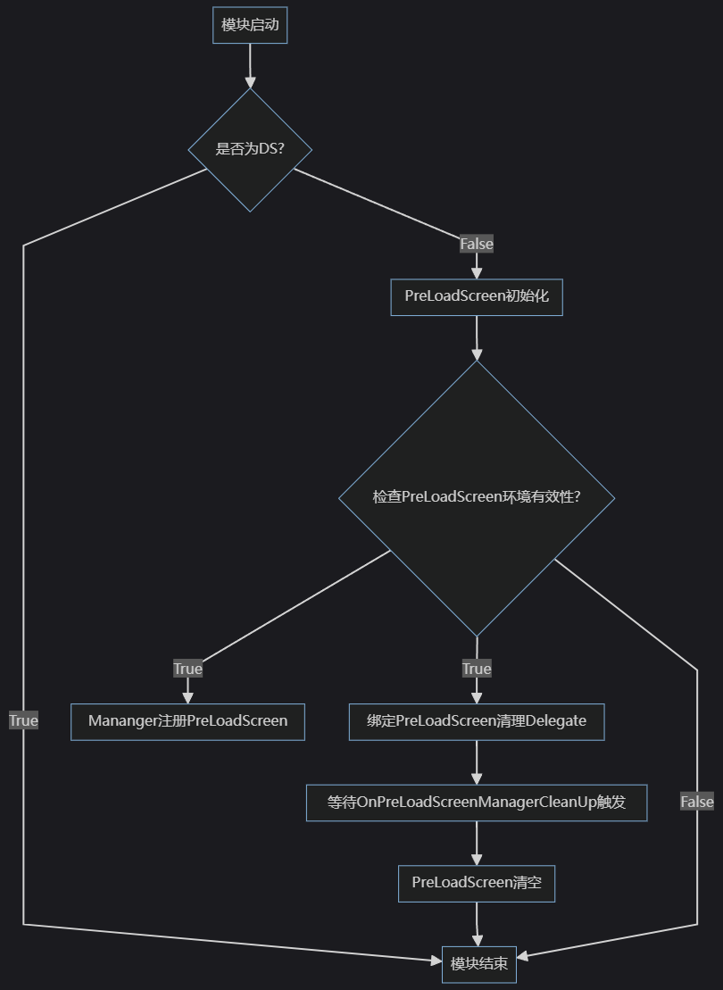

#### 3.2.2 时序图

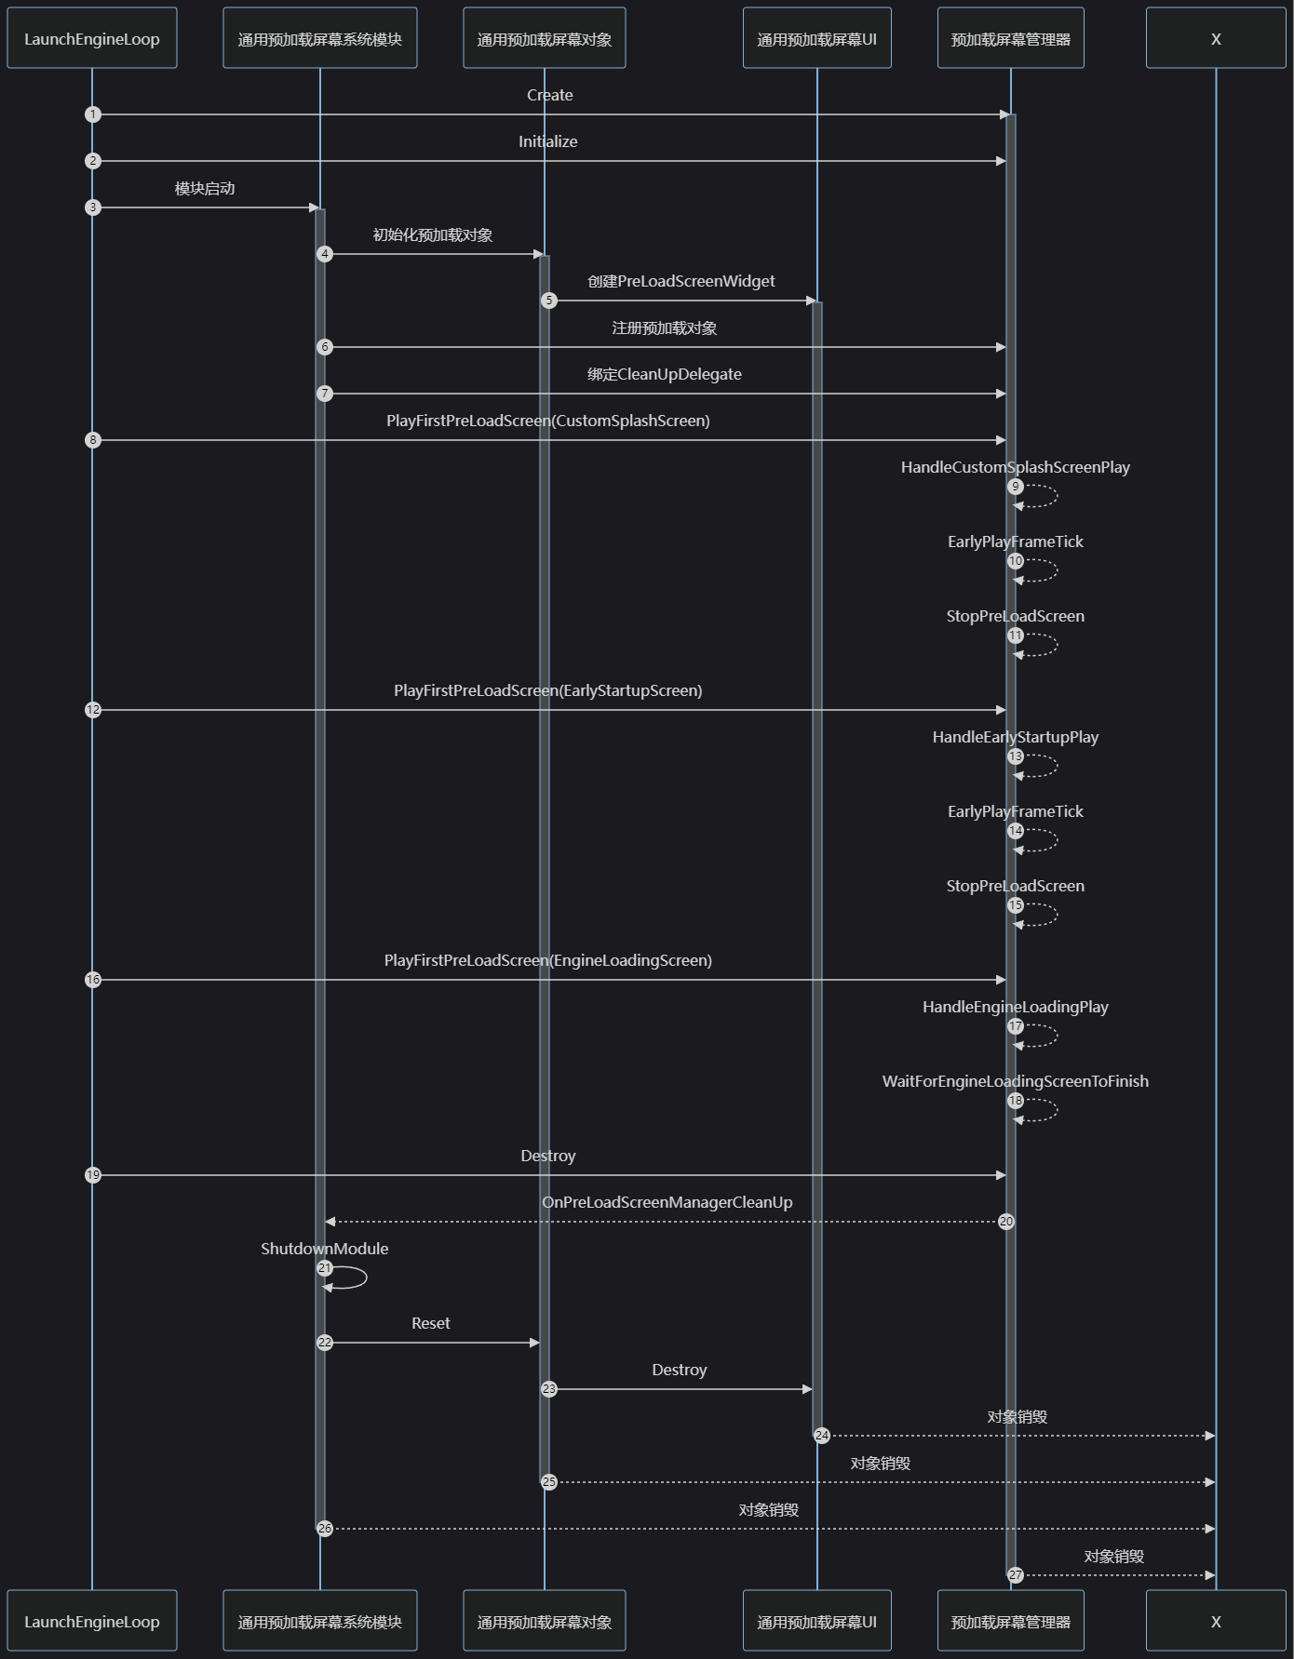

## 4 CommonLoadingScreen Module

### 4.1 CommonLoadingScreen.Build.cs

#### 4.1.1 源码

PublicDependencyModuleNames.AddRange(
  
 new string[]
  
 {
  
 "Core",
  
 // ... add other public dependencies that you statically link with here ...
  
 }
  
 );
  
  
  
 PrivateDependencyModuleNames.AddRange(
  
 new string[]
  
 {
  
 "CoreUObject",
  
 "Engine",
  
 "Slate",
  
 "SlateCore",
  
 "InputCore",
  
 "PreLoadScreen",
  
 "RenderCore",
  
 "DeveloperSettings",
  
 "UMG"
  
 }
  
 );

#### 4.1.2 关键依赖模块

1. InputCore
2. PreLoadScreen
3. DeveloperSettings
4. UMG

#### 4.1.3 模块依赖图

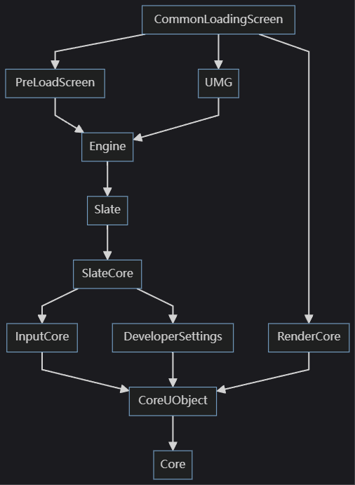

### 4.2 核心模块

#### 4.2.1 类图

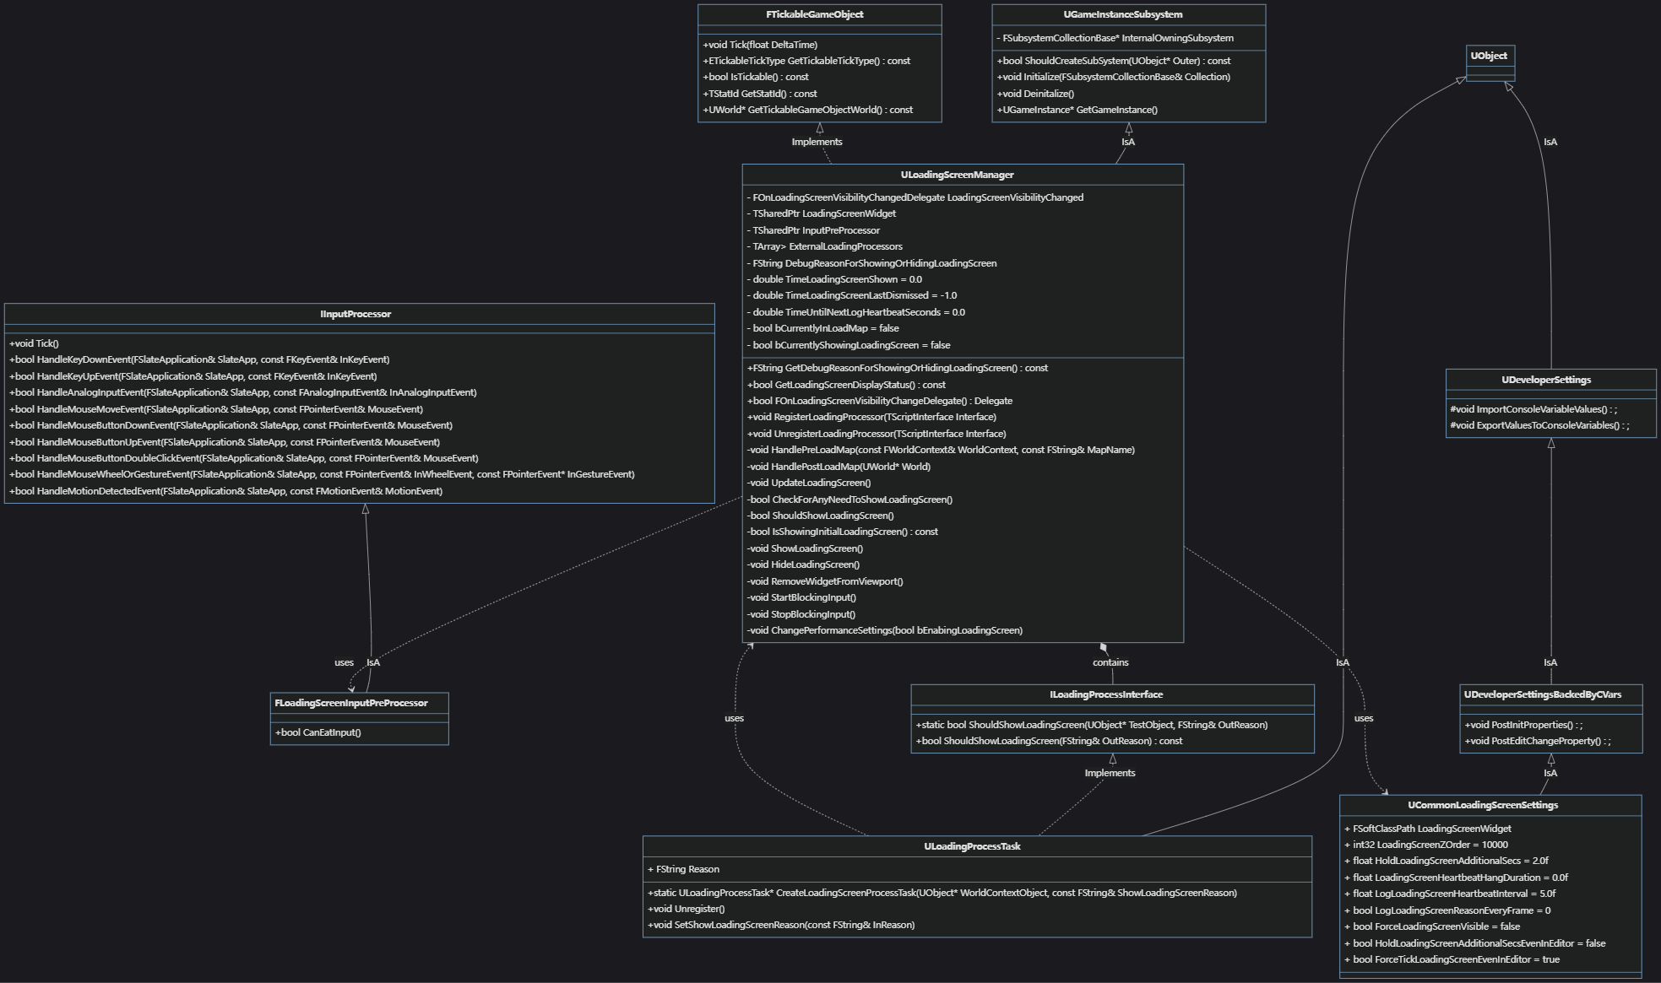

#### 4.2.2 数据图

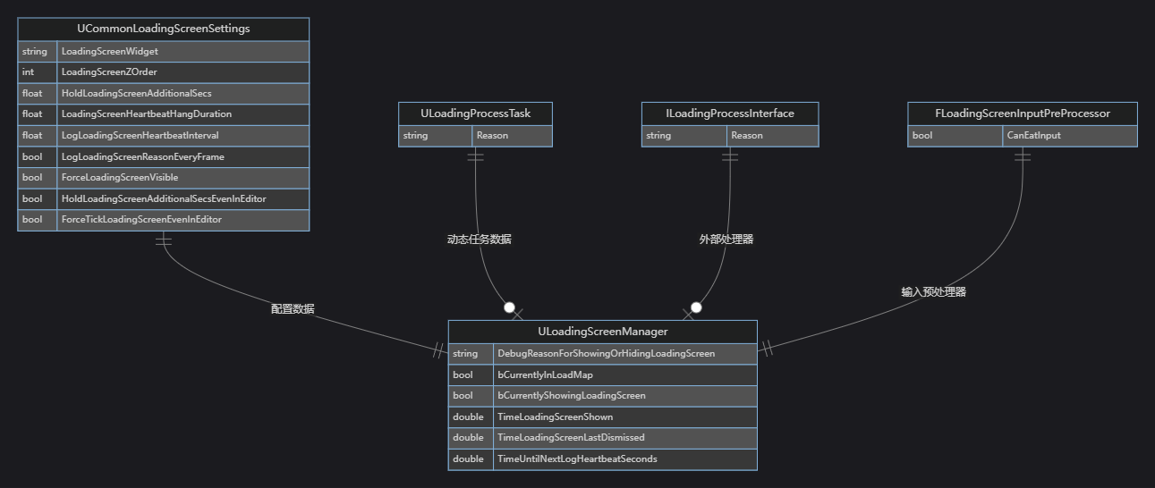

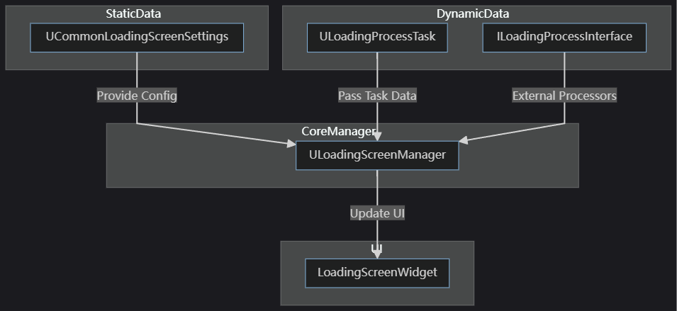

#### 4.2.3 流程图

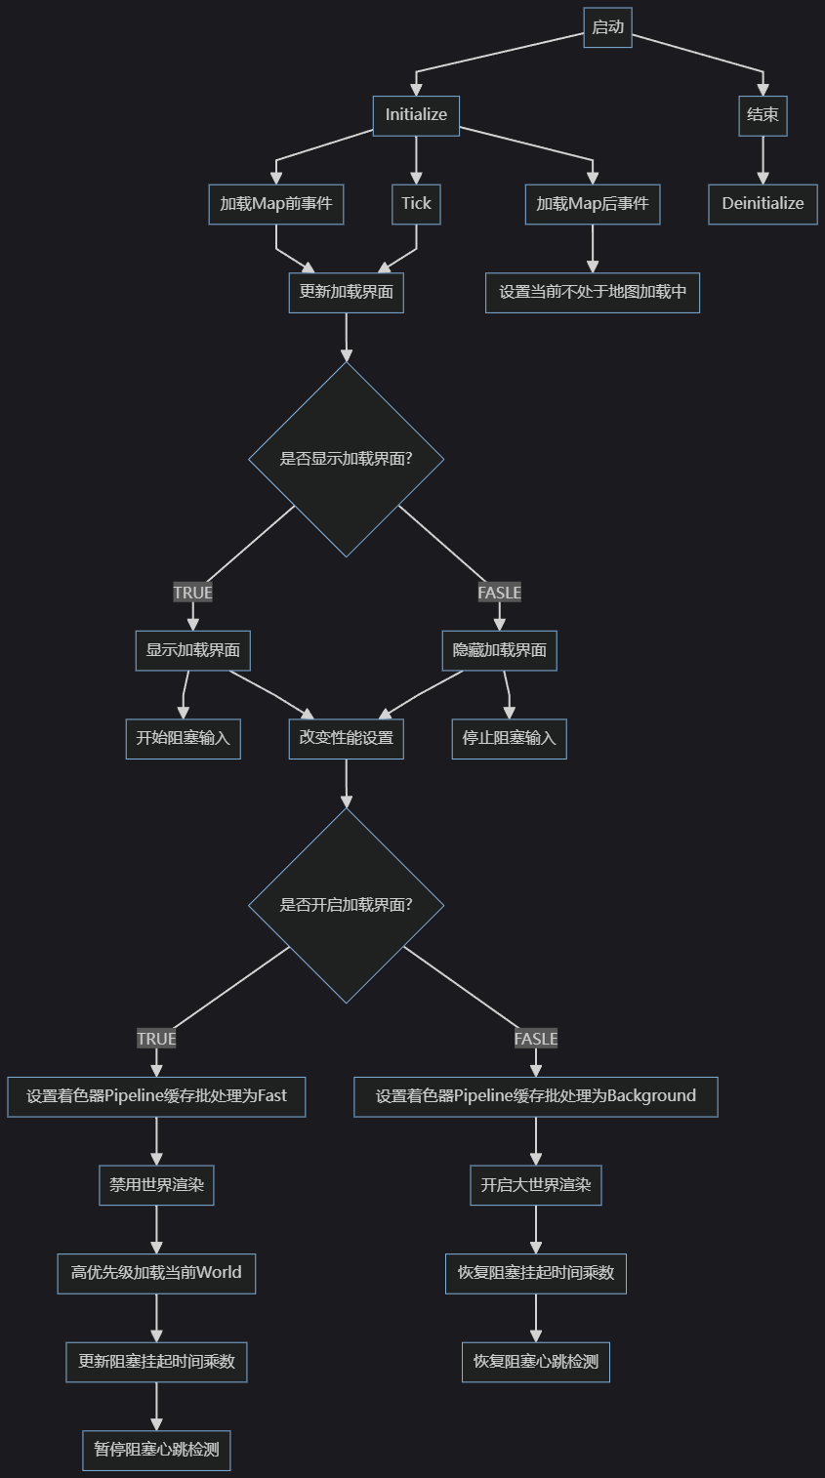

#### 4.2.4 时序图

