**НАЦІОНАЛЬНИЙ ТЕХНІЧНИЙ УНІВЕРСИТЕТ УКРАЇНИ**

**«КИЇВСЬКИЙ ПОЛІТЕХНІЧНИЙ ІНСТИТУТ імені Ігоря Сікорського»**

**ФАКУЛЬТЕТ ПРИКЛАДНОЇ МАТЕМАТИКИ**

# **Кафедра системного програмування та спеціалізованих комп’ютерних систем**

**Розрахунково-графічна робота**

з дисципліни

**«Бази даних і засоби управління»**

Виконав: студент ІII курсу

ФПМ групи КВ-13

Чоловенко Дмитро Володимирович

Telegram: @D_4ubaka

GitHub: https://github.com/D-Cholik/DB_lab-RGR-2.git

Перевірив:

**Київ – 2023**

**Створення додатку бази даних, орієнтованого на взаємодію з СУБД PostgreSQL**

*Метою роботи* є здобуття вмінь програмування прикладних додатків баз даних PostgreSQL.

*Загальне* *завдання* роботи полягає у наступному:

1. Реалізувати функції перегляду, внесення, редагування та вилучення даних у таблицях бази даних, створених у лабораторній роботі №1, засобами консольного інтерфейсу.
2. Передбачити автоматичне пакетне генерування «рандомізованих» даних у базі.
3. Забезпечити реалізацію пошуку за декількома атрибутами з двох та більше сутностей одночасно: для числових атрибутів – у рамках діапазону, для рядкових – як шаблон функції LIKE оператора SELECT SQL, для логічного типу – значення True/False, для дат – у рамках діапазону дат.
4. Програмний код виконати згідно шаблону MVC (модель-подання-контролер).

**Короткий опис бази даних**

Між Готелями і Рейсами існує зв'язок "багато до багатьох" (M:N). Один готель може відповідати багатьом рейсам, і навпаки, один рейс може мати відношення до багатьох готелів. Для вираження цього зв'язку в базі даних потрібно створити додаткову таблицю яка буде містити зв'язки між готелями і рейсами за допомогою зовнішніх ключів, що посилаються на ID готелю і ID рейсу відповідно.

**Діаграма сутність-зв’язок та структура бази даних**

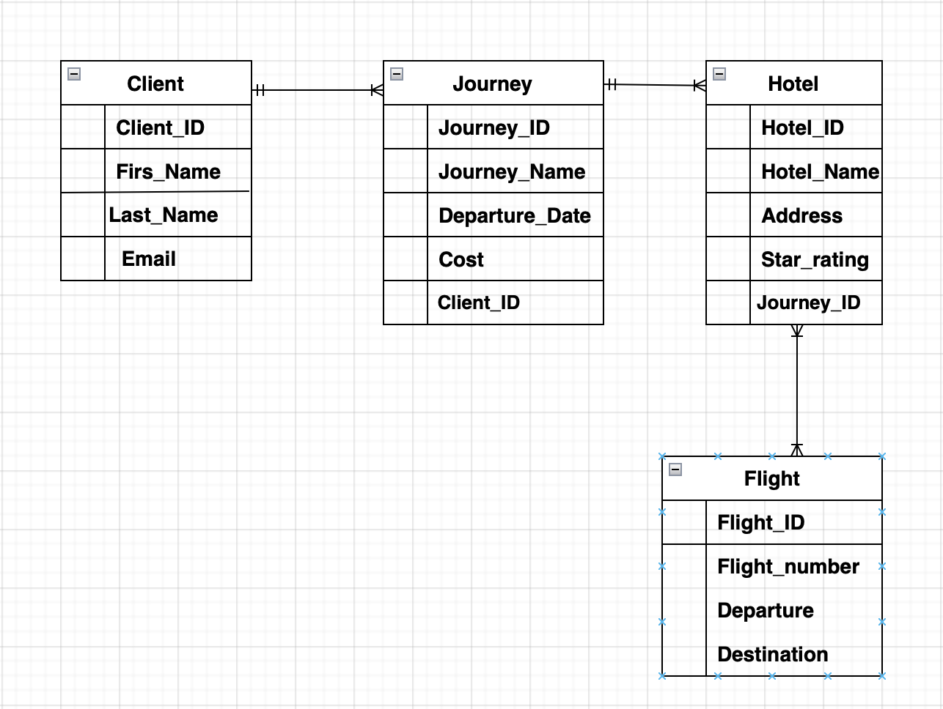

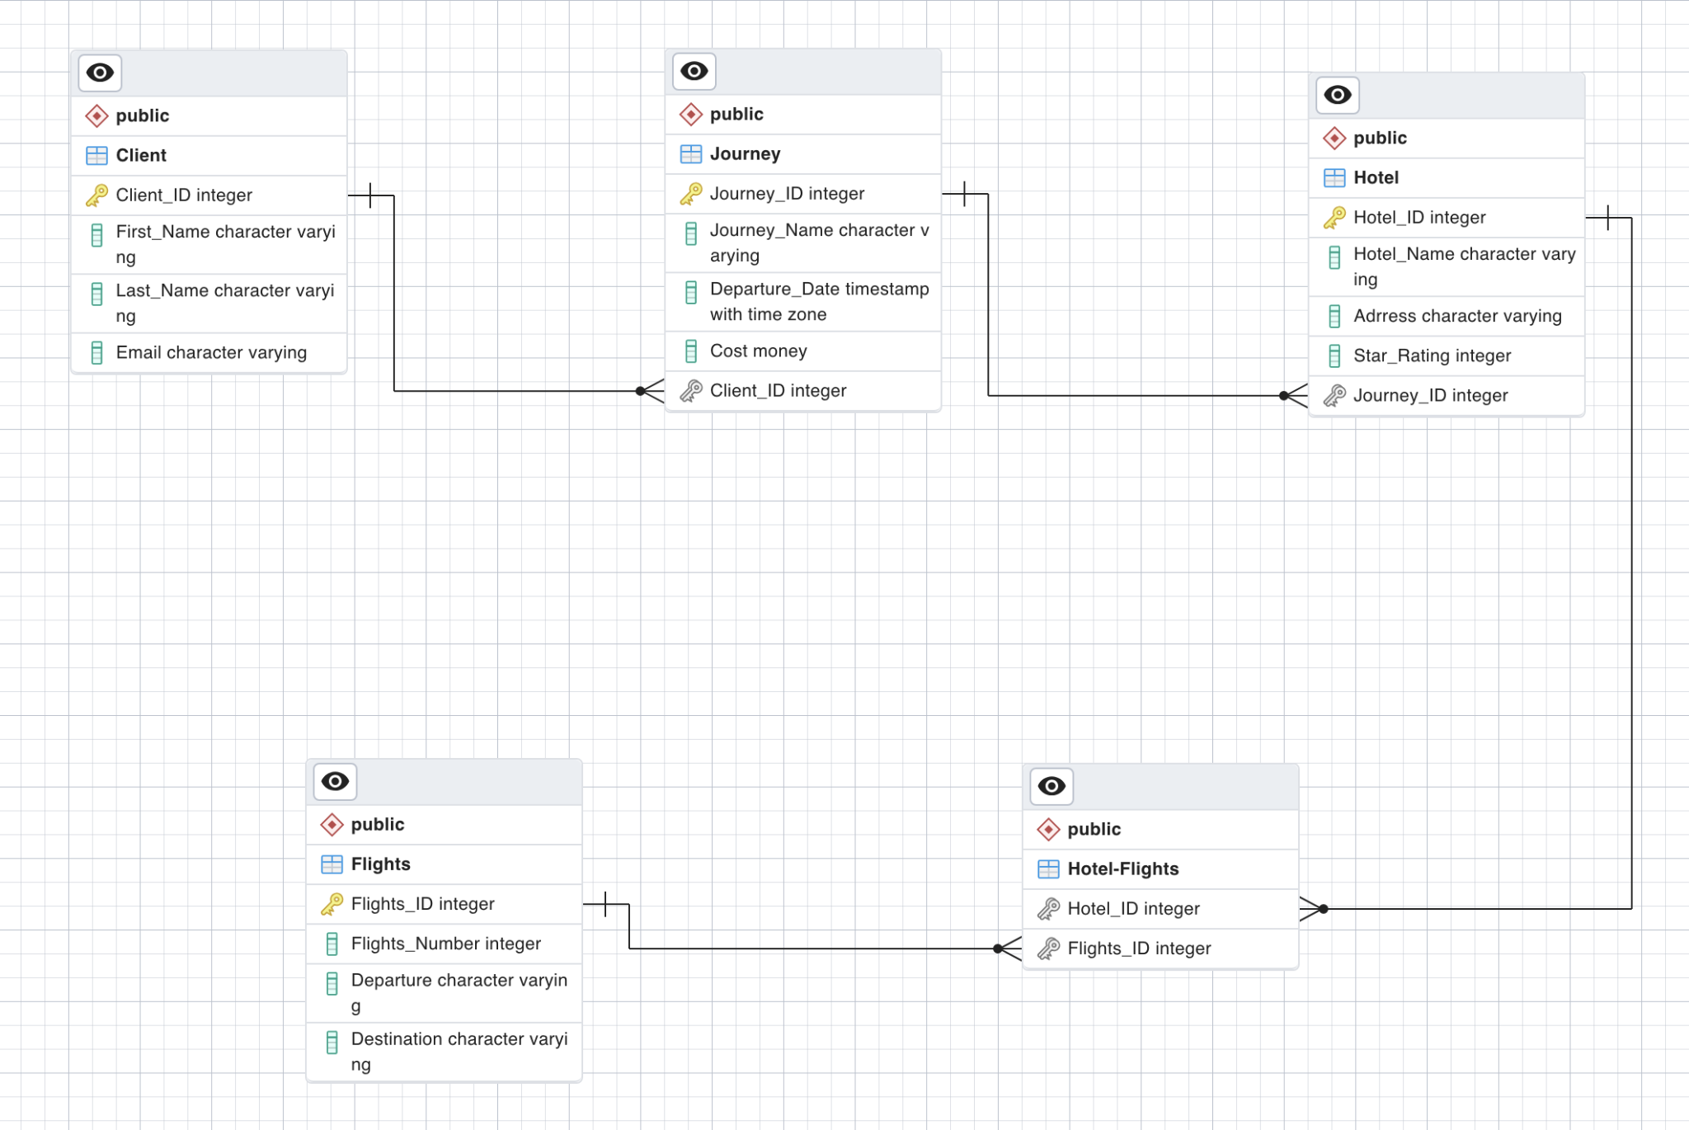

**Схема меню користувача**

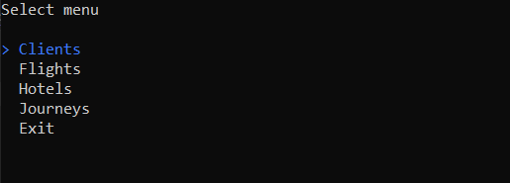

Clients:

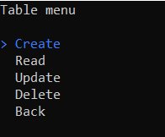

Flights:

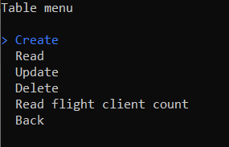

Hotels:

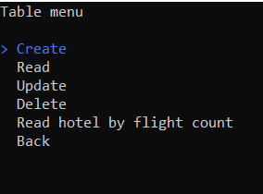

Journeys:

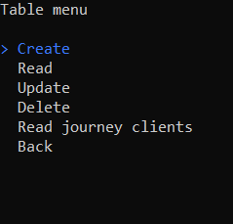

**Використані технології**

* .NET
  + ADO.NET (Npgsql)
  + Spectre.Console

**Видалення батьківських таблиць**

Спробуємо видалити запис із таблиці Clients

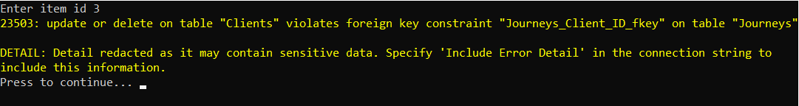

Як бачимо, ми не можемо видалити через зовнішній ключ. Програма працює правильно.

**Вставка дочірніх таблиць**

Спробуємо створити запис у таблицю Journeys з невірним значенням ключа Client_ID

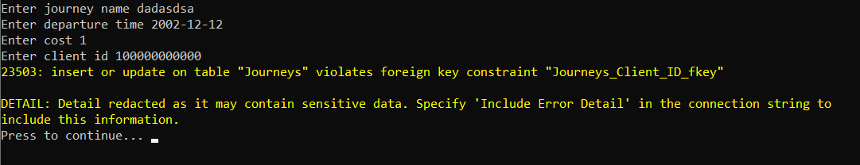

Як бачимо, програма працює правильно. Спробуємо вставити значення з існуючим ключем

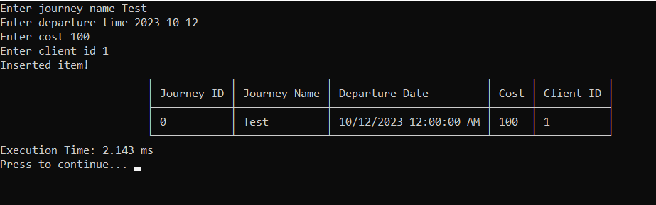

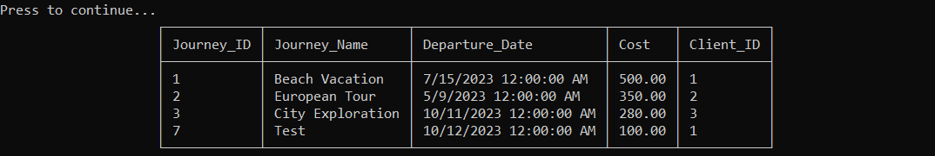

Як бачимо все пройшло успішно

**Генерація рандомізованих даних**

Згенеруємо 1000 записів для всіх таблиць, щоб побачити коректність складних запитів. Потім для тестування генерування великої кількості даних згенеруємо 100000 для таблиці Clients. Робимо це через пункт Generate

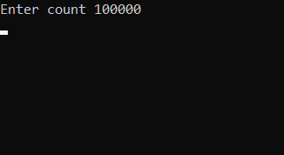

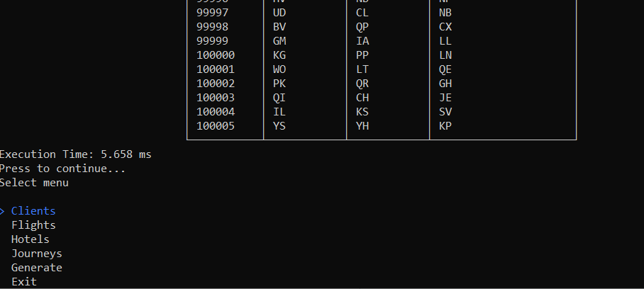

**Запити для генерації даних:**

**Clients:**

insert into "Clients"("First_Name", "Last_Name", "Email") values (chr(trunc(65 + random() * 25)::int) || chr(trunc(65 + random() * 25)::int), chr(trunc(65 + random() * 25)::int) || chr(trunc(65 + random() * 25)::int), chr(trunc(65 + random() * 25)::int) || chr(trunc(65 + random() * 25)::int));

**Flights:**

insert into "Flights"("Flight_Number", "Departure", "Destination") values (trunc(random() * 10000)::int, chr(trunc(65 + random() * 25)::int) || chr(trunc(65 + random() * 25)::int), chr(trunc(65 + random() * 25)::int) || chr(trunc(65 + random() * 25)::int));

**Hotels:**

insert into "Hotels"("Hotel_Name", "Address", "Star_Rating", "Journey_ID")

values

(

chr(trunc(65 + random() * 25)::int) || chr(trunc(65 + random() * 25)::int),

chr(trunc(65 + random() * 25)::int) || chr(trunc(65 + random() * 25)::int),

trunc(1 + random() * 5)::int,

(select f_id from trunc(1 + random() * (select max("Journey_ID") from "Journeys")) as f_id inner join "Journeys" on f_id = "Journeys"."Journey_ID")::bigint

);

**Journeys:**

insert into "Journeys"("Journey_Name", "Departure_Date", "Cost", "Client_ID")

values

(

chr(trunc(65 + random() * 25)::int) || chr(trunc(65 + random() * 25)::int),

(select timestamp '2020-01-10 20:00:00' + random() * (timestamp '2023-01-10 10:00:00' - timestamp '2020-01-10 20:00:00'))::timestamp,

trunc(1 + random() * 2000)::int,

(select f_id from trunc(1 + random() * (select max("Client_ID") from "Clients")) as f_id inner join "Clients" on f_id = "Clients"."Client_ID")::bigint

);

**Ілюстрації уведення пошукового запиту та результатів виконання запитів**

Read flight client count:

elect "Flights"."Flight_ID", "Flights"."Flight_Number", count("Client_ID") as u_c from "Flights" inner join "Hotel-Flights" using ("Flight_ID") inner join "Hotels" using ("Hotel_ID") inner join "Journeys" using ("Journey_ID") inner join "Clients" using ("Client_ID") where "Flights"."Flight_Number" > ***{filter}*** group by "Flights"."Flight_ID", "Flights"."Flight_Number", "Flights"."Departure", "Flights"."Destination" Order by "Flights"."Flight_ID";

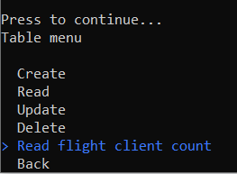

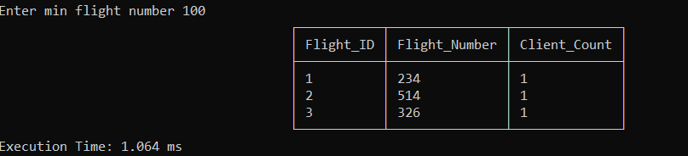

Read hotel by flight count:

select "Hotels"."Hotel_ID", "Hotels"."Hotel_Name", count("Flights"."Flight_ID") as "Flight_Count"from "Hotels"inner join "Hotel-Flights" using ("Hotel_ID")inner join "Flights" using ("Flight_ID")group by "Hotels"."Hotel_ID", "Hotels"."Hotel_Name", "Hotels"."Star_Rating"having count("Flights"."Flight_ID") between {filterF} and {filterS}Order by "Hotels"."Hotel_ID";

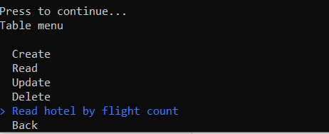

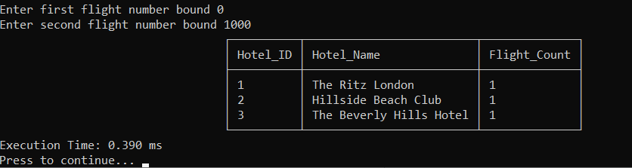

Read journey clients:

insert into "Journeys"("Journey_Name", "Departure_Date", "Cost", "Client_ID")values (chr(trunc(65 + random() * 25)::int) || chr(trunc(65 + random() * 25)::int),(select timestamp '2020-01-10 20:00:00' + random() * (timestamp '2023-01-10 10:00:00' - timestamp '2020-01-10 20:00:00'))::timestamp, trunc(1 + random() * 2000)::int,(select f_id from trunc(1 + random() * (select max("Client_ID") from "Clients")) as f_id inner join "Clients" on f_id = "Clients"."Client_ID")::bigint);

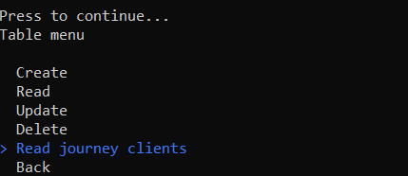

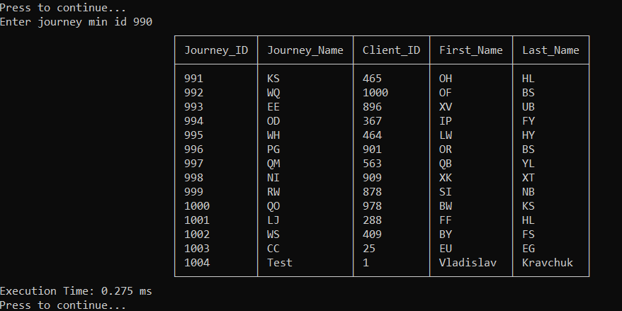

**Ілюстрації програмного коду модуля “Model”**

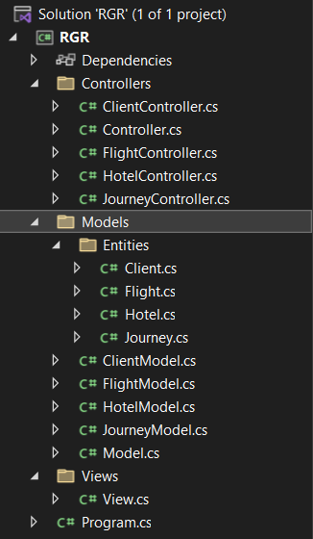

**ClientModel.cs**

using Npgsql;

using NpgsqlTypes;

using RGR.Models.Entities;

using System.Collections.Generic;

using System.Reflection.PortableExecutable;

namespace RGR.Models;

public class ClientModel : Model<Client>

{

public ClientModel(NpgsqlConnection connection) : base(connection) {}

public override void CreateItem(Client item)

{

using NpgsqlCommand command = new NpgsqlCommand();

command.Connection = Connection;

command.Parameters.Add(new NpgsqlParameter("@param_first_name", NpgsqlDbType.Varchar, 100) { Value = (object?)item.First_Name });

command.Parameters.Add(new NpgsqlParameter("@param_last_name", NpgsqlDbType.Varchar, 100) { Value = (object?)item.Last_Name });

command.Parameters.Add(new NpgsqlParameter("@param_mail", NpgsqlDbType.Varchar, 256) { Value = (object?)item.Email });

command.CommandText = $"explain analyze insert into \"Clients\"(\"First_Name\", \"Last_Name\", \"Email\") values(@param_first_name, @param_last_name, @param_mail);";

try

{

Connection.Open();

using NpgsqlDataReader reader = command.ExecuteReader();

while (reader.Read())

{

LastQueryExecutionTime = (string)reader.GetValue(0);

}

}

finally

{

Connection.Close();

}

}

public override void DeleteItem(long id)

{

using NpgsqlCommand command = new NpgsqlCommand();

command.Connection = Connection;

command.CommandText = $"delete from \"Clients\" where \"Client_ID\" = {id}";

try

{

Connection.Open();

using NpgsqlDataReader reader = command.ExecuteReader();

while (reader.Read())

{

LastQueryExecutionTime = (string)reader.GetValue(0);

}

}

finally

{

Connection.Close();

}

}

public override IEnumerable<Client> ReadItems()

{

using NpgsqlCommand command = new NpgsqlCommand();

command.Connection = Connection;

command.CommandText = $"select * from \"Clients\"";

IEnumerable<Client> items = new List<Client>();

try

{

Connection.Open();

using NpgsqlDataReader reader = command.ExecuteReader();

while (reader.Read())

{

Client item = new Client();

item.Client_ID = (long)reader["Client_ID"];

item.First_Name = (string)reader["First_Name"];

item.Last_Name = (string)reader["Last_Name"];

item.Email = (string)reader["Email"];

((List<Client>)items).Add(item);

}

}

finally

{

Connection.Close();

}

using var explain = command.Clone();

explain.CommandText = "explain analyze " + command.CommandText;

try

{

Connection.Open();

using NpgsqlDataReader explainReader = explain.ExecuteReader();

while (explainReader.Read())

{

LastQueryExecutionTime = (string)explainReader.GetValue(0);

}

}

finally

{

Connection.Close();

}

return items;

}

public override void UpdateItem(long id, Client newItem)

{

using NpgsqlCommand command = new NpgsqlCommand();

command.Connection = Connection;

command.Parameters.Add(new NpgsqlParameter("@param_first_name", NpgsqlDbType.Varchar, 100) { Value = (object?)newItem.First_Name });

command.Parameters.Add(new NpgsqlParameter("@param_last_name", NpgsqlDbType.Varchar, 100) { Value = (object?)newItem.Last_Name });

command.Parameters.Add(new NpgsqlParameter("@param_mail", NpgsqlDbType.Varchar, 256) { Value = (object?)newItem.Email });

command.CommandText = $"explain analyze update \"Clients\" set \"Client_ID\" = {id}, \"First_Name\" = @param_first_name, \"Last_Name\" = @param_last_name, \"Email\" = @param_mail where \"Client_ID\" = {id};";

try

{

Connection.Open();

using NpgsqlDataReader reader = command.ExecuteReader();

while (reader.Read())

{

LastQueryExecutionTime = (string)reader.GetValue(0);

}

}

finally

{

Connection.Close();

}

}

public override void GenerateItems(long count)

{

using NpgsqlCommand command = new NpgsqlCommand();

command.Connection = Connection;

string query = $"insert into \"Clients\"(\"First_Name\", \"Last_Name\", \"Email\") values\r\n(chr(trunc(65 + random() * 25)::int) || chr(trunc(65 + random() * 25)::int),\r\nchr(trunc(65 + random() * 25)::int) || chr(trunc(65 + random() * 25)::int),\r\nchr(trunc(65 + random() * 25)::int) || chr(trunc(65 + random() * 25)::int));";

command.CommandText = "";

for (int i = 0; i < count; i++)

command.CommandText += query;

try

{

Connection.Open();

using NpgsqlDataReader reader = command.ExecuteReader();

while (reader.Read())

{

LastQueryExecutionTime = (string)reader.GetValue(0);

}

}

finally

{

Connection.Close();

}

}

}

**FlightModel.cs**

using Npgsql;

using NpgsqlTypes;

using RGR.Models.Entities;

using System.Collections.Generic;

namespace RGR.Models;

public class FlightModel : Model<Flight>

{

public FlightModel(NpgsqlConnection connection) : base(connection) { }

public override void CreateItem(Flight item)

{

using NpgsqlCommand command = new NpgsqlCommand();

command.Connection = Connection;

command.Parameters.Add(new NpgsqlParameter("@param_number", NpgsqlDbType.Integer) { Value = (object?)item.Flight_Number });

command.Parameters.Add(new NpgsqlParameter("@param_departure", NpgsqlDbType.Varchar, 100) { Value = (object?)item.Departure });

command.Parameters.Add(new NpgsqlParameter("@param_destination", NpgsqlDbType.Varchar, 256) { Value = (object?)item.Destination });

command.CommandText = $"explain analyze insert into \"Flights\"(\"Flight_Number\", \"Departure\", \"Destination\") values(@param_number, @param_departure, @param_destination);";

try

{

Connection.Open();

using NpgsqlDataReader reader = command.ExecuteReader();

while (reader.Read())

{

LastQueryExecutionTime = (string)reader.GetValue(0);

}

}

finally

{

Connection.Close();

}

}

public override void DeleteItem(long id)

{

using NpgsqlCommand command = new NpgsqlCommand();

command.Connection = Connection;

command.CommandText = $"delete from \"Flights\" where \"Flight_ID\" = {id}";

try

{

Connection.Open();

using NpgsqlDataReader reader = command.ExecuteReader();

while (reader.Read())

{

LastQueryExecutionTime = (string)reader.GetValue(0);

}

}

finally

{

Connection.Close();

}

}

public override void GenerateItems(long count)

{

using NpgsqlCommand command = new NpgsqlCommand();

command.Connection = Connection;

string query = $"insert into \"Flights\"(\"Flight_Number\", \"Departure\", \"Destination\") values \r\n(trunc(random() * 10000)::int, \r\nchr(trunc(65 + random() * 25)::int) || chr(trunc(65 + random() * 25)::int), \r\nchr(trunc(65 + random() * 25)::int) || chr(trunc(65 + random() * 25)::int));";

command.CommandText = "";

for (int i = 0; i < count; i++)

command.CommandText += query;

try

{

Connection.Open();

using NpgsqlDataReader reader = command.ExecuteReader();

while (reader.Read())

{

LastQueryExecutionTime = (string)reader.GetValue(0);

}

}

finally

{

Connection.Close();

}

}

public override IEnumerable<Flight> ReadItems()

{

using NpgsqlCommand command = new NpgsqlCommand();

command.Connection = Connection;

command.CommandText = $"select * from \"Flights\"";

IEnumerable<Flight> items = new List<Flight>();

try

{

Connection.Open();

using NpgsqlDataReader reader = command.ExecuteReader();

while (reader.Read())

{

Flight item = new Flight();

item.Flight_ID = (long)reader["Flight_ID"];

item.Flight_Number = (int)reader["Flight_Number"];

item.Departure = (string)reader["Departure"];

item.Destination = (string)reader["Destination"];

((List<Flight>)items).Add(item);

}

}

finally

{

Connection.Close();

}

using var explain = command.Clone();

explain.CommandText = "explain analyze " + command.CommandText;

try

{

Connection.Open();

using NpgsqlDataReader explainReader = explain.ExecuteReader();

while (explainReader.Read())

{

LastQueryExecutionTime = (string)explainReader.GetValue(0);

}

}

finally

{

Connection.Close();

}

return items;

}

public override void UpdateItem(long id, Flight newItem)

{

using NpgsqlCommand command = new NpgsqlCommand();

command.Connection = Connection;

command.Parameters.Add(new NpgsqlParameter("@param_number", NpgsqlDbType.Integer) { Value = (object?)newItem.Flight_Number });

command.Parameters.Add(new NpgsqlParameter("@param_departure", NpgsqlDbType.Varchar, 100) { Value = (object?)newItem.Departure });

command.Parameters.Add(new NpgsqlParameter("@param_destination", NpgsqlDbType.Varchar, 256) { Value = (object?)newItem.Destination });

command.CommandText = $"explain analyze update \"Flights\" set \"Flight_ID\" = {id}, \"Flight_Number\" = @param_number, \"Departure\" = @param_departure, \"Destination\" = @param_destination where \"Flight_ID\" = {id};";

try

{

Connection.Open();

using NpgsqlDataReader reader = command.ExecuteReader();

while (reader.Read())

{

LastQueryExecutionTime = (string)reader.GetValue(0);

}

}

finally

{

Connection.Close();

}

}

public IEnumerable<object> ReadFlightClientCount(long filter)

{

using NpgsqlCommand command = new NpgsqlCommand();

command.Connection = Connection;

command.CommandText = $"select \"Flights\".\"Flight_ID\", \"Flights\".\"Flight_Number\", count(\"Client_ID\") as u_c\r\nfrom \"Flights\"\r\ninner join \"Hotel-Flights\" using (\"Flight_ID\")\r\ninner join \"Hotels\" using (\"Hotel_ID\")\r\ninner join \"Journeys\" using (\"Journey_ID\")\r\ninner join \"Clients\" using (\"Client_ID\")\r\nwhere \"Flights\".\"Flight_Number\" > {filter}\r\ngroup by \"Flights\".\"Flight_ID\", \"Flights\".\"Flight_Number\", \"Flights\".\"Departure\", \"Flights\".\"Destination\"\r\nOrder by \"Flights\".\"Flight_ID\";";

IEnumerable<object> items = new List<object>();

try

{

Connection.Open();

using NpgsqlDataReader reader = command.ExecuteReader();

while (reader.Read())

{

((List<object>)items).Add(new

{

Flight_ID = (long)reader["Flight_ID"],

Flight_Number = (int)reader["Flight_Number"],

Client_Count = (long)reader["u_c"]

});

}

}

finally

{

Connection.Close();

}

using var explain = command.Clone();

explain.CommandText = "explain analyze " + command.CommandText;

try

{

Connection.Open();

using NpgsqlDataReader explainReader = explain.ExecuteReader();

while (explainReader.Read())

{

LastQueryExecutionTime = (string)explainReader.GetValue(0);

}

}

finally

{

Connection.Close();

}

return items;

}

}

**HotelModel.cs**

using Npgsql;

using NpgsqlTypes;

using RGR.Models.Entities;

using System.Collections.Generic;

namespace RGR.Models;

public class HotelModel : Model<Hotel>

{

public HotelModel(NpgsqlConnection connection) : base(connection) { }

public override void CreateItem(Hotel item)

{

using NpgsqlCommand command = new NpgsqlCommand();

command.Connection = Connection;

command.Parameters.Add(new NpgsqlParameter("@param_name", NpgsqlDbType.Varchar, 100) { Value = (object?)item.Hotel_Name });

command.Parameters.Add(new NpgsqlParameter("@param_address", NpgsqlDbType.Varchar, 100) { Value = (object?)item.Address });

command.Parameters.Add(new NpgsqlParameter("@param_rating", NpgsqlDbType.Integer) { Value = (object?)item.Star_Rating });

command.Parameters.Add(new NpgsqlParameter("@param_journey", NpgsqlDbType.Bigint) { Value = (object?)item.Journey_ID });

command.CommandText = $"explain analyze insert into \"Hotels\"(\"Hotel_Name\", \"Address\", \"Star_Rating\", \"Journey_ID\") values(@param_name, @param_address, @param_rating, @param_journey);";

try

{

Connection.Open();

using NpgsqlDataReader reader = command.ExecuteReader();

while (reader.Read())

{

LastQueryExecutionTime = (string)reader.GetValue(0);

}

}

finally

{

Connection.Close();

}

}

public override void DeleteItem(long id)

{

using NpgsqlCommand command = new NpgsqlCommand();

command.Connection = Connection;

command.CommandText = $"explain analyze delete from \"Hotels\" where \"Hotel_ID\" = {id}";

try

{

Connection.Open();

using NpgsqlDataReader reader = command.ExecuteReader();

while (reader.Read())

{

LastQueryExecutionTime = (string)reader.GetValue(0);

}

}

finally

{

Connection.Close();

}

}

public override void GenerateItems(long count)

{

using NpgsqlCommand command = new NpgsqlCommand();

command.Connection = Connection;

string query = $"insert into \"Hotels\"(\"Hotel_Name\", \"Address\", \"Star_Rating\", \"Journey_ID\") \r\nvalues \r\n(\r\n\tchr(trunc(65 + random() * 25)::int) || chr(trunc(65 + random() * 25)::int), \r\n\tchr(trunc(65 + random() * 25)::int) || chr(trunc(65 + random() * 25)::int), \r\n\ttrunc(1 + random() * 5)::int, \r\n\t(select f_id from trunc(1 + random() * (select max(\"Journey_ID\") from \"Journeys\")) as f_id inner join \"Journeys\" on f_id = \"Journeys\".\"Journey_ID\")::bigint\r\n);";

command.CommandText = "";

for (int i = 0; i < count; i++)

command.CommandText += query;

try

{

Connection.Open();

using NpgsqlDataReader reader = command.ExecuteReader();

while (reader.Read())

{

LastQueryExecutionTime = (string)reader.GetValue(0);

}

}

finally

{

Connection.Close();

}

}

public override IEnumerable<Hotel> ReadItems()

{

using NpgsqlCommand command = new NpgsqlCommand();

command.Connection = Connection;

command.CommandText = $"select * from \"Hotels\"";

IEnumerable<Hotel> items = new List<Hotel>();

try

{

Connection.Open();

using NpgsqlDataReader reader = command.ExecuteReader();

while (reader.Read())

{

Hotel item = new Hotel();

item.Hotel_ID = (long)reader["Hotel_ID"];

item.Hotel_Name = (string)reader["Hotel_Name"];

item.Address = (string)reader["Address"];

item.Star_Rating = (int)reader["Star_Rating"];

item.Journey_ID = (long)reader["Journey_ID"];

((List<Hotel>)items).Add(item);

}

}

finally

{

Connection.Close();

}

using var explain = command.Clone();

explain.CommandText = "explain analyze " + command.CommandText;

try

{

Connection.Open();

using NpgsqlDataReader explainReader = explain.ExecuteReader();

while (explainReader.Read())

{

LastQueryExecutionTime = (string)explainReader.GetValue(0);

}

}

finally

{

Connection.Close();

}

return items;

}

public override void UpdateItem(long id, Hotel newItem)

{

using NpgsqlCommand command = new NpgsqlCommand();

command.Connection = Connection;

command.Parameters.Add(new NpgsqlParameter("@param_name", NpgsqlDbType.Varchar, 100) { Value = (object?)newItem.Hotel_Name });

command.Parameters.Add(new NpgsqlParameter("@param_address", NpgsqlDbType.Varchar, 100) { Value = (object?)newItem.Address });

command.Parameters.Add(new NpgsqlParameter("@param_rating", NpgsqlDbType.Integer) { Value = (object?)newItem.Star_Rating });

command.Parameters.Add(new NpgsqlParameter("@param_journey", NpgsqlDbType.Bigint) { Value = (object?)newItem.Journey_ID });

command.CommandText = $"explain analyze update \"Hotels\" set \"Hotel_ID\" = {id}, \"Hotel_Name\" = @param_name, \"Address\" = @param_address, \"Star_Rating\" = @param_rating, \"Journey_ID\" = @param_journey where \"Hotel_ID\" = {id};";

try

{

Connection.Open();

using NpgsqlDataReader reader = command.ExecuteReader();

while (reader.Read())

{

LastQueryExecutionTime = (string)reader.GetValue(0);

}

}

finally

{

Connection.Close();

}

}

public IEnumerable<object> ReadHotelFlightCount(long filterF, long filterS)

{

using NpgsqlCommand command = new NpgsqlCommand();

command.Connection = Connection;

command.CommandText = $"select \"Hotels\".\"Hotel_ID\", \"Hotels\".\"Hotel_Name\", count(\"Flights\".\"Flight_ID\") as \"Flight_Count\"\r\nfrom \"Hotels\"\r\ninner join \"Hotel-Flights\" using (\"Hotel_ID\")\r\ninner join \"Flights\" using (\"Flight_ID\")\r\ngroup by \"Hotels\".\"Hotel_ID\", \"Hotels\".\"Hotel_Name\", \"Hotels\".\"Star_Rating\"\r\nhaving count(\"Flights\".\"Flight_ID\") between {filterF} and {filterS}\r\nOrder by \"Hotels\".\"Hotel_ID\";";

IEnumerable<object> items = new List<object>();

try

{

Connection.Open();

using NpgsqlDataReader reader = command.ExecuteReader();

while (reader.Read())

{

((List<object>)items).Add(new

{

Hotel_ID = (long)reader["Hotel_ID"],

Hotel_Name = (string)reader["Hotel_Name"],

Flight_Count = (long)reader["Flight_Count"]

});

}

}

finally

{

Connection.Close();

}

using var explain = command.Clone();

explain.CommandText = "explain analyze " + command.CommandText;

try

{

Connection.Open();

using NpgsqlDataReader explainReader = explain.ExecuteReader();

while (explainReader.Read())

{

LastQueryExecutionTime = (string)explainReader.GetValue(0);

}

}

finally

{

Connection.Close();

}

return items;

}

}

**JourneyMode.cs**

using Npgsql;

using NpgsqlTypes;

using RGR.Models.Entities;

namespace RGR.Models;

public class JourneyModel : Model<Journey>

{

public JourneyModel(NpgsqlConnection connection) : base(connection) { }

public override void CreateItem(Journey item)

{

using NpgsqlCommand command = new NpgsqlCommand();

command.Connection = Connection;

command.Parameters.Add(new NpgsqlParameter("@param_name", NpgsqlDbType.Varchar, 100) { Value = (object?)item.Journey_Name });

command.Parameters.Add(new NpgsqlParameter("@param_date", NpgsqlDbType.Timestamp) { Value = (object?)item.Departure_Date });

command.Parameters.Add(new NpgsqlParameter("@param_cost", NpgsqlDbType.Money) { Value = (object?)item.Cost });

command.Parameters.Add(new NpgsqlParameter("@param_client", NpgsqlDbType.Bigint) { Value = (object?)item.Client_ID });

command.CommandText = $"explain analyze insert into \"Journeys\"(\"Journey_Name\", \"Departure_Date\", \"Cost\", \"Client_ID\") values(@param_name, @param_date, @param_cost, @param_client);";

try

{

Connection.Open();

using NpgsqlDataReader reader = command.ExecuteReader();

while (reader.Read())

{

LastQueryExecutionTime = (string)reader.GetValue(0);

}

}

finally

{

Connection.Close();

}

}

public override void DeleteItem(long id)

{

using NpgsqlCommand command = new NpgsqlCommand();

command.Connection = Connection;

command.CommandText = $"explain analyze delete from \"Journeys\" where \"Journey_ID\" = {id}";

try

{

Connection.Open();

using NpgsqlDataReader reader = command.ExecuteReader();

while (reader.Read())

{

LastQueryExecutionTime = (string)reader.GetValue(0);

}

}

finally

{

Connection.Close();

}

}

public override void GenerateItems(long count)

{

using NpgsqlCommand command = new NpgsqlCommand();

command.Connection = Connection;

string query = $"insert into \"Journeys\"(\"Journey_Name\", \"Departure_Date\", \"Cost\", \"Client_ID\")\r\nvalues \r\n(\r\n\tchr(trunc(65 + random() * 25)::int) || chr(trunc(65 + random() * 25)::int),\r\n\t(select timestamp '2020-01-10 20:00:00' + random() * (timestamp '2023-01-10 10:00:00' - timestamp '2020-01-10 20:00:00'))::timestamp, \r\n\ttrunc(1 + random() * 2000)::int,\r\n\t(select f_id from trunc(1 + random() * (select max(\"Client_ID\") from \"Clients\")) as f_id inner join \"Clients\" on f_id = \"Clients\".\"Client_ID\")::bigint\r\n);";

command.CommandText = "";

for (int i = 0; i < count; i++)

command.CommandText += query;

try

{

Connection.Open();

using NpgsqlDataReader reader = command.ExecuteReader();

while (reader.Read())

{

LastQueryExecutionTime = (string)reader.GetValue(0);

}

}

finally

{

Connection.Close();

}

}

public override IEnumerable<Journey> ReadItems()

{

using NpgsqlCommand command = new NpgsqlCommand();

command.Connection = Connection;

command.CommandText = $"select * from \"Journeys\"";

IEnumerable<Journey> items = new List<Journey>();

try

{

Connection.Open();

using NpgsqlDataReader reader = command.ExecuteReader();

while (reader.Read())

{

Journey item = new Journey();

item.Journey_ID = (long)reader["Journey_ID"];

item.Journey_Name = (string)reader["Journey_Name"];

item.Departure_Date = (DateTime)reader["Departure_Date"];

item.Cost = (decimal)reader["Cost"];

item.Client_ID = (long)reader["Client_ID"];

((List<Journey>)items).Add(item);

}

}

finally

{

Connection.Close();

}

using var explain = command.Clone();

explain.CommandText = "explain analyze " + command.CommandText;

try

{

Connection.Open();

using NpgsqlDataReader explainReader = explain.ExecuteReader();

while (explainReader.Read())

{

LastQueryExecutionTime = (string)explainReader.GetValue(0);

}

}

finally

{

Connection.Close();

}

return items;

}

public override void UpdateItem(long id, Journey newItem)

{

using NpgsqlCommand command = new NpgsqlCommand();

command.Connection = Connection;

command.Parameters.Add(new NpgsqlParameter("@param_name", NpgsqlDbType.Varchar, 100) { Value = (object?)newItem.Journey_Name });

command.Parameters.Add(new NpgsqlParameter("@param_date", NpgsqlDbType.Timestamp) { Value = (object?)newItem.Departure_Date });

command.Parameters.Add(new NpgsqlParameter("@param_cost", NpgsqlDbType.Money) { Value = (object?)newItem.Cost });

command.Parameters.Add(new NpgsqlParameter("@param_client", NpgsqlDbType.Bigint) { Value = (object?)newItem.Client_ID });

command.CommandText = $"explain analyze update \"Journeys\" set \"Journey_ID\" = {id}, \"Journey_Name\" = @param_name, \"Departure_Date\" = @param_date, \"Cost\" = @param_cost, \"Client_ID\" = @param_client where \"Journey_ID\" = {id};";

try

{

Connection.Open();

using NpgsqlDataReader reader = command.ExecuteReader();

while (reader.Read())

{

LastQueryExecutionTime = (string)reader.GetValue(0);

}

}

finally

{

Connection.Close();

}

}

public IEnumerable<object> ReadJourneyClients(long filter)

{

using NpgsqlCommand command = new NpgsqlCommand();

command.Connection = Connection;

command.CommandText = $"select \"Journey_ID\", \"Journey_Name\", \"Client_ID\", \"First_Name\", \"Last_Name\" \r\nfrom \"Journeys\"\r\ninner join \"Clients\" using (\"Client_ID\")\r\nwhere \"Journey_ID\" > {filter}\r\nOrder by \"Journey_ID\";";

IEnumerable<object> items = new List<object>();

try

{

Connection.Open();

using NpgsqlDataReader reader = command.ExecuteReader();

while (reader.Read())

{

((List<object>)items).Add(new

{

Journey_ID = (long)reader["Journey_ID"],

Journey_Name = (string)reader["Journey_Name"],

Client_ID = (long)reader["Client_ID"],

First_Name = (string)reader["First_Name"],

Last_Name = (string)reader["Last_Name"],

});

}

}

finally

{

Connection.Close();

}

using var explain = command.Clone();

explain.CommandText = "explain analyze " + command.CommandText;

try

{

Connection.Open();

using NpgsqlDataReader explainReader = explain.ExecuteReader();

while (explainReader.Read())

{

LastQueryExecutionTime = (string)explainReader.GetValue(0);

}

}

finally

{

Connection.Close();

}

return items;

}

}

**Model.cs**

using Npgsql;

namespace RGR.Models;

public abstract class Model<T> where T : class, new()

{

public NpgsqlConnection Connection { get; private set; }

public Model(NpgsqlConnection connection)

{

Connection = connection;

}

public abstract void CreateItem(T item);

public abstract IEnumerable<T> ReadItems();

public abstract void UpdateItem(long id, T newItem);

public abstract void DeleteItem(long id);

public abstract void GenerateItems(long count);

public string LastQueryExecutionTime { get; protected set; }

}