Sa localhost po muna gawin tapos kung pwede po pakipalitan narin po name ng table sa localhost gawin pong ganto

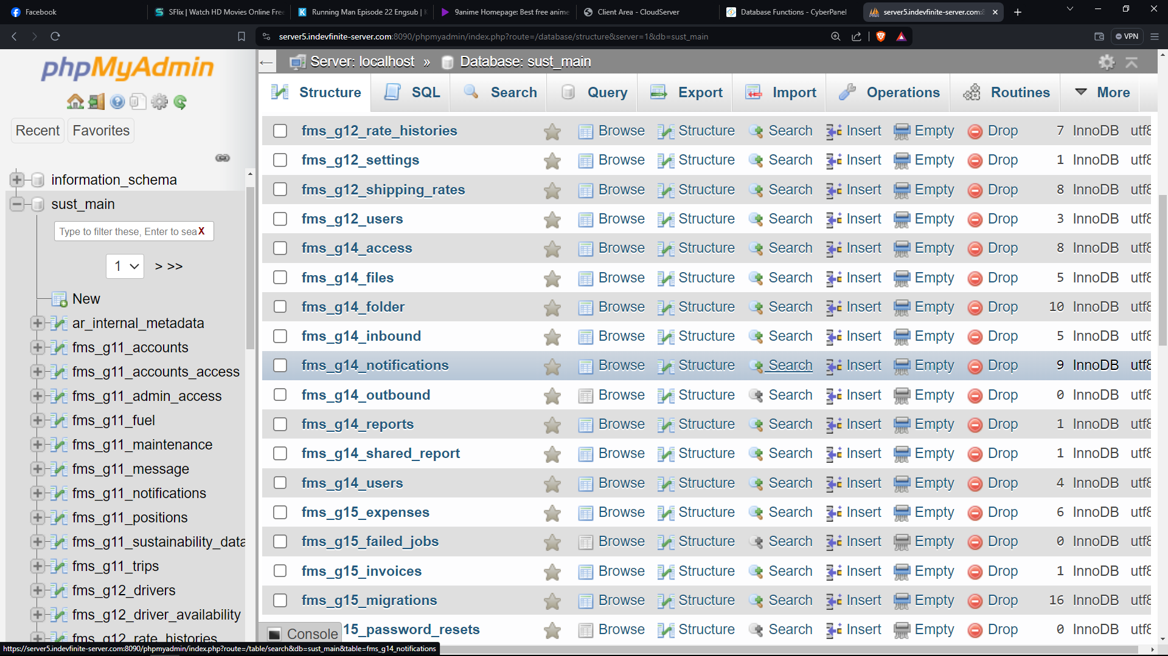

Request is dapat naka percentage ung accept, declined , and pending aalisin po ung mga number sa gilid tapos ung sa data report ung nasa baba po is ung mga modules na nag sesend samen ng data tapos ung number sa gilid numbers ng files or data na nasend tanggalin din po ung inbound and outbound sa data report

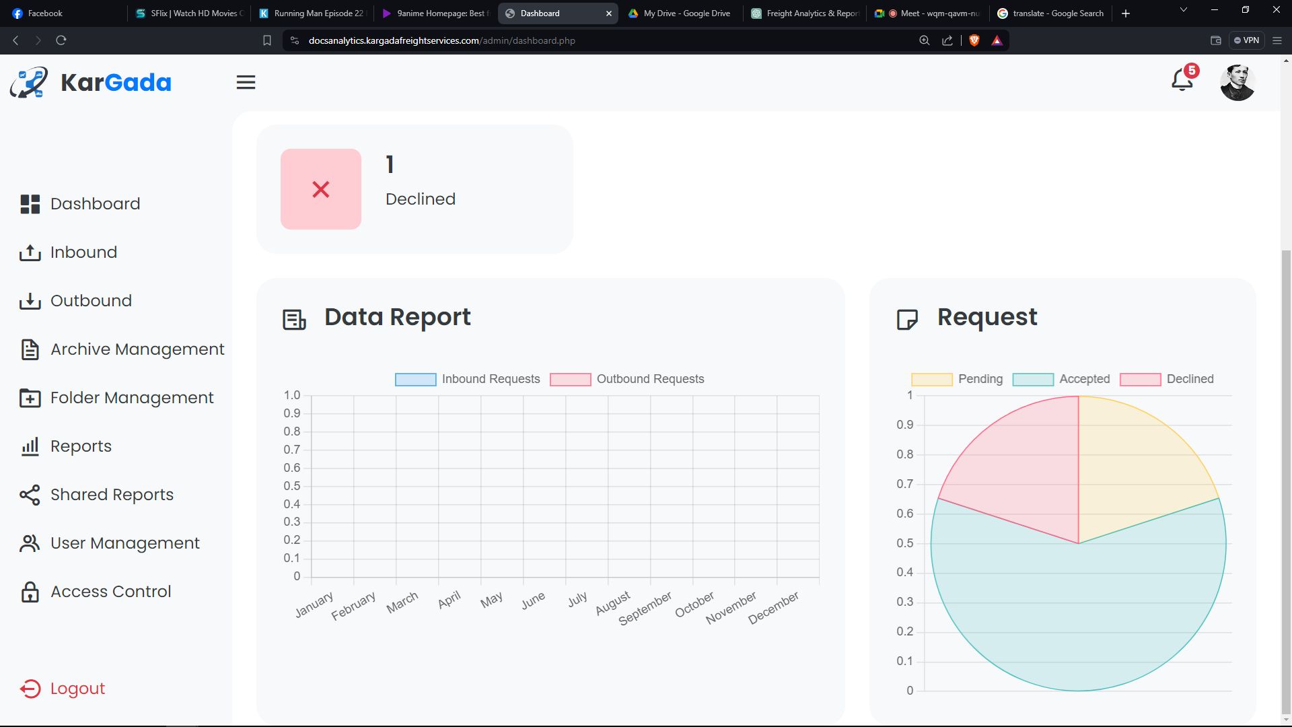

Add View functions need to get the file type, details about the file before accepting documents

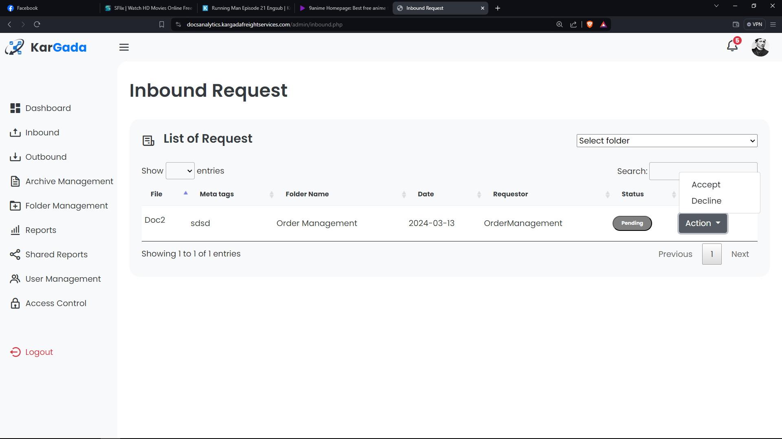

Archive is for storing and saving of documents already be deleted in document management after 1 year, and then it will go to archive management then after 6rys it will disappear from the archive management but it will not disappear from the database.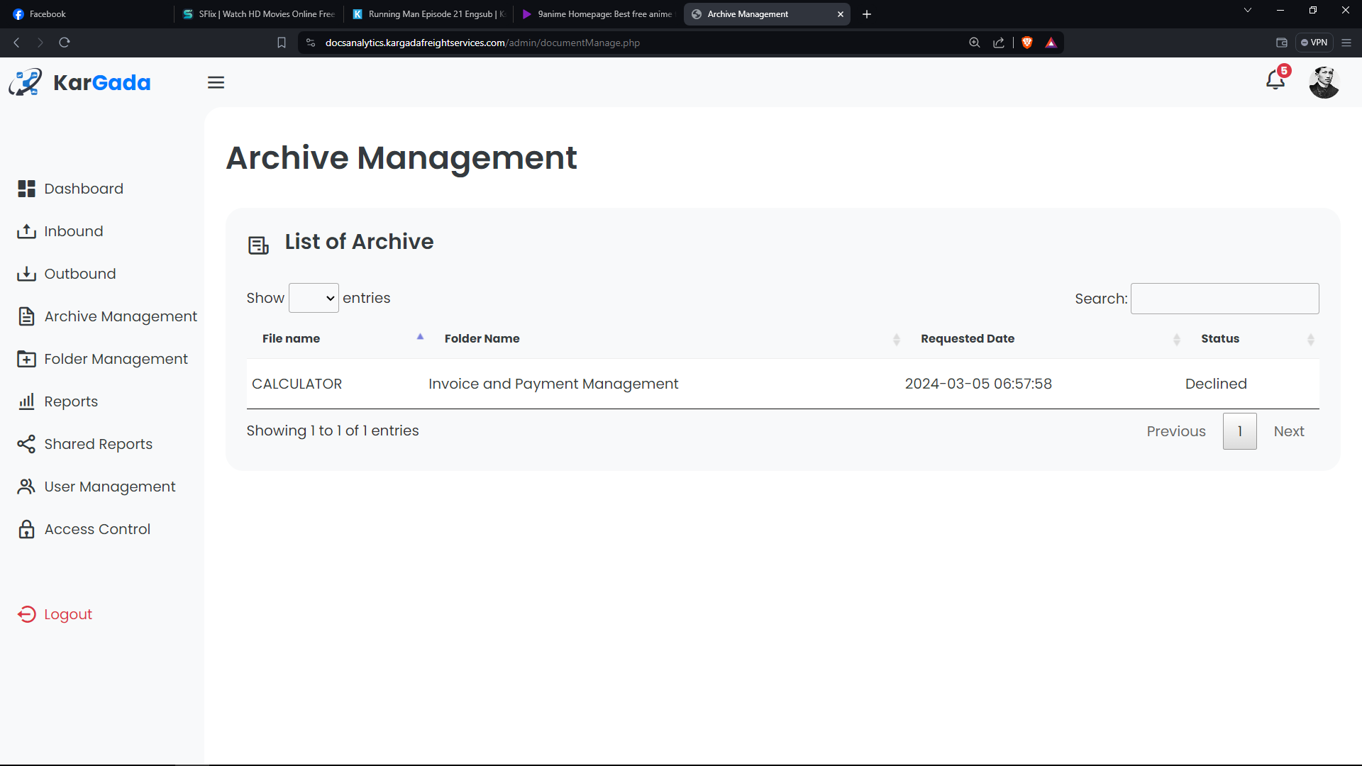

Need to manipulate all folders and files like Google Drive with functions edit, rename, delete, move, download, and folder information, activity

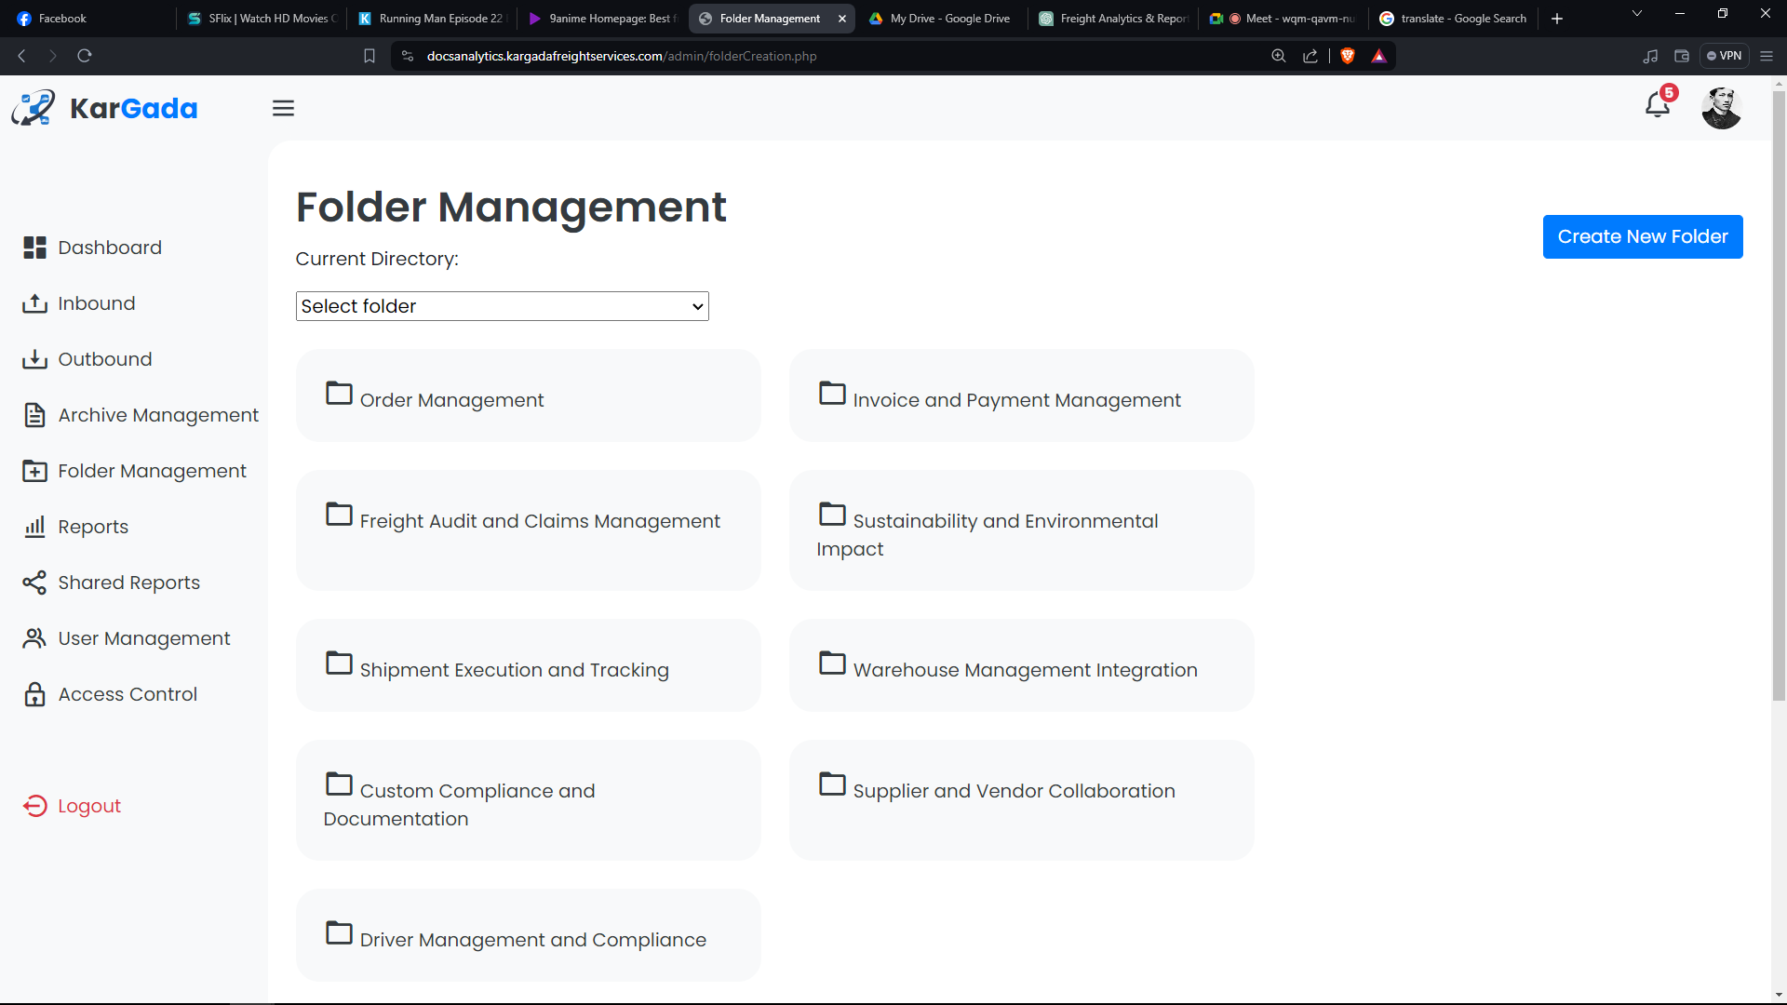

Tapos palagyan po ng trash for deleted files, folders, and decline files , and pwede po sya ma restore

Tapos sa security po palagyan po ng :

ADMIN SIDE

Middle ware  
login attempt 3 times

authentication  
forgot password  
change password

Login session auto logout if not use