Identifying the Most Attractive Neighbourhoods in London for Opening an Upmarket Cocktail Bar Using Machine Learning and K-Means Clustering

Daumantas Dulius

31/01/2021

- Introduction

  - Background
Nationally, the night-time economy is the UK's fifth-biggest industry, accounting for at least 8% of the UK's employment and annual revenues of £66bn. The industry is comprised of a plethora of restaurants, pubs, clubs and exquisite cocktail bars, the latter will be the focus of this study. Of all of London’s most alluring venues and spaces, the capital’s seemingly endless array of chic and exclusive cocktail bars are perhaps the most inspiring. From ultra-lustrous sky bars overlooking the capital’s famous skyline and riverside to eccentric and quirky lounge bars in the heart of Shoreditch, all offering a sublime otherworldly experience seemingly disconnected from reality. But if you were to pick but one neighbourhood in London to open up your very own high-end cocktail bar to maximise profits where would you choose? From Mayfair, Chelsea, Kensington to St Pauls, Bond Street, and Waterloo, the possibilities are endless. Thankfully I have done the hard work for you, by utilising machine learning techniques I will present to you, London’s most appealing neighbourhood to open up your very own little piece of intoxicating heaven.
  - Data Required
For this study I will make use of geospatial data mostly consisting of the geographical coordinates of each Inner London postcode’s centroid from OpenStreetMap, as well as venue data from Foursquare’ s API including a venue’s name, location, popularity, category, and so on. The data analysis and implementation of machine learning algorithms will be done in Python.

- Methodology

  - Data Acquisition and cleansing
To begin, each postcode and associated neighbourhood and coordinates of its centroid were scraped and sourced from the web (OpenStreetMap) and compiled into the following pandas data frame, where the first 10 rows are shown below.
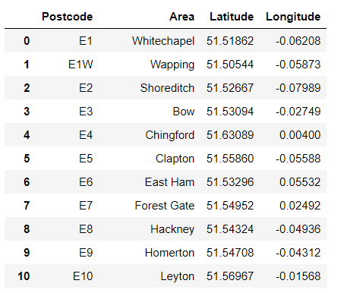
Figure 2.1. Coordinates of each inner London postcode.
Folium, a geospatial mapping Python package was used to produce a map of the plotted coordinates of each postcode, shown below in Figure 2.2.
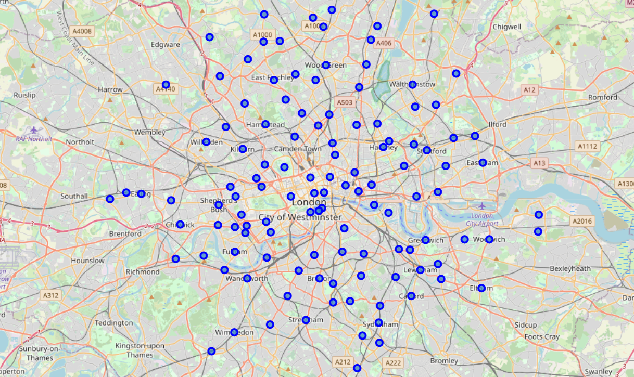
Figure 2.2. Location of every postcode within Inner London.
To obtain venue information within these postcodes, calls were made to Foursquare’ s API, where for each venue the following data was extracted:
- Neighbourhood Latitude
- Neighbourhood Longitude
- Venue
- Venue Latitude
- Venue Longitude
- Venue Category
The data was compiled into another pandas data frame and the first 10 rows are shown below in Figure 2.3, the data frame consisted of 8905 entries.
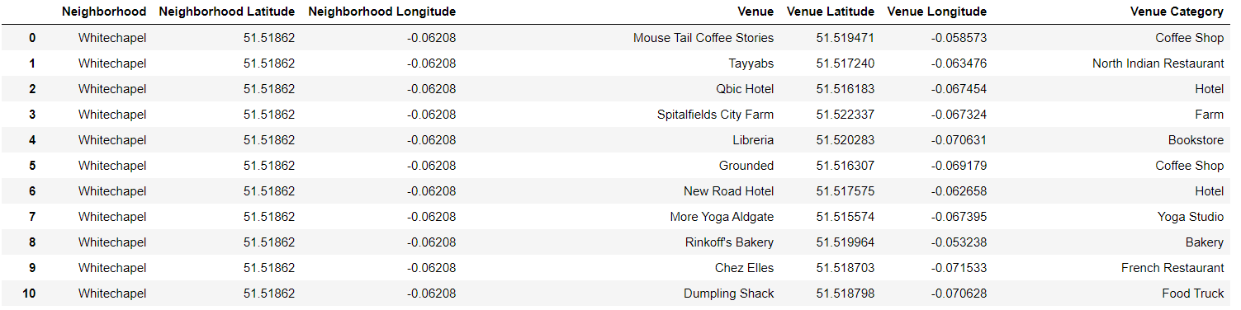
Figure 2.3. London venue data sourced from Foursquare.

The data frame shown in Figure 2.3 was further cleaned by filtering the entries down to night-time venues, as shown in Figure 2.4, where the first 6 rows of the filtered data frame are shown. Applying the filter revealed 1095 entries remaining.
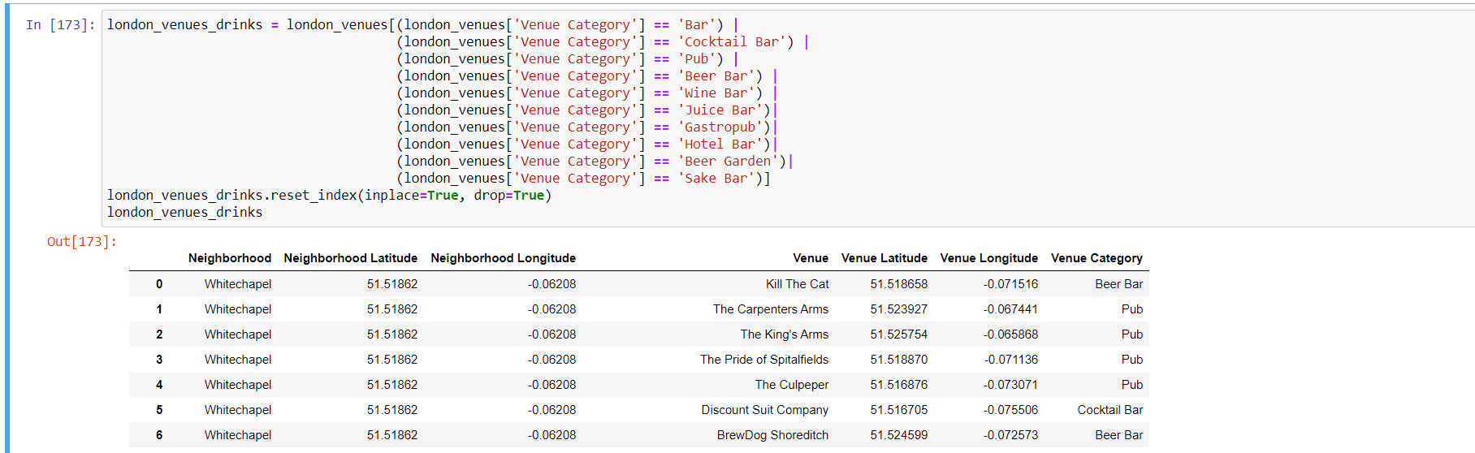
Figure 2.4. Filtered venue data

  - Exploratory Data Analysis

Next, one hot encoding was applied to the filtered data and the proportion of each venue type within each post code was calculated, shown in the data frame in Figure 2.5. At this stage the question arises of how to use the data in its current form to work out the most attractive neighbourhood in which to open up a cocktail bar. For simplicity it is assumed that areas with the highest concentration of cocktail bars are likely to be neighbourhoods where running such venues is highly profitable, as local demand is very high. Thus naturally the next step was to sort each type of venue in each area by its frequency, giving us the ranking of how common each type of venue is for a given post code, this is shown below in Figure 2.6, again for illustrative purposes only the first few rows of each data frame are shown. This data was then plotted as a bar chart shown in Figure 2.9 to give some indication on potential candidates, though further analysis had to be performed as a high fraction of cocktail bars in one area doesn’t necessarily mean it is the most common venue type in that area, in the next chapter I go through how K-means clustering was employed to further narrow down potential neighbourhood candidates.
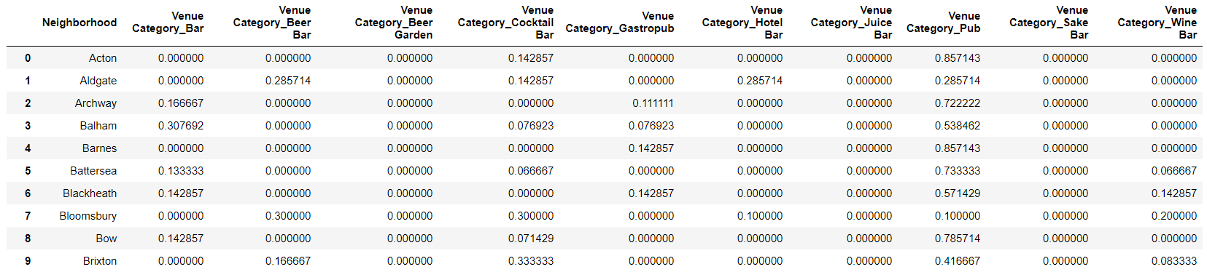
Figure 2.5. The proportion of each venue type within each London neighbourhood.

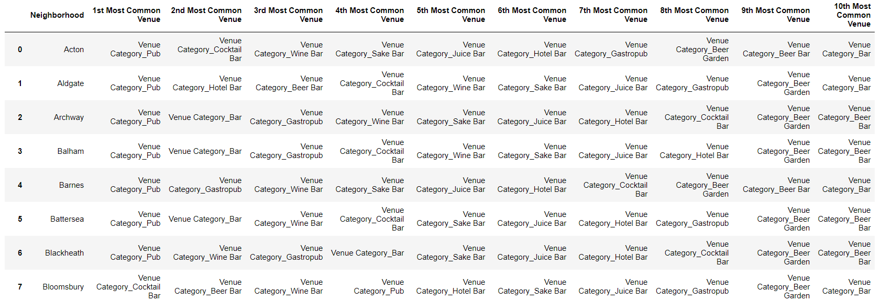
Figure 2.6. Most common venues ranked for each post code.

  - Implementation of the K-Means Clustering Algorithm

The K-means clustering algorithm is a machine learning method of vector quantisation, which aims to partition n observations into k clusters in which each observation belongs to the cluster with the nearest mean. In other words, observations with similar characteristics (in this case the most common venue types in a given post code) are grouped within the same cluster, see Figure 2.7. The algorithm is outlined below:
Given an initial set of k means $m_{1}^{(1)}… m_{k}^{(1)}$, the algorithm proceeds by alternating between two steps:
- Assignment step: Assign each observation to the cluster with the nearest mean: that with the least squared Euclidean distance:

$S_{i}^{(t)}=\left.\left\{x_{p} :{\left\|x_{p}- m_{i}^{(t)}\right\|}^{2}≤{\left\|x_{p}- m_{j}^{\left(t\right)}\right\|}^{2}∀j, 1≤j≤k\right.\right\}$ (2.1)

- Update step: Recalculate means (centroids) for observations assigned to each cluster:

$m_{i}^{(t+1)}=\frac{1}{\left|S_{i}^{\left(t\right)}\right|}\sum_{x_{j}∈S_{i}^{\left(t\right)}}{x_{j}}$ (2.2)
The algorithm has converged when the assignments no longer change. The algorithm was run on the data frame shown in Figure 2.5 and the results plotted using another folium map below in Figure 2.8.

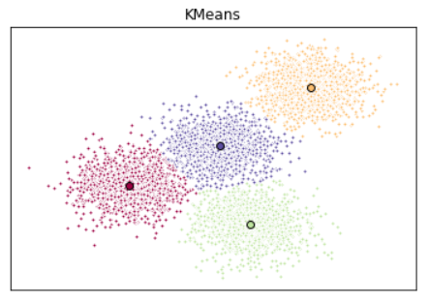
Figure 2.7. An illustrative example of K-means clustering once the algorithm has converged to a local optimum.
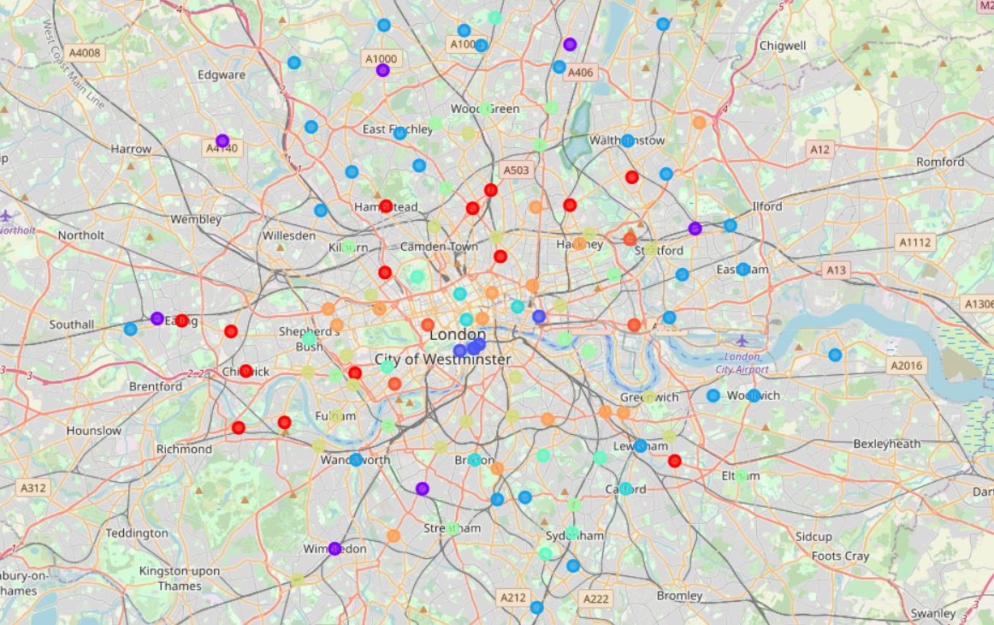
Figure 2.8. Each postcode was classified into 1 of 10 clusters based on its characteristics.

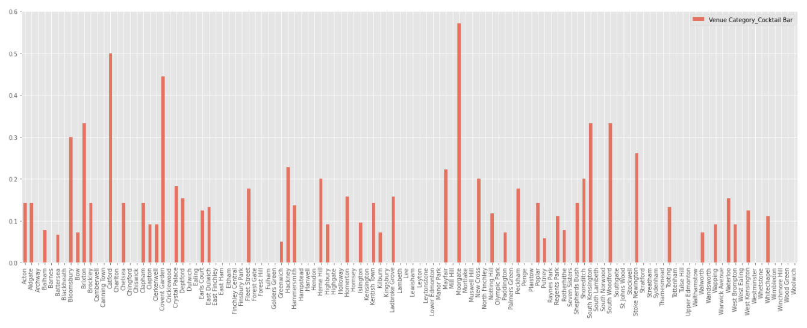
Figure 2.9. Fraction of venues that are cocktail bars for each Inner London post code.

- Results & Discussion

  - Findings
Upon inspection of the various clusters created using the K-means clustering algorithm, the cluster most suitable for our purposes was identified as cluster 4, shown below in Figure 3.1. This is because as shown, contained within this cluster are three areas with cocktail bars as the most common night-time venue for those respective post codes, and is the only cluster to contain such areas.

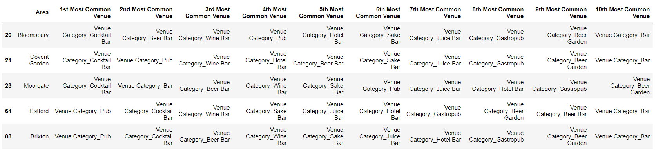
Figure 3.1. Post codes in cluster 4.

  - Recommendations
The three neighbourhoods identified above in Figure 3.1 with cocktail bars as their most common night-time venue are therefore:
- Bloomsbury
- Covent Garden
- Moorgate
Of these three areas, Moorgate has the highest number of cocktail bars as a fraction of total night-time venues (57%) in the area, in fact it is the only London neighbourhood where cocktail bars make up the majority of night-time venues (excluding clubs), as shown in Figure 2.9. Therefore this study recommends Moorgate (EC2) at the most appropriate neighbourhood for one to open up a lavish, new cocktail bar – due to the high local demand, though the other two areas highlighted above (Bloomsbury and Covent Garden) would also be very good options.

  - Limitations of the Study and Assumptions Made
For simplicity, the rather basic approach of deciding which neighbourhood was most appropriate for opening a cocktail bar based on the area’s most common venue type and proportion of that venue type (in this case cocktail bars) clearly has it’s limitations. In reality, far more complex factors may influence how profitable it is to open up a cocktail bar in any given area such as average rent prices and projected footfall, to name but a few. The K-means clustering algorithm also has it’s limitations, since every run of the algorithm converges on a local optimum because boundary conditions on initialisation are arbitrarily chosen (starting cluster centroid positions), results may vary slightly with each run. There is no doubt more advanced methods that may partition the data more effectively exist. Despite these drawbacks and limitations, the three most appropriate neighbourhoods identified in this study should come as no surprise to frequent bar-goers.

- Conclusion
To conclude, after clustering each post code within Inner London using the K-means clustering algorithm and venue geospatial data from Foursquare, three attractive candidates for opening up a cocktail bar were identified:
- Bloomsbury
- Covent Garden
- Moorgate
With Moorgate (EC2) being recommended as the top candidate in which to open a new cocktail bar, due to having the highest proportion of such venues in the area – bottom’s up.

