How do Flight Prices evolve as Flight Day Approaches?
CSC1143 Data Visualisation Assignment

Amitoj NAYAR
Durga Prasad NARSING

Abstract
This report explores how flight ticket prices change as the departure date approaches. Our goal was to understand whether there is a consistent pattern in how flights evolve in price during the final month before departure.
To answer this question, we used a large dataset of flights available on Expedia between April and October 2022. The results reveal a clear trend: prices tend to rise as the departure date gets closer, with noticeable spikes occurring at regular weekly intervals.
Our visualisation demonstrates that waiting until the last days before travelling generally leads to significantly higher fares and the animation allows viewers to easily observe this progression over time.

Dataset
The dataset comes from Kaggle (Flight Prices) and contains flight ticket information scraped from Expedia. It includes flights from April and October 2022 for routes connecting 16 airports across the United States.
The data consists of a single CSV file of 31.09 GB, containing 27 columns and more than 82 million rows. It covers a wide range of information, such as the origin and destination airports, ticket prices before and after taxes, dates of search and travel, airline details, seats remaining and some boolean indicators, such as whether the ticket is basic economy.
In terms of big data aspects, the dataset demonstrates volume, as it contains a vast number of records. While the dataset itself is static, it was built from a high-velocity context (rapidly changing flight prices), though velocity is not a defining characteristic of the final stored data.

Data Exploration, Processing, Cleaning
The goal of this project was to look at how ticket prices change as the departure day gets closer. To keep things consistent, we focused only on basic economy tickets and non-stop flights. For our chart, we only needed a few columns from the original dataset: the search and flight dates, total fare, the starting and destination airports and the indicators for basic economy and non-stop.
Since the dataset was huge, we couldn’t load it all at once, so we processed it in chunks using pandas on our local machine in order to extract the relevant data. After filtering everything, we ended up with a much smaller file of about 138 MB and 3,569,724 rows. We were then able to upload it to Google Drive and work with it in Google Colab.
There, we created a new column, daysBeforeFlight, by subtracting the search date from the flight date.
To avoid overcrowding our visualisation but still keep the results meaningful, we selected the five most popular routes in the dataset, which are SFO (San Francisco) to LAX (Los Angeles), LAX to SFO, ORD (Chicago) to LGA (New York), LGA to ORD and EWR (Newark) to BOS (Boston).
We realised that the prices don’t really evolve between 60 to 30 days before flight day, so we decided to only keep data from 30 to 1 day before flight day.
Before building the final chart, we wanted to see how flight prices varied from month to month, to see if it made sense to use the average prices across all months. Below is a boxplot showing the monthly distribution of flight prices:

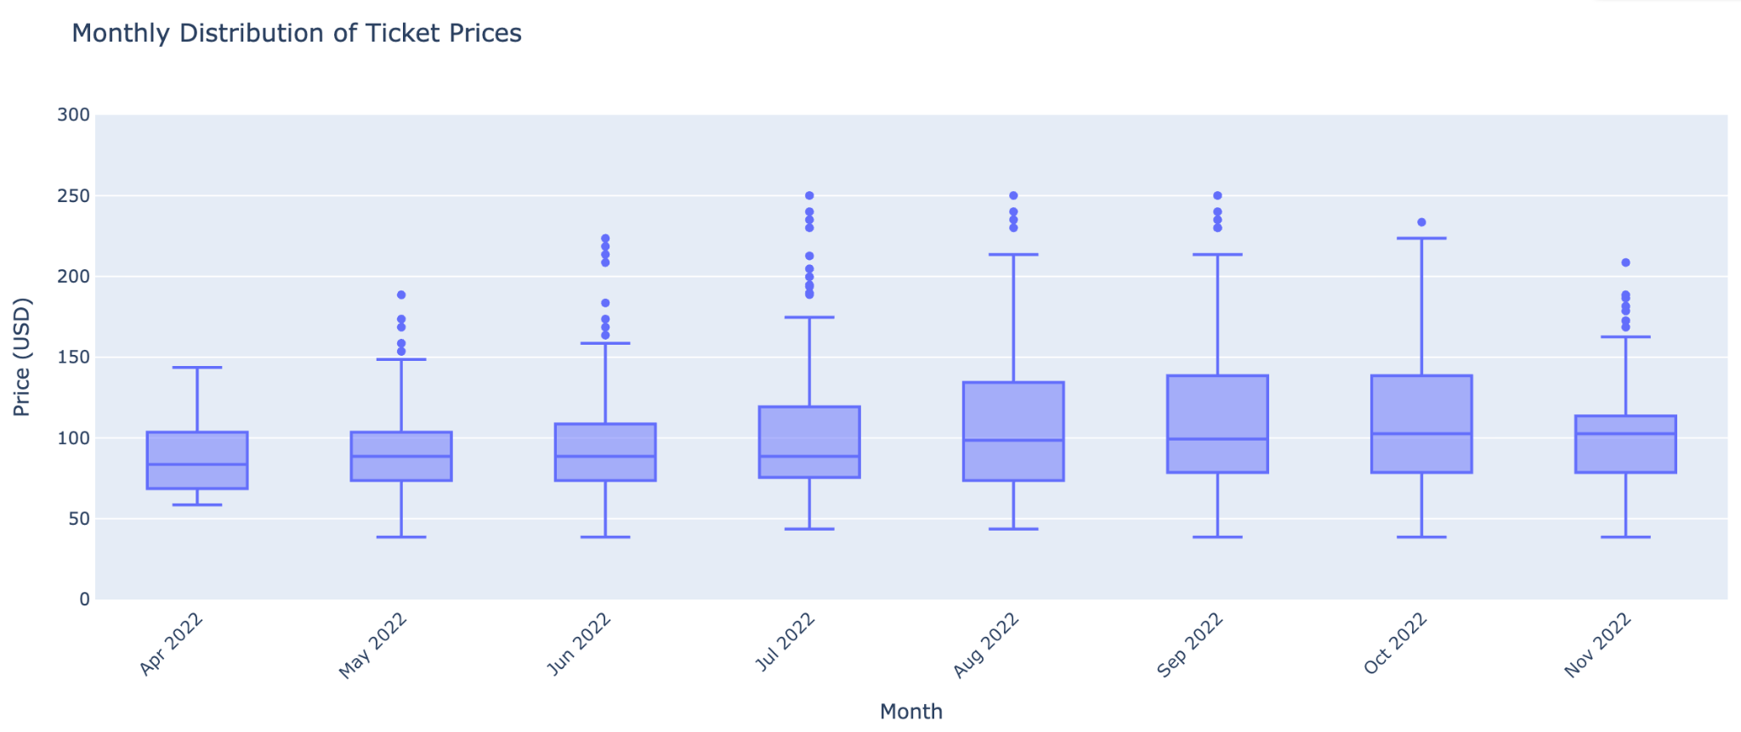
This chart shows that the distributions look pretty similar across months, so using average prices in our visualisation makes sense.

Visualisation
To answer our question on how flight prices change as the departure date approaches, we first thought of using a line chart, since line charts show change over time.
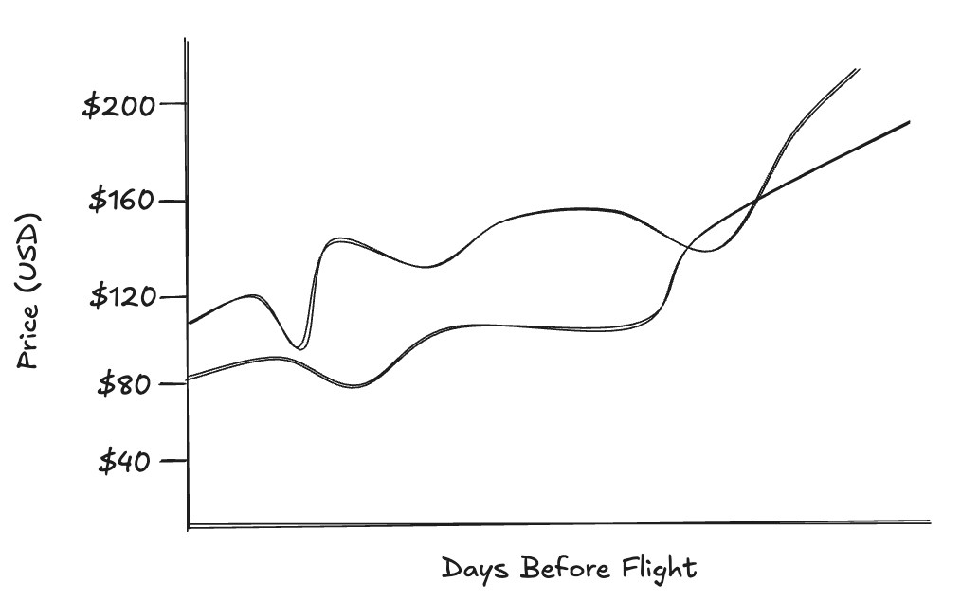
However, we realised this approach does not fit our dataset well. The x-axis would not represent real time but days before flight, which counts from 30 to 1. Reversing the x-axis (from 30 to 1), as it would be in the sketch above, felt unintuitive, while keeping it in the opposite direction (1 to 30) made the progression feel backwards. Because of this, a line chart didn’t seem to suit.
Instead, we chose to go for an animated bar chart.
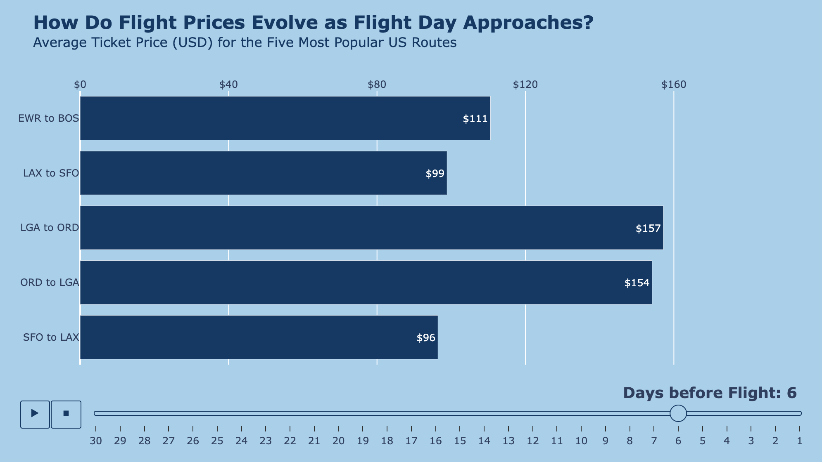
Below is our final chart:
In this animated chart, each frame represents one day before the flight, starting at 30 days and progressing down to 1. Using a horizontal bar chart made the evolution easier to see.
Since the goal was to observe the overall behaviour of prices and not highlight differences between routes, we kept all bars the same color. We chose a blue color palette because blue is associated with airplanes, as written in this article.
To keep the visualisation clean, we removed the axis titles, as they can easily be interpreted with the subtitle. We moved the x-axis to the top and decided to show only a few price values, which improves readability.
To help the viewer track the progression of time, we added the current days before flight indicator in large text at the bottom of the chart. There is also a slider that matches the animation. We restyled the play/pause buttons and the slider in order for them to remain visible but not grab too much attention.
Animation helps show how prices change day by day, making the trend easier to follow, while the slider and buttons add interactivity by allowing the viewer to pause on any specific day before the flight and look at the prices in detail.

Conclusion
To build our visualisation, we first used Pandas locally to process the original file. We then moved the cleaned dataset to Google Colab, where we continued working with Pandas for further processing. We designed the initial sketch of our idea using Excalidraw. The final visualisation was built with the Plotly library, which allowed us to easily implement animation and interactivity.
Unfortunately, our chart shows limitations. The visualisation relies too much on animation: when viewed as a screenshot, the chart loses most of its meaning because the whole purpose is to observe how the bars change over time. Without the animation, it becomes just a comparison of average prices between routes, which is not what we aim to show. Another limitation is that the route labels use airport codes, which may not be immediately recognisable to all viewers. We explored alternatives such as using full airport names, but this made the layout visually unbalanced.
Despite these issues, our chart successfully shows how flight prices evolve as the departure date gets closer. The animation shows that there are weekly spikes, particularly around 20, 13, 5, and 1 day before the flight. The viewer can easily see that prices tend to rise as the date approaches and it is the same on every route, so it shows that it is a general tendency.
We split the work so that Amitoj did the processing of the original file on his laptop, the final processing on Google Colab and the visualisation. Durga did the exploratory graph on monthly distribution of ticket prices.

References
- Dataset: Flight Prices
- Code examples for bar chart using plotly: Horizontal bar charts in Python
- Article supporting color choice: Flying Colors

