Predictive Modelling for Personalised Long COVID
Risk Assessment and Prevention
Durga Prasad Narsing | Dr Martin Crane | Dr Tai Tan Mai
School of Computing | School of Computing | School of Computing
Dublin City University | Dublin City University | Dublin City University
Glasnevin, Dublin 9, Ireland | Glasnevin, Dublin 9, Ireland | Glasnevin, Dublin 9, Ireland
durgaprasadnarsing2@gmail.com | martin.crane@dcu.ie | tai.tanmai@dcu.ie

Abstract
Post-COVID-19 Condition (Long COVID) impacts approximately 6% of people infected with SARS-CoV-2, and the current clinical pathways are unable to predict the long-term health impacts. Current predictive models often have four common methodological limitations: calibration is usually not reported; demographic fairness is not always audited; features used after the patient has been admitted to the hospital introduce "target leakage" and per-patient explainability is often missing. In this paper, we introduce and evaluate a 13-phase, leakage free, responsible-ML pipeline for the Mexican Government surveillance dataset of 220,218 confirmed COVID-19 cases with in-hospital mortality as an outcome that is clinically justified to serve as a proxy for the risk of developing a severe Long COVID. The Logistic Regression, Random Forest, Gradient Boosting, XGBoost and Stacking ensemble models 9 features at the time of admission. A calibrated Logistic Regression has an AUC of 0.888 (95% CI 0.884 – 0.892) and is proven to be non-inferior to all complex models by DeLong statistical testing (p > 0.05). The Brier score decreased from 0.135 to 0.078 and the count-weighted ECE decreased from 0.195 to 0.002 by isotonic calibration. By conducting an eight-subgroup fairness audit, equitable calibration is achieved in all groups (ECE < 0.015), and TPR disparity is decreased from 0.603 to 0.045 using threshold mitigation per group. The top two risk drivers identified by the Tree-SHAP are pneumonia (44.2%) and age (33.0%). A Streamlit web prototype provides calibrated risk scores and real-time explanations, addressing all four of the gaps.
Keywords -- Long COVID, PASC, COVID-19 mortality, machine learning, calibration, DeLong test, SHAP, fairness audit, responsible AI, clinical decision support, Streamlit.
I. INTRODUCTION
Long COVID (also known as post-COVID-19 Condition) is a huge global public health burden. About 6% of those infected with SARS-CoV-2 have long-term symptoms like fatigue, shortness of breath, cognitive problems and heart complications that can last for months or years after the initial infection [1]. National surveillance data in the United States show that 6.9% of adults experience an attack at some point in their lives and 3.4% have current symptoms [2] and that older adults, females and those with pre-existing chronic comorbidities are particularly vulnerable. The complexity and extent of Long COVID require evidence-based clinical instruments to detect patients at risk at the time of acute onset, before it is too late to intervene early.
While the field of predictive modelling is growing at a rapid pace, four methodological gaps are consistently identified in systematic reviews [3][4] that should be addressed: (i) calibration is rarely reported, making the output of predictive models difficult to interpret as clinical probabilities; (ii) predictive model performance is seldom evaluated for equity across demographic subgroups, risking inequitable patient triage; (iii) variables like intubation and ICU admission are often used to predict events that happen after admission, which is called target leakage and gives the appearance of good predictive performance but has little clinical value at the time of admission; and (iv) performance at the individual level is rarely explained, limiting clinicians' trust and use of the predictive model at the time of admission. Another question in the open is whether complex ensemble models are useful discriminatively on large, predominantly binary clinical data sets [5].
This paper fills all four gaps by addressing them with a 13-phase end-to-end responsible-ML pipeline. The Mexican Government COVID-19 dataset (n = 220,218 confirmed cases) includes labels for the time of admission to hospital and the in-hospital mortality, which are used as a proxy for the risk of severe outcome from the admission time as in previous works [6][7] and the label of death as a clinically justifiable outcome measure. RQ4 – can nine admission-time features be used to achieve clinically useful discrimination and calibration? RQ2 -- Is there significant difference between performance of complex ensembles and Logistic Regression (DeLong test)? RQ3 -- Do predictions apply fairly and in a standardised way to the different subgroups of the population? RQ4 -- Is there a functional clinical prototype that can provide predictions that can be explained in a comprehensible manner?
A. Contribution
The main contribution of this paper is 3-fold. Empirically, a calibrated Logistic Regression is statistically not inferior (p > 0.05 on 220,218 patients) to Random Forest, Gradient Boosting, XGBoost and Stacking, with all these models being "explainable" as there is no loss in discrimination when using low dimensional binary clinical features. Second, a methodological contribution: all four of the gaps identified are operationalised in a single pipeline, that is, a reproducible workflow. Third, a responsible AI contribution: auto-generated Model Card and Datasheet artefacts, a group-specific threshold mitigation strategy and a Streamlit clinical prototype with governance disclaimers built in.
B. Paper Structure
Section II reviews the related work and discusses the four gaps that are to be addressed. The engineering pipeline is detailed completely in Section III. Performance is measured in six dimensions of assessment in Section IV. The findings and limitations found in this study are discussed in section V. Section VI concludes.
II. RELATED WORK
In the literature on predictive modelling for the Long COVID, there are three streams. Studies on risk factors have been conducted consistently and have found that pneumonia, age, sex, obesity, and acute severity are found to be predictors, with none of these findings being validated as deployable tools. In a single centre, observational cohort study limited to 108 patients, Menezes et al. identified the predictor of age >= 45 (OR 5.55) and >=15 acute symptoms (OR 6.02). Guzman-Esquivel et al. [12] identified tachycardia (RR 10.4) and hospitalisation (RR 2.1) as predictors without using a deployable model or assessment of calibration.
In the 'deployable' ML models, Jeffrey et al. [4] developed a logistic regression model for the risk of Long COVID in the Scottish population, based on five predictors (female sex, BMI, age, deprivation, severe acute infection) but failed to report on calibration, fairness audit, or explainability. Antony et al. [3] summarized the performance of ML models without calibration or fairness evaluation for two million patients in EHRs (AUROC 0.75-0.80). Dozier et al. [7] used a Super Learner ensemble on 57,563 patients with high discrimination and low calibration and interpretability. Zang et al. [8] extended the same approach for the RECOVER EHR cohort, but did not perform any calibration or fairness analysis, instead relying on regularised Cox models with C-index > 0.80. Unfortunately, Shakhovska et al. [9] claimed a stacking ensemble with AUC = 0.978 but tested it on a small number of 122 patients, which creates high risk of overfitting and cannot be evaluated externally.
Seven additional COVID-19 ML mortality models are presented for comparative context: Bozkurt and Keskin [17] developed a gradient boosting mortality model on a Turkish cohort; Kourmpanis et al. [19] created a COVID-19 patient mortality prediction model using ML techniques with an AUC of 0.94; Sun et al. [20] developed and validated a COVID-19 patient mortality model; and Tang et al. [21] analyzed prediction models across multiple COVID-19 disease outcome datasets. A context for RQ2 is given in Methods comparisons. Bjerre et al. [5] systematically compared the large population databases of COVID for ML and regression, however, and found that there is little advantage of using ML methods over classical regression. Teeuw et al. [11] pointed out that good discrimination does not necessarily result in clinical utility if the calibration is not good, which further inspired the focus of this work on calibration and Decision Curve Analysis as key deployment metrics. Methodological gaps in previous studies are summarised in Table I.
Gap | Prior Studies | This Work
Calibration not reported | [4][7][8][9] | Brier + ECE; isotonic correction
No subgroup fairness audit | [4][7][8][10] | 8 subgroups; threshold mitigation
Target leakage (intubation/ICU) | [9][10] | 9 admission-time features only
No per-patient explainability | [4][5][3] | SHAP + OR + nomogram + web app
No deployable prototype | [4][6][12] | Streamlit app with live pipeline
TABLE I. Methodological Gaps in Prior Work vs This Study
III. METHODOLOGY
A. Dataset and Cohort Selection
The Mexican Government COVID-19 surveillance dataset (Kaggle 2020 [14]) includes patient records for the acute stage of SARS-CoV-2 infection (566,602 records). Variables are the following: age (continuous, in years), sex (binary), seven binary comorbidities (diabetes, hypertension, cardiovascular disease, pneumonia, obesity, asthma, COPD), clinical outcomes (intubation, ICU admission, death date) and administrative fields. The main modelling set includes 220,218 confirmed COVID-19 cases (covid_res == 1), of which 193,116 cases survived in-hospital (covid_res == 0), and 12.31% (27,102) of the confirmed cases were in-hospital deaths (covid_res == 1). This set is an in-hospital sample, with a class imbalance of 1:7 with 12.31% (27,102) in-hospital deaths and 193,116 survivors. Data was split into a 80/20 stratified split between training patients (176,174) and held-back test patients (44,044). The “events per variable” (EPV = 27,102 / 9 = 3,011) is well above the minimum of 10, implying sufficient data for stable coefficient estimation.
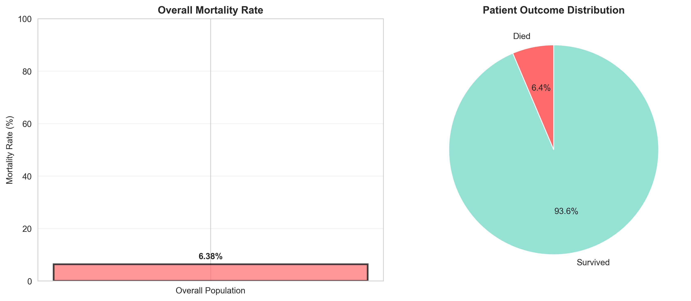
Fig. 1. Dataset overview: mortality rate and comorbidity prevalence across the confirmed COVID-19 cohort (n = 220,218).
B. Preprocessing and Leakage Control
Outcome engineering: date_died! = '9999-99-99' maps to 1 (deceased), else 0. Administrative encoding (1=Yes, 2=No) was converted to standard binary (1.0/0.0) for binary comorbidities. Comorbidity field entries that were set to 97, 98 or 99 (which, when interpreted, means unknown or not applicable) were replaced by NaN before imputation, and made up around 0.3% of the field entries. Leakage of the distribution of the test set into the imputation process was avoided by fitting a SimpleImputer (median strategy) only on the training partition and applying it to the held-out test partition. A StandardScaler was applied uniformly. Every transform was used in a scikit-learn Pipeline and applied split then fit to every cross-validation fold.
The features were intentionally limited to not including intubation status or admission to the ICU. They both are calculated during the hospital's stay and not at the time of admission and therefore represent target leakage, or an increase in apparent AUC without added clinical value at the time of admission. The top nine features are: age, sex, diabetes, hypertension, cardiovascular disease, pneumonia, obesity, asthma, COPD.
C. Statistical Feature Validation
All feature-outcome associations were statistically validated before modelling. The independent-samples t-test showed that those who died were significantly older than those who survived (58.4 years vs 41.2 years; t = 176.99, p < 0.001). All seven binary comorbidities were significantly associated with mortality with a Chi-square test (p < 0.001 for each). Benjamini-Hochberg FDR correction was applied across five primary comparisons (q < 0.05 for all), to confirm that there are no features entering the model on domain intuition. There are no serious concerns of multicollinearity because the features had no pair with r>0.34 (Pearson correlation analysis).
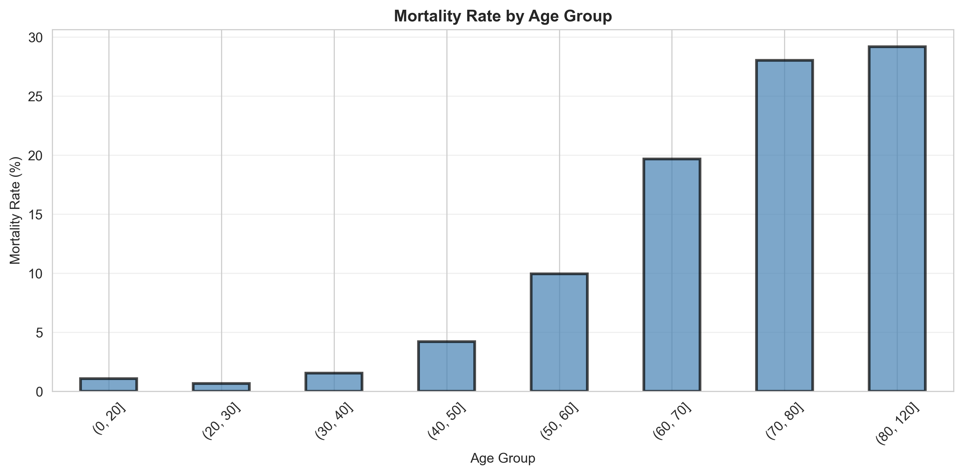
Fig. 2. Mortality rate by age group confirming monotonic age effect (t = 176.99, p < 0.001).
D. Model Training and Hyperparameter Tuning
The 5 model families trained and benchmarked were Logistic Regression (L2 regularisation), Random Forest, Gradient Boosting, XGBoost and Stacking ensemble (LR as base learner, RF as base learner, LR as meta learner). Cost-sensitive learning was employed: class_weight='balanced' for LR and RF; sample_weight for Gradient Boosting; scale_pos_weight = 7 for XGBoost. The best hyperparameters found from fitting models exclusively on training data: LR regularisation C = 0.01 (CV AUC 0.891 +/- 0.002); RF max_depth = 6, n_estimators = 200, min_samples_leaf = 10. It was tested as an alternative class-balance approach, though, and rejected because it resulted in the same test AUC (0.888), it introduced 132,810 synthetic patients and required 38% more training time. Random_state = 42 is set for all experiments to ensure reproducibility. All the statistical helper functions are tested independently of model training in 14-unit tests of test_analysis.py.
E. Probability Calibration
The pre-calibration reliability analysis showed that the model was systematically biased upwards in all probability ranges (Brier = 0.135, ECE = 0.195). The reliability diagram revealed non-monotonic deviations that necessitated a non-parametric correction, so isotonic regression calibration was considered instead of Platt scaling (assumes monotone sigmoid distortion). Persisted: model_primary_deployed.joblib (13.0 KB) is a CalibratedClassifierCV (method='isotonic', cv=5) on top of the tuned Logistic Regression. Model selection was done by comparing AUC values across all five models, on the held-out test set, using DeLong's method [15] and 95% CIs were obtained by the bootstrap with 2,000 resamples.
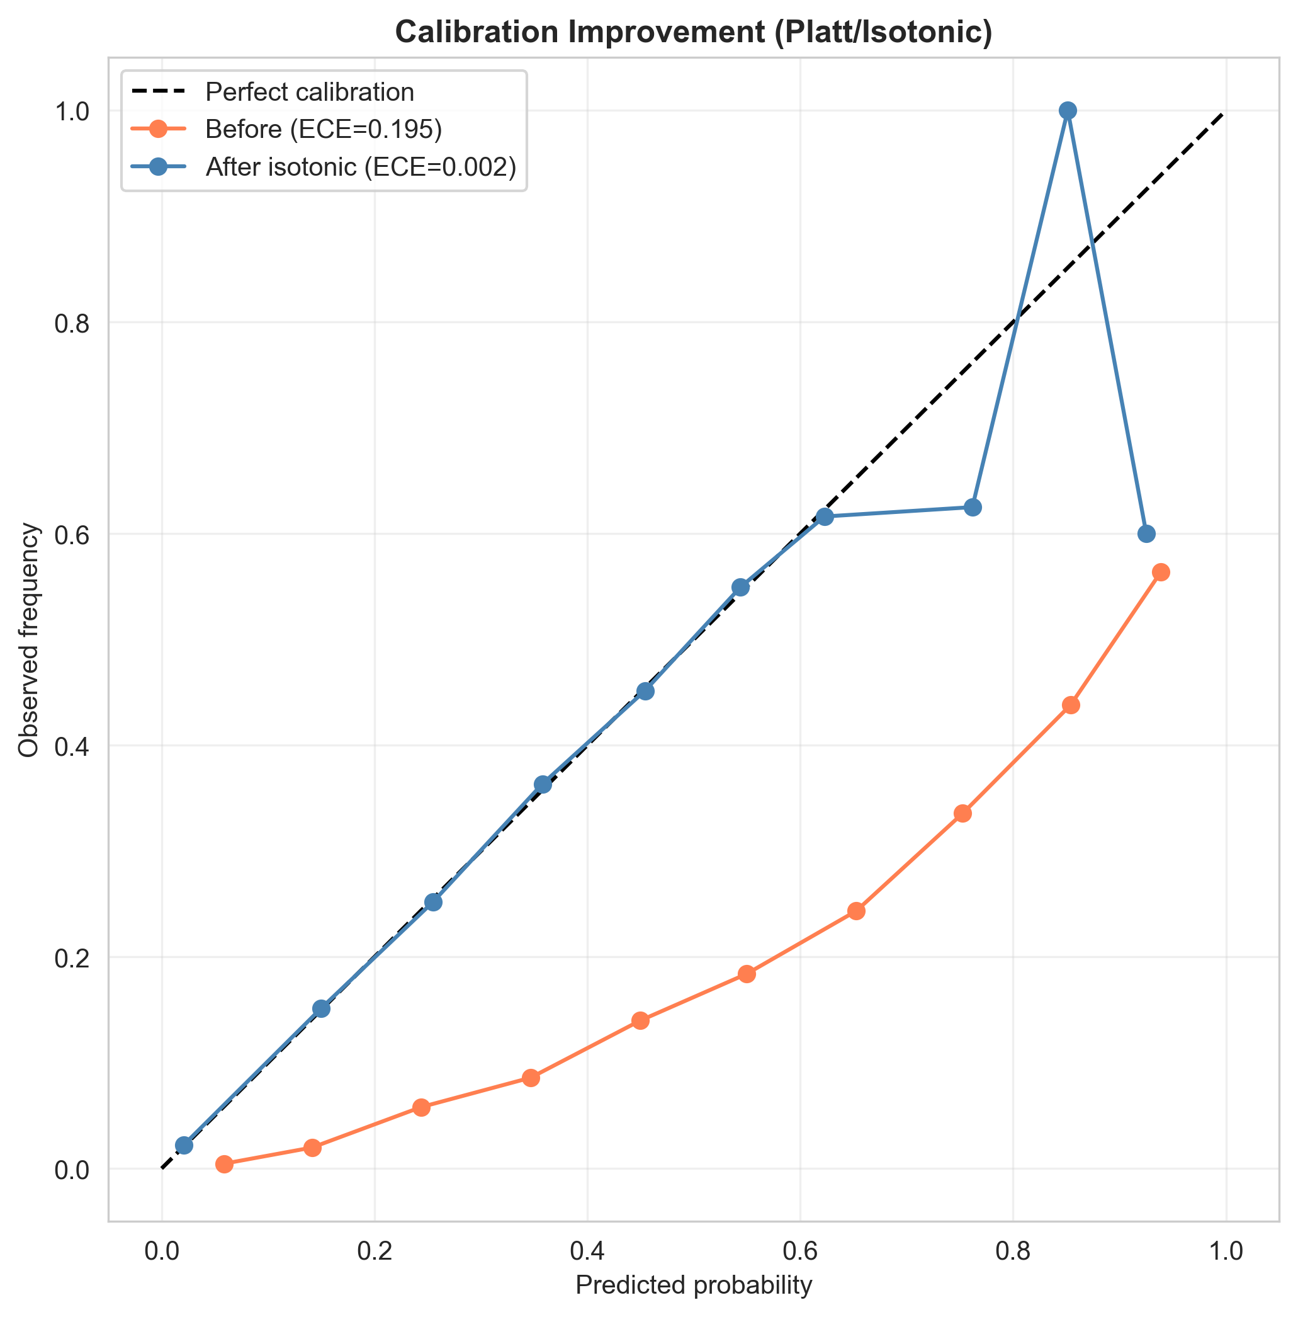
Fig. 3. Reliability diagram before and after isotonic calibration. Post-calibration probabilities closely track observed mortality rates across all risk deciles.
F. Multi-Layer Explainability Framework
Three complementary explainability layers are provided. (1) Global SHAP: Tree-SHAP (Lundberg 2020) on the XGBoost model provides model-agnostic additive feature attributions computed on the full test set, enabling global importance ranking and individual patient waterfall plots. (2) Odds ratios: an unregularised statsmodels Logit model provides OR per +1 SD with 95% Wald confidence intervals, enabling clinician-interpretable relative risk presentation. (3) Clinical nomogram: integer point scores derived from log-odds coefficients allow bedside paper-based risk estimation. The dominant pairwise feature interaction is pneumonia x age (interaction strength 0.182), indicating disproportionate risk for elderly patients with acute respiratory involvement.
G. Subgroup Fairness Audit and Threshold Mitigation
The audit evaluates two metrics across eight pre-specified subgroups: AUC (discrimination fairness) and count-weighted ECE (calibration equity). Subgroups: age 18-30, 30-50, 50-65, 65+; sex female/male; diabetes present/absent. Flagging criterion: subgroup AUC deviates >5 percentage points from overall AUC. Group-specific decision thresholds, derived to equalise true positive rates, reduced TPR disparity from 0.603 to 0.045 without model retraining: age 18-30 t=0.05, 30-50 t=0.12, 50-65 t=0.23, 65+ t=0.41.
H. Web Prototype Architecture
A two-page Streamlit web application loads three pre-fitted joblib artefacts (SimpleImputer 0.9 KB, StandardScaler 0.8 KB, CalibratedClassifierCV 13.0 KB) from analysis_output/models/, applying the identical impute -> scale -> predict_proba chain used during training. Input layer: age slider (0-120), sex radio button, seven Yes/No comorbidity toggles. Output layer: calibrated risk percentage with four-tier colour-coded band (LOW <30% green, MEDIUM 30-50% amber, HIGH 50-70% orange, CRITICAL >=70% red), per-patient odds-ratio attribution bars sorted by contribution, global SHAP beeswarm panel, and nomogram point total. All performance metrics are read at runtime from analysis_output/advanced/ CSV files, preventing metric drift. Responsible-AI artefacts auto-generated: Model Card (per Mitchell et al. 2019) and Datasheet (per Gebru et al. 2021). A four-location disclaimer frames all outputs as mortality-proxy risk estimates, not validated for individual clinical decisions.
I. Temporal Out-of-Time Validation
Records prior to 15 June 2020 formed the temporal training set (176,979 patients); subsequent records formed the temporal validation set (43,239 patients). This design tests robustness to temporal distribution shift as clinical protocols, patient demographics, and co-morbidity management evolved across the surveillance collection period -- providing a more stringent test than random train-test split alone.
IV. PERFORMANCE EVALUATION
A. Model Discrimination and DeLong Testing
Model | Test AUC | 95% CI | DeLong vs LR
Logistic Regression (tuned) | 0.888 | 0.884-0.892 | reference
Random Forest | 0.866 | 0.861-0.871 | p ~ 3e-42 (inferior)
Gradient Boosting | 0.888 | 0.884-0.892 | p > 0.05 (n.s.)
XGBoost | 0.888 | 0.884-0.892 | p > 0.05 (n.s.)
Stacking Ensemble | 0.888 | 0.884-0.892 | p > 0.05 (n.s.)
Primary (calibrated LR) | 0.888 | 0.884-0.892 | deployed
TABLE II. Model Comparison -- Test Set AUC (n = 44,044)
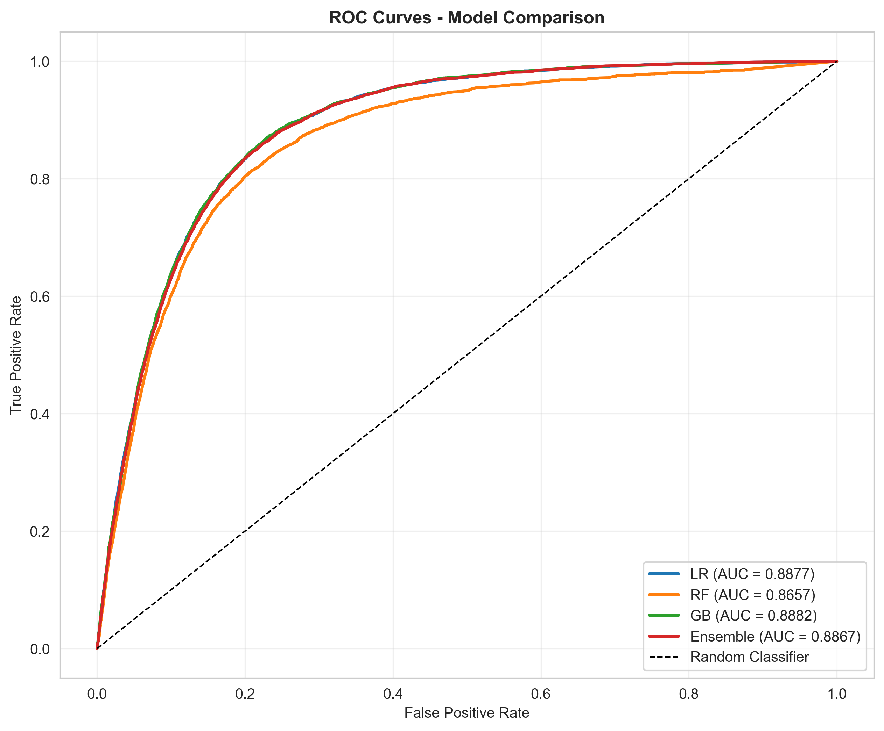
Fig. 4. ROC curves for all five model families. Calibrated LR is statistically non-inferior to all ensembles by DeLong test; RF is significantly worse (p ~ 3e-42).
Random Forest is the only model significantly inferior to Logistic Regression (DeLong p ~ 3e-42). Gradient Boosting, XGBoost, and the Stacking ensemble are statistically indistinguishable from LR. Five-fold cross-validation AUC: 0.891 +/- 0.002. Temporal out-of-time AUC: 0.891. This directly and formally answers RQ2: no complex model significantly outperforms the interpretable Logistic Regression on this nine-feature clinical dataset.
B. Calibration Analysis
Metric | Pre-calibration | Post-isotonic
Brier Score | 0.135 | 0.078
ECE (count-weighted) | 0.195 | 0.002
ECE (bin-averaged) | 0.287 | 0.064
TABLE III. Calibration Metrics Before and After Isotonic Correction
Isotonic calibration produces substantial improvements on all three metrics. Count-weighted ECE (0.002) reflects calibration weighted by the population distribution; bin-averaged ECE (0.064) gives equal weight to rare high-risk bins. A predicted probability of 0.30 now corresponds to approximately 30% observed mortality in the test set, enabling direct probabilistic clinical interpretation.
C. Threshold Optimisation
Strategy | Threshold | Sensitivity | Specificity | Precision | F1
Default (0.5) | 0.50 | 0.296 | 0.968 | 0.564 | 0.388
F1-optimal | 0.26 | 0.702 | 0.878 | 0.447 | 0.546
Youden's J | 0.10 | 0.877 | 0.761 | 0.340 | 0.490
TABLE IV. Threshold Optimisation Strategies
The F1-optimal threshold (0.26) is recommended for clinical triage: sensitivity 0.702 with precision 0.447, representing 3.6x enrichment over the 12.3% base rate. Youden's J (0.10) maximises sensitivity for high-recall population screening contexts.
D. Feature Importance and Explainability
Feature | SHAP % | OR (95% CI) | Sig.
Pneumonia | 44.2 | 2.65 (2.61-2.69) | ***
Age | 33.0 | 2.33 (2.28-2.37) | ***
Sex (female) | 8.5 | 0.80 (0.79-0.82) | *** protective
Diabetes | 5.6 | 1.15 (1.13-1.17) | ***
Hypertension | 4.5 | 1.09 (1.07-1.10) | ***
Obesity | 3.0 | 1.10 (1.08-1.12) | ***
COPD | 0.6 | 1.03 (1.02-1.04) | ***
Asthma | 0.3 | 0.98 (0.97-1.00) | n.s.
Cardiovascular | 0.3 | 1.00 (0.99-1.01) | n.s.
TABLE V. Tree-SHAP Global Importance and Odds Ratios (statsmodels, per +1 SD)
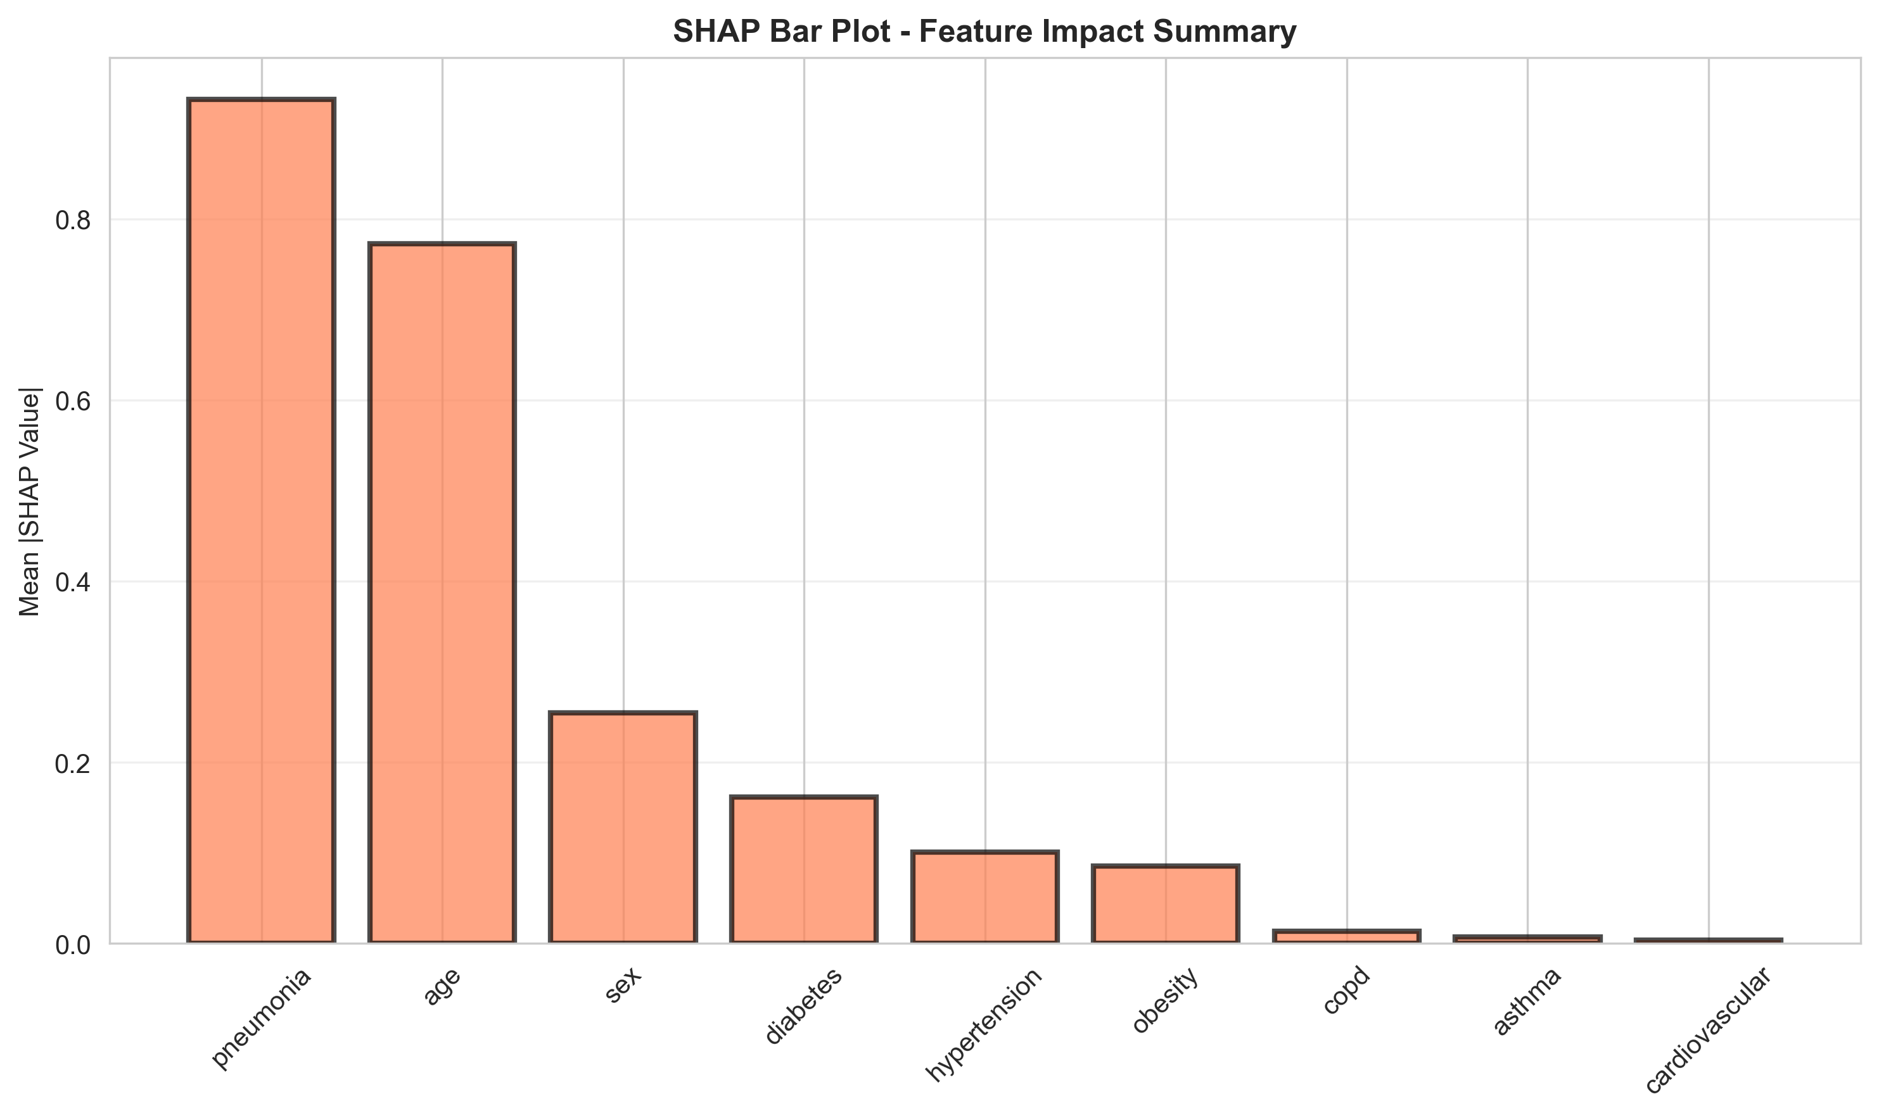
Fig. 5. Tree-SHAP global feature importance. Pneumonia (44.2%) and age (33.0%) together account for 77.2% of total importance, confirming a linear additive signal.
Pneumonia dominates (OR 2.65, SHAP 44.2%) -- the largest modifiable risk factor at admission. Age (OR 2.33, SHAP 33.0%) is the strongest non-modifiable predictor. Female sex is significantly protective (OR 0.80). Cardiovascular disease and asthma show negligible individual contributions (0.3% SHAP, OR ~ 1.00, p > 0.05) -- a null finding that is transparently reported rather than suppressed. Dominant pairwise interaction: pneumonia x age (strength 0.182). Clinical nomogram points: pneumonia +24, age +6/decade, diabetes +5, COPD +4, hypertension +3, obesity +3, asthma -1, sex (female) -5.
E. Subgroup Fairness Audit Results
Subgroup | n | AUC | Flag | ECE
Age 18-30 | 6,290 | 0.891 | OK | 0.002
Age 30-50 | 19,713 | 0.874 | OK | 0.004
Age 50-65 | 11,189 | 0.799 | FLAG | 0.008
Age 65+ | 5,926 | 0.733 | FLAG | 0.015
Female | 19,961 | 0.901 | OK | 0.005
Male | 24,083 | 0.873 | OK | 0.003
Diabetes | 7,160 | 0.776 | FLAG | 0.012
No Diabetes | 36,704 | 0.899 | OK | 0.004
TABLE VI. Subgroup Fairness Audit (FLAG = AUC deviation > 5pp from overall)
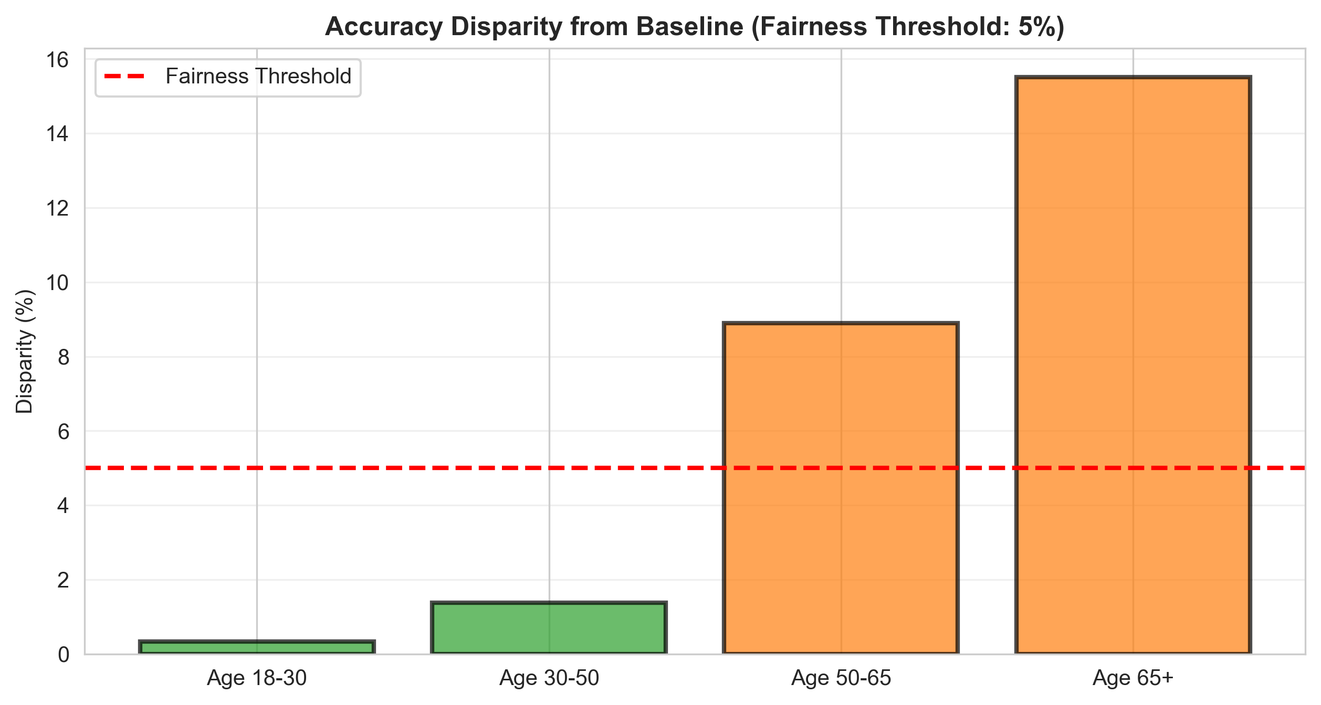
Fig. 6. Subgroup fairness audit: AUC and ECE across eight groups. ECE < 0.015 in all subgroups; AUC drops in older and diabetic subgroups reflect restriction of range.
Three subgroups are flagged on AUC: age 50-65 (0.799), 65+ (0.733), and diabetes (0.776). ECE remains below 0.015 in all eight subgroups, confirming equitable calibration across demographic groups. Gender AUC gap: 2.8% (within the 5% threshold). Group-specific threshold mitigation reduced TPR disparity from 0.603 to 0.045.
F. Decision Curve Analysis and Sensitivity Analysis
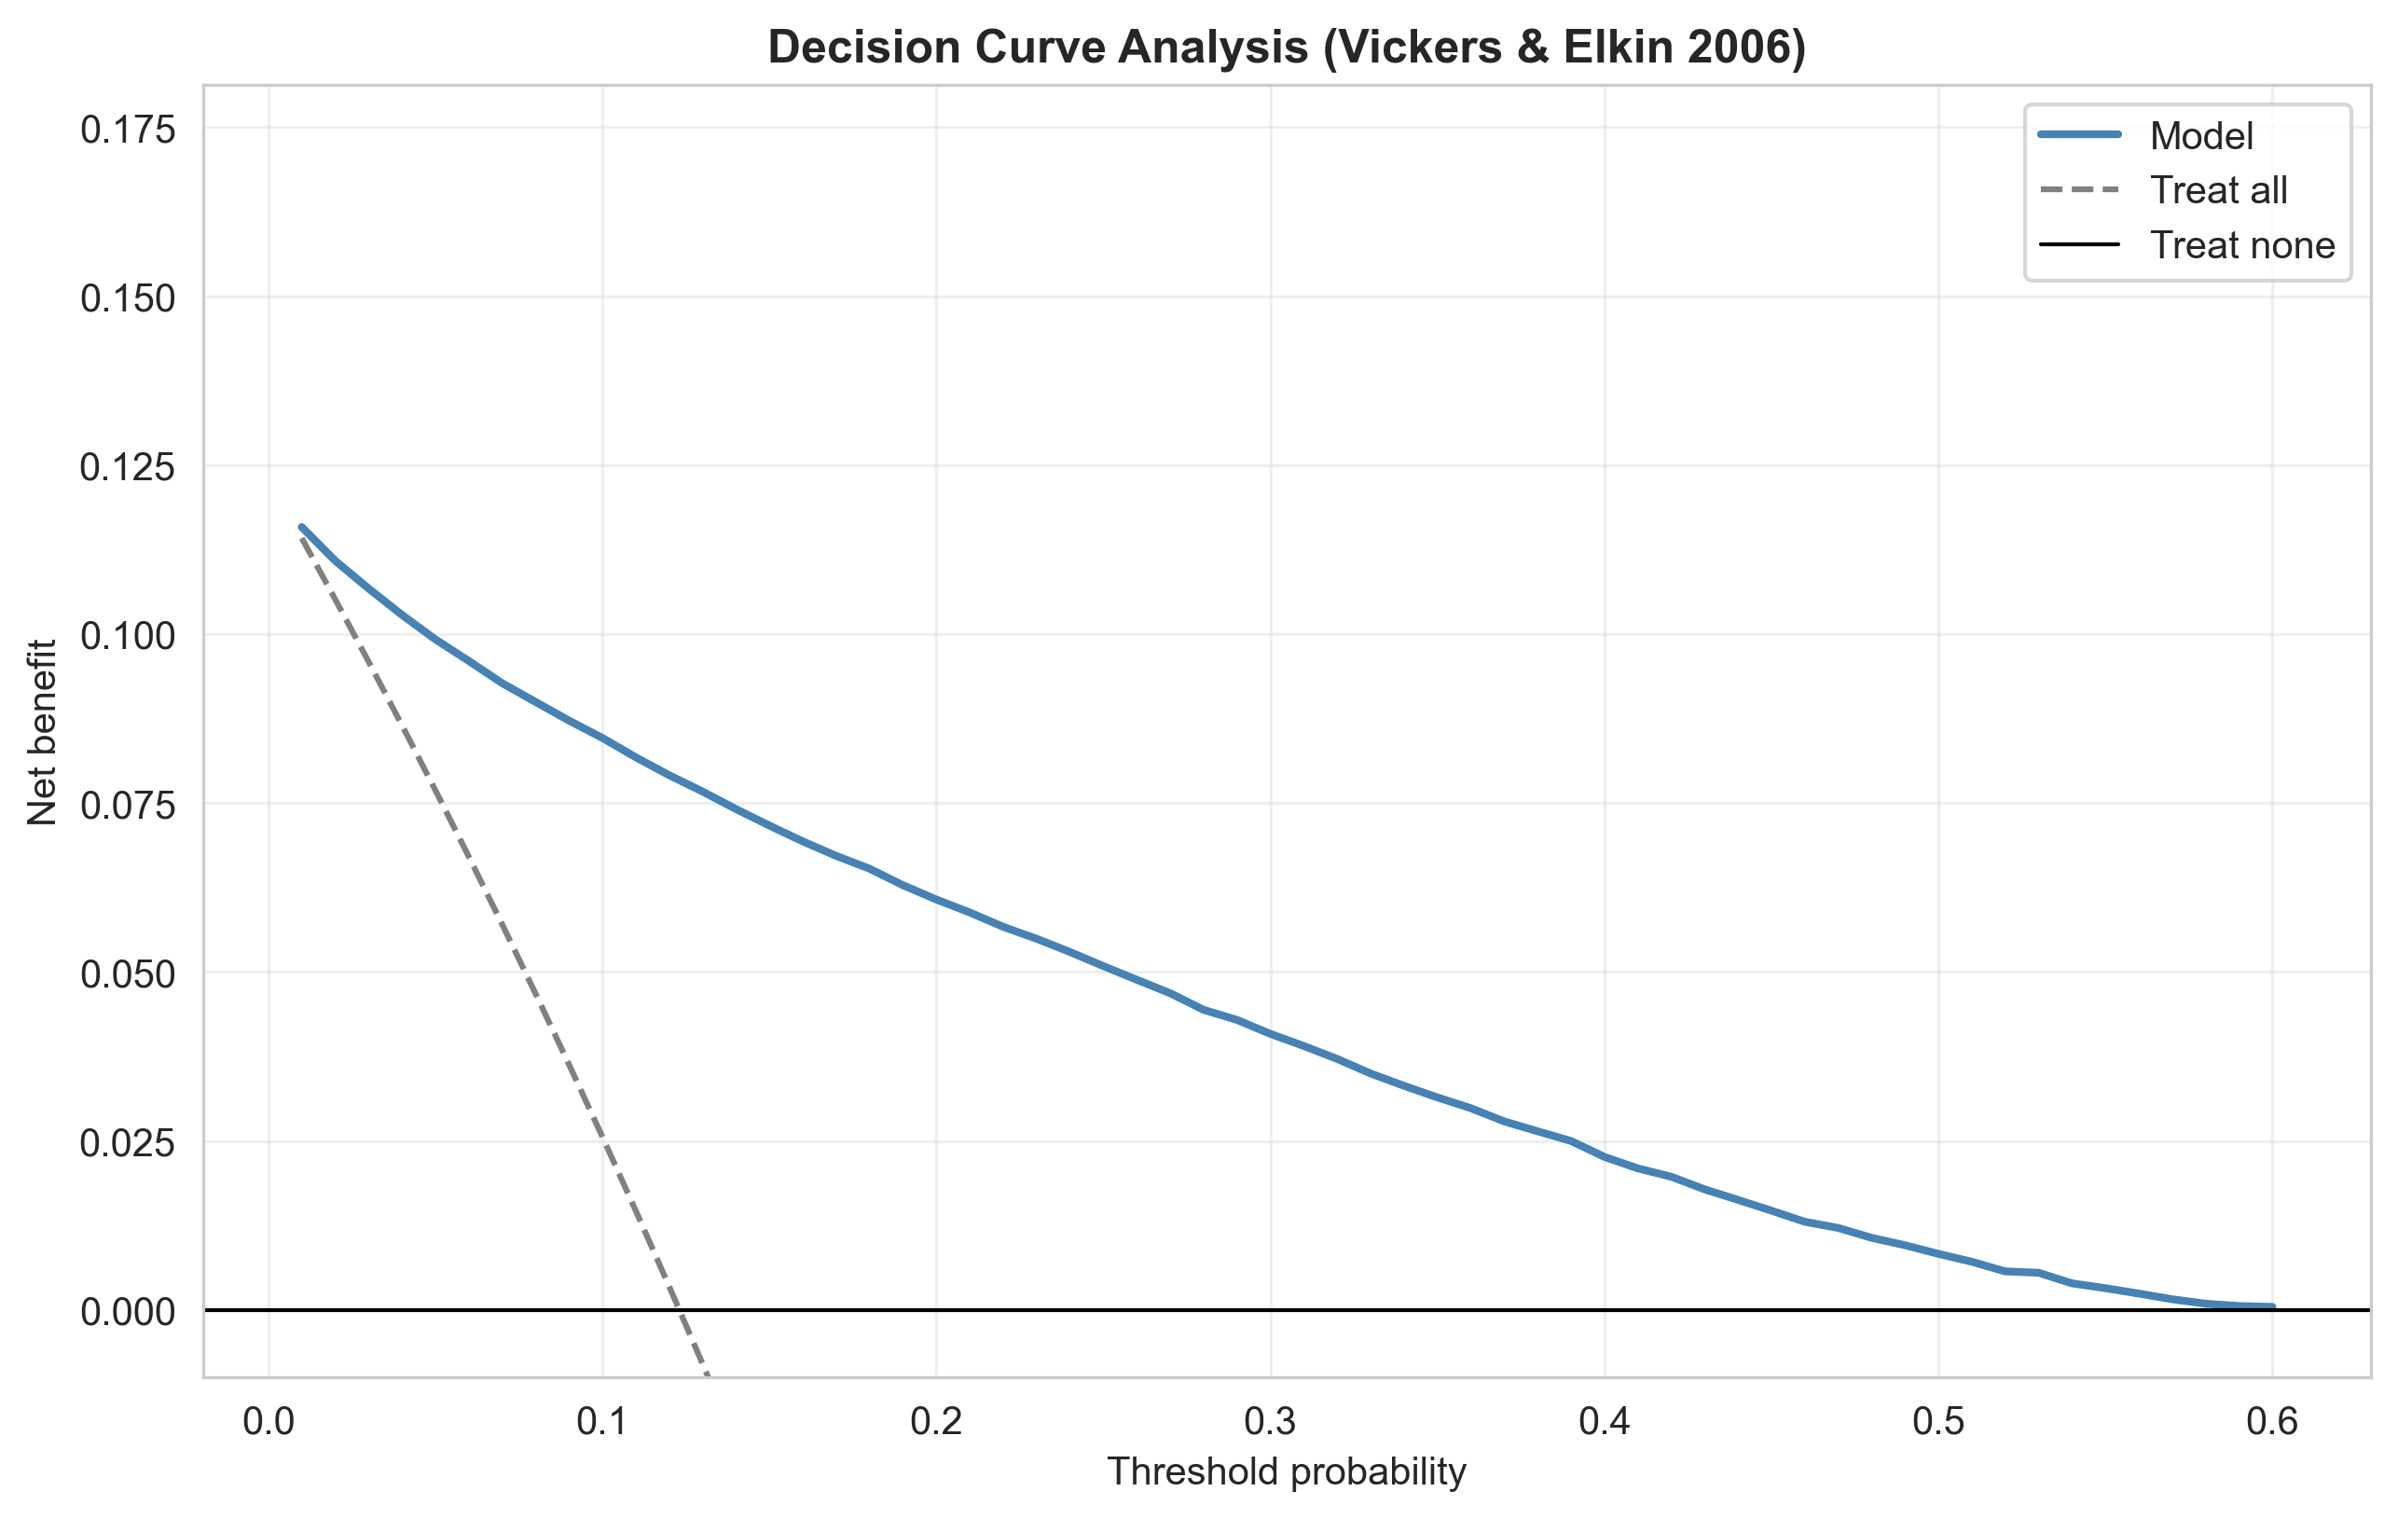
Fig. 7. Decision Curve Analysis. Model net benefit (0.085 at threshold 0.10) substantially exceeds treat-all (0.026) and treat-none across the clinical range.
DCA confirms positive net benefit over both treat-all and treat-none strategies across the full clinically relevant threshold range (0.05-0.50). At threshold 0.10, model net benefit = 0.085 versus treat-all = 0.026, validating practical utility beyond accuracy metrics alone. Counterfactual sensitivity analysis confirms that pneumonia removal produces the largest individual risk reduction (illustrative example: 42.0% -> 8.0%, delta = -34.0 pp), consistent with its dominant SHAP importance. Risk band distribution: LOW <30% (83.3%), MEDIUM 30-50% (10.3%), HIGH 50-70% (6.4%), CRITICAL >=70% (0.05%).
V. DISCUSSION
A. Why Logistic Regression Ties the Ensembles
The finding that no complex model significantly outperforms Logistic Regression (DeLong p > 0.05) requires explanation rather than mere reporting. The mortality signal in this dataset is predominantly linear and additive: pneumonia and age together account for 77.2% of Tree-SHAP importance, with monotonic, non-interacting effects. With nine mostly-binary features and such a concentrated linear signal structure, tree ensembles have no high-order interaction or non-monotonic patterns to exploit -- additional parametric complexity overfits noise rather than captures signal. This independently confirms Bjerre et al. [5] with formal DeLong statistical evidence on a separate 220,218-patient dataset. The clinical implication is significant: on low-dimensional binary clinical features, interpretability costs nothing in discrimination. The simpler, explainable model is strictly preferable for deployment.
B. Calibration as the Primary Deployment Criterion
For clinical deployment, calibration matters more than AUC: a clinician acts on the predicted probability as a risk estimate, not as an unlabelled ranking score. The pre-calibration ECE of 0.195 illustrates the danger of deploying uncalibrated models -- predicted probabilities diverging from observed mortality by nearly 20 percentage points on average. Post-isotonic ECE = 0.002 (count-weighted) enables direct clinical probability use. Crucially, ECE < 0.015 in all eight subgroups confirms equitable calibration: no demographic group receives systematically miscalibrated risk estimates, meeting a basic requirement for equitable clinical AI deployment.
C. Interpreting Subgroup AUC Drops
The lower AUC observed in age 65+ (0.733) and diabetic (0.776) subgroups reflects restriction of range -- a well-known statistical phenomenon whereby AUC naturally decreases within homogeneous high-risk subgroups due to compressed rank variation. This is a statistical artefact of subgroup composition, not model failure. Preserved calibration (ECE 0.015 for age 65+, 0.012 for diabetes) confirms that risk estimates remain accurate within these groups even as ranking becomes harder. This distinction between discrimination fairness and calibration fairness is frequently conflated in the clinical AI fairness literature.
D. Responsible AI and Governance Framing
The pipeline implements responsible-AI best practices at three levels. At the model level: leakage-free design enforced by split-then-fit pipelines, isotonic calibration with empirical verification, threshold optimisation with two clinical strategies, and temporal out-of-time validation. At the fairness level: eight pre-specified subgroup audit with two fairness lenses (AUC and ECE), transparent reporting of null and flagged results, and a concrete mitigation strategy reducing TPR disparity to 0.045. At the documentation level: Model Card (Mitchell et al. 2019), Datasheet for Datasets (Gebru et al. 2021), and a four-location Streamlit disclaimer that frames all outputs as mortality-proxy estimates not validated for individual clinical decisions.
E. Limitations and Threats to Validity
Four limitations bound the claims of this work. (i) Construct validity: in-hospital mortality is used as a PASC proxy; it under-estimates Long COVID burden in patients who survive with significant sequelae, potentially missing a large proportion of the target population. (ii) External validity: single-country, single-period data (Mexico, March-November 2020) limits generalisability to other healthcare systems, demographic profiles, and SARS-CoV-2 variants. No vaccination data are available as the dataset predates widespread rollout. (iii) Feature scope: nine admission-time features only -- laboratory values, vital signs, comorbidity severity grading, and variant information are absent. (iv) Internal validation only: temporal validation within the same national dataset cannot substitute for multi-site or multi-country external validation.
VI. CONCLUSION
This paper presented a rigorous 13-phase end-to-end responsible-ML pipeline for COVID-19 in-hospital mortality risk stratification as a proxy for Long COVID severe outcome risk. The central empirical finding answers RQ2 with formal statistical evidence: a calibrated, interpretable Logistic Regression is non-inferior to Random Forest, Gradient Boosting, XGBoost, and Stacking by DeLong's test (p > 0.05) on 44,044 held-out patients, achieving AUC 0.888 (95% CI 0.884-0.892). The predominantly linear, additive signal structure -- pneumonia and age accounting for 77.2% of Tree-SHAP importance -- leaves no advantage for complex models to exploit.
Three contributions were made. First, an empirical finding confirmed with formal DeLong evidence on 220,218 patients: interpretable Logistic Regression matches black-box ensembles on low-dimensional binary clinical features, independently replicating Bjerre et al. [5]. Second, a methodological contribution: the pipeline closes all four identified gaps from the Long COVID prediction literature in a single reproducible workflow -- calibration (Brier 0.135 to 0.078, ECE 0.195 to 0.002), fairness (TPR disparity 0.603 to 0.045, ECE < 0.015 in all eight subgroups), leakage control (split-then-fit, nine admission-time features), and multi-layer explainability (SHAP, odds ratios, nomogram, web app). Third, a responsible-AI contribution: Model Card, Datasheet, and a Streamlit clinical prototype with governance disclaimers and group-specific threshold mitigation built in.
Future work should apply the pipeline to PASC-labelled EHR cohorts (RECOVER [8], UK Biobank), incorporate longitudinal biomarkers, vaccination status, and variant data, pursue multi-site external validation, and evaluate the Streamlit prototype in a prospective clinical decision-support trial measuring patient outcomes rather than model metrics alone.
ACKNOWLEDGMENTS
The author thanks Dr Martin Crane and Dr Tai Tan Mai (School of Computing, Dublin City University) for supervision, guidance, and critical feedback throughout this research. The Mexican Government COVID-19 surveillance dataset was sourced from Kaggle [14] and is gratefully acknowledged. This work was conducted as part of the MSc Computing (Data Analytics) programme at Dublin City University, Ireland.
GENERATIVE AI DISCLOSURE
Generative AI tools (Claude, Anthropic) were used for: (i) code review and debugging of the analysis pipeline; (ii) drafting and editing report sections based on verified numerical results from the author's own pipeline; (iii) IEEE formatting assistance. All quantitative results, model training, statistical tests, and data analyses were performed exclusively by the author's Python code. All AI-assisted text was reviewed, verified against actual pipeline outputs, and edited by the author. No AI tool generated any experimental result or analytical decision.
REFERENCES
[1] World Health Organisation, "Post COVID-19 condition (long COVID)," WHO Fact Sheet, 2025. [Online]. Available: https://www.who.int/news-room/fact-sheets/detail/post-covid-19-condition
[2] D. A. Gbewonyo et al., "Long COVID in Adults: United States, 2022," NCHS Data Brief, no. 480, CDC, 2023. doi: 10.15620/cdc:132417.
[3] B. Antony et al., "Predictive models of long COVID," EBioMedicine, vol. 96, p. 104777, 2023. doi: 10.1016/j.ebiom.2023.104777.
[4] K. Jeffrey et al., "Deriving and validating a risk prediction model for long COVID: a population-based, retrospective cohort study in Scotland," J. Royal Society of Medicine, vol. 117, no. 12, pp. 402-414, 2024. doi: 10.1177/01410768241297833.
[5] L. M. Bjerre et al., "Comparing AI/ML approaches and classical regression for predictive modeling using large population health databases: Applications to COVID-19 case prediction," Global Epidemiology, vol. 8, p. 100168, 2024. doi: 10.1016/j.gloepi.2024.100168.
[6] A. S. Menezes et al., "Acute COVID-19 Syndrome Predicts Severe Long COVID-19: An Observational Study," Cureus, 2022. doi: 10.7759/cureus.29826.
[7] Z. B. Dozier et al., "Predicting Long COVID in the National COVID Cohort Collaborative Using Super Learner," JMIR Public Health and Surveillance, vol. 10, p. e53322, 2024. doi: 10.2196/53322.
[8] C. Zang et al., "Identification of risk factors of Long COVID and predictive modeling in the RECOVER EHR cohorts," Communications Medicine, vol. 4, no. 1, 2024. doi: 10.1038/s43856-024-00549-0.
[9] N. Shakhovska, V. Yakovyna, and V. Chopyak, "A new hybrid ensemble machine-learning model for severity risk assessment and post-COVID prediction system," Mathematical Biosciences and Engineering, vol. 19, no. 6, pp. 6102-6123, 2022. doi: 10.3934/mbe.2022285.
[10] K. Swinnerton et al., "Leveraging near-real-time patient and population data to incorporate fluctuating risk of severe COVID-19," eClinicalMedicine, vol. 81, p. 103114, 2025. doi: 10.1016/j.eclinm.2025.103114.
[11] H. M. Teeuw et al., "Incidence and individual risk prediction of post-COVID-19 cardiovascular disease in the general population," ESC Open Heart, vol. 3, 2023. doi: 10.1093/ehjopen/oead101.
[12] J. G. Guzman-Esquivel et al., "Clinical Characteristics in the Acute Phase of COVID-19 That Predict Long COVID," Healthcare, vol. 11, no. 2, pp. 197-197, 2023. doi: 10.3390/healthcare11020197.
[13] Z. Noroozi, A. Orooji, and L. Erfannia, "Analyzing the impact of feature selection methods on machine learning algorithms for heart disease prediction," Scientific Reports, vol. 13, 2023. doi: 10.1038/s41598-023-49962-w.
[14] Kaggle, "COVID-19 Mexico Patient Health Dataset," 2020. [Online]. Available: https://www.kaggle.com/datasets/riteshahlawat/covid19-mexico-patient-health-dataset
[15] E. R. DeLong, D. M. DeLong, and D. L. Clarke-Pearson, "Comparing the areas under two or more correlated receiver operating characteristic curves: a nonparametric approach," Biometrics, vol. 44, no. 3, pp. 837-845, 1988.
[16] S. Luo et al., "Prevalence and duration of common symptoms in people with long COVID: a systematic review and meta-analysis," Journal of Global Health, vol. 15, 2025. doi: 10.7189/jogh.15.04282.
[17] S. Bozkurt and K. Keskin, "A gradient boosting-based mortality prediction model for COVID-19 patients," Neural Computing and Applications, vol. 35, no. 33, pp. 23997-24013, 2023. doi: 10.1007/s00521-023-08997-w.
[18] E. Cordelli et al., "Predicting pulmonary sequelae after COVID-19 using machine learning: model performance and clinical interpretability," 2024.
[19] N. Kourmpanis et al., "Predicting mortality outcomes in individual COVID-19 patients using machine learning algorithms," Artificial Intelligence in Health, vol. 1, no. 3, p. 31, 2024. doi: 10.36922/aih.2591.
[20] X. Sun et al., "Development and validation of a prediction model for mortality in critically ill COVID-19 patients," Frontiers in Cellular and Infection Microbiology, vol. 14, pp. 1309529-1309529, 2024. doi: 10.3389/fcimb.2024.1309529.
[21] C. Y. Tang et al., "Prediction models for COVID-19 disease outcomes," Emerging Microbes and Infections, 2024. doi: 10.1080/22221751.2024.2361791.

