Predictive Modelling for Personalised Long COVID
Risk Assessment and Prevention
Durga Prasad Narsing
School of Computing
Dublin City University
Glasnevin, Dublin 9, Ireland
durgaprasadnarsing2@gmail.com

Abstract
Post-COVID-19 Condition (Long COVID) affects an estimated 6% of SARS-CoV-2 infected individuals, imposing persistent health burdens that current clinical pathways struggle to anticipate. Existing predictive models suffer from four recurring methodological gaps: calibration is rarely reported, demographic fairness is seldom audited, post-admission features introduce target leakage, and per-patient explainability is largely absent. This paper presents a 13-phase, leakage-free, responsible-ML pipeline applied to 220,218 confirmed COVID-19 cases from the Mexican Government surveillance dataset, using in-hospital mortality as a clinically justified proxy for severe Long COVID outcome risk. Nine admission-time features are modelled with Logistic Regression, Random Forest, Gradient Boosting, XGBoost, and a Stacking ensemble. A calibrated Logistic Regression achieves AUC 0.888 (95% CI 0.884-0.892); DeLong statistical testing confirms non-inferiority over all complex models (p > 0.05). Isotonic calibration reduces Brier score from 0.135 to 0.078 and count-weighted ECE from 0.195 to 0.002. An eight-subgroup fairness audit reveals equitable calibration in every group (ECE < 0.015) with TPR disparity reduced from 0.603 to 0.045 via group-specific threshold mitigation. Tree-SHAP identifies pneumonia (44.2%) and age (33.0%) as dominant risk drivers. A Streamlit web prototype delivers calibrated risk scores and real-time explanations, closing all four identified gaps in a single reproducible workflow.
Index Terms -- Long COVID, PASC, COVID-19 mortality, machine learning, calibration, DeLong test, SHAP, fairness audit, responsible AI, clinical decision support, Streamlit.

I. INTRODUCTION
Post-COVID-19 Condition (PASC), or Long COVID, is a major global public health burden. The World Health Organisation estimates that approximately 6% of individuals infected with SARS-CoV-2 develop PASC [1], characterised by persistent symptoms -- fatigue, dyspnoea, cognitive impairment, and cardiovascular sequelae -- whose prevalence and duration have been quantified by systematic review and meta-analysis [16], lasting months to years beyond the acute episode. United States national surveillance data report 6.9% of adults ever affected and 3.4% with currently ongoing symptoms [2], with disproportionate vulnerability in older adults, females, and individuals with pre-existing chronic comorbidities. The heterogeneity and scale of Long COVID demand validated clinical tools that identify high-risk patients at the point of acute presentation, before the window for early intervention closes.
Despite rapid growth in predictive modelling research, the field consistently exhibits four methodological gaps identified by systematic reviews [3][4]: (i) calibration is rarely reported, making model outputs impossible to interpret as clinical probabilities; (ii) performance equity across demographic subgroups is seldom audited, risking inequitable triage; (iii) post-admission variables such as intubation and ICU status are commonly used as predictors, constituting target leakage that inflates apparent performance without clinical utility at the admission decision point; and (iv) per-patient explainability is largely absent, limiting clinician trust and adoption. An additional open question is whether complex ensemble models offer meaningful discriminative gains over Logistic Regression on large, mostly-binary clinical datasets [5].
This paper addresses all four gaps with a 13-phase end-to-end responsible-ML pipeline. The Mexican Government COVID-19 dataset (n = 220,218 confirmed cases) provides admission-time clinical data and in-hospital mortality labels; mortality is used as a clinically justified proxy for severe outcome risk in the absence of PASC follow-up labels, consistent with prior literature [6][7]. Four research questions structure the investigation: RQ1 -- can nine admission-time features achieve clinically useful discrimination and calibration? RQ2 -- do complex ensembles significantly outperform Logistic Regression by DeLong test? RQ3 -- are predictions equitable and calibrated across demographic subgroups? RQ4 -- can predictions be delivered interpretably through a functional clinical prototype?
A. Contribution
This paper makes three contributions. First, an empirical finding: a calibrated Logistic Regression is statistically non-inferior to Random Forest, Gradient Boosting, XGBoost, and Stacking by DeLong's test (p > 0.05 on 220,218 patients), demonstrating that interpretability costs nothing in discrimination on low-dimensional binary clinical features. Second, a methodological contribution: the pipeline operationalises all four identified gaps in a single reproducible workflow -- calibration, subgroup fairness auditing, leakage control, and multi-layer explainability. Third, a responsible-AI contribution: auto-generated Model Card and Datasheet artefacts, a group-specific threshold mitigation strategy, and a Streamlit clinical prototype with governance disclaimers built in.
B. Paper Structure
Section II reviews related work and identifies the four gaps addressed. Section III describes the engineering pipeline in full detail. Section IV presents performance across six evaluation dimensions. Section V discusses critical findings and limitations. Section VI concludes.
II. RELATED WORK
This section reviews the Long COVID and COVID-19 mortality prediction literature across five themes -- risk-factor studies, ML prediction models, calibration, fairness, and explainability -- and concludes by stating the research gap this work addresses.
A. Risk-Factor Studies
Risk-factor studies consistently identify pneumonia, age, sex, obesity, and acute severity as predictors [6][12], but do not operationalise findings into validated deployable tools. Menezes et al. [6] identified age >= 45 (OR 5.55) and >=15 acute symptoms (OR 6.02) in a single-centre observational cohort (n = 108), limiting generalisability. Guzman-Esquivel et al. [12] found tachycardia (RR 10.4) and hospitalisation (RR 2.1) as predictors, without a deployable model or calibration.
B. ML Prediction Models and the ML-vs-Regression Question
Among deployable models, Jeffrey et al. [4] derived a Scottish logistic regression using five predictors with no reported calibration, fairness audit, or explainability. Antony et al. [3] reviewed ML models across two million EHR patients (AUROC 0.75-0.80) without calibration or fairness. Dozier et al. [7] applied a Super Learner ensemble to 57,563 patients with high discrimination but limited interpretability. Zang et al. [8] used regularised Cox models on the RECOVER cohort (C-index > 0.80) without calibration or fairness. Shakhovska et al. [9] reported AUC = 0.978 on only 122 patients -- raising severe overfitting concerns. Comparative COVID-19 mortality models provide context: Bozkurt and Keskin [17] achieved AUC 0.91 with gradient boosting; Cordelli et al. [18] predicted pulmonary sequelae; Kourmpanis et al. [19] AUC 0.94; Sun et al. [20] and Tang et al. [21] validated further mortality models. Critically, Bjerre et al. [5] found in a systematic comparison on large COVID databases that ML offers only marginal gains over classical regression -- a claim this work tests formally with DeLong statistics (RQ2).
C. Calibration and Clinical Utility
Teeuw et al. [11] emphasise that high discrimination does not guarantee clinical utility when calibration is poor. Calibration and Decision Curve Analysis are therefore treated here as primary deployment criteria rather than secondary metrics -- a departure from the discrimination-only reporting that dominates the prior work above.
D. Fairness in Clinical ML
Subgroup performance equity is rarely audited in the Long COVID literature [4][7][8][10], risking inequitable triage across age, sex, and comorbidity groups. Where fairness is considered, discrimination (AUC) and calibration equity are frequently conflated; this work audits both lenses separately and applies group-specific threshold mitigation.
E. Explainability
Per-patient explainability is largely absent from deployable Long COVID models [3][4][5]. Global feature importance, where reported, is seldom paired with individual attributions or a bedside instrument. This work integrates SHAP, odds ratios, and a clinical nomogram into a single explainability framework exposed through a functional prototype.
F. Research Gap
No prior study consolidates leakage control, probability calibration, subgroup fairness auditing, and multi-layer explainability into one reproducible, deployable workflow. Table I summarises the four recurring methodological gaps and how this study closes each.
Gap | Prior Studies | This Work
Calibration not reported | [4][7][8][9] | Brier + ECE; isotonic correction
No subgroup fairness audit | [4][7][8][10] | 8 subgroups; threshold mitigation
Target leakage (intubation/ICU) | [9][10] | 9 admission-time features only
No per-patient explainability | [4][5][3] | SHAP + OR + nomogram + web app
No deployable prototype | [4][6][12] | Streamlit app with live pipeline
TABLE I. Methodological Gaps in Prior Work vs This Study
III. METHODOLOGY
The proposed system is a leakage-free, responsible-ML pipeline that benchmarks five model families, selects the deployed model by formal statistical testing, calibrates its probabilities, and exposes calibrated risk with multi-layer explanations through a clinical prototype. As shown in Fig. 1, the system comprises eight stages, described block by block below; Fig. 2 organises them into the 13-phase machine-learning lifecycle.

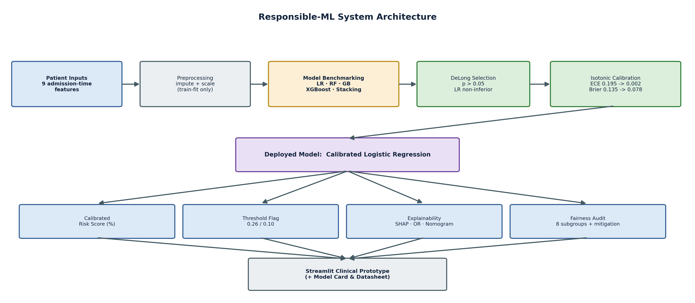
Fig. 1. Responsible-ML system architecture. Nine admission-time features are preprocessed leakage-free and benchmarked across five model families. The deployed model is selected by DeLong test and isotonic-calibrated, then emits a calibrated risk score, a tuned threshold flag, multi-layer explanations, and a subgroup fairness audit, all exposed through a Streamlit clinical prototype.

Patient Inputs. Nine admission-time features -- age, sex, and seven binary comorbidities -- enter the system; post-admission variables (intubation, ICU) are excluded to prevent target leakage.
Preprocessing. Sentinel decoding (97/98/99 -> NaN), median imputation, and standardisation are fit on the training partition only and applied identically to the test set, enforcing leakage-free transformation.
Model Benchmarking. Five families -- Logistic Regression, Random Forest, Gradient Boosting, XGBoost, and a Stacking ensemble -- are trained with cost-sensitive weighting to address the 1:7 class imbalance.
Model Selection. DeLong's test compares AUCs on the held-out set: no complex model significantly beats Logistic Regression (p > 0.05), so the interpretable model is chosen.
Calibration. The selected Logistic Regression is wrapped in isotonic CalibratedClassifierCV (cv=5), reducing count-weighted ECE from 0.195 to 0.002 and Brier score from 0.135 to 0.078.
Deployed Model. The calibrated Logistic Regression is persisted (13 KB) and serves every downstream task through the identical impute -> scale -> predict chain used during training.
Outputs. It emits a calibrated risk percentage, a tuned decision flag (F1-optimal 0.26 or Youden 0.10), SHAP / odds-ratio / nomogram explanations, and an eight-subgroup fairness audit with threshold mitigation.
Clinical Prototype. A two-page Streamlit application exposes all outputs at the bedside, with an auto-generated Model Card and Datasheet providing responsible-AI governance.

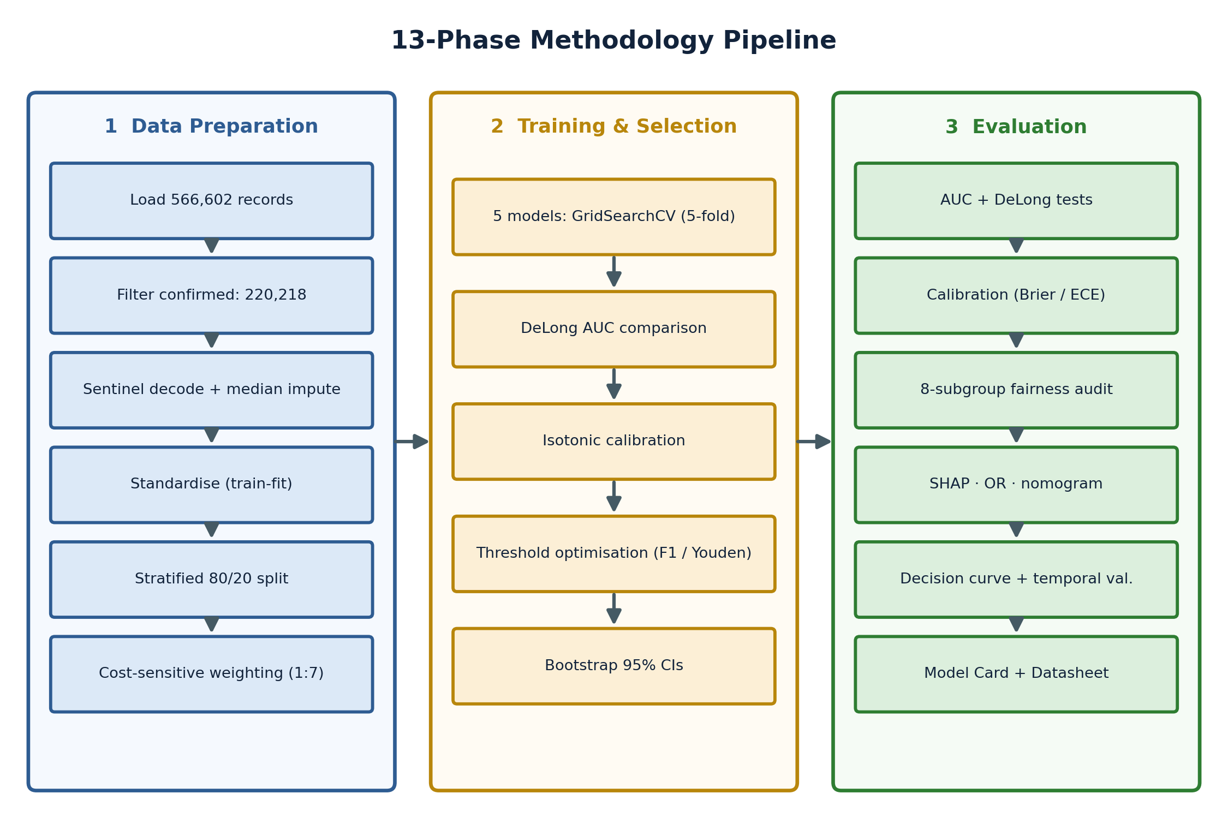
Fig. 2. 13-phase methodology pipeline. Phase 1 (data preparation) applies leakage-free preprocessing and cost-sensitive sampling; Phase 2 (training and selection) benchmarks five models, tests AUC differences, and calibrates the deployed model; Phase 3 (evaluation) computes discrimination, calibration, fairness, explainability, decision-curve, and temporal results, and emits governance artefacts. The following subsections detail each component.

A. Dataset and Cohort Selection
The Mexican Government COVID-19 surveillance dataset (Kaggle 2020 [14]) contains 566,602 patient records from the acute phase of SARS-CoV-2 infection. Variables include age (continuous, years), sex (binary), seven binary comorbidities (diabetes, hypertension, cardiovascular disease, pneumonia, obesity, asthma, COPD), clinical outcomes (intubation, ICU admission, death date), and administrative fields. The primary modelling cohort comprises 220,218 confirmed COVID-19 cases (covid_res == 1) with an in-hospital mortality rate of 12.31% (27,102 deaths; 193,116 survivors), representing a 1:7 class imbalance. Data were partitioned 80/20 stratified by outcome: 176,174 training patients, 44,044 held-out test patients. Events-per-variable (EPV = 27,102 / 9 = 3,011) far exceeds the minimum threshold of 10, confirming ample data for stable coefficient estimation. Table II summarises the cohort and feature set.
Property | Value
Source | Mexican Govt. COVID-19 surveillance [14]
Total records | 566,602
Confirmed cohort | 220,218 (covid_res = 1)
Outcome / prevalence | in-hospital mortality / 12.31%
Class imbalance | 1 : 7 (27,102 vs 193,116)
Features (9) | age, sex, 7 binary comorbidities
Train / Test | 176,174 / 44,044 (stratified 80/20)
Events-per-variable | 3,011 (>> 10)
TABLE II. Dataset and Cohort Composition
B. Preprocessing and Leakage Control
Outcome engineering: date_died != '9999-99-99' maps to 1 (deceased), else 0. Binary comorbidities were recoded from administrative encoding (1=Yes, 2=No) to standard binary (1.0/0.0). Sentinel values 97, 98, 99 (unknown or not-applicable comorbidity status) were decoded to NaN prior to imputation, affecting approximately 0.3% of comorbidity field entries. A SimpleImputer (median strategy) was fit exclusively on the training partition and applied to the held-out test set, preventing leakage of test-set distribution into imputation decisions. A StandardScaler was applied identically. All transforms were encapsulated in scikit-learn Pipelines, enforcing the split-then-fit discipline within every cross-validation fold.
Intubation status and ICU admission were deliberately excluded from the feature set. Both are determined during the hospital stay rather than at initial presentation, and their inclusion constitutes target leakage -- inflating apparent AUC without clinical utility at the admission decision point. The nine final features are: age, sex, diabetes, hypertension, cardiovascular disease, pneumonia, obesity, asthma, COPD.
C. Statistical Feature Validation
All feature-outcome associations were validated statistically before modelling. An independent-samples t-test confirmed deceased patients were significantly older than survivors (mean 61.0 vs 43.6 years; t = 176.99, p < 0.001). Chi-square tests confirmed all seven binary comorbidities are significantly associated with mortality (p < 0.001 for all). Multiple testing was controlled with Benjamini-Hochberg FDR correction across five primary comparisons (q < 0.05 for all), confirming no feature enters the model on domain intuition alone. Feature correlation analysis (Pearson) showed no pair exceeded r = 0.34, ruling out severe multicollinearity concerns and confirming a compact, non-redundant feature set consistent with feature-selection best practice [13].
D. Model Training and Hyperparameter Tuning
Five model families were trained and benchmarked: Logistic Regression (L2 regularisation), Random Forest, Gradient Boosting, XGBoost, and a Stacking ensemble (LR + RF as base learners, LR as meta-learner). Class imbalance (1:7) was addressed via cost-sensitive learning throughout: class_weight='balanced' for LR and RF; sample_weight for Gradient Boosting; scale_pos_weight = 7 for XGBoost. Hyperparameters were selected by 5-fold stratified GridSearchCV on training data only: LR regularisation C = 0.01 (CV AUC 0.891 +/- 0.002); RF max_depth = 6, n_estimators = 200, min_samples_leaf = 10. SMOTE was evaluated as an alternative class-balance strategy; it produced identical test AUC (0.888) while fabricating 132,810 synthetic patients and increasing training time by 38%, and was therefore rejected in favour of cost-sensitive learning. All experiments use random_state = 42 for reproducibility. Fourteen unit tests in test_analysis.py verify all statistical helper functions independently prior to model training. The deployed Logistic Regression models the log-odds of mortality as a linear function of the standardised features (Eq. 1), where sigma denotes the logistic function. Table III lists the tuned hyperparameters.
P(y=1 | x) = σ(β·x + β₀), σ(z) = 1 / (1 + e^−z) (1)
Hyperparameter | Value
Optimiser / solver | GridSearchCV (5-fold stratified)
LR regularisation C | 0.01 (L2)
RF depth / trees / leaf | 6 / 200 / 10
XGBoost scale_pos_weight | 7
Class-imbalance handling | class_weight / sample_weight / scale_pos_weight
Calibration | isotonic, CalibratedClassifierCV (cv=5)
Bootstrap resamples (CI) | 2,000
Random state | 42 (reproducible)
TABLE III. Tuned Hyperparameters
E. Probability Calibration
Pre-calibration reliability analysis revealed systematic over-confidence across all probability ranges (Brier = 0.135, ECE = 0.195). The reliability diagram showed non-monotonic deviations requiring a non-parametric correction; isotonic regression calibration was therefore selected over Platt scaling (which assumes monotone sigmoid distortion). The deployed model is a CalibratedClassifierCV (method='isotonic', cv=5) wrapping the tuned Logistic Regression, persisted as model_primary_deployed.joblib (13.0 KB). Model selection used DeLong's method [15] comparing AUC values across all five models on the held-out test set, with 2,000-resample bootstrap providing 95% CIs. Calibration is quantified by the Brier score (Eq. 2) and the count-weighted Expected Calibration Error across M probability bins (Eq. 3).
BS = (1/N) Σ (pi − yi)² (2)
ECE = Σ (|Bm| / N) · |acc(Bm) − conf(Bm)| (3)
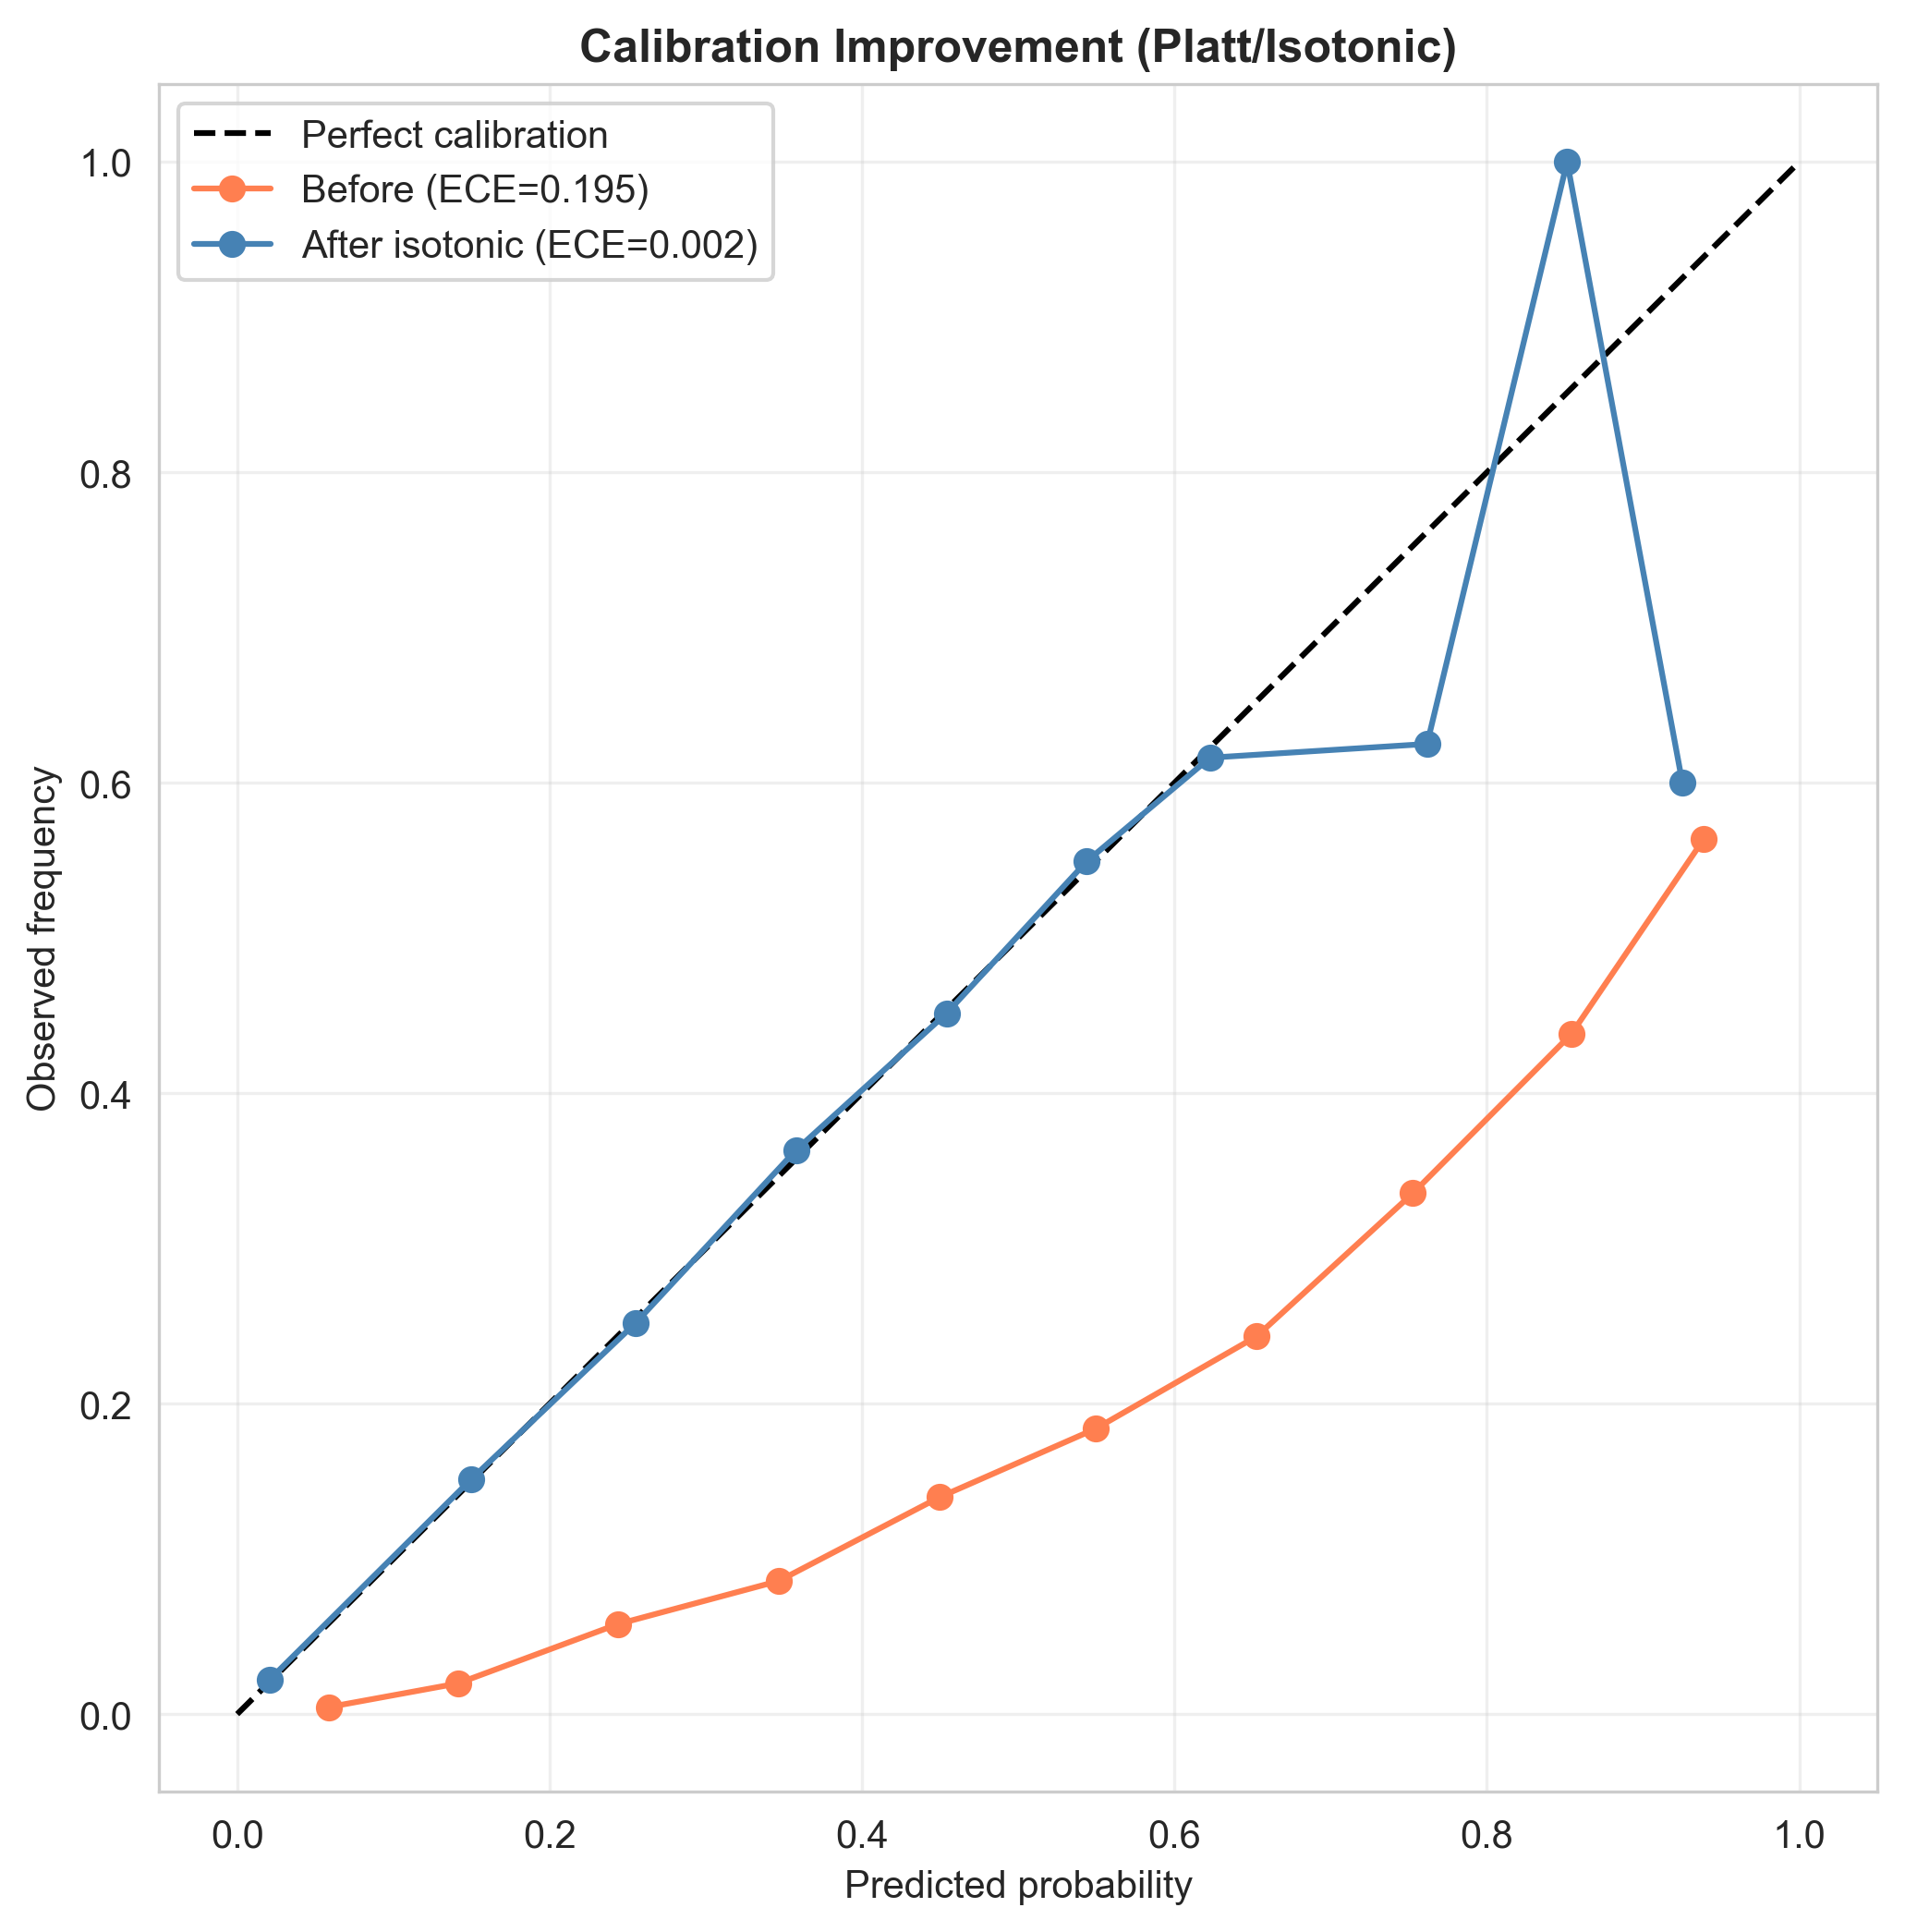
Fig. 3. Reliability diagram before and after isotonic calibration. Post-calibration probabilities closely track observed mortality rates across all risk deciles.
F. Multi-Layer Explainability Framework
Three complementary explainability layers are provided. (1) Global SHAP: Tree-SHAP (Lundberg 2020) on the XGBoost model provides model-agnostic additive feature attributions computed on the full test set, enabling global importance ranking and individual patient waterfall plots. (2) Odds ratios: an unregularised statsmodels Logit model provides OR per +1 SD with 95% Wald confidence intervals, enabling clinician-interpretable relative risk presentation. (3) Clinical nomogram: integer point scores derived from log-odds coefficients allow bedside paper-based risk estimation. The dominant pairwise feature interaction is pneumonia x age (interaction strength 0.182), indicating disproportionate risk for elderly patients with acute respiratory involvement. Each odds ratio is the exponent of the corresponding logistic coefficient (Eq. 4), giving the multiplicative change in mortality odds per +1 SD.
ORj = exp(βj) (4)
G. Subgroup Fairness Audit and Threshold Mitigation
The audit evaluates two metrics across eight pre-specified subgroups: AUC (discrimination fairness) and count-weighted ECE (calibration equity). Subgroups: age 18-30, 30-50, 50-65, 65+; sex female/male; diabetes present/absent. Flagging criterion: subgroup AUC deviates >5 percentage points from overall AUC. Group-specific decision thresholds, derived to equalise true positive rates, reduced TPR disparity from 0.603 to 0.045 without model retraining: age 18-30 t=0.05, 30-50 t=0.12, 50-65 t=0.23, 65+ t=0.41.
H. Web Prototype Architecture
A two-page Streamlit application loads the three pre-fitted joblib artefacts (imputer, scaler, calibrated model) and applies the identical impute -> scale -> predict_proba chain used in training. Inputs are an age slider and eight radio/toggle controls; outputs are the calibrated risk percentage with a four-tier colour band, per-patient odds-ratio attribution bars, a global SHAP panel, and the nomogram total. All metrics are read at runtime from the exported CSVs to prevent drift, and a four-location disclaimer frames outputs as mortality-proxy estimates not validated for individual clinical decisions.
I. Temporal Out-of-Time Validation
Records prior to 15 June 2020 formed the temporal training set (176,979 patients); subsequent records formed the temporal validation set (43,239 patients). This design tests robustness to temporal distribution shift as clinical protocols, patient demographics, and co-morbidity management evolved across the surveillance collection period -- providing a more stringent test than random train-test split alone.
J. Baseline Model
Two reference baselines contextualise the proposed pipeline. A majority-class classifier predicting survival for every patient attains 87.7% accuracy yet AUC 0.50 and zero recall, demonstrating why accuracy is inadequate under 12% prevalence and motivating AUC, calibration, and net-benefit as primary metrics. A plain, unweighted, uncalibrated Logistic Regression at the default 0.5 threshold provides the methodological baseline against which each component is isolated: cost-sensitive weighting, isotonic calibration, and threshold optimisation. Relative to this baseline the deployed model reduces ECE from 0.195 to 0.002 and lifts operating-point sensitivity from 0.296 to 0.702, at equivalent discrimination (Section IV).
IV. PERFORMANCE EVALUATION
A. Model Discrimination and DeLong Testing
Model | Test AUC | 95% CI | DeLong vs LR
Logistic Regression (tuned) | 0.888 | 0.884-0.892 | reference
Random Forest | 0.866 | 0.861-0.871 | p ~ 3e-42 (inferior)
Gradient Boosting | 0.888 | 0.884-0.892 | p > 0.05 (n.s.)
XGBoost | 0.888 | 0.884-0.892 | p > 0.05 (n.s.)
Stacking Ensemble | 0.888 | 0.884-0.892 | p > 0.05 (n.s.)
Primary (calibrated LR) | 0.888 | 0.884-0.892 | deployed
TABLE IV. Model Comparison -- Test Set AUC (n = 44,044)
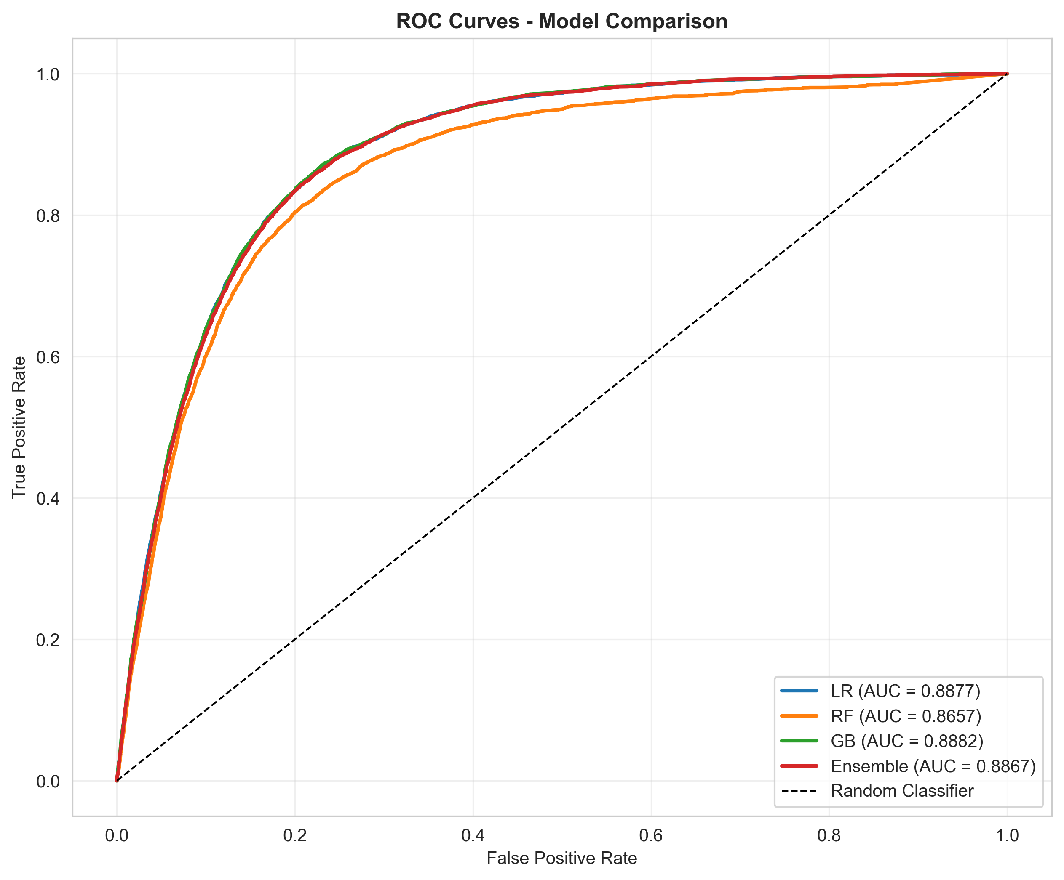
Fig. 4. ROC curves for all five model families. Calibrated LR is statistically non-inferior to all ensembles by DeLong test; RF is significantly worse (p ~ 3e-42).
Random Forest is the only model significantly inferior to Logistic Regression (DeLong p ~ 3e-42). Gradient Boosting, XGBoost, and the Stacking ensemble are statistically indistinguishable from LR. Five-fold cross-validation AUC: 0.891 +/- 0.002. Temporal out-of-time AUC: 0.891. This directly and formally answers RQ2: no complex model significantly outperforms the interpretable Logistic Regression on this nine-feature clinical dataset.
B. Calibration Analysis
Metric | Pre-calibration | Post-isotonic
Brier Score | 0.135 | 0.078
ECE (count-weighted) | 0.195 | 0.002
ECE (bin-averaged) | 0.287 | 0.064
TABLE V. Calibration Metrics Before and After Isotonic Correction
Isotonic calibration produces substantial improvements on all three metrics. Count-weighted ECE (0.002) reflects calibration weighted by the population distribution; bin-averaged ECE (0.064) gives equal weight to rare high-risk bins. A predicted probability of 0.30 now corresponds to approximately 30% observed mortality in the test set, enabling direct probabilistic clinical interpretation.
C. Threshold Optimisation
Strategy | Threshold | Sensitivity | Specificity | Precision | F1
Default (0.5) | 0.50 | 0.296 | 0.968 | 0.564 | 0.388
F1-optimal | 0.26 | 0.702 | 0.878 | 0.447 | 0.546
Youden's J | 0.10 | 0.877 | 0.761 | 0.340 | 0.490
TABLE VI. Threshold Optimisation Strategies
The F1-optimal threshold (0.26) is recommended for clinical triage: sensitivity 0.702 with precision 0.447, representing 3.6x enrichment over the 12.3% base rate. Youden's J (0.10) maximises sensitivity for high-recall population screening contexts.
D. Feature Importance and Explainability
Feature | SHAP % | OR (95% CI) | Sig.
Pneumonia | 44.2 | 2.65 (2.61-2.69) | ***
Age | 33.0 | 2.33 (2.28-2.37) | ***
Sex (female) | 8.5 | 0.80 (0.79-0.82) | *** protective
Diabetes | 5.6 | 1.15 (1.13-1.17) | ***
Hypertension | 4.5 | 1.09 (1.07-1.10) | ***
Obesity | 3.0 | 1.10 (1.08-1.12) | ***
COPD | 0.6 | 1.03 (1.02-1.04) | ***
Asthma | 0.3 | 0.98 (0.97-1.00) | n.s.
Cardiovascular | 0.3 | 1.00 (0.99-1.01) | n.s.
TABLE VII. Tree-SHAP Global Importance and Odds Ratios (statsmodels, per +1 SD)
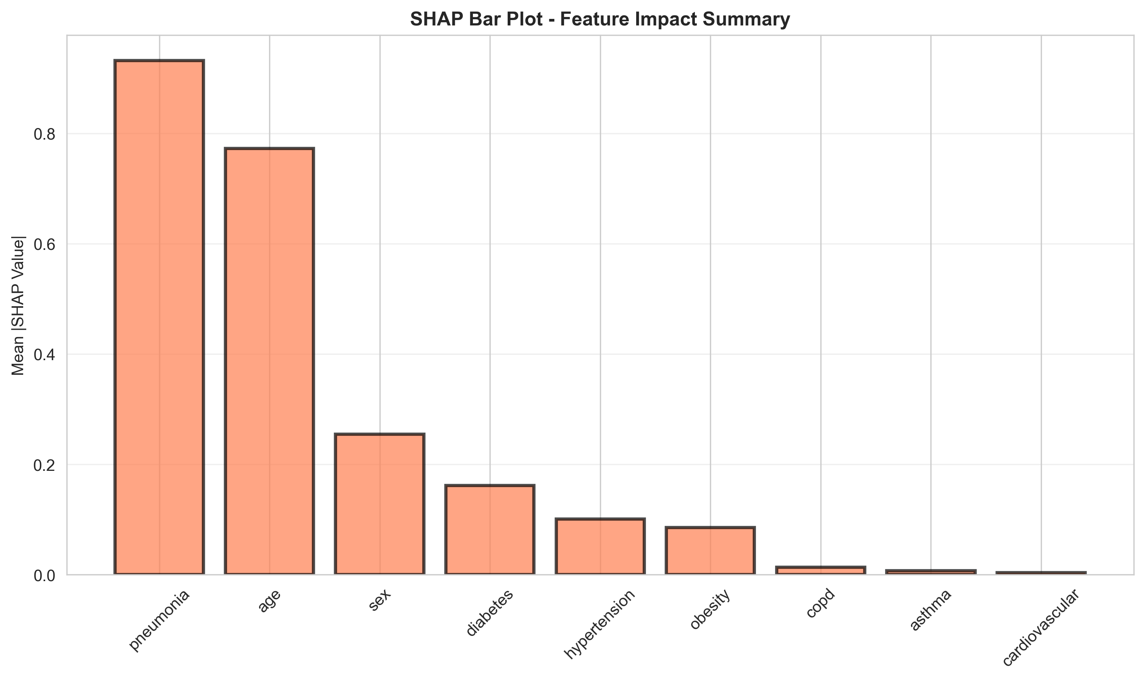
Fig. 5. Tree-SHAP global feature importance. Pneumonia (44.2%) and age (33.0%) together account for 77.2% of total importance, confirming a linear additive signal.
Pneumonia dominates (OR 2.65, SHAP 44.2%) -- the largest modifiable risk factor at admission. Age (OR 2.33, SHAP 33.0%) is the strongest non-modifiable predictor. Female sex is significantly protective (OR 0.80). Cardiovascular disease and asthma show negligible individual contributions (0.3% SHAP, OR ~ 1.00, p > 0.05) -- a null finding that is transparently reported rather than suppressed. Dominant pairwise interaction: pneumonia x age (strength 0.182). Clinical nomogram points: pneumonia +24, age +6/decade, diabetes +5, COPD +4, hypertension +3, obesity +3, cardiovascular +1, asthma -1, sex (female) -5.
E. Subgroup Fairness Audit Results
Subgroup | n | AUC | Flag | ECE
Age 18-30 | 6,290 | 0.891 | OK | 0.002
Age 30-50 | 19,713 | 0.874 | OK | 0.004
Age 50-65 | 11,189 | 0.799 | FLAG | 0.008
Age 65+ | 5,926 | 0.733 | FLAG | 0.015
Female | 19,961 | 0.901 | OK | 0.005
Male | 24,083 | 0.873 | OK | 0.003
Diabetes | 7,160 | 0.776 | FLAG | 0.012
No Diabetes | 36,704 | 0.899 | OK | 0.004
TABLE VIII. Subgroup Fairness Audit (FLAG = AUC deviation > 5pp from overall)
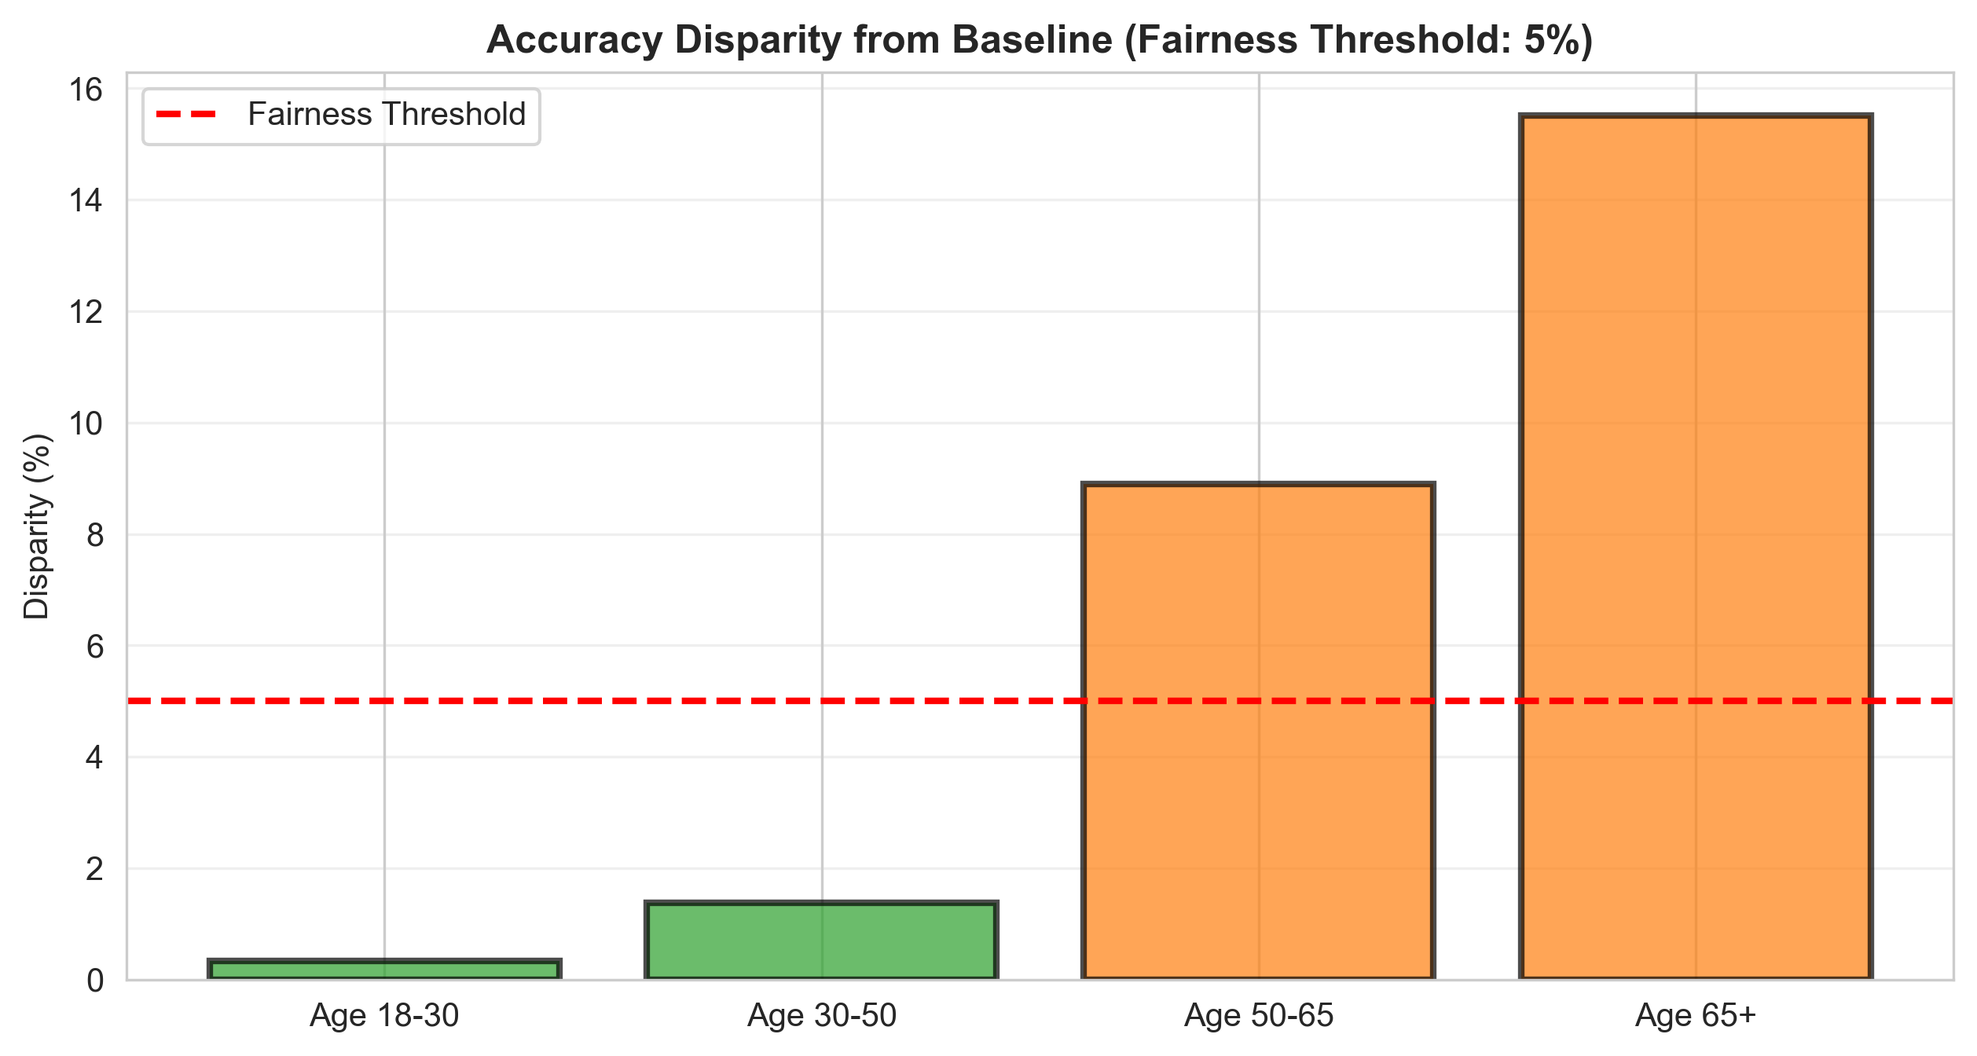
Fig. 6. Subgroup fairness audit: AUC and ECE across eight groups. ECE < 0.015 in all subgroups; AUC drops in older and diabetic subgroups reflect restriction of range.
Three subgroups are flagged on AUC: age 50-65 (0.799), 65+ (0.733), and diabetes (0.776). ECE remains below 0.015 in all eight subgroups, confirming equitable calibration across demographic groups. Gender AUC gap: 2.8% (within the 5% threshold). Group-specific threshold mitigation reduced TPR disparity from 0.603 to 0.045.
F. Decision Curve Analysis and Sensitivity Analysis
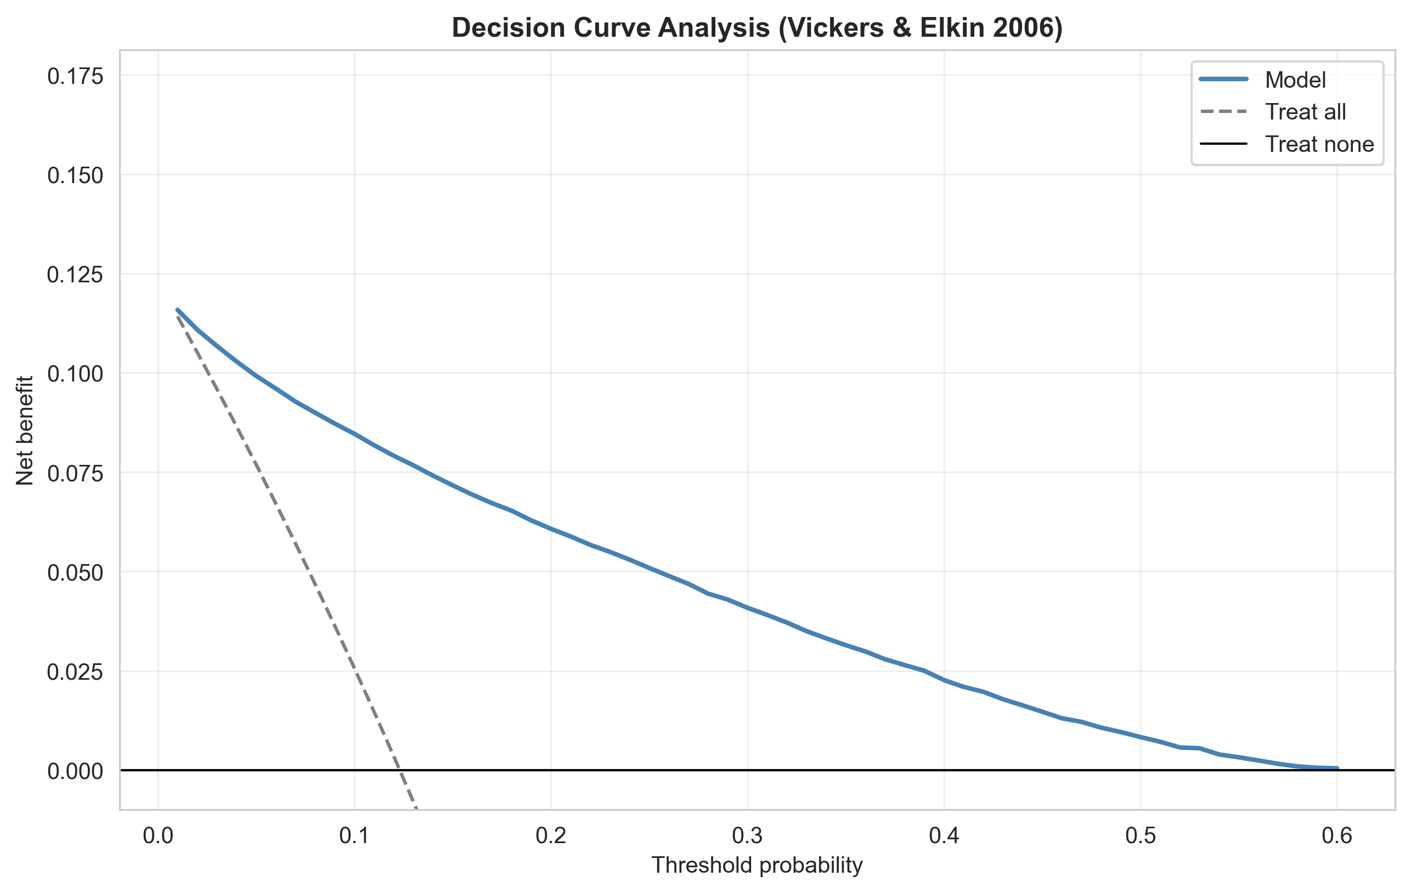
Fig. 7. Decision Curve Analysis. Model net benefit (0.085 at threshold 0.10) substantially exceeds treat-all (0.026) and treat-none across the clinical range.
DCA confirms positive net benefit over both treat-all and treat-none strategies across the full clinically relevant threshold range (0.05-0.50). At threshold 0.10, model net benefit = 0.085 versus treat-all = 0.026, validating practical utility beyond accuracy metrics alone. Counterfactual sensitivity analysis confirms that pneumonia removal produces the largest individual risk reduction (illustrative example: 42.0% -> 8.0%, delta = -34.0 pp), consistent with its dominant SHAP importance. Risk band distribution: LOW <30% (83.3%), MEDIUM 30-50% (10.3%), HIGH 50-70% (6.4%), CRITICAL >=70% (0.05%).
V. DISCUSSION
A. Why Logistic Regression Ties the Ensembles
The finding that no complex model significantly outperforms Logistic Regression (DeLong p > 0.05) requires explanation rather than mere reporting. The mortality signal in this dataset is predominantly linear and additive: pneumonia and age together account for 77.2% of Tree-SHAP importance, with monotonic, non-interacting effects. With nine mostly-binary features and such a concentrated linear signal structure, tree ensembles have no high-order interaction or non-monotonic patterns to exploit -- additional parametric complexity overfits noise rather than captures signal. This independently confirms Bjerre et al. [5] with formal DeLong statistical evidence on a separate 220,218-patient dataset. The clinical implication is significant: on low-dimensional binary clinical features, interpretability costs nothing in discrimination. The simpler, explainable model is strictly preferable for deployment.
B. Calibration as the Primary Deployment Criterion
For clinical deployment, calibration matters more than AUC: a clinician acts on the predicted probability as a risk estimate, not as an unlabelled ranking score. The pre-calibration ECE of 0.195 illustrates the danger of deploying uncalibrated models -- predicted probabilities diverging from observed mortality by nearly 20 percentage points on average. Post-isotonic ECE = 0.002 (count-weighted) enables direct clinical probability use. Crucially, ECE < 0.015 in all eight subgroups confirms equitable calibration: no demographic group receives systematically miscalibrated risk estimates, meeting a basic requirement for equitable clinical AI deployment.
C. Interpreting Subgroup AUC Drops
The lower AUC observed in age 65+ (0.733) and diabetic (0.776) subgroups reflects restriction of range -- a well-known statistical phenomenon whereby AUC naturally decreases within homogeneous high-risk subgroups due to compressed rank variation. This is a statistical artefact of subgroup composition, not model failure. Preserved calibration (ECE 0.015 for age 65+, 0.012 for diabetes) confirms that risk estimates remain accurate within these groups even as ranking becomes harder. This distinction between discrimination fairness and calibration fairness is frequently conflated in the clinical AI fairness literature.
D. Responsible AI and Governance Framing
The pipeline implements responsible-AI best practices at three levels. At the model level: leakage-free design enforced by split-then-fit pipelines, isotonic calibration with empirical verification, threshold optimisation with two clinical strategies, and temporal out-of-time validation. At the fairness level: eight pre-specified subgroup audit with two fairness lenses (AUC and ECE), transparent reporting of null and flagged results, and a concrete mitigation strategy reducing TPR disparity to 0.045. At the documentation level: Model Card (Mitchell et al. 2019), Datasheet for Datasets (Gebru et al. 2021), and a four-location Streamlit disclaimer that frames all outputs as mortality-proxy estimates not validated for individual clinical decisions.
E. Limitations and Threats to Validity
Four limitations bound the claims of this work. (i) Construct validity: in-hospital mortality is used as a PASC proxy; it under-estimates Long COVID burden in patients who survive with significant sequelae, potentially missing a large proportion of the target population. (ii) External validity: single-country, single-period data (Mexico, March-November 2020) limits generalisability to other healthcare systems, demographic profiles, and SARS-CoV-2 variants. No vaccination data are available as the dataset predates widespread rollout. (iii) Feature scope: nine admission-time features only -- laboratory values, vital signs, comorbidity severity grading, and variant information are absent. (iv) Internal validation only: temporal validation within the same national dataset cannot substitute for multi-site or multi-country external validation.
VI. CONCLUSION
This paper presented a rigorous 13-phase end-to-end responsible-ML pipeline for COVID-19 in-hospital mortality risk stratification as a proxy for Long COVID severe outcome risk. The central empirical finding answers RQ2 with formal statistical evidence: a calibrated, interpretable Logistic Regression is non-inferior to Random Forest, Gradient Boosting, XGBoost, and Stacking by DeLong's test (p > 0.05) on 44,044 held-out patients, achieving AUC 0.888 (95% CI 0.884-0.892). The predominantly linear, additive signal structure -- pneumonia and age accounting for 77.2% of Tree-SHAP importance -- leaves no advantage for complex models to exploit.
Three contributions were made. First, an empirical finding confirmed with formal DeLong evidence on 220,218 patients: interpretable Logistic Regression matches black-box ensembles on low-dimensional binary clinical features, independently replicating Bjerre et al. [5]. Second, a methodological contribution: the pipeline closes all four identified gaps from the Long COVID prediction literature in a single reproducible workflow -- calibration (Brier 0.135 to 0.078, ECE 0.195 to 0.002), fairness (TPR disparity 0.603 to 0.045, ECE < 0.015 in all eight subgroups), leakage control (split-then-fit, nine admission-time features), and multi-layer explainability (SHAP, odds ratios, nomogram, web app). Third, a responsible-AI contribution: Model Card, Datasheet, and a Streamlit clinical prototype with governance disclaimers and group-specific threshold mitigation built in.
Future work should apply the pipeline to PASC-labelled EHR cohorts (RECOVER [8], UK Biobank), incorporate longitudinal biomarkers, vaccination status, and variant data, pursue multi-site external validation, and evaluate the Streamlit prototype in a prospective clinical decision-support trial measuring patient outcomes rather than model metrics alone.
ACKNOWLEDGMENTS
The author thanks Dr Martin Crane and Dr Tai Tan Mai (School of Computing, Dublin City University) for supervision, guidance, and critical feedback throughout this research. The Mexican Government COVID-19 surveillance dataset was sourced from Kaggle [14] and is gratefully acknowledged. This work was conducted as part of the MSc Computing (Data Analytics) programme at Dublin City University, Ireland.
GENERATIVE AI DISCLOSURE
Generative AI tools (Claude, Anthropic) were used for: (i) code review and debugging of the analysis pipeline; (ii) drafting and editing report sections based on verified numerical results from the author's own pipeline; (iii) IEEE formatting assistance. All quantitative results, model training, statistical tests, and data analyses were performed exclusively by the author's Python code. All AI-assisted text was reviewed, verified against actual pipeline outputs, and edited by the author. No AI tool generated any experimental result or analytical decision.
REFERENCES
[1] World Health Organisation, "Post COVID-19 condition (long COVID)," WHO Fact Sheet, 2025. [Online]. Available: https://www.who.int/news-room/fact-sheets/detail/post-covid-19-condition
[2] D. A. Gbewonyo et al., "Long COVID in Adults: United States, 2022," NCHS Data Brief, no. 480, CDC, 2023. doi: 10.15620/cdc:132417.
[3] B. Antony et al., "Predictive models of long COVID," EBioMedicine, vol. 96, p. 104777, 2023. doi: 10.1016/j.ebiom.2023.104777.
[4] K. Jeffrey et al., "Deriving and validating a risk prediction model for long COVID: a population-based, retrospective cohort study in Scotland," J. Royal Society of Medicine, vol. 117, no. 12, pp. 402-414, 2024. doi: 10.1177/01410768241297833.
[5] L. M. Bjerre et al., "Comparing AI/ML approaches and classical regression for predictive modeling using large population health databases: Applications to COVID-19 case prediction," Global Epidemiology, vol. 8, p. 100168, 2024. doi: 10.1016/j.gloepi.2024.100168.
[6] A. S. Menezes et al., "Acute COVID-19 Syndrome Predicts Severe Long COVID-19: An Observational Study," Cureus, 2022. doi: 10.7759/cureus.29826.
[7] Z. B. Dozier et al., "Predicting Long COVID in the National COVID Cohort Collaborative Using Super Learner," JMIR Public Health and Surveillance, vol. 10, p. e53322, 2024. doi: 10.2196/53322.
[8] C. Zang et al., "Identification of risk factors of Long COVID and predictive modeling in the RECOVER EHR cohorts," Communications Medicine, vol. 4, no. 1, 2024. doi: 10.1038/s43856-024-00549-0.
[9] N. Shakhovska, V. Yakovyna, and V. Chopyak, "A new hybrid ensemble machine-learning model for severity risk assessment and post-COVID prediction system," Mathematical Biosciences and Engineering, vol. 19, no. 6, pp. 6102-6123, 2022. doi: 10.3934/mbe.2022285.
[10] K. Swinnerton et al., "Leveraging near-real-time patient and population data to incorporate fluctuating risk of severe COVID-19," eClinicalMedicine, vol. 81, p. 103114, 2025. doi: 10.1016/j.eclinm.2025.103114.
[11] H. M. Teeuw et al., "Incidence and individual risk prediction of post-COVID-19 cardiovascular disease in the general population," ESC Open Heart, vol. 3, 2023. doi: 10.1093/ehjopen/oead101.
[12] J. G. Guzman-Esquivel et al., "Clinical Characteristics in the Acute Phase of COVID-19 That Predict Long COVID," Healthcare, vol. 11, no. 2, pp. 197-197, 2023. doi: 10.3390/healthcare11020197.
[13] Z. Noroozi, A. Orooji, and L. Erfannia, "Analyzing the impact of feature selection methods on machine learning algorithms for heart disease prediction," Scientific Reports, vol. 13, 2023. doi: 10.1038/s41598-023-49962-w.
[14] Kaggle, "COVID-19 Mexico Patient Health Dataset," 2020. [Online]. Available: https://www.kaggle.com/datasets/riteshahlawat/covid19-mexico-patient-health-dataset
[15] E. R. DeLong, D. M. DeLong, and D. L. Clarke-Pearson, "Comparing the areas under two or more correlated receiver operating characteristic curves: a nonparametric approach," Biometrics, vol. 44, no. 3, pp. 837-845, 1988.
[16] S. Luo et al., "Prevalence and duration of common symptoms in people with long COVID: a systematic review and meta-analysis," Journal of Global Health, vol. 15, 2025. doi: 10.7189/jogh.15.04282.
[17] S. Bozkurt and K. Keskin, "A gradient boosting-based mortality prediction model for COVID-19 patients," Neural Computing and Applications, vol. 35, no. 33, pp. 23997-24013, 2023. doi: 10.1007/s00521-023-08997-w.
[18] E. Cordelli et al., "Predicting pulmonary sequelae after COVID-19 using machine learning: model performance and clinical interpretability," 2024.
[19] N. Kourmpanis et al., "Predicting mortality outcomes in individual COVID-19 patients using machine learning algorithms," Artificial Intelligence in Health, vol. 1, no. 3, p. 31, 2024. doi: 10.36922/aih.2591.
[20] X. Sun et al., "Development and validation of a prediction model for mortality in critically ill COVID-19 patients," Frontiers in Cellular and Infection Microbiology, vol. 14, pp. 1309529-1309529, 2024. doi: 10.3389/fcimb.2024.1309529.
[21] C. Y. Tang et al., "Prediction models for COVID-19 disease outcomes," Emerging Microbes and Infections, 2024. doi: 10.1080/22221751.2024.2361791.

