# Sales Report - 2025-06-26

## Executive Summary

This report provides an analysis of the Superstore sales data.

The total sales figure across all regions and categories is $2,261,536.78.

## Sales Performance by Region

The bar chart below illustrates the sales distribution across different regions.

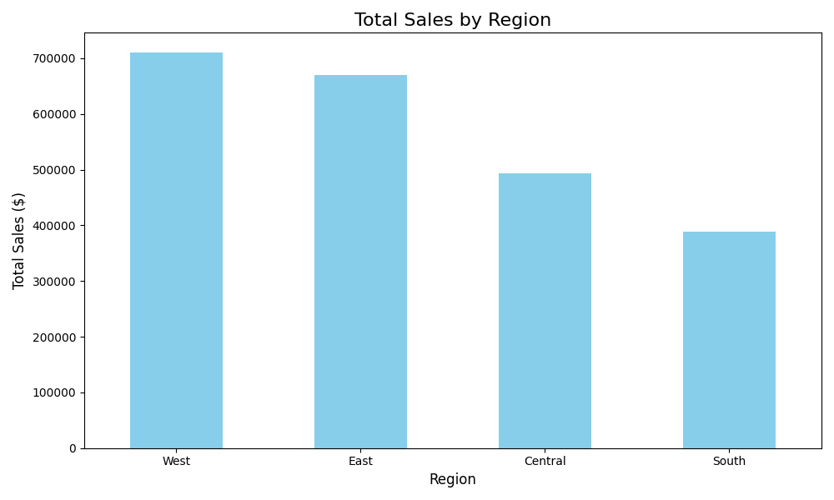

The table below provides the detailed sales figures for each region.

|  |  |
| --- | --- |
| Region | Total Sales ($) |
| West | 710,219.68 |
| East | 669,518.73 |
| Central | 492,646.91 |
| South | 389,151.46 |

## Sales Performance by Category

The table below provides the detailed sales figures for each product category.

|  |  |
| --- | --- |
| Category | Total Sales ($) |
| Technology | 827,455.87 |
| Furniture | 728,658.58 |
| Office Supplies | 705,422.33 |