DeJanae Faison 1.2 Assignment GitHub Repository Set Up

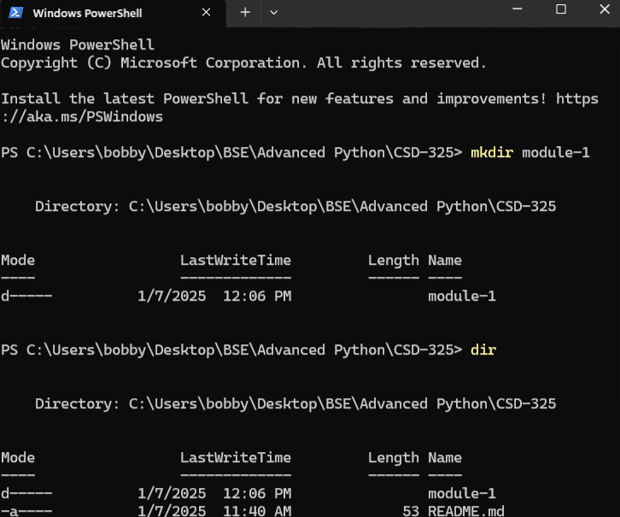

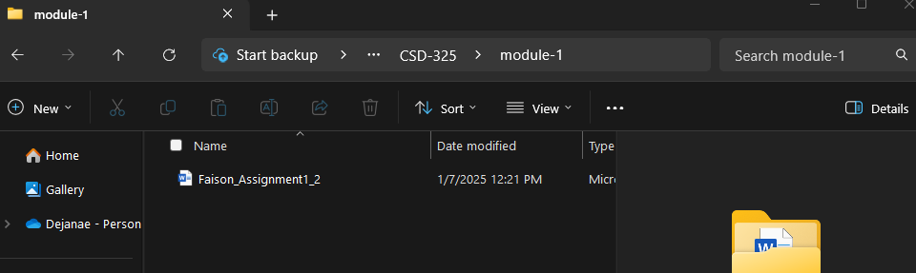

URL:

<https://github.com/D-Faison/CSD-325>