DeJanae Faison 2/2/2025 Forest Fire Simulation

Tabari Harvey

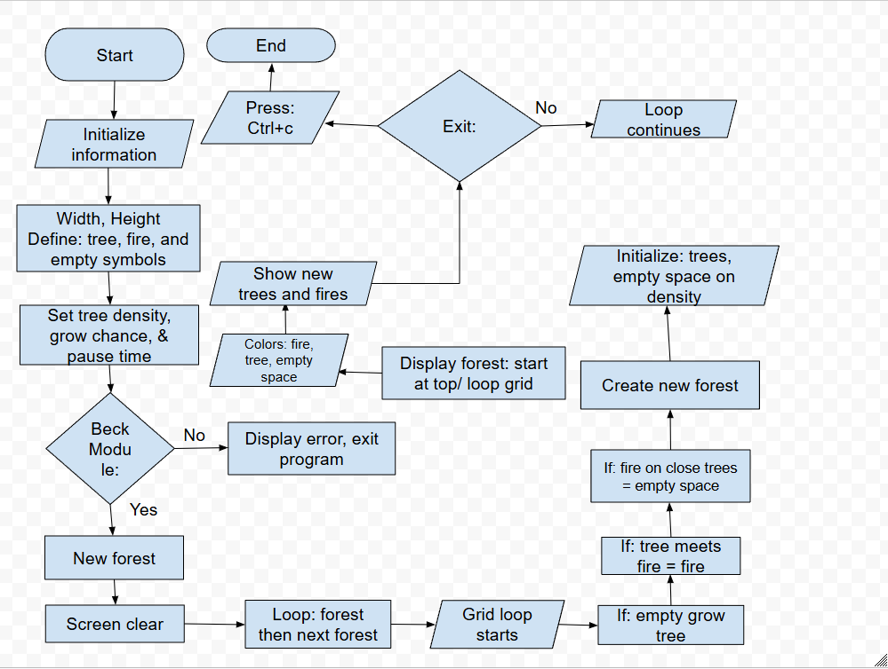Mark Joiner

