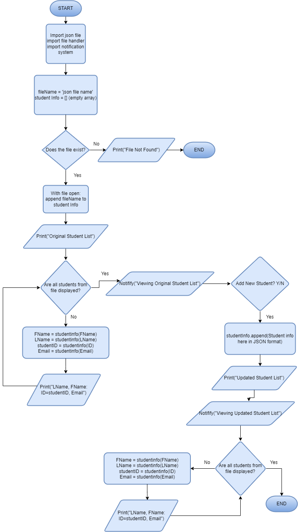DeJanae Faison 2/23/25 Assignment 8.2 JSON Practice

