DeJanae Faison

Assignment 3.2 GitHub Pages

3/30/2025

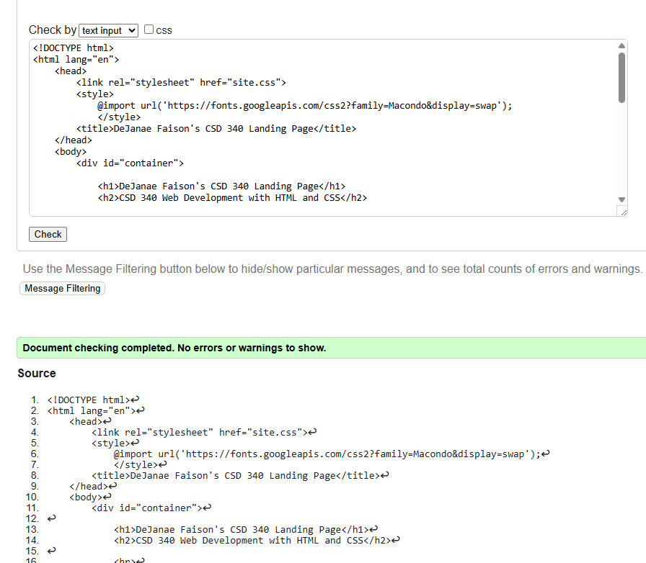HTML Validation:

CSS Validation:

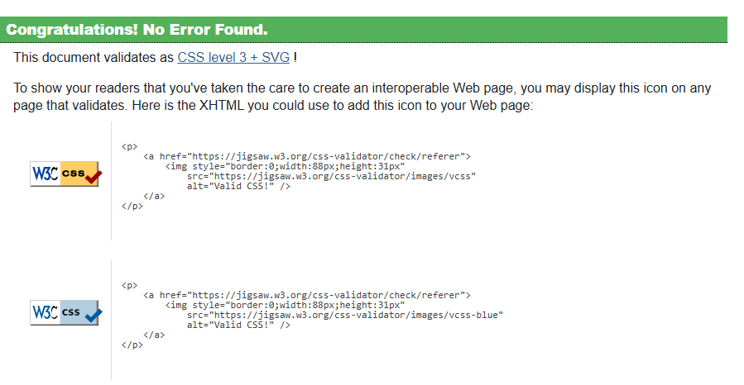

Index Page:

