DeJanae Faison

M7 CSS Java Assignment

Due 7.6.25

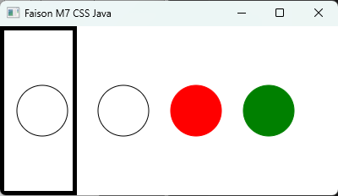

Resources:

Y Daniel Liang. (2021). Introduction to Java programming and data structures. Comprehensive version. Pearson.