Names

CSD-310 Assignment 9.1

# February 2025

**Selected Case Study: Outland Adventures**

**Business Rules**

1. **Customers**:
   * Customers can rent or buy hiking and camping equipment from Outland Adventures.
   * Each customer has personal information stored in the system, including name, contact details, and purchase/rental history, which must be kept secure.
   * Customers must be able to make secure transactions via a third-party handler to complete purchases and book trips and rentals.
   * A customer may book a trip to any of the available destinations within the available time periods for each on the site calendar.
   * Customers may complete any transaction type in person or online, but online transactions must be completed with an electronic payment system.
   * Customers must be an adult or have an adult proxy to book trips or rent or buy equipment.
2. **Equipment**:
   * There is equipment for rental and for sale, but their stock must be kept separate.
   * Rental equipment has a price per day rented.
   * Rental equipment can be reserved 1-5 days before chosen pickup date.
   * For-sale equipment can be purchased online and picked up at the store within 2 weeks of purchase, after which time the funds will be automatically reimbursed to the payment method if the equipment was not picked up.
   * Rental equipment must have the date it entered circulation for rental, and must be checked and verified for full functionality upon being returned after a rental.
   * Rental equipment is tracked per individual item but does have a product code.
   * Rental equipment that has been in use for 3 or fewer years may be re-allocated as used equipment for sale if it is still fully functional. Equipment re-allocated in this way may be given a condition of used-good if it looks new aside from minor surface blemishes and has been in use for 1.5 or fewer years; otherwise, it must be marked as used-fair.
   * Rental equipment that has been in use for 5 or more years must be retired and disposed of.
   * All for-sale equipment items have a product code, price, description, weight, dimensions, and a stock amount. Condition (new, used-good, or used-fair) must be used in combination with product code to track stock.
   * Equipment for sale may be re-allocated as equipment for rental if there is a surplus that has not been sold for 2-3 years.
3. **Trips**:
   * Each trip has a unique ID, a destination, a schedule, and an assigned guide (John ‘Mac’ MacNell or D.B. ‘Duke’ Marland).
   * A trip must be booked far enough in advance that any required paperwork can be completed and approved.
   * For each trip, at least one adult must have an account and be designated as the primary point of contact; this is the customer who initiates the trip by default but may be changed.
   * For each trip, all adults must have contact information on file and sign a legal waiver agreeing to the timeline and expectations of each party (business owners, trip guide, and customer). All minors must be accounted for on a waiver signed by their guardian, even if that guardian is not going on the trip.
   * To book a trip, there must be 4 – 10 participants, of which at least half must be adults.
4. **Guides**:
   * Each guide must have up-to-date requirements and certifications on file, such as First Aid and proof of insurance.
   * Each guide must have contact information on file.
   * Guides will have sensitive information on file (such as contact information) that must be kept secure.
   * Guides will have a salary with a specified bonus for each trip led.
5. **Sales**:
   * Sales transactions for rentals, equipment purchases, and trips are all tracked separately.
   * Sales transactions indicate whether they were completed online or in person.
   * Equipment sales include the shipping tracking number for all shipped items, automatically generated by the third-party shipping partner once the order is confirmed.
   * Equipment rental transactions include the start and end date chosen for the rental.

**Assumptions**

1. **E-Commerce Functionality**: The e-commerce site will make use of third-party applications for things such as payment processing and shipping estimates and tracking.
2. **Trip Booking**: We assumed that there would be a limit on participants for a trip. Too few and it’s not profitable for the company, too many and it becomes too much of a liability.
3. **Equipment Age Limit**: Equipment that is new/not in use shouldn’t really age out, although it’s probably good to ensure older equipment is sold before newer equipment of the same type. The age limit seems more designed for wear and tear on rental equipment, which is what we went with in the business rules.
4. **Guides**: The guides will have certain requirements they have to meet for liability reasons, such as being certified in First Aid.

**Initial Entity Relationship Diagram (ERD)**

**Entities:**

1. **Customer**
   * Attributes: Customer_ID (PK), Name, Contact Information
   * Relationships: Books -> Trip, Purchases/Rents -> Equipment
2. **Sale Equipment**
   * Attributes: Product_Code (PK), Condition, Description, Price, Weight, Dimensions, Stock
   * Relationships: Purchased -> Customer
3. **Rental Equipment**
   * Attributes: Item_ID, First_Use (date), Rate, Product_Code (FK)
   * Relationships: Booked_by -> Customer
4. **Trip**
   * Attributes: Trip_ID (PK), Destination, Trip_Start, Trip_End, Guide_ID (FK)
   * Relationships: Booked_by -> Customer
5. **Trip Participants**
   * Attributes: Participant_ID (PK), Trip_ID (FK), Date_of_Birth, Reservation Info (air travel to/from location, lodging, etc), Waiver, Contact Information, Passport Status
   * Relationships: Participates in -> Trip
6. **Staff**
   * Attributes: Staff_ID (PK), Name, Role, Contact Information, Requirements, Salary, Bonus
   * Relationships: If role is guide, Organizes -> Trip
7. **Sale**
   * Attributes: Transaction_ID (PK), Date, Customer_ID (FK), Product_Code + Condition (FK), Shipping Tracking
   * Relationships: Links -> Customer, Links -> Sale Equipment
8. **Rental**
   * Attributes: Transaction_ID (PK), Date, Customer_ID (FK), Item_ID (FK), Start_Date, End_Date
   * Relationships: Links -> Customer, Links -> Rental Equipment

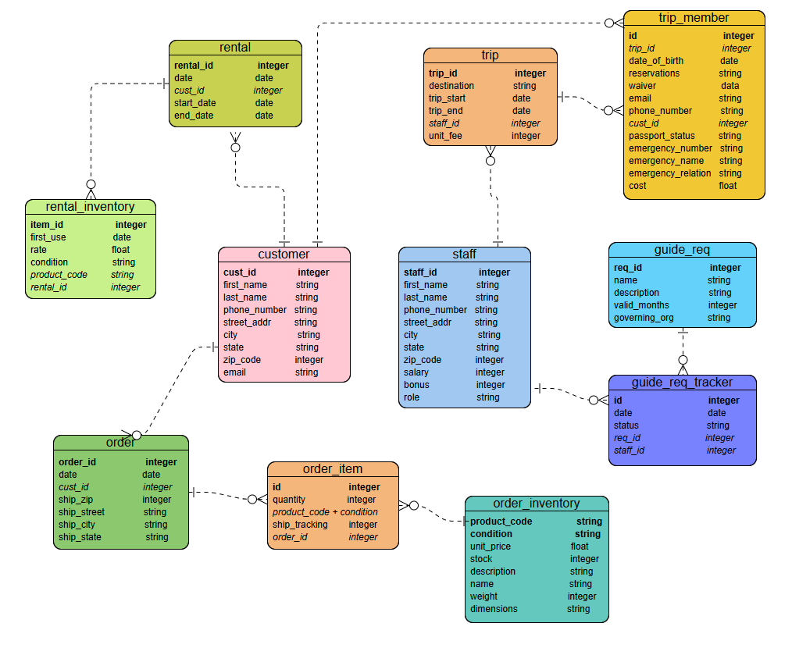**ERD Diagram:**