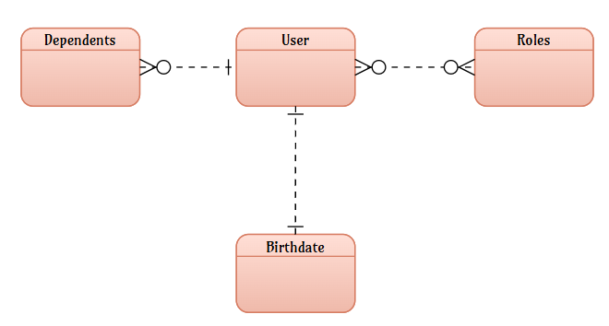DeJanae Faison Assignment 2.3: Data Models DATE

NoSQL Structure:

{

}