Dejanae Faison DATE Module 5.2 Assignment MySQL Functions

**MySQL Functions**

**CONCAT ()**

CONCAT( ) is a function that adds two or more strings together. The strings are parameters; the parameters can be written strings or values within the table. For example:

Input:

 Output:

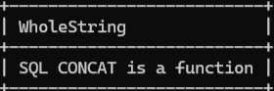

Concat can be used to combine columns into one whole column. For instance, in a database there is an individual column for the city, state, the zip code. The function can combine the three values for each row of the database and combine them into a new column with the alias ADDRESS.

**ROUND()**

ROUND( ) is used to round the given number and it is optional to decide the number of decimal places for the number to be rounded to. For example:

Input:



Output:

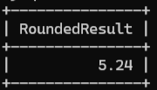

The first number represents the number to be rounded and can either be placed directly within the function or can be a number within the table. The second number is the number is the number of decimal points the function should round to. An instance where this function would be used is when rounding up prices. Let’s say a business purchases its product from Japan where one yen is equivalent to 0.0064 dollars in the states. The function could use the function to round its final cost to buy its product up to 2 decimals rather than 4. A similar function would be FORMAT().

**TIMEDIFF( )**

TIMEDIFF() or time difference calculated the difference between two time or two date and time expressions; time A minus time B. The date and time can either be fetched from a table or can be formatted in the function as: YEAR-MONTH-DAY, or YEAR-MONTH-DAY HOUR: MINUTE: SECOND. Both time formats should be the same.

Input:



Output:

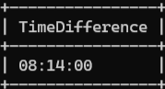

An example of when this would be used could be to calculate the subscription time of users. It can calculate the difference between when the user subscribed to the service to the current time.

*Resources:*

GeeksforGeeks. (2020, October 3). *CONCAT() function in MySQL*. GeeksforGeeks. https://www.geeksforgeeks.org/concat-function-in-mysql/

GeeksforGeeks. (2020, September 28). *ROUND() Function in MySQL*. GeeksforGeeks. https://www.geeksforgeeks.org/round-function-in-mysql/

*MySQL Functions*. (2020). W3schools.com. https://www.w3schools.com/sql/sql_ref_mysql.asp

‌*MySQL - TIMEDIFF() Function*. (2018). Tutorialspoint.com. https://www.tutorialspoint.com/mysql/mysql_date_time_functions_timediff.htm

‌

‌