DeJanae Faison

Module 1 Assignment – Project Setup and Repository

Due 8.17.25

**GitHub Repository-** <https://github.com/D-Faison/csd-430>

**Java**

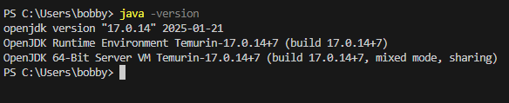

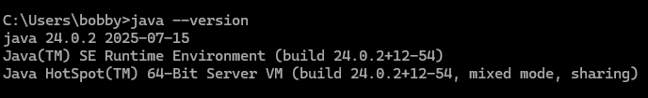

**Jakarta-Tomcat**

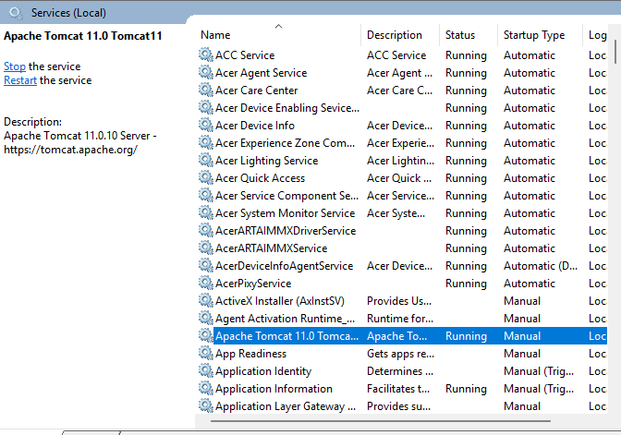

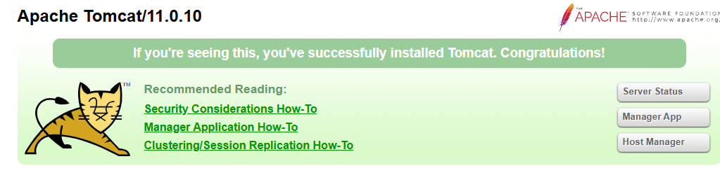

**IDE (VS Code)**

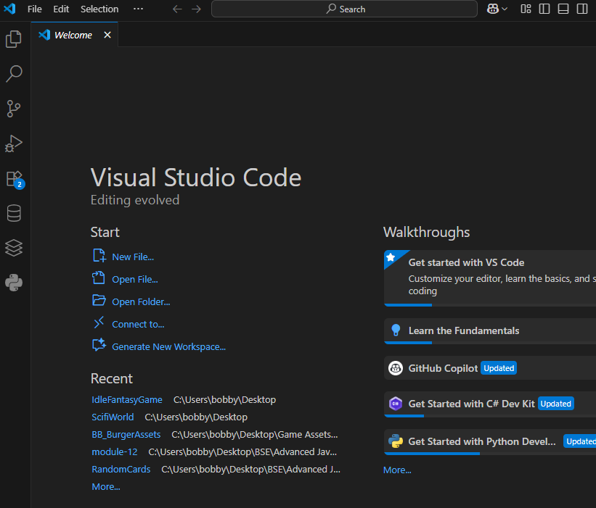

**JSP File-**