**Problem: 1**

**Create a new React Application with the name “myfirstreact”, Run the application to print “welcome to the first session of React” as heading of that page.**

**App.js**:

import React from 'react';

function App() {

  return (

    <div>

      <h1>Welcome to the first session of React</h1>

    </div>

  );

}

export default App;

**Output:**

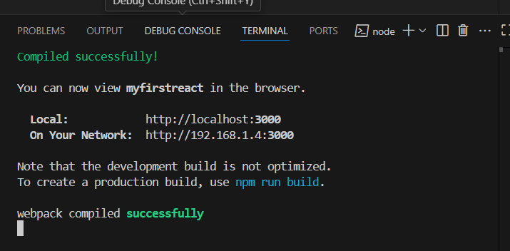

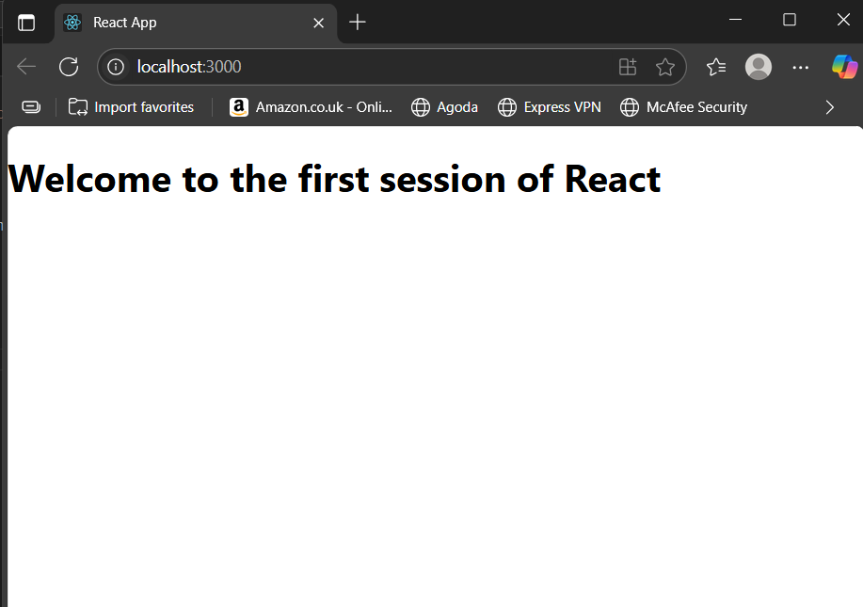

**Problem: 2**

**Create a react app for Student Management Portal named StudentApp and create a component named Home which will display the Message “Welcome to the Home page of Student Management Portal”. Create another component named About and display the Message “Welcome to the About page of the Student Management Portal”. Create a third component named Contact and display the Message “Welcome to the Contact page of the Student Management Portal”. Call all the three components.**

**Home.js:**

import React from 'react';

function Home() {

  return (

    <div>

      <h1>Welcome to the Home page of Student Management Portal</h1>

    </div>

  );

}

export default Home;

**About.js:**

import React from 'react';

function About() {

  return (

    <div>

      <h1>Welcome to the About page of the Student Management Portal</h1>

    </div>

  );

}

export default About;

**Contact.js:**

import React from 'react';

function Contact() {

  return (

    <div>

      <h1>Welcome to the Contact page of the Student Management Portal</h1>

    </div>

  );

}

export default Contact;

**App.js:**

import React from 'react';

import Home from './Components/Home';

import About from './Components/About';

import Contact from './Components/Contact';

function App() {

  return (

    <div>

      <Home />

      <About />

      <Contact />

    </div>

  );

}

export default App;

**Output:**

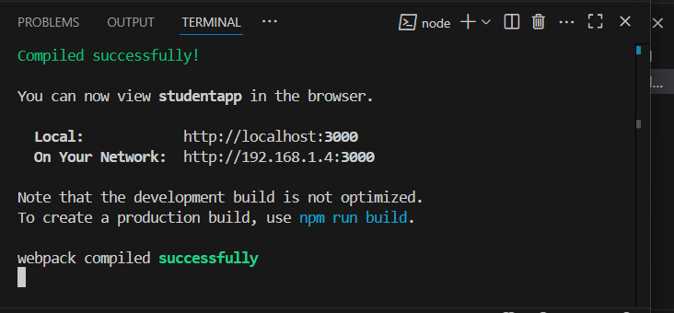

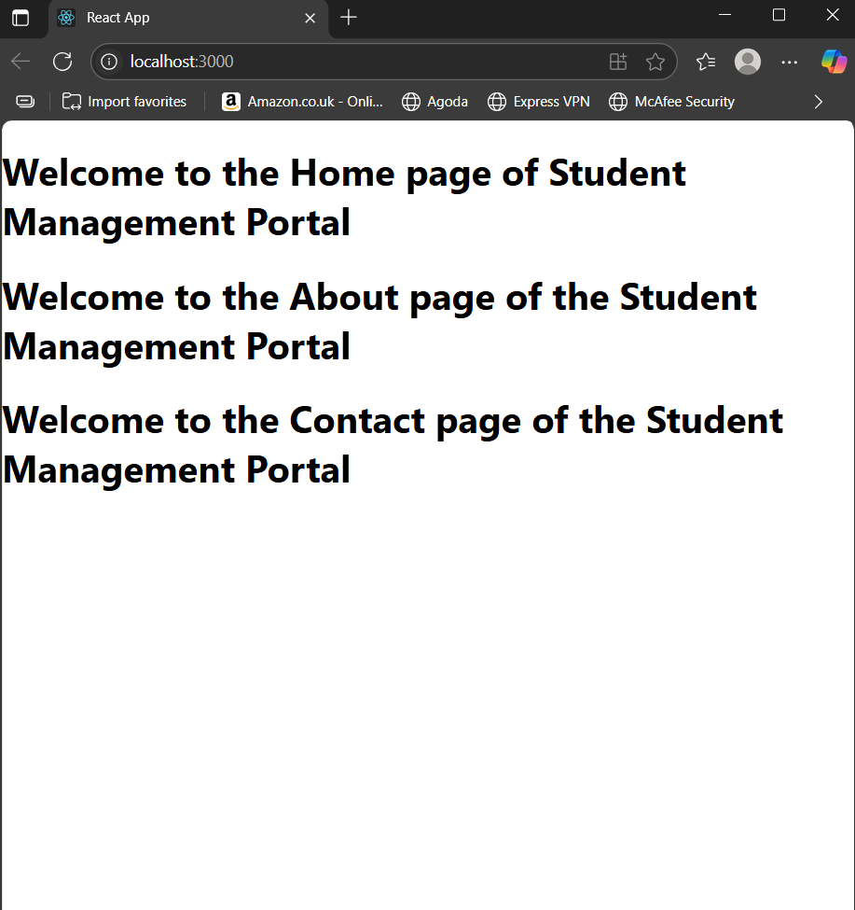

**Problem: 3.**

**Create a react app for Student Management Portal named scorecalculatorapp and create a function component named “CalculateScore” which will accept Name, School, Total and goal in order to calculate the average score of a student and display the same.**

**CalculateScore.js:**

import React from 'react';

import '../Stylesheets/mystyle.css';

function CalculateScore(props) {

  const average = props.total / props.goal;

  return (

    <div className="score-box">

      <h2>Student Score Calculator</h2>

      <p><strong>Name:</strong> {props.name}</p>

      <p><strong>School:</strong> {props.school}</p>

      <p><strong>Total Score:</strong> {props.total}</p>

      <p><strong>Goal:</strong> {props.goal}</p>

      <p className="average">Average Score: {average.toFixed(2)}</p>

    </div>

  );

}

export default CalculateScore;

**mystyle.css:**

.score-box {

  border: 2px solid #4CAF50;

  padding: 20px;

  margin: 20px auto;

  width: 50%;

  background-color: #f9f9f9;

  font-family: Arial, sans-serif;

  border-radius: 8px;

  box-shadow: 0 0 10px rgba(0, 0, 0, 0.1);

}

.score-box h2 {

  color: #4CAF50;

  text-align: center;

}

.score-box p {

  font-size: 16px;

  line-height: 1.6;

}

.average {

  font-weight: bold;

  color: #333;

}

**App.js:**

import React from 'react';

import CalculateScore from './Components/CalculateScore';

function App() {

  return (

    <div className="App">

      <CalculateScore name="Gopesh Sharam " school="Myhtilee High" total={477} goal={5} />

    </div>

  );

}

export default App;

**Output:**

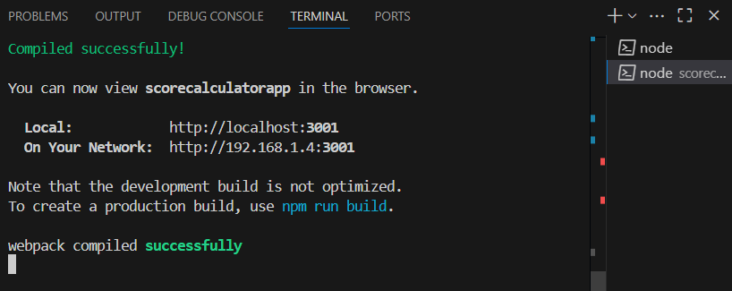

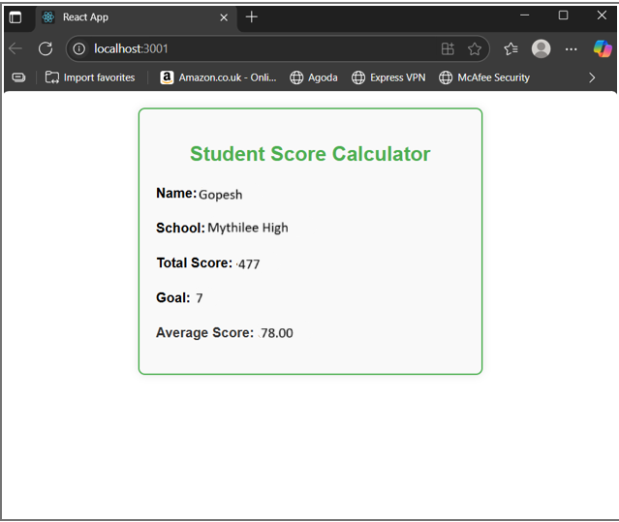

**Problem: 4.**

**Create a new react application using *create-react-app* tool with the name as “blogapp”**

**Post.js:**

import React from 'react';

class Post extends React.Component {

  render() {

    return (

      <div style={{ border: "1px solid gray", margin: "10px", padding: "10px" }}>

        <h3>{this.props.title}</h3>

        <p>{this.props.body}</p>

      </div>

    );

  }

}

export default Post;

**Posts.js:**

import React from 'react';

import Post from './Post';

class Posts extends React.Component {

  constructor(props) {

    super(props);

    this.state = {

      posts: [],

      hasError: false

    };

  }

  // Step 6: Load Posts from API

  loadPosts = () => {

    fetch('https://jsonplaceholder.typicode.com/posts')

      .then(response => response.json())

      .then(data => this.setState({ posts: data }))

      .catch(error => {

        console.error("Error fetching posts:", error);

        this.setState({ hasError: true });

      });

  };

  // Step 7: Call loadPosts in componentDidMount

  componentDidMount() {

    this.loadPosts();

  }

  // Step 9: Handle errors in rendering lifecycle

  componentDidCatch(error, info) {

    console.error("Error caught in component:", error);

    alert("Something went wrong while displaying posts.");

    this.setState({ hasError: true });

  }

  // Step 8: Render posts

  render() {

    if (this.state.hasError) {

      return <h2>Error loading posts.</h2>;

    }

   return (

      <div>

        <h2>Blog Posts</h2>

        {this.state.posts.map(post => (

          <Post key={post.id} title={post.title} body={post.body} />

        ))}

      </div>

    );

  }

}

export default Posts;

**App.js:**

import React from 'react';

import Posts from './Posts';

function App() {

  return (

    <div className="App">

      <h1>Welcome to BlogApp</h1>

      <Posts />

    </div>

  );

}

export default App;

**Output:**

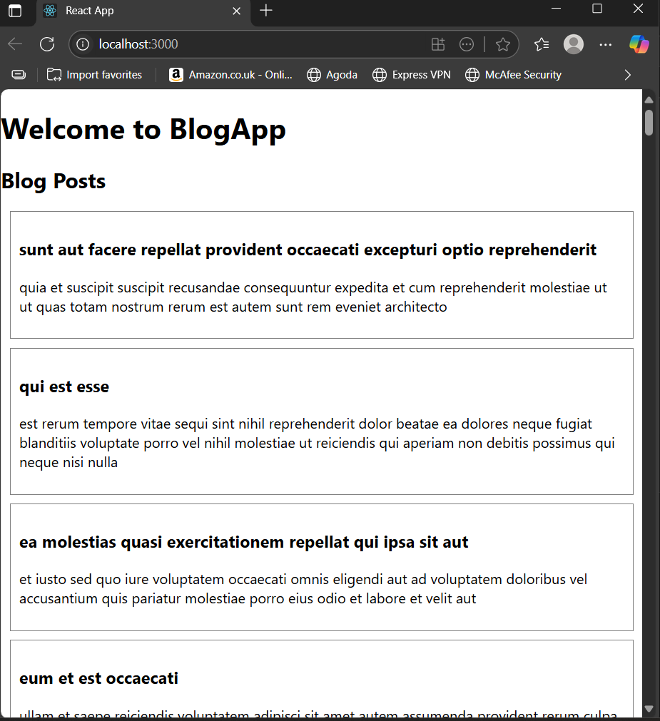

**Problem: 5.**

**Create a React Application named “shoppingapp” with a class component named “OnlineShopping” and “Cart”.**

**Cart.js:**

import React, { Component } from 'react';

class Cart extends Component {

  render() {

    return (

      <div style={{ border: "1px solid gray", padding: "10px", margin: "10px" }}>

        <h3>Item: {this.props.Itemname}</h3>

        <p>Price: ₹{this.props.Price}</p>

      </div>

    );

  }

}

// Default Props (if not passed)

Cart.defaultProps = {

  Itemname: "Unknown Item",

  Price: "0"

};

export default Cart;

**OnlineShopping.js:**

import React, { Component } from 'react';

import Cart from './Cart';

class OnlineShopping extends Component {

  render() {

    const items = [

      { Itemname: "Shoes", Price: 1500 },

      { Itemname: "Shirt", Price: 800 },

      { Itemname: "Watch", Price: 2500 },

      { Itemname: "Backpack", Price: 1200 },

      { Itemname: "Headphones", Price: 3000 },

    ];

    return (

      <div>

        <h1>Online Shopping Cart</h1>

        {items.map((item, index) => (

          <Cart key={index} Itemname={item.Itemname} Price={item.Price} />

        ))}

      </div>

    );

  }

}

export default OnlineShopping;

Index.js:

import React from 'react';

import ReactDOM from 'react-dom/client';

import './index.css';

import OnlineShopping from './OnlineShopping';

import reportWebVitals from './reportWebVitals';

const root = ReactDOM.createRoot(document.getElementById('root'));

root.render(

  <React.StrictMode>

    <OnlineShopping />

  </React.StrictMode>

);

reportWebVitals();

**Output:**

