**9.Create a React Application named “cricketapp”**

**ListofPlayers.js:**

import React from 'react';

const ListofPlayers = () => {

  const players = [

    { name: 'Virat Kohli', score: 95 },

    { name: 'Rohit Sharma', score: 88 },

    { name: 'KL Rahul', score: 45 },

    { name: 'Shubman Gill', score: 72 },

    { name: 'Hardik Pandya', score: 60 },

    { name: 'Rishabh Pant', score: 30 },

    { name: 'Ravindra Jadeja', score: 85 },

    { name: 'Bumrah', score: 75 },

    { name: 'Siraj', score: 48 },

    { name: 'Chahal', score: 65 },

    { name: 'Shami', score: 70 }

  ];

  const lowScorers = players.filter(player => player.score < 70);

  return (

    <div>

      <h2>All Players (with scores)</h2>

      <ul>

        {players.map((player, index) => (

          <li key={index}>{player.name} - {player.score}</li>

        ))}

      </ul>

      <h3>Players with score below 70</h3>

      <ul>

        {lowScorers.map((player, index) => (

          <li key={index}>{player.name} - {player.score}</li>

        ))}

      </ul>

    </div>

  );

};

export default ListofPlayers;

**IndianPlayers.js:**

import React from 'react';

const IndianPlayers = () => {

  const team = ['Player1', 'Player2', 'Player3', 'Player4', 'Player5', 'Player6'];

  const [p1, p2, p3, p4, p5, p6] = team;

  const oddTeam = [p1, p3, p5];

  const evenTeam = [p2, p4, p6];

  const T20players = ['Virat', 'Rohit', 'Bumrah'];

  const RanjiTrophy = ['Pujara', 'Rahane'];

  const allPlayers = [...T20players, ...RanjiTrophy]; // Spread operator

  return (

    <div>

      <h2>Team Players</h2>

      <p><strong>Odd Team:</strong> {oddTeam.join(', ')}</p>

      <p><strong>Even Team:</strong> {evenTeam.join(', ')}</p>

      <h3>Merged Players List</h3>

      <ul>

        {allPlayers.map((player, index) => (

          <li key={index}>{player}</li>

        ))}

      </ul>

    </div>

  );

};

export default IndianPlayers;

**App.js:**

import React from 'react';

import ListofPlayers from './ListofPlayers';

import IndianPlayers from './IndianPlayers';

function App() {

  const flag = true; // Change this to false to test both components

return (

    <div className="App">

      <h1>Welcome to Cricket App</h1>

      {flag ? <ListofPlayers /> : <IndianPlayers />}

    </div>

  );

}

export default App;

**Output:**

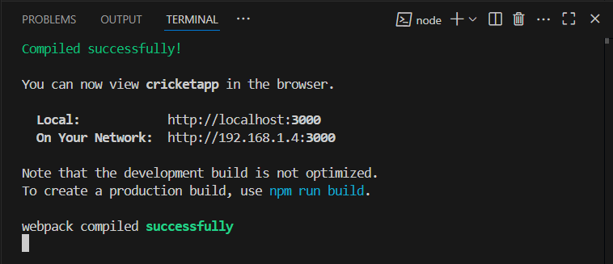

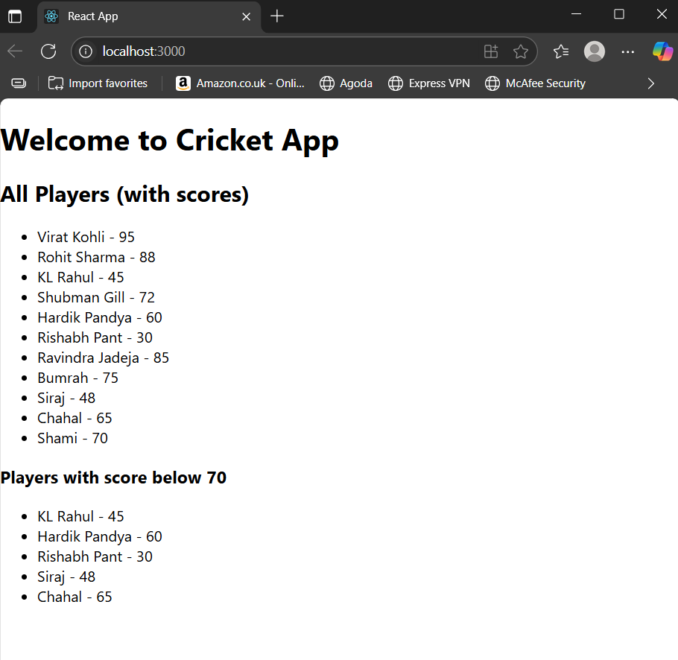

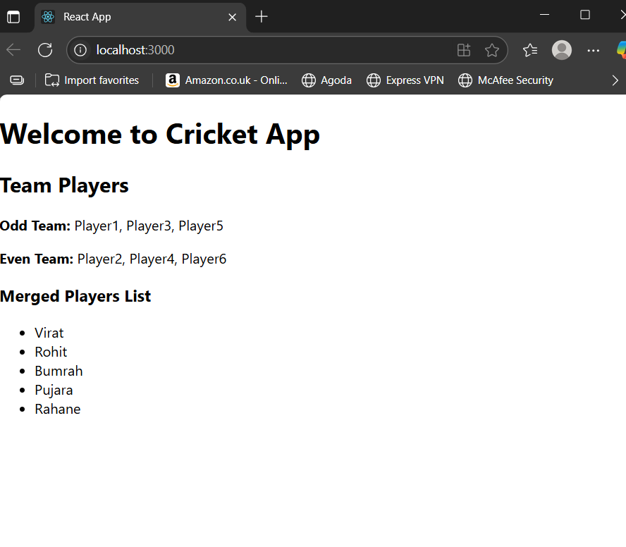

**10. Create a React Application named “officespacerentalapp” which uses React JSX to create elements, attributes and renders DOM to display the page.**

**App.js:**

import React from 'react';

const officeSpaces = [

  {

    id: 1,

    name: "Downtown Co-Work",

    rent: 55000,

    address: "123 Main Street, Bangalore",

    image: "https://via.placeholder.com/300x200?text=Office+1"

  },

  {

    id: 2,

    name: "Tech Hub Space",

    rent: 75000,

    address: "456 Tech Park, Hyderabad",

    image: "https://via.placeholder.com/300x200?text=Office+2"

  },

  {

    id: 3,

    name: "Startup Nest",

    rent: 60000,

    address: "789 Innovation Street, Pune",

    image: "https://via.placeholder.com/300x200?text=Office+3"

  }

];

function App() {

  return (

    <div style={{ padding: '20px', fontFamily: 'Arial' }}>

      {/* JSX heading element */}

      <h1>Office Space Rental Portal</h1>

      {/* Render each office space */}

      {officeSpaces.map(office => (

        <div key={office.id} style={{

          border: '1px solid #ccc',

          padding: '15px',

          marginBottom: '20px',

          borderRadius: '8px',

          backgroundColor: '#f9f9f9',

        }}>

          {/* JSX attributes */}

          <img src={office.image} alt={office.name} style={{ width: '100%', maxWidth: '300px', borderRadius: '5px' }} />

          <h2>{office.name}</h2>

          <p><strong>Address:</strong> {office.address}</p>

          {/* Inline CSS with conditional expression */}

          <p>

            <strong>Rent:</strong>{' '}

            <span style={{ color: office.rent > 60000 ? 'green' : 'red' }}>

              ₹{office.rent.toLocaleString()}

            </span>

          </p>

        </div>

      ))}

    </div>

  );

}

export default App;

Output:

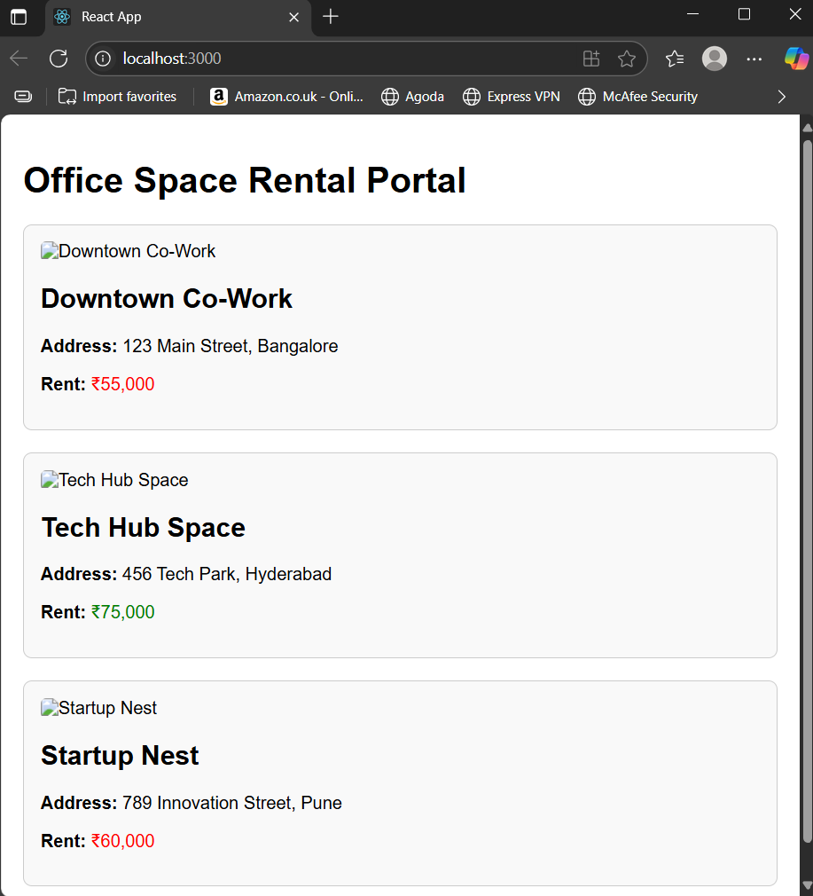

**11. Create a React Application “eventexamplesapp” to handle various events of the form elements in HTML.**

**CurrencyConverter.js:**

import React from 'react';

class CurrencyConvertor extends React.Component {

  constructor(props) {

    super(props);

    this.state = {

      rupees: '',

      euros: null,

    };

  }

  handleChange = (e) => {

    this.setState({ rupees: e.target.value });

  };

  handleSubmit = () => {

    const rupees = parseFloat(this.state.rupees);

    const euroRate = 0.011; // 1 INR = 0.011 EUR (example rate)

    const euros = (rupees * euroRate).toFixed(2);

    this.setState({ euros });

  };

  render() {

    return (

      <div>

        <h3>Currency Converter (INR ➜ EUR)</h3>

        <input

          type="number"

          placeholder="Enter amount in Rupees"

          value={this.state.rupees}

          onChange={this.handleChange}

        />

        {' '}

        <button onClick={this.handleSubmit}>Convert</button>

        {this.state.euros && (

          <p>

            Converted Amount in Euros: <strong>€{this.state.euros}</strong>

          </p>

        )}

      </div>

    );

  }

}

export default CurrencyConvertor;

**App.js:**

import React from 'react';

import CurrencyConvertor from './CurrencyConvertor';

class App extends React.Component {

  constructor(props) {

    super(props);

    this.state = {

      counter: 0,

    };

  }

  handleIncrement = () => {

    this.setState(prevState => ({

      counter: prevState.counter + 1,

    }));

    this.sayHello();

  };

  handleDecrement = () => {

    this.setState(prevState => ({

      counter: prevState.counter - 1,

    }));

  };

  sayHello = () => {

    console.log("Hello! Button clicked.");

    alert("Hello! You just increased the count.");

  };

  sayWelcome = (message) => {

    alert(message);

  };

  handleClick = (e) => {

    alert("I was clicked!");

    console.log("Synthetic event object:", e);

  };

  render() {

    return (

      <div style={{ padding: "20px", fontFamily: "Arial" }}>

        <h2>Event Examples App</h2>

        <h3>Counter: {this.state.counter}</h3>

        <button onClick={this.handleIncrement}>Increment</button>{' '}

        <button onClick={this.handleDecrement}>Decrement</button>

        <hr />

        <button onClick={() => this.sayWelcome("Welcome to React Events!")}>

          Say Welcome

        </button>

        <hr />

        <button onClick={this.handleClick}>Click Me (Synthetic Event)</button>

        <hr />

        <CurrencyConvertor />

      </div>

    );

  }

}

export default App;

**Output:**

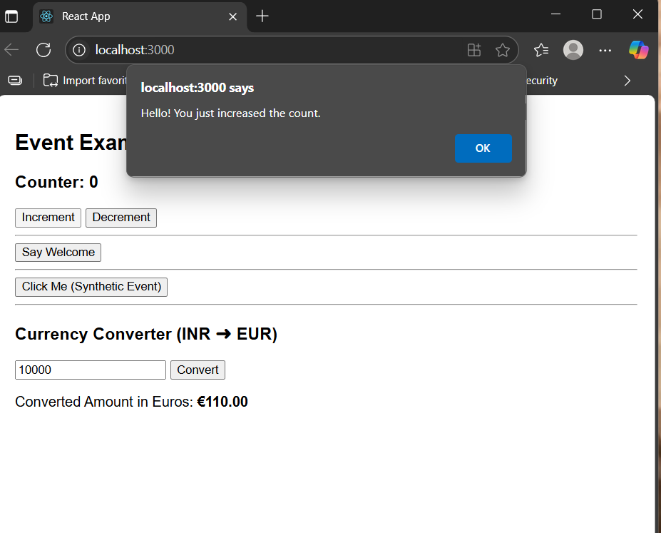

**12.Create a React Application named “ticketbookingapp” where the guest user can browse the page where the flight details are displayed whereas the logged in user only can book tickets.**

**GuestPage.js:**

import React from 'react';

function GuestPage() {

  return (

    <div>

      <h2>Welcome Guest</h2>

      <p>Browse flights and see available routes. Please log in to book tickets.</p>

    </div>

  );

}

export default GuestPage;

**UserPage.js:**

import React from 'react';

function UserPage() {

  return (

    <div>

      <h2>Welcome Back, User!</h2>

      <p>You are now logged in. You can proceed to book your flight tickets.</p>

      <button>Book Now</button>

    </div>

  );

}

export default UserPage;

**App.js:**

import React, { Component } from 'react';

import GuestPage from './Components/GuestPage';

import UserPage from './Components/UserPage';

class App extends Component {

  constructor(props) {

    super(props);

    this.state = {

      isLoggedIn: false,

    };

  }

  handleLogin = () => {

    this.setState({ isLoggedIn: true });

  };

  handleLogout = () => {

    this.setState({ isLoggedIn: false });

  };

  render() {

    // Element variable

    let pageContent;

    if (this.state.isLoggedIn) {

      pageContent = <UserPage />;

    } else {

      pageContent = <GuestPage />;

    }

    return (

      <div style={{ padding: '20px', fontFamily: 'Arial' }}>

        <h1>✈️ Flight Ticket Booking App</h1>

        {/* Conditional Button Rendering */}

        {this.state.isLoggedIn ? (

          <button onClick={this.handleLogout}>Logout</button>

        ) : (

          <button onClick={this.handleLogin}>Login</button>

        )}

        <hr />

        {/* Conditional Page Rendering */}

        {pageContent}

      </div>

    );

  }

}

export default App;

**Output:**

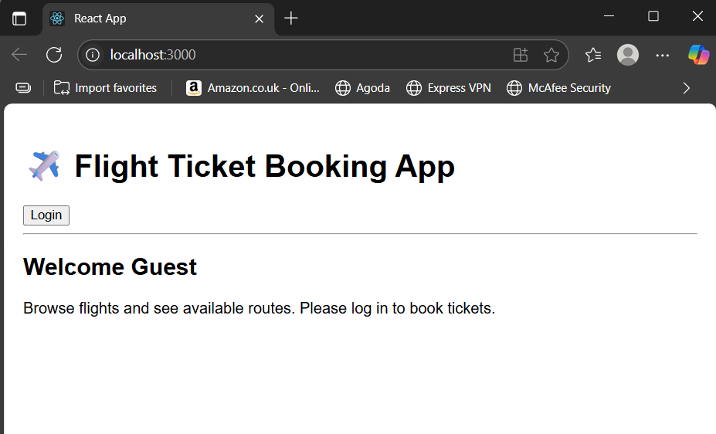

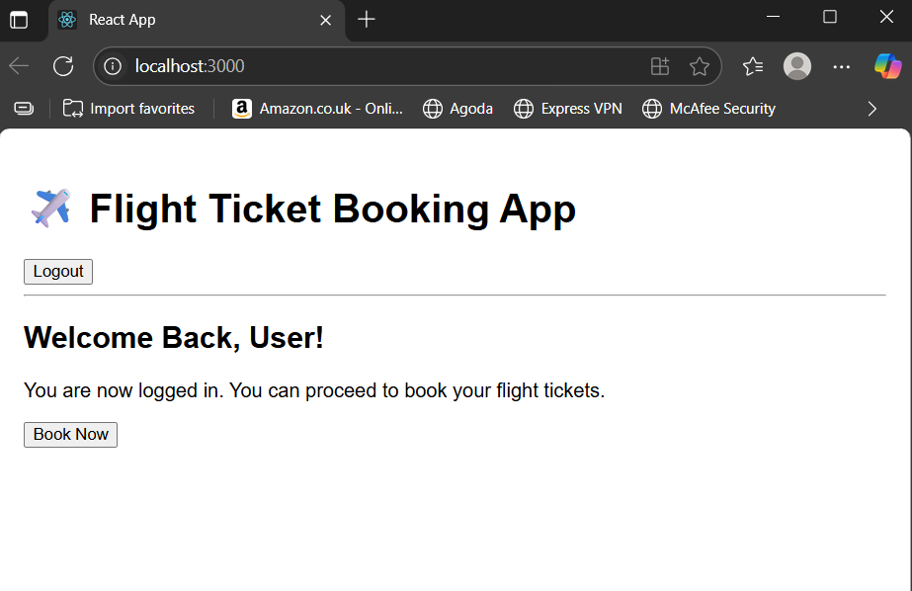

**13.Create a React App named “bloggerapp” in with 3 components**

**BookDetails.js:**

import React from 'react';

function BookDetails({ books }) {

  return (

    <div>

      <h2>Book Details</h2>

      <ul>

        {books.map(book => (

          <li key={book.id}>

            <strong>{book.title}</strong> by {book.author}

          </li>

        ))}

      </ul>

    </div>

  );

}

export default BookDetails;

**BlogDetails.js:**

import React from 'react';

function BlogDetails({ blogs }) {

  return (

    <div>

      <h2>Blog Details</h2>

      {blogs.map(blog => (

        <div key={blog.id} style={{ marginBottom: '1rem' }}>

          <h3>{blog.title}</h3>

          <p>{blog.content}</p>

        </div>

      ))}

    </div>

  );

}

export default BlogDetails;

**CourseDetails.js:**

import React from 'react';

function CourseDetails({ courses }) {

  return (

    <div>

      <h2>Course Details</h2>

      <ul>

        {courses.map(course => (

          <li key={course.id}>

            {course.name} - Duration: {course.duration} weeks

          </li>

        ))}

      </ul>

    </div>

  );

}

export default CourseDetails;

**App.js:**

import React, { useState } from 'react';

import BookDetails from './Components/BookDetails';

import BlogDetails from './Components/BlogDetails';

import CourseDetails from './Components/CourseDetails';

function App() {

  const [showCourses, setShowCourses] = useState(true);

  const [isLoggedIn, setIsLoggedIn] = useState(false);

  const books = [

    { id: 1, title: "React Basics", author: "Dan Abramov" },

    { id: 2, title: "Learning JSX", author: "Sophie Alpert" },

  ];

  const blogs = [

    { id: 1, title: "Why React?", content: "React makes UI predictable." },

    { id: 2, title: "JSX vs HTML", content: "JSX is syntactic sugar for JS." },

  ];

  const courses = [

    { id: 1, name: "React Fundamentals", duration: 4 },

    { id: 2, name: "Advanced Hooks", duration: 3 },

  ];

  return (

    <div style={{ padding: "20px", fontFamily: "Arial" }}>

      <h1>Blogger App</h1>

      {/* Toggle course visibility using && conditional */}

      <button onClick={() => setShowCourses(!showCourses)}>

        {showCourses ? "Hide Courses" : "Show Courses"}

      </button>

      {/* Ternary rendering */}

      <button onClick={() => setIsLoggedIn(!isLoggedIn)} style={{ marginLeft: '10px' }}>

        {isLoggedIn ? "Logout" : "Login"}

      </button>

      <hr />

      {/* Always show */}

      <BookDetails books={books} />

      {/* Only show when logged in */}

      {isLoggedIn ? <BlogDetails blogs={blogs} /> : <p>Please log in to see blogs.</p>}

      {/* Show or hide based on boolean toggle */}

      {showCourses && <CourseDetails courses={courses} />}

    </div>

  );

}

export default App;

**Output:**

