**1.To create a new repository, signup with GitLab and register your credentials Login to GitLab and create a “GitDemo” project**

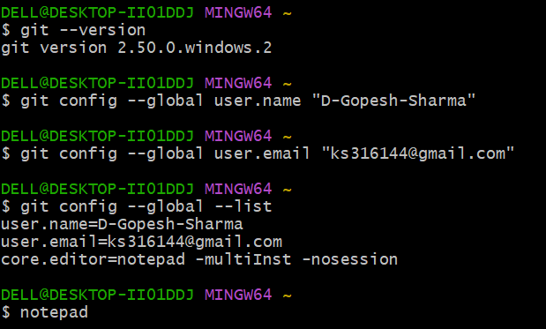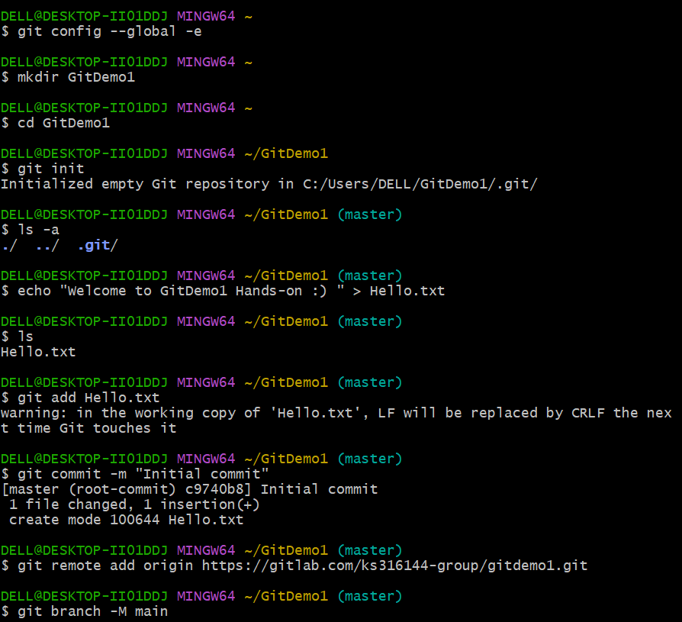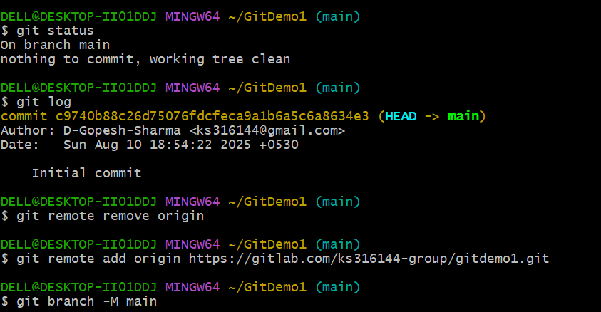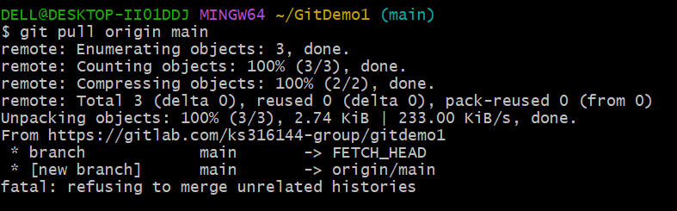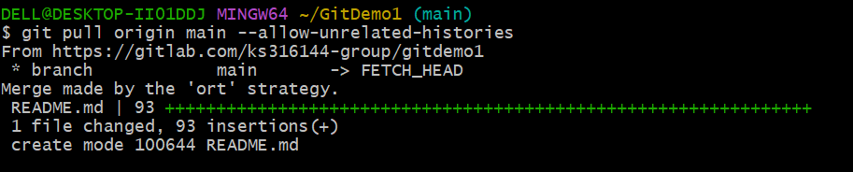

**2.Create a “.log” file and a log folder in the working directory of Git. Update the .gitignore file in such a way that on committing, these files (.log extensions and log folders) are ignored.**

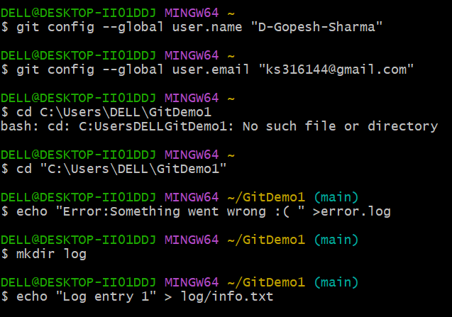

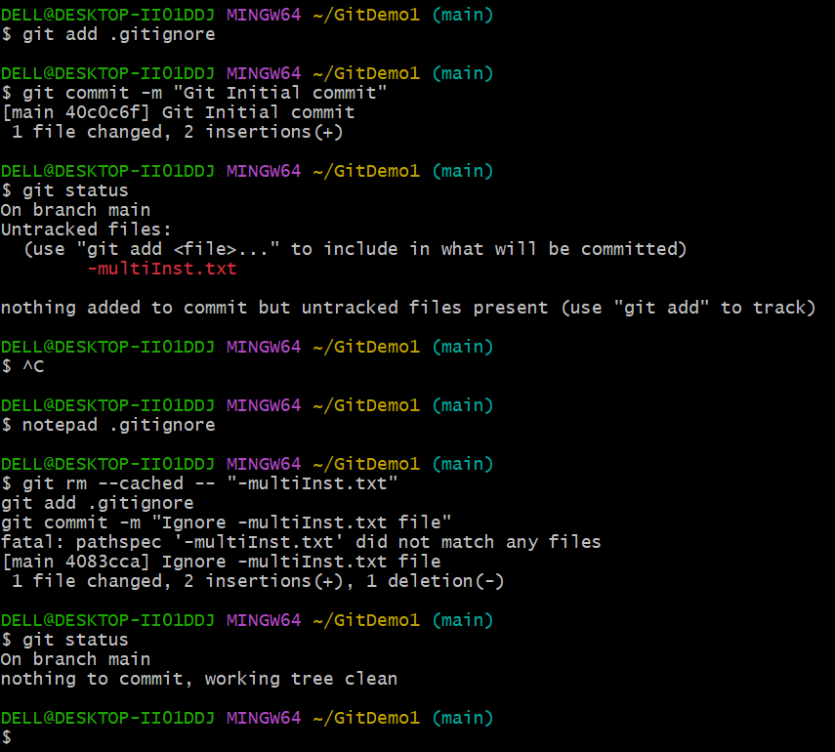

**Branching:**

1. Create a new branch **“GitNewBranch”.**
2. List all the local and remote branches available in the current trunk. Observe the “*” mark which denote the current pointing branch.
3. Switch to the newly created branch. Add some files to it with some contents.
4. Commit the changes to the branch.
5. Check the status with **“git status”** command.

**Merging:**

1. Switch to the master
2. List out all the differences between trunk and branch. These provide the differences in command line interface.
3. List out all the visual differences between master and branch using **P4Merge tool**.
4. Merge the source branch to the trunk.
5. Observe the logging after merging using **“git log –oneline –graph –decorate”**
6. Delete the branch after merging with the trunk and observe the git status.

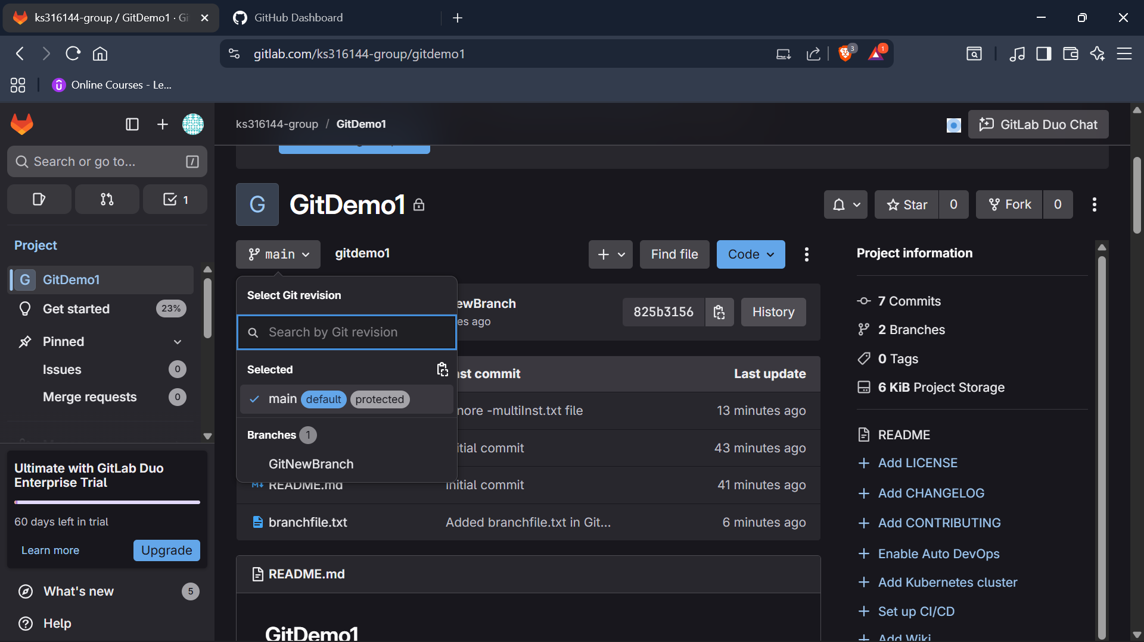

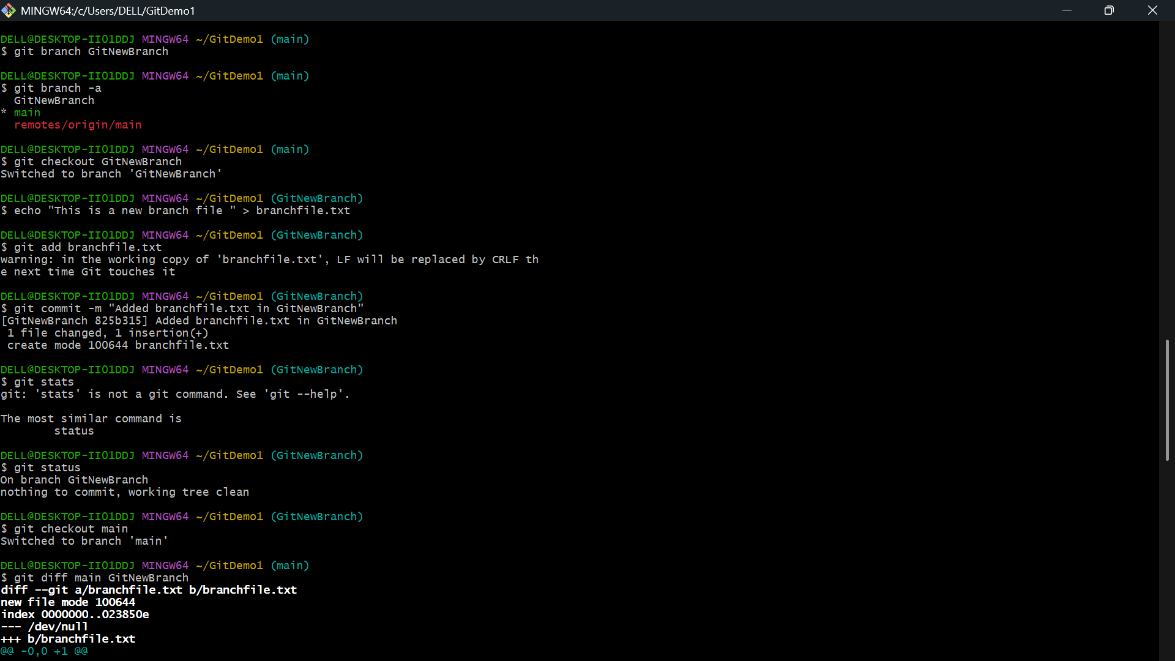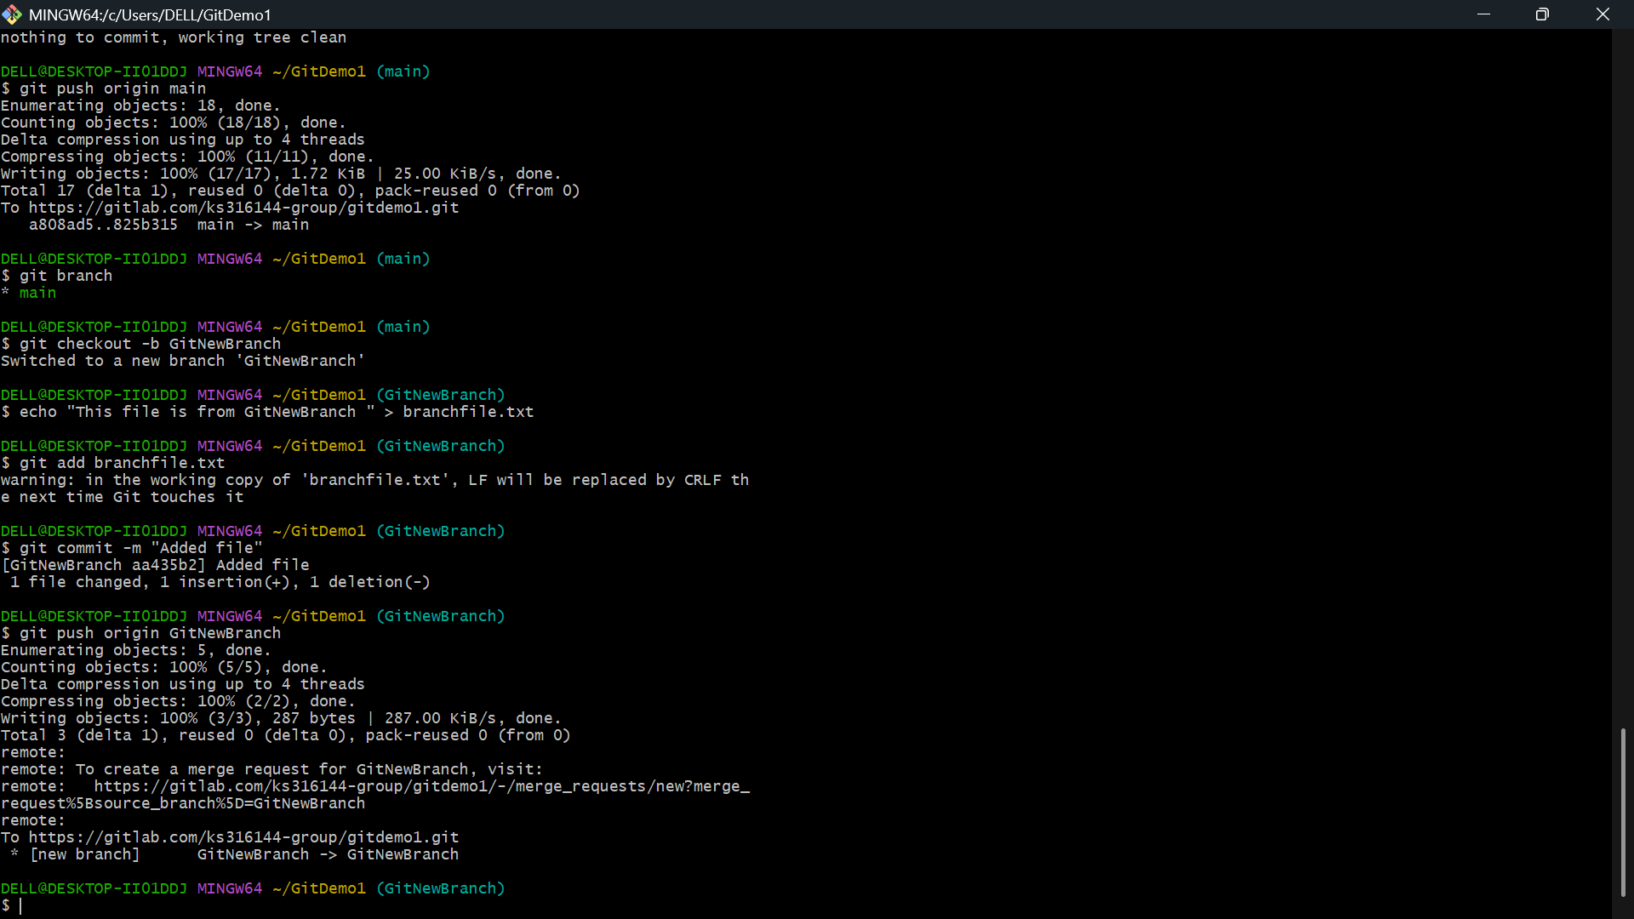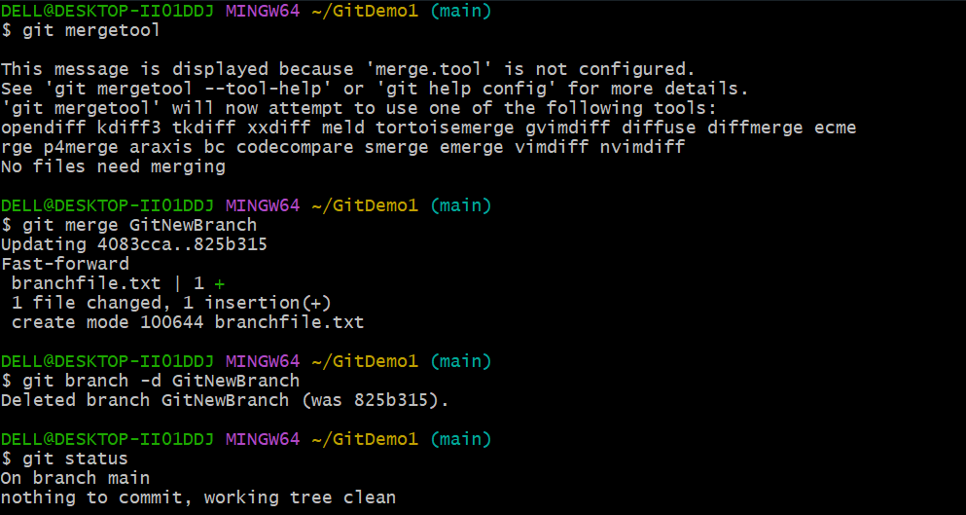

Please follow the instructions to complete the hands-on. Each instruction expect a command for the Git Bash.

1. Verify if master is in clean state.
2. Create a branch **“GitWork”.** Add a file “hello.xml”.
3. Update the content of “hello.xml” and observe the status
4. Commit the changes to reflect in the branch
5. Switch to master.
6. Add a file **“hello.xml”** to the master and add some different content than previous.
7. Commit the changes to the master
8. Observe the log by executing **“git log –oneline –graph –decorate –all”**
9. Check the differences with Git diff tool
10. For better visualization, use P4Merge tool to list out all the differences between master and branch
11. Merge the bran to the master
12. Observe the git mark up.
13. Use 3-way merge tool to resolve the conflict
14. Commit the changes to the master, once done with conflict
15. Observe the git status and add backup file to the .gitignore file.
16. Commit the changes to the .gitignore
17. List out all the available branches
18. Delete the branch, which merge to master.

Observe the log by executing **“git log –oneline –graph –decorate”**

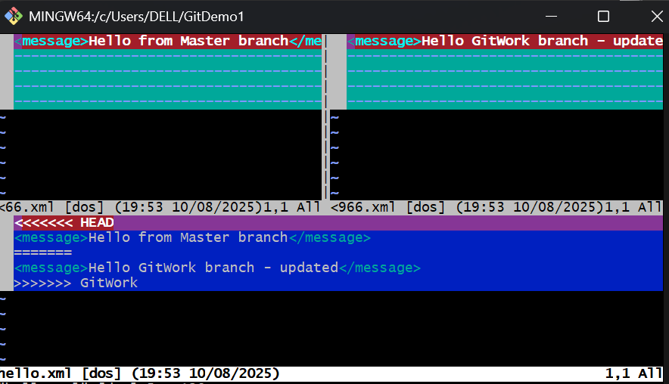

**5.Objectives**

* Explain how to clean up and push back to remote Git

In this hands-on lab, you will learn how to:

* Execute steps involving clean up and push back to remote Git.

**Prerequisites**

The following are the pre-requisites to complete this hands-on lab:

* Hands-on ID: **“Git-T03-HOL_002”**

Notes*:

|  |
| --- |
| Please follow the below steps for creating a free account in GitHub.  Do not use cognizant credentials to login to GitHub. |

Estimated time to complete this lab: **10 minutes.**

Please follow the instructions to complete the hands-on. Each instruction expects a command for the Git Bash.

Verify if master is in clean state.

List out all the available branches.

Pull the remote git repository to the master

Push the changes, which are pending from **“Git-T03-HOL_002”** to the remote repository.

Observe if the changes are reflected in the remote repository.

