1. CORS vulnerability with basic origin reflection 1
2. CORS vulnerability with trusted null origin 2
3. CORS vulnerability with trusted insecure protocols 3

CORS vulnerability with basic origin reflection
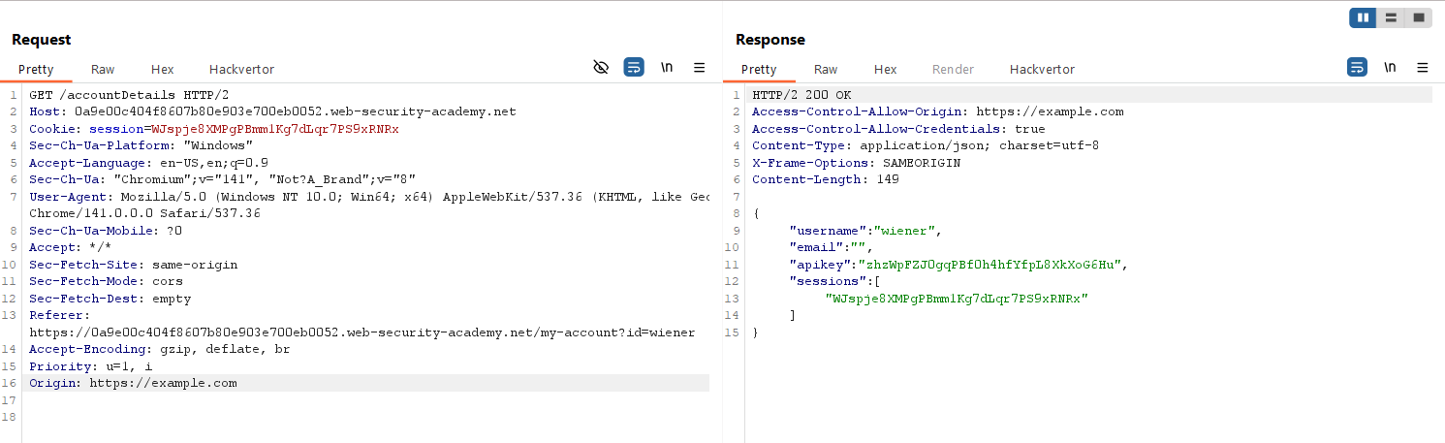

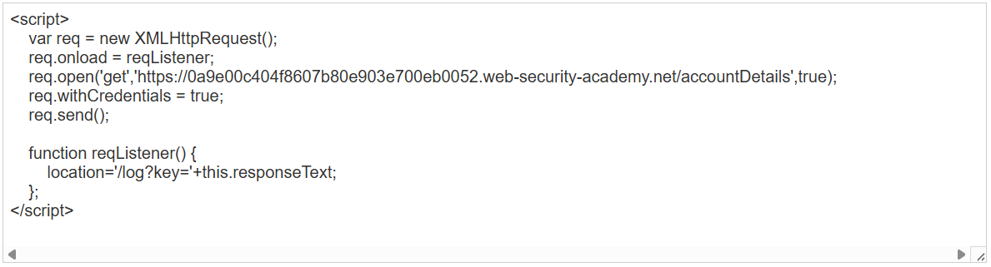
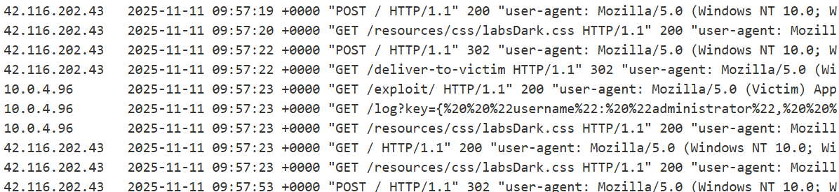
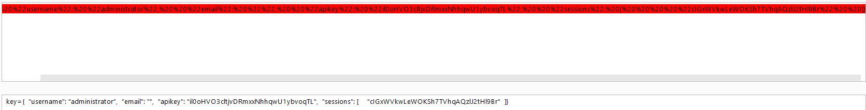

CORS vulnerability with trusted null origin
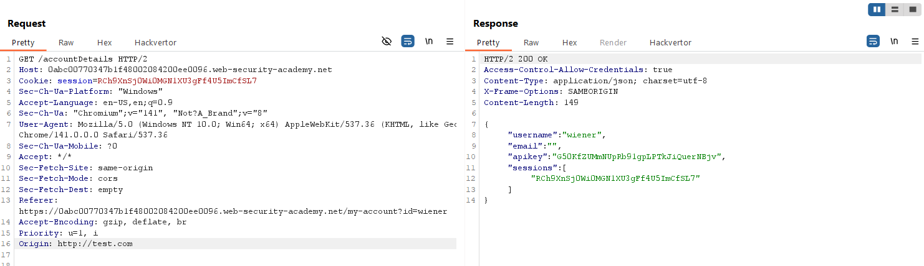
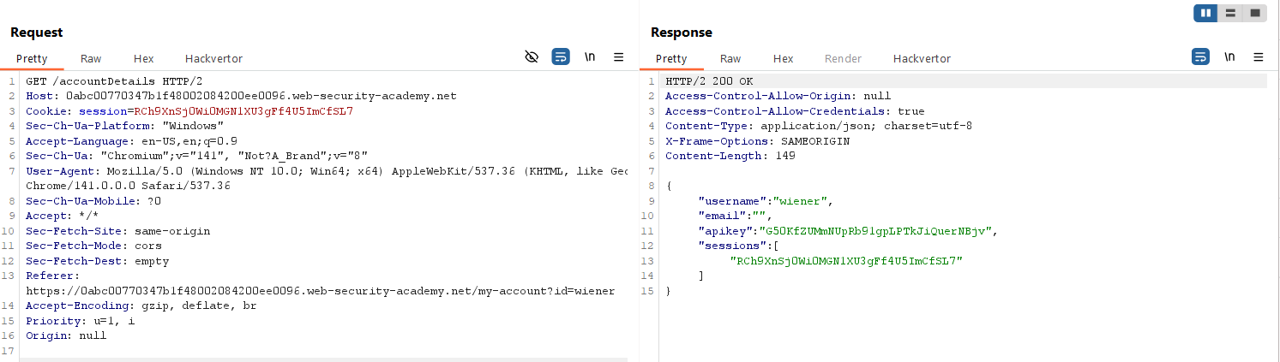
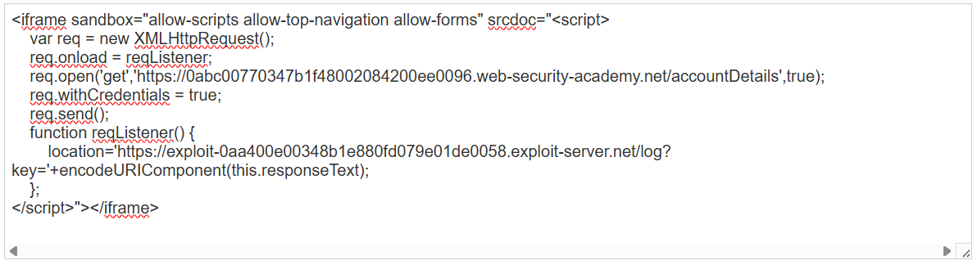
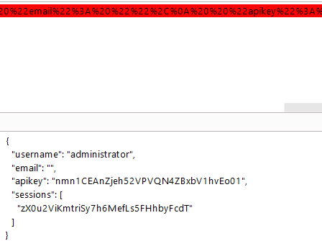

CORS vulnerability with trusted insecure protocols
