1. Basic clickjacking with CSRF token protection 1
2. Clickjacking with form input data prefilled from a URL parameter 1
3. Clickjacking with a frame buster script 1
4. Exploiting clickjacking vulnerability to trigger DOM-based XSS 2
5. Multistep clickjacking 3

Basic clickjacking with CSRF token protection
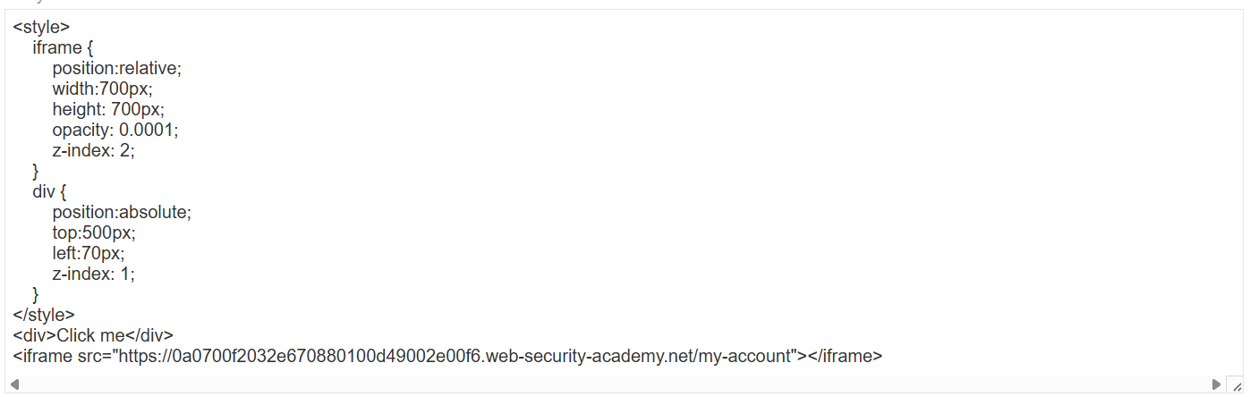

Clickjacking with form input data prefilled from a URL parameter
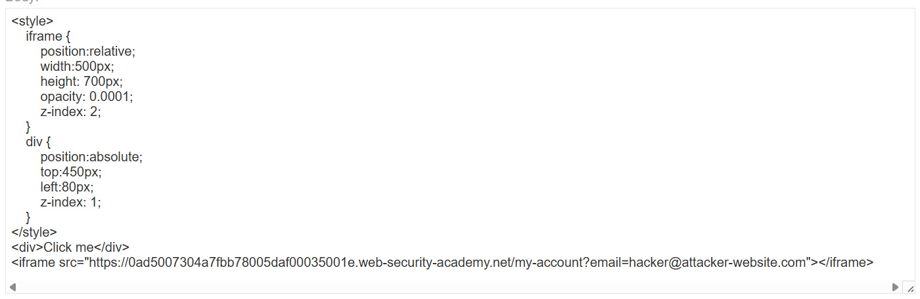

Clickjacking with a frame buster script
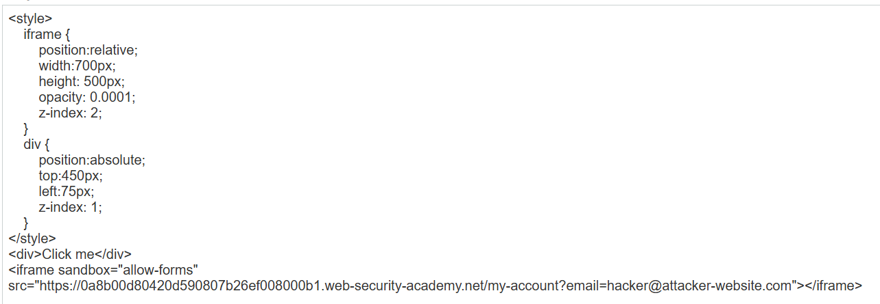
Nếu không có atribute sandbox thì sẽ có kết quả như sau:
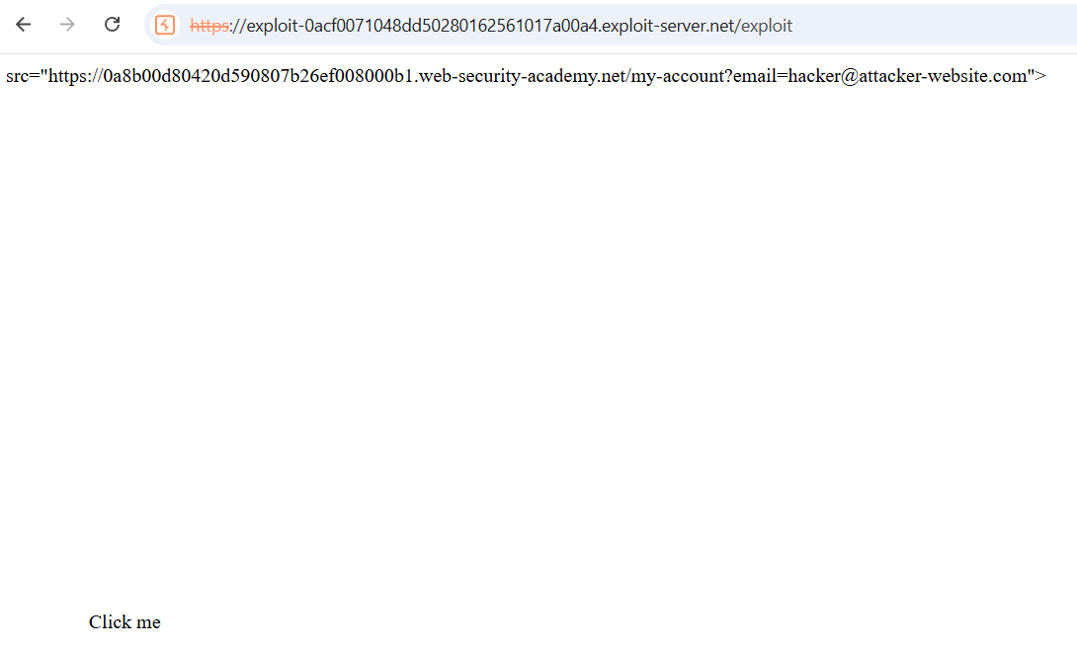

Exploiting clickjacking vulnerability to trigger DOM-based XSS
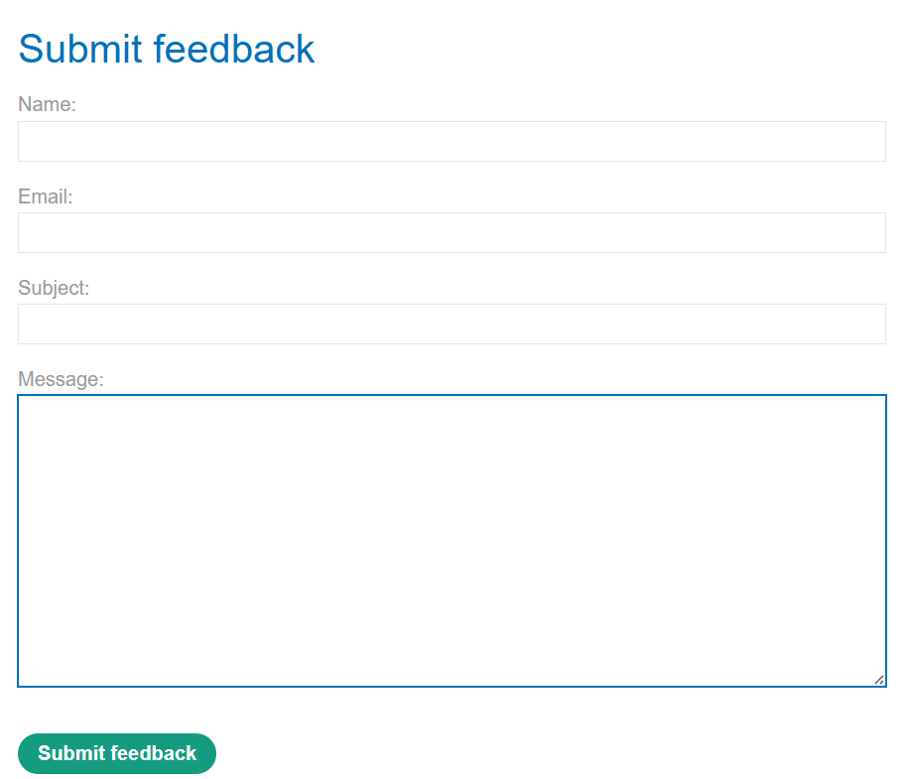
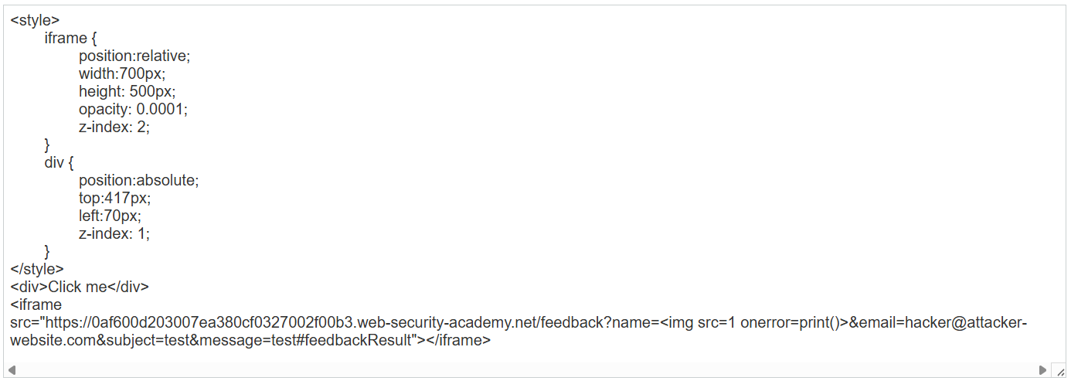

Multistep clickjacking
