1. Exploiting XXE using external entities to retrieve files 1
2. Exploiting XXE to perform SSRF attacks 1
3. Blind XXE with out-of-band interaction 2
4. Blind XXE with out-of-band interaction via XML parameter entities 3
5. Exploiting blind XXE to exfiltrate data using a malicious external DTD 3
6. Exploiting blind XXE to retrieve data via error messages 4
7. Exploiting XInclude to retrieve files 5
8. Exploiting XXE via image file upload 6

Exploiting XXE using external entities to retrieve files
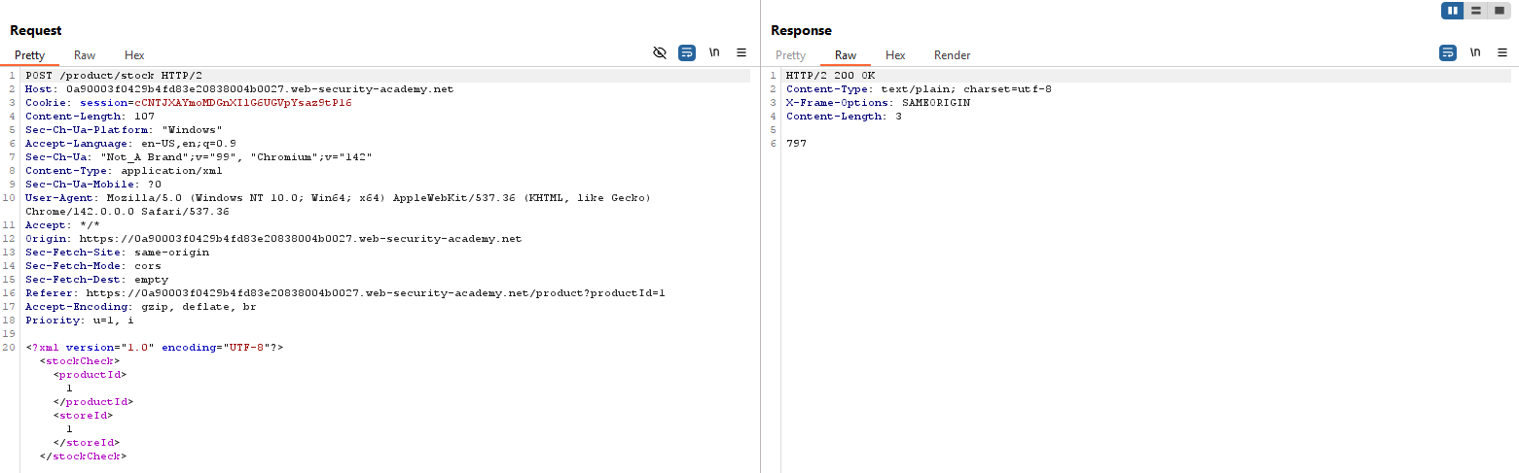
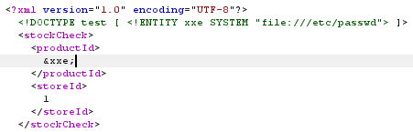

Exploiting XXE to perform SSRF attacks
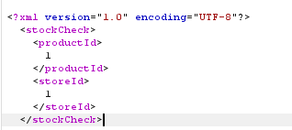
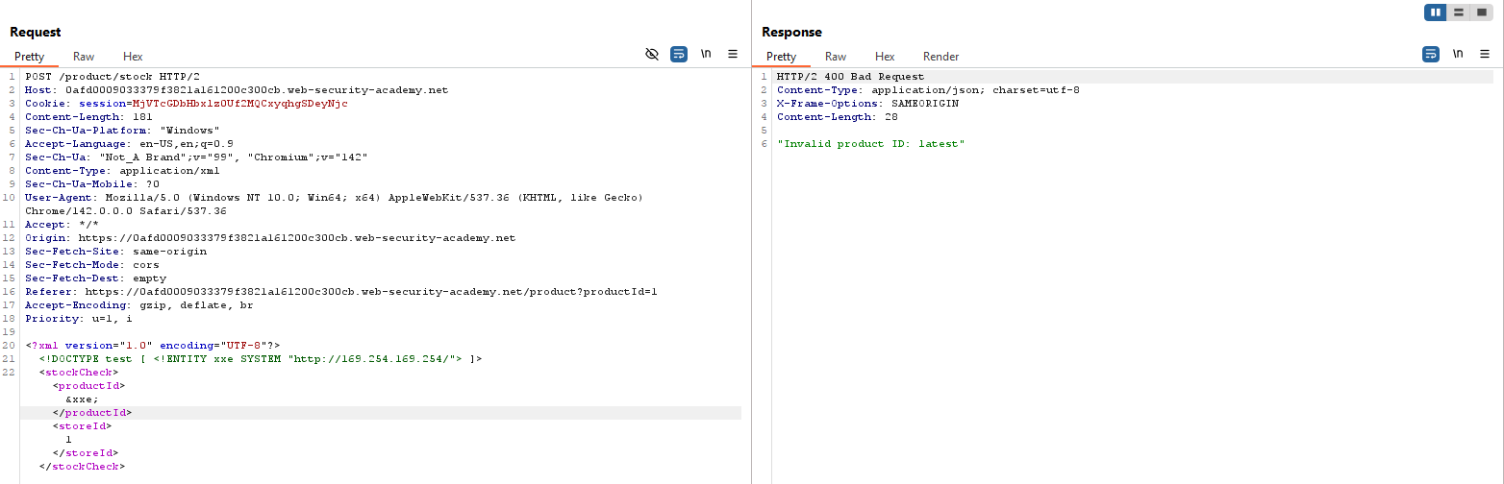
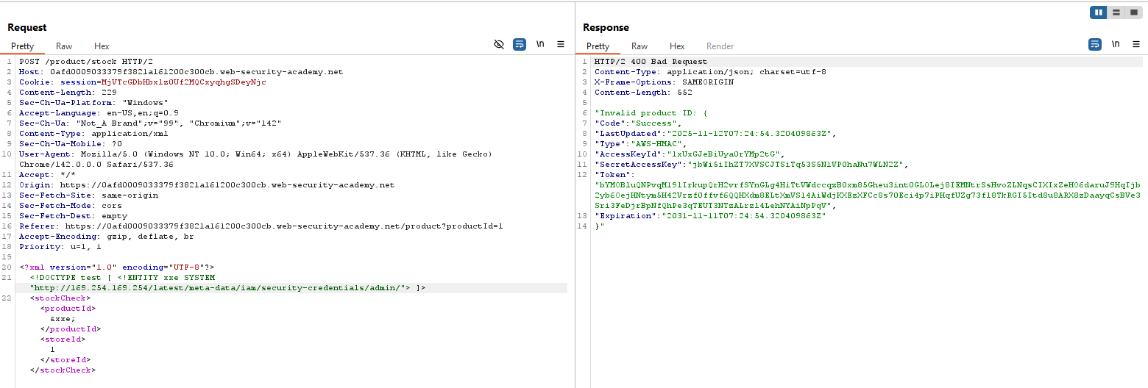

Blind XXE with out-of-band interaction
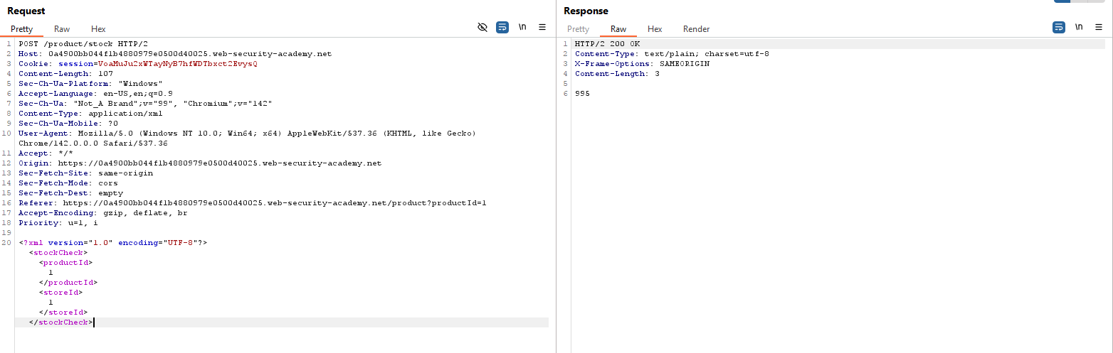
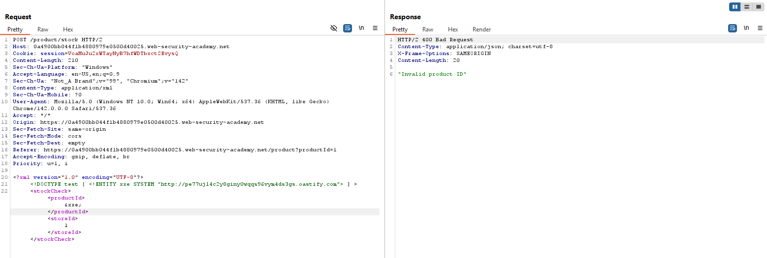

Blind XXE with out-of-band interaction via XML parameter entities
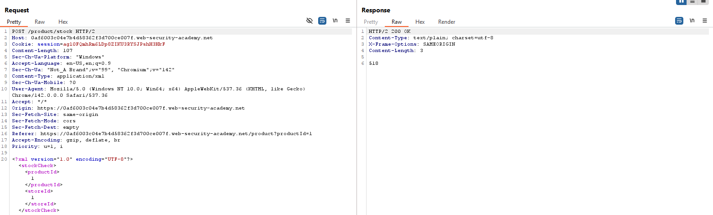
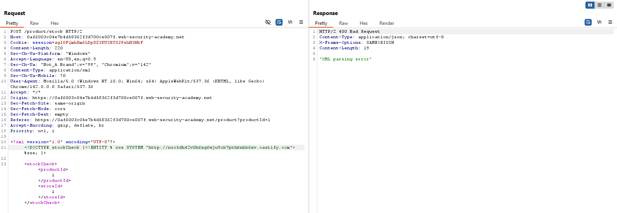

Exploiting blind XXE to exfiltrate data using a malicious external DTD
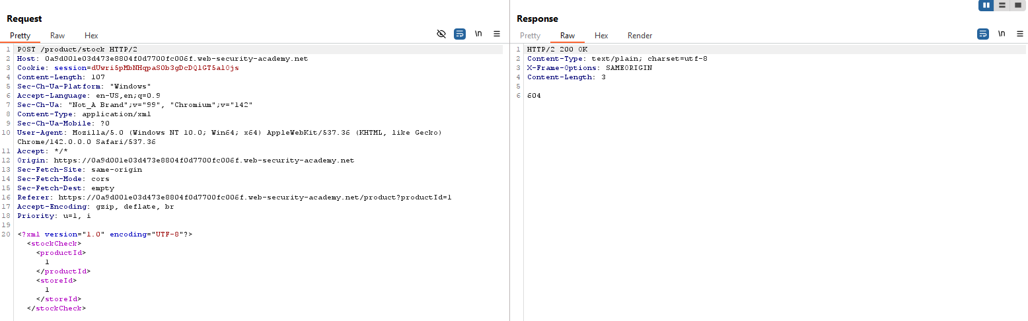
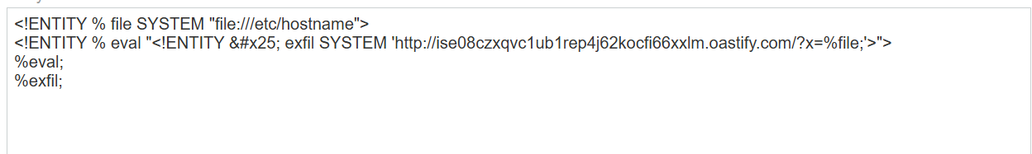
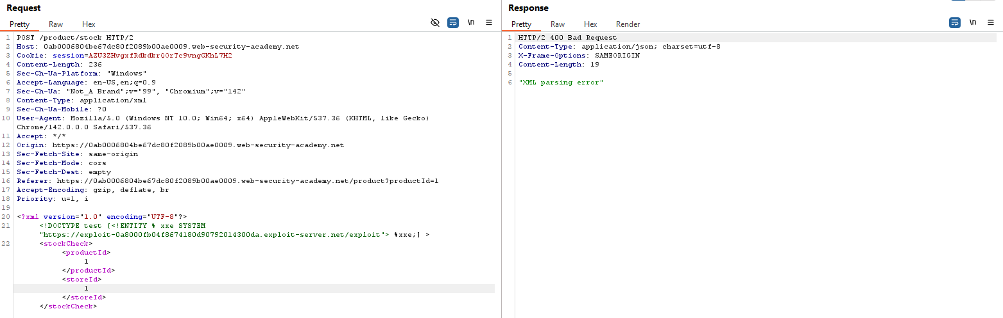
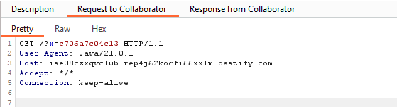

Exploiting blind XXE to retrieve data via error messages
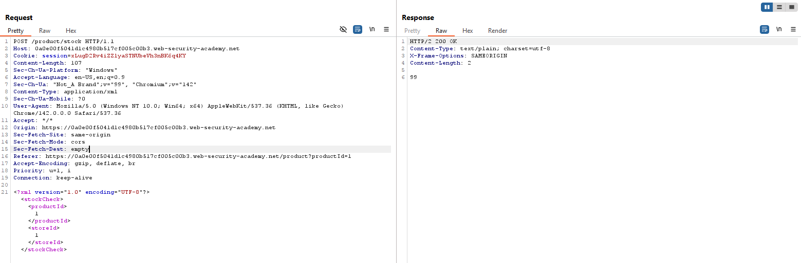
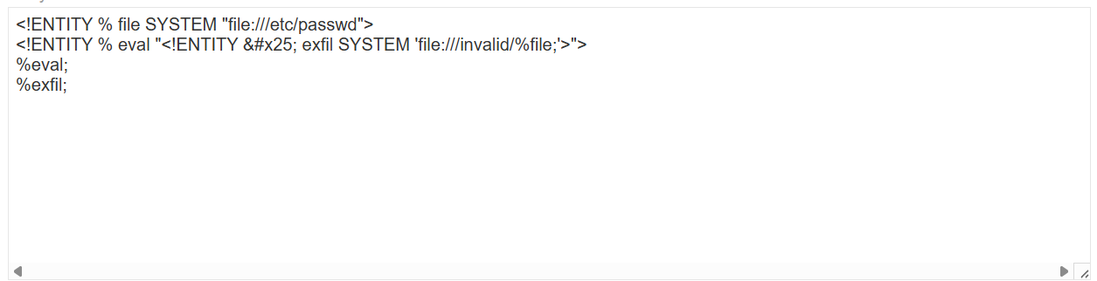
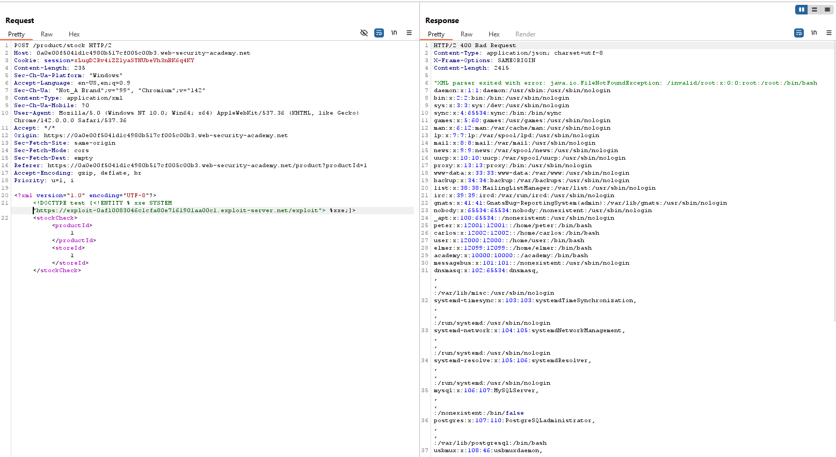

Exploiting XInclude to retrieve files
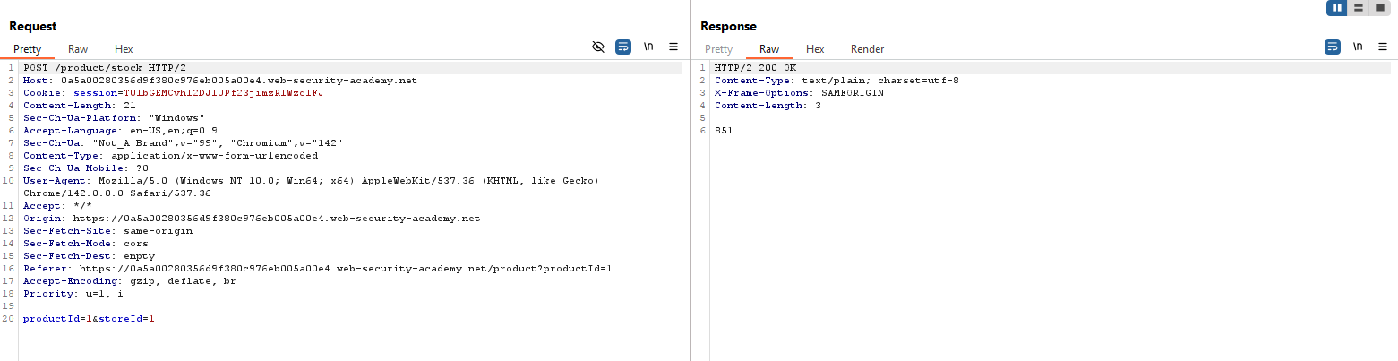
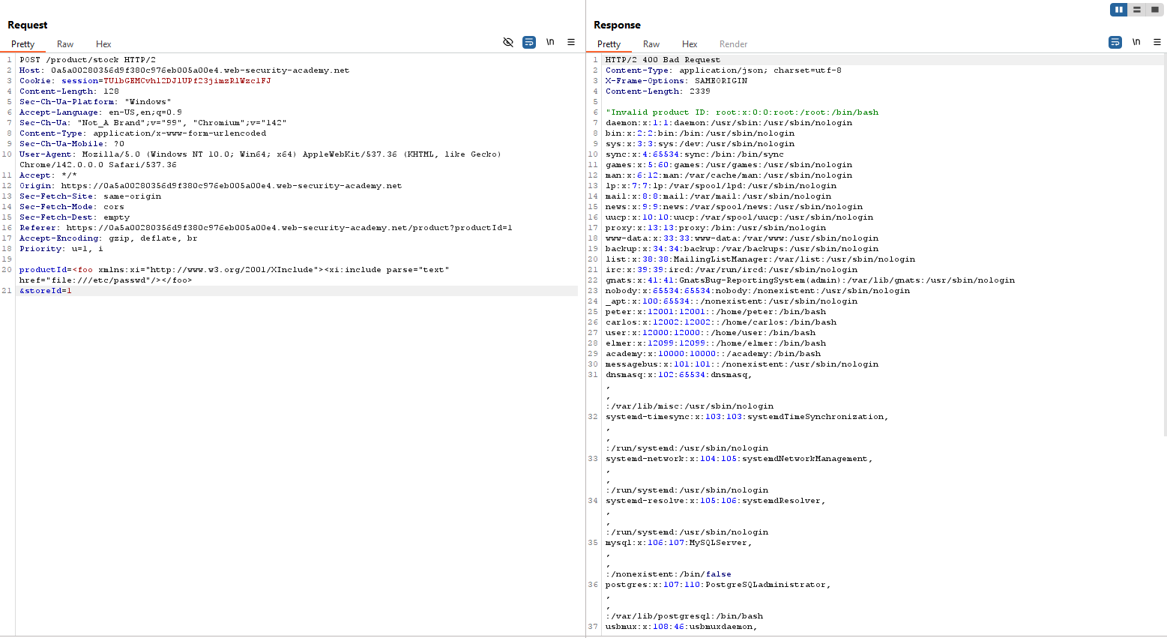

Exploiting XXE via image file upload
