CLOUD COMPUTING PROJECT REPORT
Title: Launch and Use a Cloud Virtual Machine
Name: Dilan Mathias
Course: Cloud Computing
Date: 02/05/2026

1. Introduction
Cloud computing is a modern technology that allows users to access computing resources such as servers, storage, and applications over the internet instead of relying on local machines. It eliminates the need for physical hardware and enables users to work from anywhere using remote systems hosted in data centres.
In this project, a cloud-based virtual machine was created using Amazon Web Services through its Amazon EC2 service. The virtual machine acts like a real computer, allowing installation of software, execution of commands, and hosting of applications.
The main objective of this project is to understand the practical working of cloud infrastructure by launching a virtual machine, connecting to it remotely using SSH, installing a web server, and accessing it through a web browser. This provides hands-on experience of how real-world cloud systems operate.

2. Objective
The objective of this project is to understand the practical implementation of cloud computing by creating and managing a virtual machine in a cloud environment. This includes learning how to configure system resources such as CPU, memory, and storage, and accessing the virtual machine remotely over the internet.
The project also aims to provide hands-on experience in connecting to the virtual machine using SSH, installing and running a web server, and accessing the hosted web page through a browser. Through this, the project demonstrates how real-world cloud infrastructure operates and how applications can be deployed and managed remotely.

• Create a virtual machine in the cloud
• Configure system resources
• Connect remotely using SSH
• Install a web server
• Access it through a browser

3. Tools and Platform Used
Platform: Amazon Web Services (AWS)
Service: EC2
Operating System: Ubuntu Server
Protocol: SSH
Web Server: Apache2

4. Steps Performed

Step 1: Creating the Virtual Machine
Logged into AWS, selected EC2 service, launched an instance using Ubuntu OS, selected t3.micro (free tier), configured storage and network, created key pair, and launched the instance.
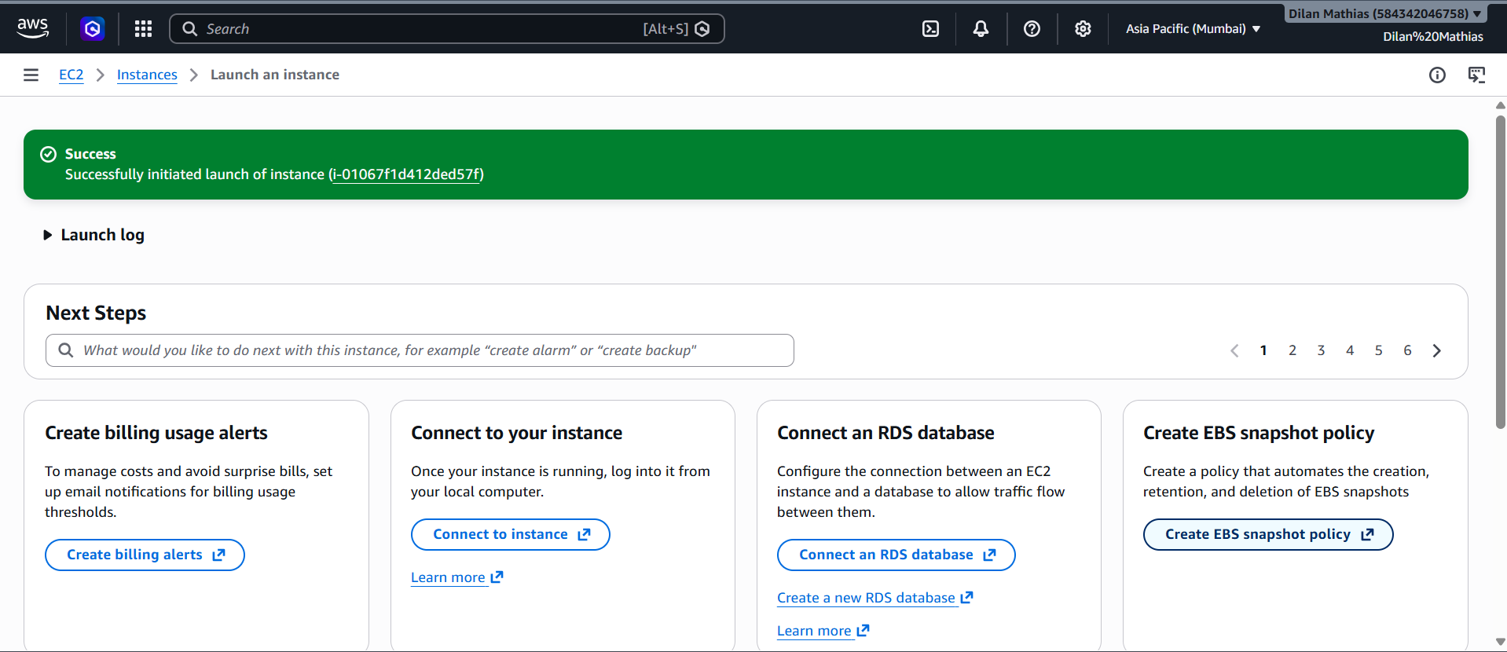
VM Running

Step 2: Connecting to the Virtual Machine
Connected using EC2 Instance Connect browser-based SSH terminal using the public IP address.
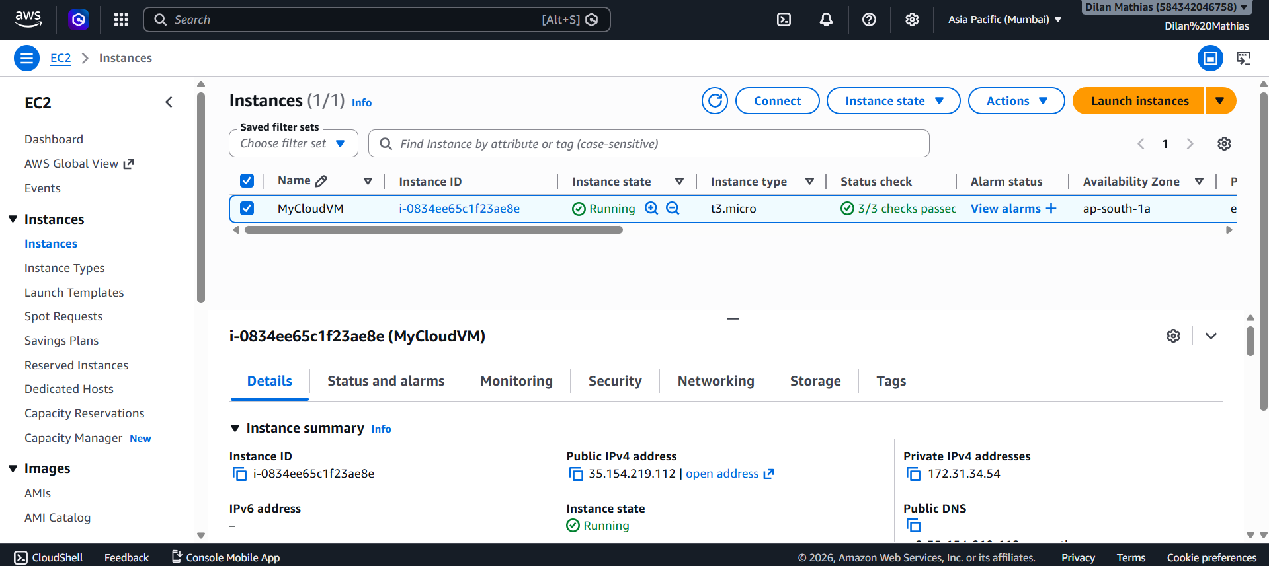
Terminal Connection

Step 3: Installing Web Server
Commands used:
sudo apt update
sudo apt install apache2 -y
sudo systemctl start apache2
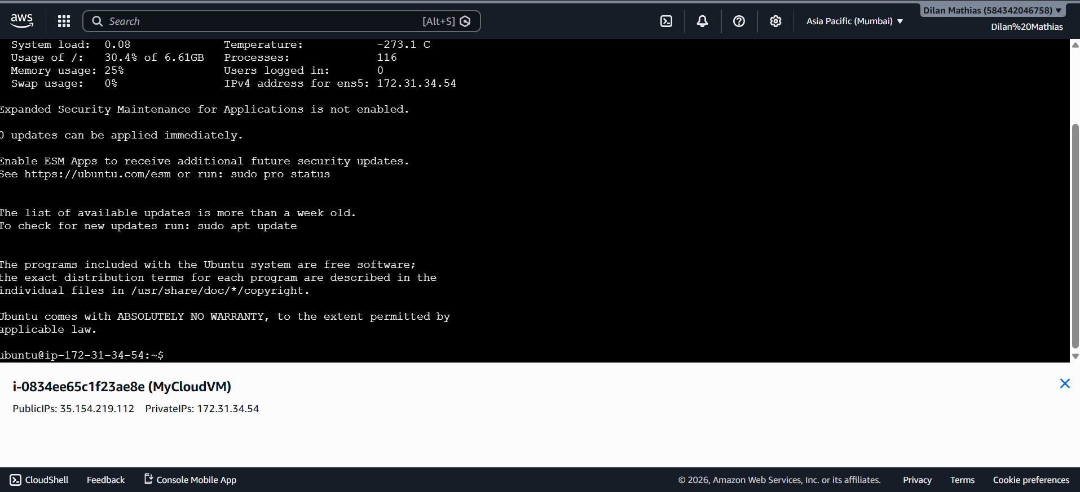

Step 4: Accessing Web Page
Opened browser and entered the public IP address. The Apache default page was displayed.

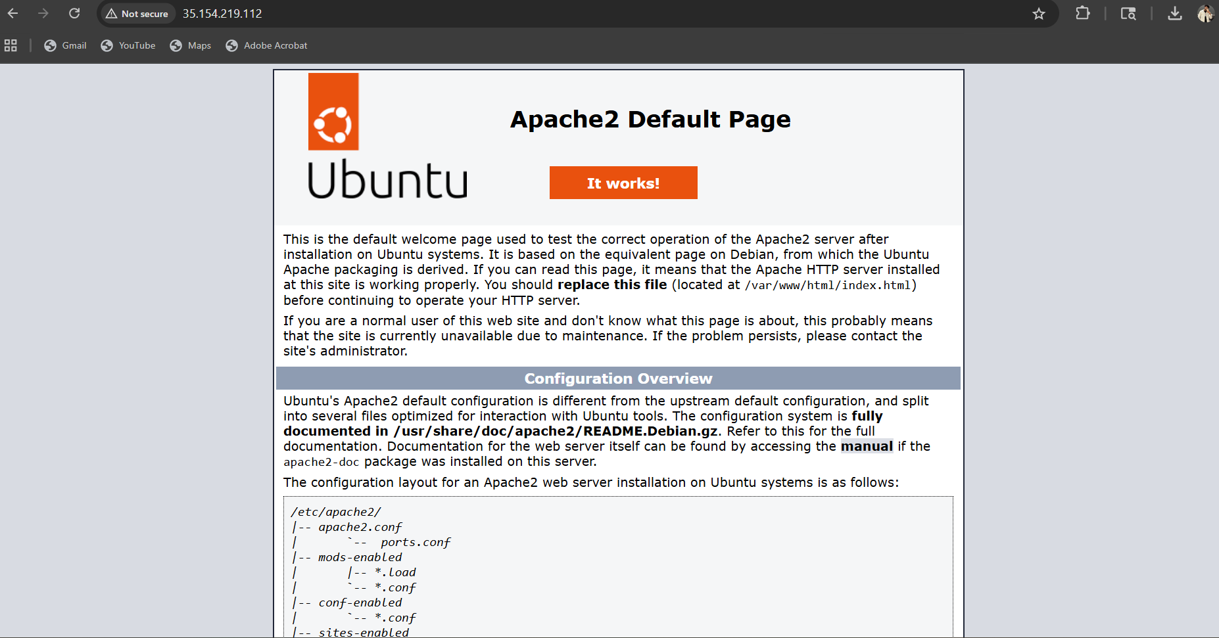
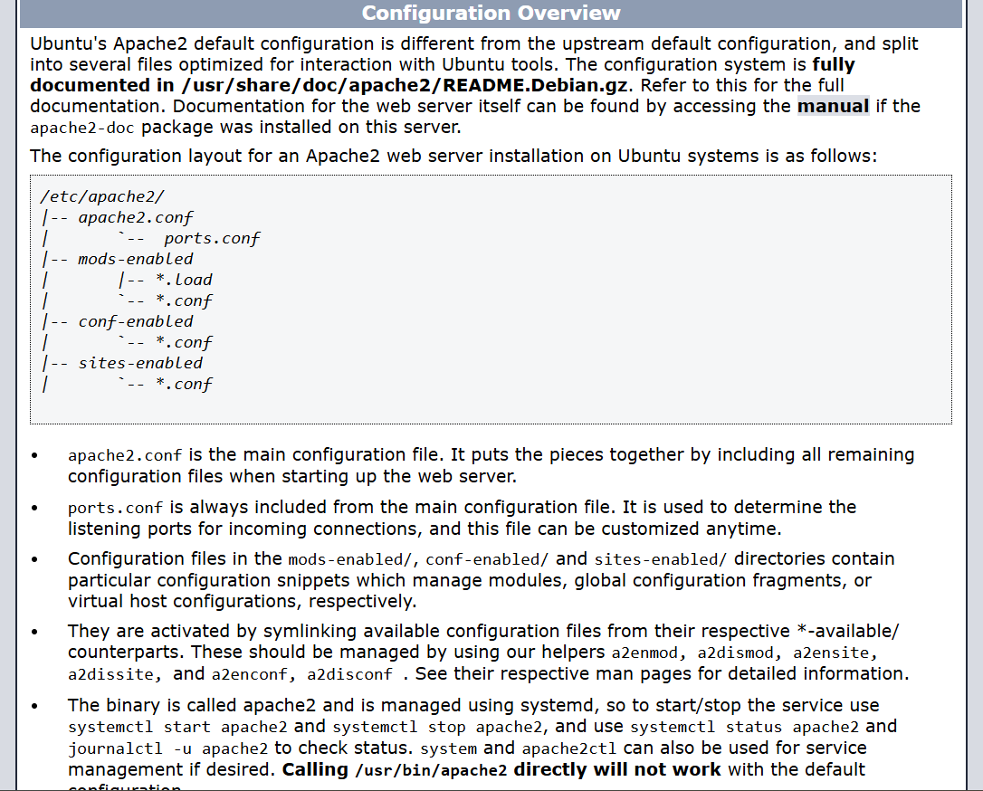
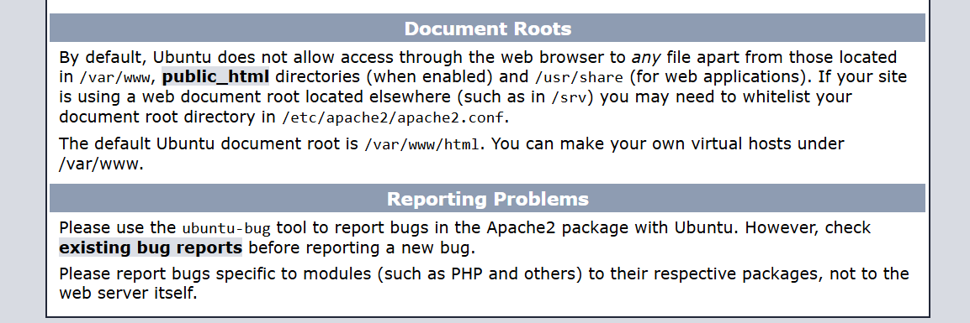

5. Results
The cloud virtual machine was successfully created and accessed remotely. The Apache web server was installed and hosted a web page accessible via browser.

6. Key Concepts Learned
• Cloud computing
• Virtual machines
• Remote access using SSH
• Web server deployment
• Networking basics

7. Conclusion
This project successfully demonstrated the practical use of cloud computing by creating and managing a virtual machine in a cloud environment. A virtual machine was launched using Amazon Web Services through the Amazon EC2 service, and it was accessed remotely using SSH.
A web server (Apache) was installed and configured on the virtual machine, and the hosted web page was successfully accessed through a browser using the public IP address. This confirmed that the server was functioning correctly and accessible over the internet.
Through this project, I gained hands-on experience in working with cloud infrastructure, remote server management, and basic web hosting. It also helped me understand how real-world cloud systems operate, where applications run on remote servers and are accessed globally via the internet.

