**SOFTWARE ENGINEERING PROJECT REPORT**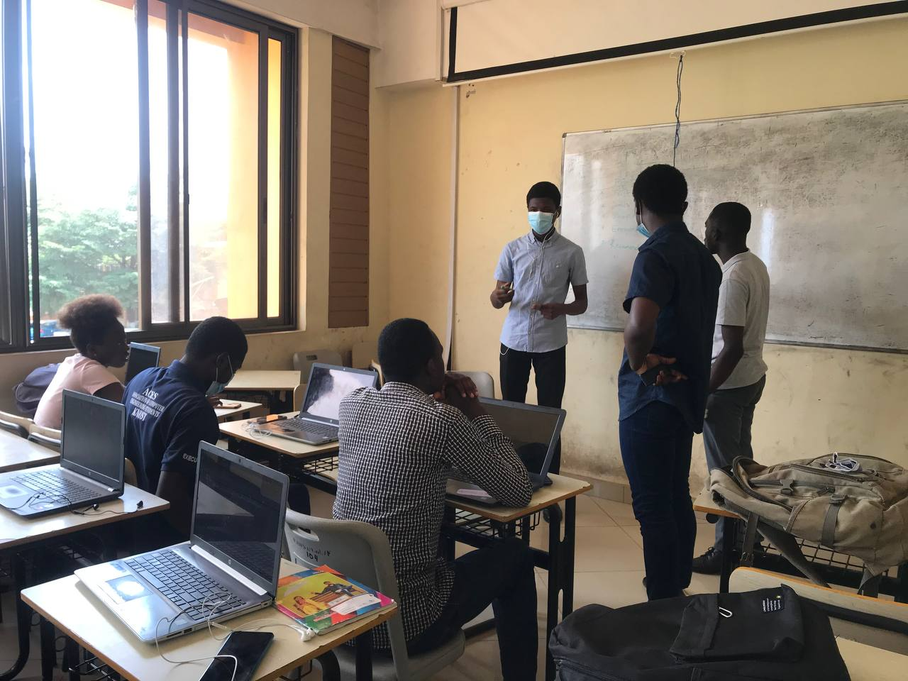

**A Sample Documentation**

**by X-bit for Pharmasoft Report**

Prepared by X-bit

October 2021

## **TABLE OF CONTENTS**

**1.** Project description

1. Project Overview………………………………………………………………………..2
2. Purpose of the project………………………………………………………………..2
3. Goals of the project…………………………………………………………………….2

2. Scope of project

a. Current situation……………………………………………………….3

b. Context of the work………………………………………3

c. Work partitioning………………………………………………...3

3. Product Scenario…………………………………………………4

**4.** Stakeholders

a. Customer…………………………….5

b. Maintenance Users and Service Technicians………….5

5. Implementation Environment of the Current System ………6

6. Naming conventions and definitions……………………………..6

**PROJECT DESCRIPTION**

1. **Project overview**

X-bit was a team of ten members that was tasked to solve a community related problem using their knowledge in software engineering.

The team came up with pharmasoft; an online pharmacy shop which consisted of a daily first aid alert, a direct ambulance button, medicine shopping cart for both the user and pharmacist.

Stakeholders:

The major stakeholders are users(students and native in Ayeduase), Pharmacists / over the counter medicine sellers and designers

1. **Purpose of the project**

The main purpose of the project was to reduce stress and pain in buying medicines physically

1. **Goals of the project**

We want to give immediate and complete response to customers who order our medicine over the telephone.

To link the medicine buyer(purchaser) directly to the available and close seller(pharmacist).

To provide daily medical tips(first aid) to the user

To provide secured drug purchases without leaking information to third party.

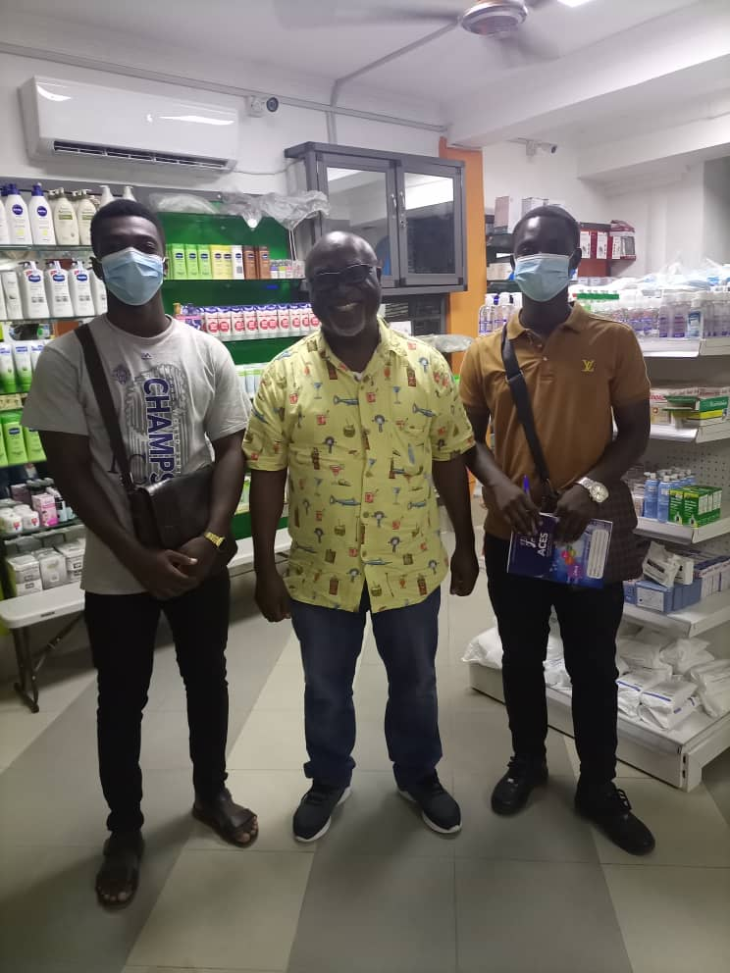

**Scope of Project**

1. **Current situation:**

Folks residing around knust campus results to walking distances from their home to access a pharmacy shop. Also, the one who is very sick and cannot walk distance result to self-medications. Again location of the nearest pharmacy shop is a problem

1. **Context of the work:**

The work was to enable the people of ayeduase to purchase medicine conveniently.

1. **Work partitioning:**

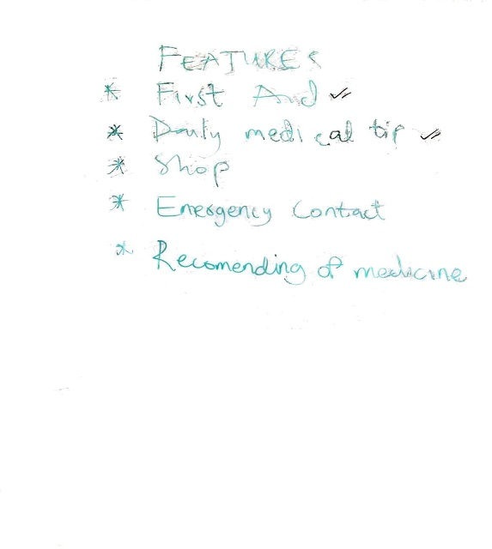

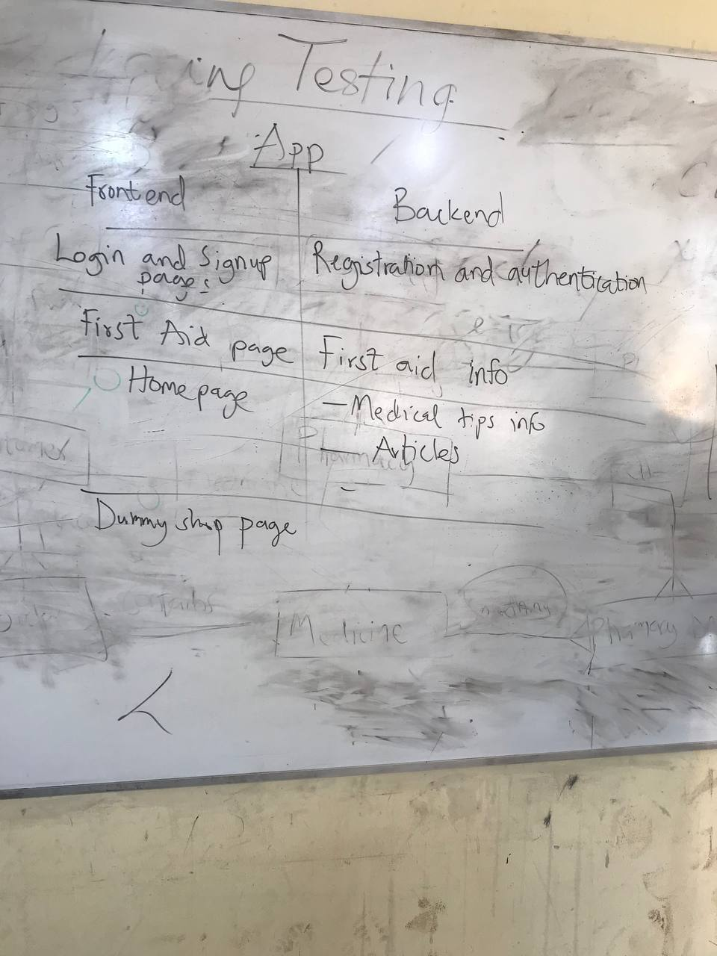

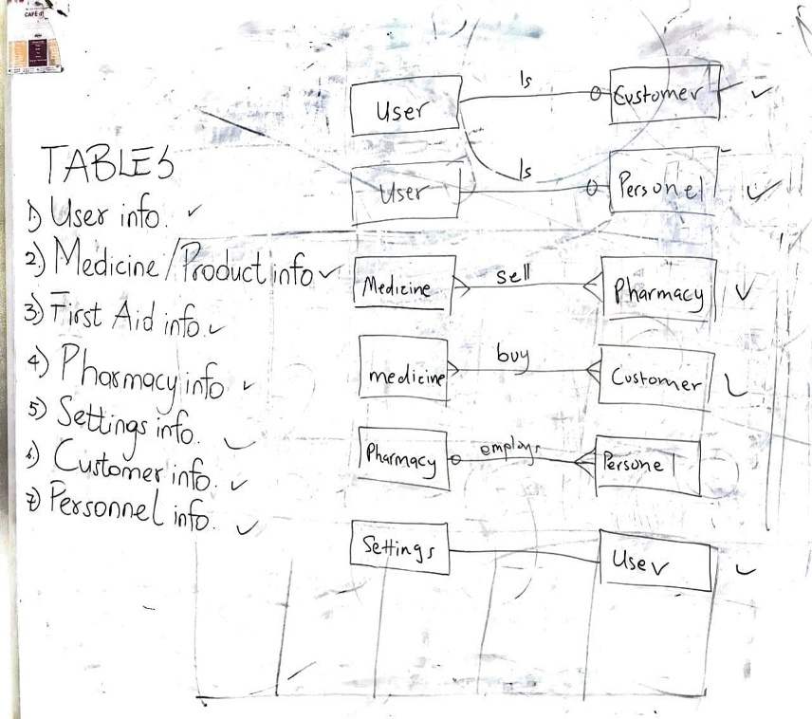

**Products Scenario:**

Whenever a user log in using the pharmasoft mobile app,he will be able to create a profile at the profile’s page, order medicine, add medicine to cart, get in touch with the ambulance service, first aid tips and change color theme to dark mode.

**Stakeholders**

1. **Customer:**

Student

Native

Pharmacist / over-the-counter medicine seller

1. **Hands­On Users of the Product**

|  |  |  |  |  |
| --- | --- | --- | --- | --- |
| User | User role | Subject matter experience | Technological experience | Other user characteristics |
| Student |  | Ability to navigate around mobile app | master | Language: English  Ability to read  Age group: 15-30 |
| Native |  |  | novice | Language: twi  Inability to read  Age group: 25-70 |
| Pharmacist |  | Be willing to sell drugs to customer virtually | Journeyman, master | Language: English, Twi  Ability to read/write  Age group: 22-30 |

**Maintenance Users and Service Technicians**

Maintenance users are the pharmacist who will be uploading the available medicines and provide interaction to buyers whilst the service technicians are the members of the x-bit team .

**Implementation Environment of the Current System:**

The pharmasoft mobile app has an apk for installation on any android mobile app

**NAMING CONVENTIONS AND DEFINITIONS**

**Definitions of Key Terms**

APK – Android Application Package

Pharmasoft – Product name

Frontend – the development of graphical user interface for an application

Backend – server side development