Overview
The Food Pantry at Roselle United Methodist Church has need of software to assist in handling inventory and client-to-pantry connectivity.

Functions
- View, edit, and add food pantry clients
- View, edit, and add items to the pantry's inventory
- View and edit order form templates for family sizes
- Log in as a client and fill out an appropriate order form to the client family size
- View order forms filled by clients to be fulfilled (and indicate as such)
- Review past orders to gain insightful information

Key questions to ask in the application design document:
- What does the application do, and how quickly does it do it?
- What are possible failure conditions and how are they handled?
- What one-time operations are done at the first execution (i.e., after installation)?
- If the user creates entries of any kind (e.g., bookmarks), what are the limitations?

Function Details:

View, edit, and add food pantry clients

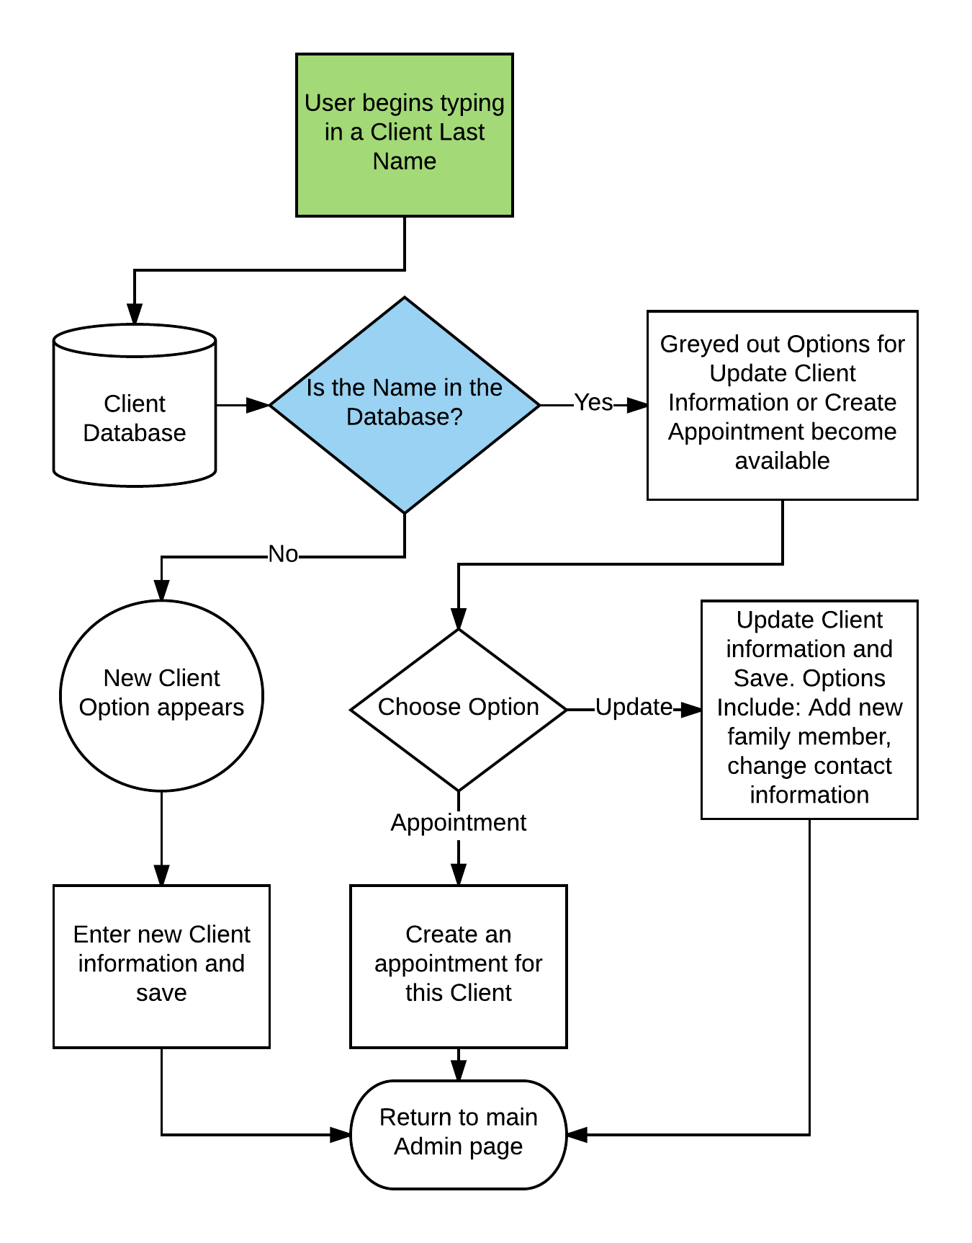

Function Details:

View, edit, and add items to the pantry's inventory

View, edit, and add items to the pantry's inventory
View and edit order form templates for family sizes
Log in as a client and fill out an appropriate order form to the client family size
View order forms filled by clients to be fulfilled (and indicate as such)
Review past orders to gain insightful information

Database Layout
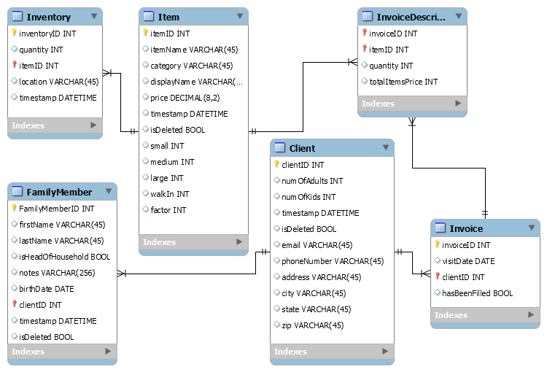

Menu Wireframe
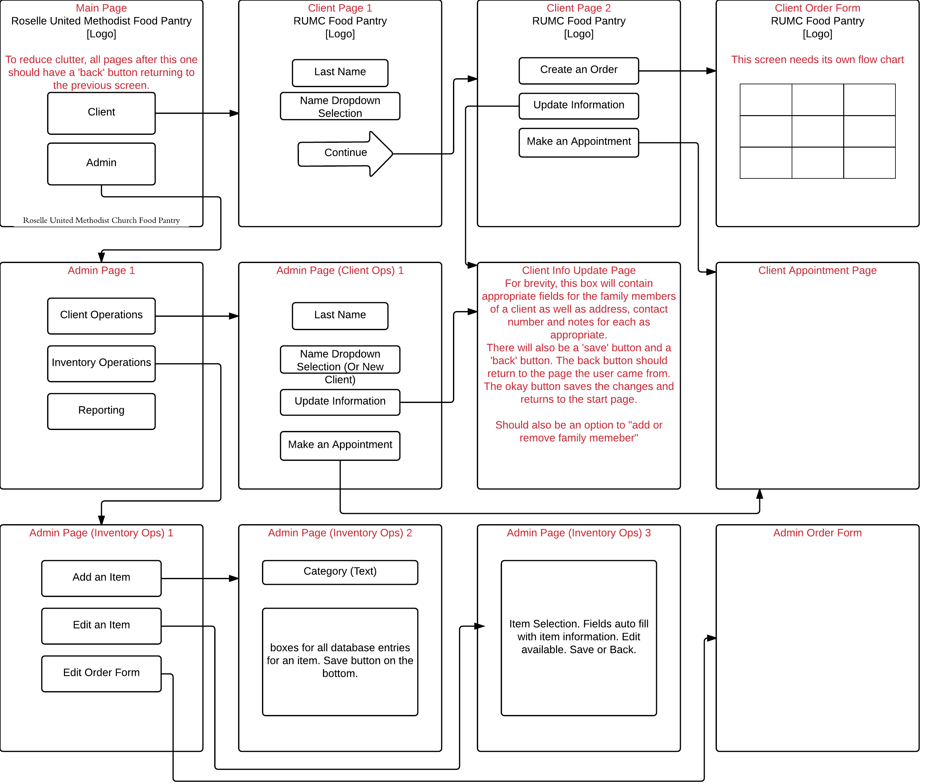

Milestones

Milestone # | Details
1 | Bare bones site. Has links between pages and placeholder text
2 | Connectivity through php and sql to add, edit and view items and client information.
3 | Ability to create and manage an order form, as well as fill out one based on client log in.  - Program restricted by simple password  - Clients can log in  - Admin can create order forms  - Clients can fill out an order  - Admins can view and set an order to fulfilled  Program is functional at this point.
4 | Make it pretty through CSS templates
5 | Add reporting functionality

Setup

Setting up the Database Server
- Download and Install XAMPP here
- In the XAMPP/Apache/conf directory, edit httpd file.
  - Add: AddType application/x-httpd-php .html .htm to the end of the file
- Run XAMPP Control center
- Start SQL and Apache
- If port errors occur in regard to port 80:
File | Value | New Value
httpd.conf | Listen 80 | Listen 81
http.conf | ServerName localhost:80 | ServerName localhost: 81
httpd-ssl.conf | Listen 432 | Listen 82
httpd-ssl.conf | <VirtualHost _default_:432> | <VirtualHost _default_:82>
- Also, in the XAMPP Control Panel: Config → Service and Port Settings → Set the Apache ports to match the new ports above. (Other values may be used in place of 81 and 82 if issues still occur)

Setting up the Program
- Place all files into your XAMPP directory /htdocs/RUMCPantry

Accessing The Program From Another Machine
- Run ( + r) cmd
- Type ipconfig and enter
- Find the IPv4 value in the output
- Open a web browser on the client machine.
- In the address bar: IPv4/RUMCPantry/mainpage.html (Case sensitive!).
  - Example: 192.168.1.92/RUMCPantry/mainpage.html
  - If the port number has changed (due to the port issue listed above) the client machine will need to append the port number
  - Ex:192.168.1.92:81/RUMCPantry/mainpage.html

