**Assignment 2:**

**Q. 1**

**Program:**

**public** **class** Main {

**public** **static** **void** main(String[] args) {

Single single1 = Single.*getInstance*();

System.***out***.println(single1);

Single single2 = Single.*getInstance*();

System.***out***.println(single2);

}

}

**public** **class** Single {

**private** **static** Single *single*;

**private** Single()

{

System.***out***.println("This is Singleton class.");

}

**public** **static** Single getInstance()

{

**if**(**null** == *single*)

{

*single* =**new** Single();

}

**return** *single*;

}

}

**Output:**

This is Singleton class.

Single@3fee733d

Single@3fee733d

**Q. 2**

**Program:**

**package** company;

**public** **class** Employee {

**public** **static** **int** *base* = 25000;

**int** salary()

{

**return** *base*;

}

}

**class** Manager **extends** Employee {

**int** salary()

{

**return** *base* + 15000;

}

}

**class** Labour **extends** Employee {

**int** salary()

{

**return** *base* + 5000;

}

}

**class** Main {

**static** **void** printSalary(Employee e)

{

System.***out***.println(e.salary());

}

**public** **static** **void** main(String[] args) {

Employee total1 = **new** Manager();

System.***out***.print("Manager's salary : ");

*printSalary*(total1);

Employee total2 = **new** Labour();

System.***out***.print("Labour's salary : ");

*printSalary*(total2);

}

}

**Output:**

Manager's salary : 40000

Labour's salary : 30000

**Q. 3**

**Program:**

**public** **class** Cash {

**static** **double** add(**int** Savings_bal,**int** Current_bal)

{

**return** Savings_bal+Current_bal;

}

}

**class** TotalAmount

{

**public** **static** **void** main(String[] args) {

System.***out***.println("The Total amount in Bank is:");

System.***out***.println(Cash.*add*(220100,150020));

}

}

**Output:**

The Total amount in Bank is:

370120.0

**---------------------------------------------------------------------------------------------------------------------------------------**

**Q. 4**

**Program:**

**1)**

**class** Account{

**public** **void** user() {

System.***out***.println("Hello User!");

}

**public** **abstract** **void** enter();

}

**class** Login **extends** Account{

**public** **void** enter() {

System.***out***.println("Login Successful!");

}

}

**public** **class** Abstraction {

**public** **static** **void** main(String[] args) {

Login s= **new** Login();

s.user();

s.enter();

}

}

**Output:**

Exception in thread "main" java.lang.Error: Unresolved compilation problems:

The type Account must be an abstract class to define abstract methods

The abstract method enter in type Account can only be defined by an abstract class

at Account.<init>(Abstraction.java:1)

at Login.<init>(Abstraction.java:8)

at Abstraction.main(Abstraction.java:18)

**------------------------------------------------------------------------------------------------------------------------------------------**

**Q. 4**

**2)**

**abstract** **class** Account{

String Login_id;

**public** **void** login() {

System.***out***.println("Login Successful!");

}

}

**public** **class** Abstraction {

**public** **static** **void** main(String[] args) {

Account s= **new** Account();

s.login();

}

}

**Output:**

Exception in thread "main" java.lang.Error: Unresolved compilation problem:

Cannot instantiate the type Account

at Abstraction.main(Abstraction.java:13)

**Q. 4**

**3)**

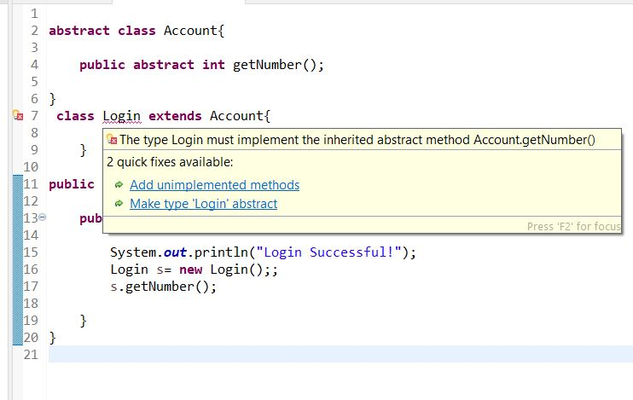

**------------------------------------------------------------------------------------------------------------------------------------------**

**Q. 4**

**4)**

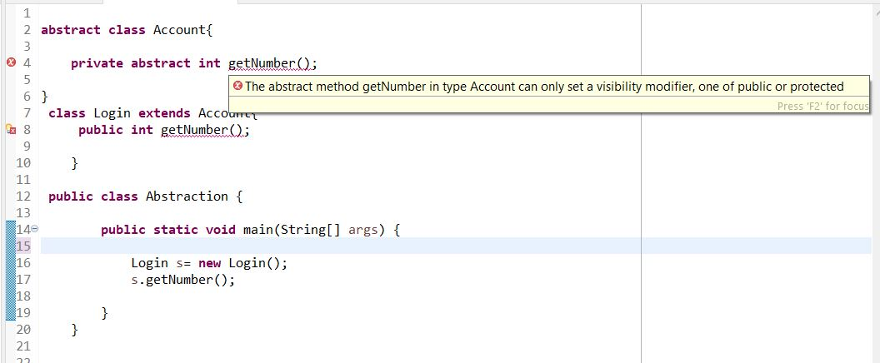

**Q. 4**

**5)**

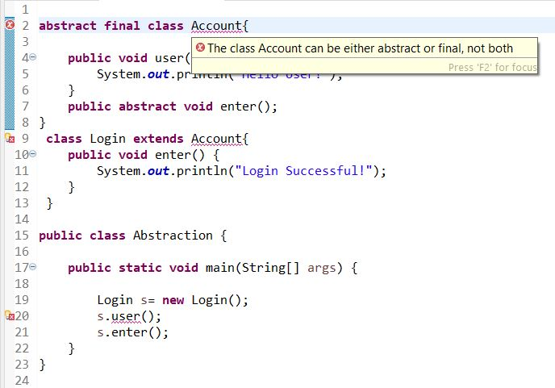

**------------------------------------------------------------------------------------------------------------------------------------------**

**Q. 4**

**6)**

**Program:**

**abstract** **class** Account{

**public** **void** user()

{

System.***out***.println("Hello User!");

}

}

**class** Login **extends** Account{

**public** **void** enter() {

System.***out***.println("Login Successful!");

}

}

**public** **class** Abstraction {

**public** **static** **void** main(String[] args) {

Login s= **new** Login();

s.user();

s.enter();

}

}

**Output:**

Hello User!

Login Successful!

**------------------------------------------------------------------------------------------------------------------------------------------**

**Q.5**

**Program:**

**abstract** **class** Draw {

**public** **abstract** **void** draw();

}

**class** Line **extends** Draw

{

**public** **void** draw() {

System.***out***.println("This is Line.");

}

}

**class** Rectangle **extends** Draw

{

**public** **void** draw() {

System.***out***.println("This is Rectangle.");

}

}

**class** Cube **extends** Draw

{

**public** **void** draw() {

System.***out***.println("This is Cube.");

}

}

**public** **class** Shapes {

**public** **static** **void** main(String[] args) {

Line line= **new** Line();

Rectangle rectangle= **new** Rectangle();

Cube cube= **new** Cube();

line.draw();

rectangle.draw();

cube.draw();

}

}

**Output:**

This is Line.

This is Rectangle.

This is Cube.

**------------------------------------------------------------------------------------------------------------------------------------------**

**Q.6**

**Program:**

**import** java.util.Scanner;

**abstract** **class** Persistence

{

String file_name;

Scanner sc=**new** Scanner(System.***in***);

**abstract** **public** **void** persist();

}

**class** FilePersistence **extends** Persistence

{

**public** **void** persist()

{

System.***out***.println("Enter the file_name 1:");

file_name=sc.nextLine();

}

}

**class** DatabasePersistence **extends** Persistence

{

**public** **void** persist()

{

System.***out***.println("Enter the file_name 2:");

file_name=sc.nextLine();

}

}

**public** **class** Data

{

**public** **static** **void** main(String args[])

{

FilePersistence file=**new** FilePersistence();

file.persist();

DatabasePersistence data=**new** DatabasePersistence();

data.persist();

}

}

**Output:**

Enter the file_name 1:

CapG

Enter the file_name 2:

Mumbai