Project paper

2019-9-11



Contents

Project paper 1

1 Project Overview 3

1.1 Project Background 3

1.2 The framework of the project 4

1.3 Project Advantages 5

2 Project Strategy 8

2.1 User Portrait 8

2.2 Recommended strategy 10

2.3 Construction of fixed fund portfolio 15

2.4 Determine the investment ratio strategy of each fund in the portfolio 17

3. Software Technology Explanation 21

3.1 Technical Details 21

3.2 Architectural Design 26

4 market analysis 30

4.1 market environment analysis 30

4.2Market entry feasibility analysis 32

4.3 Market competition analysis 35

5 Financial analysis 39

5.1 Financial status estimation 39

5.2 Expected Income Statement 41

5.3 Cash flow estimation 41

5.4 Net present value of investment 42

5.5 Financial risk control 42

## 1 Project Overview

### 1.1 Project Background

For individual investors, how to deal with asset allocation and wealth management is undoubtedly a long-term problem. In this case, investment advisers emerge at the historic moment. Before the end of the 20th century, people often turned to traditional customer service. However, traditional investment advisers only provided one-to-one service for high net worth clients, which led to a tedious and inefficient service process. What’s worse, the high service fee was daunting for middle and low-income people. Yet with the development of science and technology and the boom of Internet finance, investment services have also entered a new stage -- robo-advisor stage. Companies like Wealthfront and Betterment have begun to make a figure in the field of wealth management and even become world-renowned intelligent investment adviser platforms.

With the help of advanced technologies like artificial intelligence, cloud computing and big data, robo-advisor has utilized intelligent algorithms and portfolio theory model, combining customer's information such as risk tolerance, risk preference and earnings targets, to recommend portfolios and provide asset allocation proposals to clients. While robo-advisor is a later starter in China, it has a long history in the United States. At the beginning, it was financial practitioners in the field of investment research who used scientific and technological means to depict their clients and help companies sell financial products. After decades of evolution and improvement, this method gradually formed today's robo-advisor. Compared with traditional investment advisers, robo-advisors replace manual services with computer programs, which not only eliminates the irrational factors of manual services, but also improves its work efficiency, thereby possessing the characteristics of objectivity and scale. At the same time, the high service fee avoided in robo-advisor has greatly contributed to remove the limitation of the target customer groups of investment advisory service, which is able to expand to the large middle class. Therefore, investment service threshold has been lowered significantly since the emergence of robo-advisor.

In China, the middle-class people account for a large proportion of the population and the majority of them demand for asset allocation and wealth management to some extent. Therefore, robo-advisors, which offer convenient and efficient investment advice to individual investors, obviously owns a fairly broad prospect in the Chinese market. Companies full of visions start to launch a variety of intelligent investment services and the concept of robo-advisor has become increasingly hot. Nevertheless, considering the short development time and immature application of relative technologies in China, more or less deficiencies have appeared on most robo-advisors in the market and the asset allocation suggestions or recommended portfolios they provide cannot meet the needs of investors as well.

Based on the above studies, we plan to further improve the intelligent investment advisor system in this project. First, we will select the appropriate strategy to screen funds from the pool of funds, and generate a series of high-quality fund portfolios for customers to choose. At the same time, we will use cluster analysis to conduct customer classification research and make more accurate user portraits for customers. Finally, we will use a more advanced recommendation algorithm to select the appropriate fund for the user, and use a reasonable model allocation ratio to provide each customer with a personalized investment portfolio, in order to better achieve the investor's investment objectives.

### 1.2 The framework of the project

#### 1.2.1 New users

We will select appropriate strategies, select funds from the fund pool, and generate a series of fixed portfolios with different risk coefficients. New users choose their own combinations that are similar to their risk preferences. Then we will generate the purchase records to get accurate recommendations subsequently.

select

generate

Fixed combination

New users

Fund pool

Buy

Choose by yourself

#### 1.2.2 Regular user

For regular users with purchase records, we firstly use cluster analysis to classify and study customers, so we can make more accurate customers’ portraits. Then we will use the advanced recommendation algorithm to recommend the appropriate fund list for the user, from which the user chooses the fund he wants to buy. Finally, we use the late portfolio algorithm to determine the purchase ratio of each fund for the user, and provide personalized portfolio for each customer, to achieve the investment objectives of investors better.

Regular users

Recommend fund

Wanted fund

Recommend combination

Buy

Cluster

select

Combination algorithm

Provide ratio

### 1.3 Project Advantages

#### 1.3.1 Multi - index customer segmentation model based on RFM model

Existing research on customer classification considers only one aspect of basic information index, value index and behavior index, which is not well integrated. Therefore, when building the customer model, we refer to the paper "Research on the Classification of Commercial Banks’ Fund Clients Based on Clustering Analysis", and comprehensively consider customer information, value and behavioral indicators to establish a three-dimensional analysis system of customer segmentation.

RFM model is an important tool to measure customer value and customer profitability. The model describes the value status of a customer through three indicators: the recent purchase behavior, the overall purchase frequency and the transaction amount. Based on this, we established two subdivided variable groups: the attributes of RFM and the types of funds purchased. Variables are defined in detail as follows :(1) The attributes of RFM, including frequency (F) and maximum currency transaction value (MMT), which respectively represent the number of transactions and maximum single transaction amount in a sample cycle. (2) Types of funds purchased, behavioral indicators that reflect the diverse product needs and risk attitudes of customers. It includes the proportion of stock fund purchase, bond fund purchase, balance fund purchase and money market fund purchase, which are respectively the proportion of the amount of stock fund purchase, bond fund purchase, allocation fund purchase and money fund purchase in the total transaction amount.

Then, based on the three-dimensional analysis system of customer segmentation built and all the data mastered, we can get the specific customer types more easily through the clustering algorithm, to provide support for discriminant analysis. Through the customer base of existing data, we can find the target customer base more accurately, and expand and retain customer base, recommend corresponding products to meet customer needs according to customer behavior analysis.

#### 1.3.2 A combined recommendation algorithm based on user clustering

With the growth of user data and product data，To provide personalized recommendation service for users has gradually become the focus of many merchants，including fund portfolio. At present, the common intelligent investment products in the market, almost simply rank users’ risk appetite by the contents of the questionnaire filled by users, and recommend different fund portfolio on the basis of the rank of users’ risk appetite. However, there is a gap between the contents of the questionnaire and the actual preferences of users and fund portfolios cannot be divided simply by risk indices. Therefore, for the current situation of financial products, we apply A combined recommendation algorithm based on user clustering, to provide users with more accurate recommendations. On the recommendation system, this project adopts the combination recommendation method based on user clustering scoring recommendation, content-based new fund recommendation and fixed combination recommendation based on new user.

The scoring and recommendation method based on user clustering is to build the scoring matrix of users and funds on the basis of a more accurate user portrait. Then, based on the scoring matrix, SVDpp algorithm is adopted to predict the users' scoring of funds. Finally, 10 funds with the highest scoring are selected as the recommendation results. The scoring matrix is generated according to the purchase record of the fund by the user, and the score will vary according to the time of purchase, the length of holding, the proportion of purchase amount and other factors. SVDpp algorithm reduces the risk of over-fitting by improving the traditional SVD algorithm (singular value decomposition algorithm), and has good processing results for extremely sparse matrices like user-fund scoring matrix.

For new funds, because there is no or only a small historical record of behavior, it will not be recommended for a long time in the collaborative filtering process, and it is easy to be ignored. However, based on the content-based recommendation method, the new fund can be recommended immediately, and does not require the user to purchase the historical behavior data of the fund, that is, solve the problem of "cold start". When a new fund joins the fund pool, the new fund may be recommended, and the probability of recommendation is consistent with the probability of the old fund recommendation. This is the advantage of this project.

#### 1.3.3Application of Decomposition Model of Return Rat

The analysis methods of fund style can be divided into two categories from the perspective of available data. The first is analyzing fund style by using fund open interest detail. The second kind is to use the fund historical rate of return analysis fund style. However, the first category is difficult to continuously track fund style changes due to the low release frequency of detailed open interest data. The second type can fit the style performance of the fund in any period of time through Portfolio Based Analysis (PBSA), and extract the style characteristics of the fund from the investment results. Although the accuracy is not as good as the position Analysis, the higher data release frequency makes the analysis can track the fund changes relatively continuously. Stock selection Alpha index removes the influence of the overall market style on fund performance and can more purely examine the stock selection ability of fund managers, which is an important indicator to distinguish good and bad funds.

## 2 Project Strategy

### 2.1 User Portrait

#### 2.1.1 User Data

According to the multi-index customer segmentation model built on the RFM model, combined with the user data types available in the Citi API, we select the fund transaction frequency, the maximum transaction amount, the purchase fund type and the ratio to describe the user's trading preferences and generate 10,325 users in line with market rules and their transaction records. Among them, the type of purchase fund is a market-accessible fund, which is divided into five types: stock type, bond type, currency type, hybrid type and other types.

#### 2.1.2 Clustering algorithm

Cluster analysis is also called cluster analysis. The basic idea is to use a matrix of independent variables to classify individuals with similar properties into one class. Individuals with different natures belong to different classes, and finally achieve higher homogeneity within the class. Qualitative, individuals of different classes have higher heterogeneity. This project uses the K-Means algorithm to cluster users with transaction data.

The goal of the K-Means algorithm is to divide the data set into K groups based on the input parameter K. The algorithm uses an iterative update method to make the group have higher similarity, and the similarity between clusters is lower. When using the K-Means clustering method, it is necessary to first determine that the data is divided into K groups, then the method will automatically determine the central position of the K groups, and then calculate the distance between the K central positions of each recording distance, according to the principle of the nearest distance. Each record is added to K groups, the center position of K groups is recalculated, the distance of each K record position of each record distance is calculated again, and all records are reclassified, the center position is adjusted again, and so on. When certain standards are met, the above steps are ended. This method is fast and suitable for large data volumes.

#### 2.1.3 Discriminant algorithm

The basic principle of discriminant analysis is to establish one or more discriminant functions according to certain discriminant criteria, determine the undetermined coefficients in the discriminant function with a large amount of data of the research object, and calculate the discriminant index. Based on this, you can determine what kind of sample belongs to. This project adopts the commonly used Fisher discriminant method, which is to first project the projection, and then use the method of distance and distance to obtain the criterion. The new user who adds the new transaction data is added to the existing old user category to enrich the portrait of the new user. The selection of discriminant variables follows the segmentation variables used in cluster analysis, including indicators such as fund trading frequency, maximum transaction amount, and product preference.

#### 2.1.4 Clustering results

Through machine learning, users are finally divided into five types: the first category, mature customers with high risk preferences; the second category, old customers with low risk preferences; the third category, active low value old customers; the fourth category, Inactive high value old customers; fifth category, high value new customers. Each type of users have similar value types and transaction preferences, which can reduce the interference of invalid information and increase the availability of user portraits and the accuracy of subsequent recommendations.

### 2.2 Recommended strategy

The combined recommendation algorithm adopted by the project is divided into three parts: grading recommendation method based on user clustering, new fund recommendation method based on content, and fixed combination recommendation based on new users. Its flow chart is shown in the figure below。method based on user clustering and content-based new fund recommendation are the main contents of portfolio recommendation, both of which are aimed at old customers with certain purchase records, while the recommendation for new users is generated by the administrator with fixed portfolio for recommendation. At the same time, considering that scoring recommendation based on user clustering is very unfavorable to funds without purchase records or new funds, it is combined with content-based new fund recommendation method to make new funds appear on the user's recommendation interface. The following is an introduction to the main contents of combinatorial recommendation algorithm.

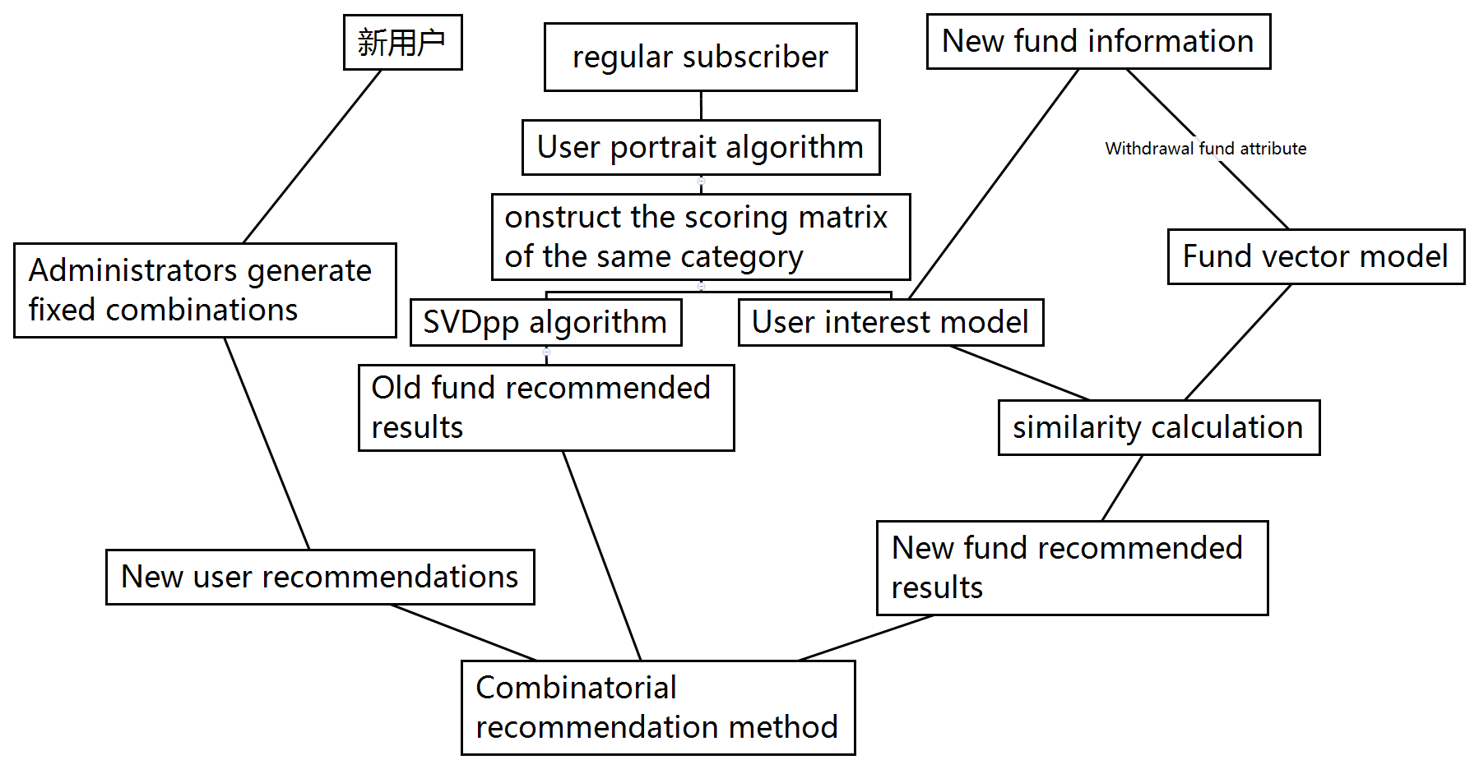

Figure 1 combined recommendation process

#### 2.2.1 User clustering based scoring algorithm

The scoring algorithm based on user clustering is based on user clustering. In each category, the scoring moment of the user on the fund is generated according to the purchase record of the user on the fund. Then SVDpp algorithm is invoked to predict the user's scores on all funds, and the 10 funds with the highest scores are selected as the recommendation results. Its flow chart is shown in the figure below.

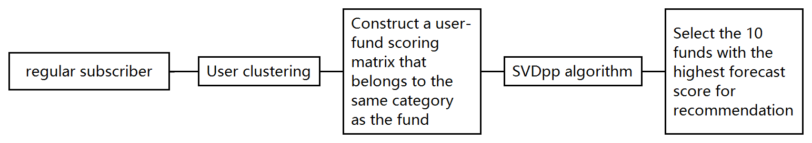

Figure 2 recommendation based on user clustering scoring algorithm

Among them, the strategy of user clustering will be introduced in detail in the section of user portrait. Here, the method of constructing scoring matrix and the main idea of SVDpp algorithm are mainly introduced.

**(1) Build the user-fund scoring matrix**

The purpose of the scoring matrix is to reflect the degree of users' preference to funds through the scoring, which requires the purchase records of users to funds. The scoring method follows the following rules :(1) the higher the proportion of the user's investment amount in the total investment amount of the user, the higher the user's score on the fund;(2) the smaller the difference between the time stamp of the user who bought the fund and the time stamp of the user who bought the fund at the latest, the higher the user's score on the fund. Following the above two rules, we constructed the following scoring method:

represents the score of the ith user on the jth fund. represents the investment amount of the ith user in the JTH fund. represents the total amount of investment for the ith user. timeij represents the timestamp of the jth fund purchased by the ith user, and maxi represents the latest timestamp of the purchase by the ith user.

**(2) SVDpp algorithm**

User-scoring matrix was generated according to different categories of users, and svd-pp algorithm was used for each category to predict users' scores of different funds under each category. SVDpp algorithm, also known as SVD++ algorithm, is an improved version of SVD algorithm.

SVD algorithm, which is a Singular Value Decomposition algorithm, is an important matrix Decomposition method in linear algebra.

Singular value decomposition proves that for any matrix A, there is its full rank decomposition Am*n=Xm*k * Yk*n. where k=rank(A), refers to the rank of the matrix, that is, the maximum number of linearly independent row or column vectors of A matrix. The user-fund matrix is a very sparse matrix, and its rank is much smaller than the number of rows or columns. In this way, an m*n matrix can be decomposed into m*k and k*m matrices by using SVD, and then X matrix and Y matrix can well fit A through training, which is SVD algorithm.

However, the traditional SVD algorithm has the problem of over-fitting. Therefore, based on the traditional SVD algorithm, Koren improved the algorithm and added penalty term to prevent over-fitting.

#### 2.2.2 New fund recommendation algorithm based on fund content

**2.1 flow chart**

Fund information

Base metal

User interest model

Fund vector model

Fund information

User-fund

Scoring matrix

Extract user interest

Similarity calculation

**2.2 The main steps**

First, extract some attributes for each fund to describe fund things. According to relevant data, when investing in fund products, Internet investment users are most concerned with the relatively intuitive factors such as profitability, investment funds, investment risks, investment cycles, etc. After determining the product type, the products to be invested will be Detailed analysis, in the end, netizens also have certain requirements in terms of convenient product redemption and fast arrival time. Based on the survey data, the project selects the following attributes of the fund to describe: the yield, risk level, investment period, transaction cost, starting amount, fund size, and fund company in the past year.

In the second step, the user's preference on each attribute needs to be calculated according to the user-fund score matrix, and a preference vector is derived to describe the user's overall preference. Let user j buy n old funds, the scores are wi (i = 1, 2, ..., n) (each user scores 1 for all purchased funds and should be 1, if not 1, standardize For 1, which guarantees =1), the eigenvectors of each fund are respectively Fi (i=1, 2,...,n), then the user j's favorite vector is

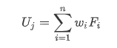

In the third step, the similarity is calculated according to the attribute vector of each new fund and the preference vector of each user. The greater the similarity calculated, the stronger the correlation between the fund and the user. For the calculation of similarity, the project uses the method of space vector cosine similarity to calculate, the calculation formula is as follows:

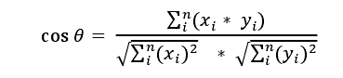

Since the range of values of each attribute is different, each attribute value needs to be normalized before the similarity is calculated based on the vector space cosine. Since the difference between the values of the attributes of the yield, risk level, investment period, transaction cost, starting amount, and fund size in the past year represents the difference between the two, the Z-score standardization method is used. ,Calculated as follows:

3

Where σ represents the standard deviation of all sample data and μ represents the mean of all sample data.

For the fund company's attributes, there are only two cases that are the same or different from the user's preferences. Therefore, we calculate this: if the fund is the same as the user's favorite fund company, the value of the attribute in the fund's fund vector is 1 Otherwise the value of this attribute is 0.

After completing the above three steps, the similarity of all users to the new fund is obtained. At this time, the top N users with the highest similarity can recommend the new fund.

### 2.3 Construction of fixed fund portfolio

#### 2.3.1 Idea of Combination

Core of this system is to use the recommendation algorithm to recommend appropriate fund portfolioto the customer, which involves buying records of all the customers. As for new customers, the system administrator has to create several fund portfolio with different risk factor, so that new customers can simply select the product which is similar to their appetite for risk of funds and the background can generate the purchasing record. The difficulty in this part lies in the selection and combination of funds by the system administrator.

#### 2.3.2 Select Funds by Using Decomposition Model of Return Rat

In 1992, William F.Sharpe put forwardDecomposition Model of Return Rat with the combination of Asset Factor Model, dividing fund style into overall market value and growth, mid-market, small-market and different types of bonds and foreign markets, which uses the method of multiple linear regressionto regress Fund Return Rate. Taking minimizing residual sum of squares as the goal, we can get approximate percentage of fund assets in various styles.

Rt=[δ1x1,t+δ2x2,t+...+δnxn,t]+εt

s.t. δ1+δ2+...+δn=1,

δi>=0,i=1,2...n

Rt represents the FundReturn Rate in t period, x1,t represents the return rate of asset style i in t period, and regression coefficient represents the approximate proportion of fund of each asset style. With the approximate proportion of the fund in each asset style, we can use this proportion to construct the fund's "historical style index"as FundStyleIndex. After selecting the index of the market as Benchmark, we can obtain a decomposition form of the Excess Return Rate of the fund in any range of the investigation period, as follows:

Rt-Benchmark=[Rt-FundStyleIndex]+[FundStyleIndex-Benchmark]

So that we can get the fund's stock selection Alpha = Rt-FundStyleIndex.

The interpret-ability of the model is represented by R2=1-VaR(εt)/VaR(Rt), where VaR represents the maximum loss in a certain confidence interval.

The target selection strategy for Alpha stock selection in this report iscalculating the average selection of Alpha stock in the past 12 months under the monthly frequency as the base selection index. The fund with the model interpretation degree greater than 0.6 was selected as the alternative fund and ranked by the base selection index. Select 30 funds with the highest index to construct the FOF portfolio with equal weightsand the warehouse was adjusted according to the monthly frequency. (Because of the 20% position limit of public-offered FOF single fund, there are at least five funds that need equal options for a FOF product.)

#### 2.3.3 Constructing Compound Fund Portfolio Based on Risk Preference Coefficient

Thirty selected funds were evaluated by return rate and VaR value. According to VaR value, 30 funds were divided into five categories: high risk, medium-high risk, medium-low risk and low-risk. The fund is selected according to the risk tolerance of different groups. We can use the index utility function to get the risk-adjusted return formula, which can be applied to calculate the risk-adjusted returnaccording to people's risk aversion.

Exponential utility function：u(w)=-exp(-θ·w)

As w=w0(1+r), we can get u(w0(1+r))=-exp(-θ·w0(1+r))

As for expected utility function：u(w*)=u(w0(1+r*))=E{u(w)}=E{-exp(-θ·w0(1+r))}

-exp(-θ·w0(1+r*))=E{-exp(-θ·w0(1+r))}

r*=-(1/θ)·w0·ln{E[-exp(-θ·w0(1+r))]}

Finally we can get the risk-adjusted return:

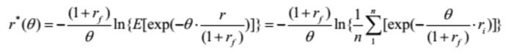

θ is the absolute risk aversion coefficient, rf is the risk-free rate of return, and ri is the rate of return of fundi.

The degree of aversion shows that the aversion coefficient θ indicates people's preference for the fund. The higher the degree of preference, the lower the aversion coefficient, and the aversion coefficient is a fixed value defined by the system administrator. We take 1, 3, 5, 7 and 9 as aversion coefficients of low, medium, low, medium, high and high aversion levels respectively. According to different aversion levels (different aversion coefficients), we normalize the funds under each category to obtain the fund portfolio with different risk tolerance.

### 2.4 Determine the investment ratio strategy of each fund in the portfolio

#### 2.4.1 Introduction of Late Portfolio

After using the recommendation algorithm to generate the specific fund recommendation list according to the user's purchase records, the user can freely choose one or more funds from the fund recommendation list to purchase according to his risk preference and risk tolerance. In the case of multiple funds selected by the user, how to generate composite fund portfolio is the problem to be solved in this section.

Generally speaking, given a limited number of funds to build a composite fund portfolio, the goal of our investment decision is to maximize returns and minimize risks. By studying the existing literature, we refer to Bai Xiaoning's research result. Guided by Markowitz's portfolio theory and Capital Asset Pricing Model, he introduces the investor's risk aversion coefficient to represent the investor's investment style and constructs a single objective nonlinear programming problem with parameters. In this project, we chose the model provided in his paper as the basis for the construction of late portfolio. What’s more, we realized the function of generating composite fund portfolio through the program.

#### 2.4.2 Theoretical Support for the Late Portfolio Model

**1. Markowitz's Portfolio Theory**

In March 1952, American economist Harry Markowitz published his paper "portfolio selection", which was the beginning of modern portfolio management theory. In this paper, Markowitz assumed that participants' preferences depended on two characteristics of future wealth distribution, namely, the mean and variance. He quantified risks and returns, constructed the mean variance model, and proposed the basic model to determine the optimal asset portfolio.

The problem of solving this kind of portfolio is expressed as follows:

Instructions: denotes the portfolio weight vector; denotes security return vector;denotes the mean of; denotes a given expected rate of return; denotes the covariance matrix. In all the portfolios with the same expected rate of return, the variance of the portfolio rate of return obtained in the solving process is the least, which means its risk is also the least.

However, this method requires calculating the covariance matrix of all assets, which is too large to be suitable for practical application.

**2. Capital Asset Pricing Model**

In the 1960s, William Sharpe, John Lintner, Jack Treynor and Jan Mossin proposed the capital asset pricing model (CAPM). This model mainly studies the relationship between the expected rate of return of assets and risky assets in the securities market and how the equilibrium price is formed.

The model is described as follows:

E(ri)=rf+βim(E(rm)-rf)

Instructions: E(ri) denotes the expected rate of return on asset i; rf denotes risk-free rate; βim denotes the Beta coefficient, which isthe systemic risk of asset i; E(rm) denotes market m's expected market rate of return; E(rm)-rf denotes market risk premium.

Capital Asset Pricing Model is developed on the basis of Markowitz’s portfolio theory, which is the pillar of modern financial market price theory and widely used in the field of investment decision-making and corporate finance.

#### 2.4.3 Construction of Late Portfolio Model

**1. Specification of Symbols**

N：N kinds of fund

n：n samples of fund returns

t：the t-th day, t = 1, 2,…,n

R：fund expected return vector

：the expected rate of return of the i-th fund

，i=1,…,N

where denotes the rate of return of the i-th fund on day t

，where denotes the closing price (i.e. net value) of fund i on day t.

：the risk-free rate of return vector

, where denotes the risk-free rate of return.

W：allocation vector of fund portfolio

E：covariance matrix

，i=1,…,N，j=1,…,N

I：N dimensional column vectors with all components being 1.

：risk aversion coefficientand



The larger μ is, the more risk averse the investor is.

The questions related to risk appetite in the questionnaire are 9-18 except 14, consisting of 9 questions with a score range of 9-45.

**2. Model Assumptions**

(1) Suppose investors only consider the factors of return and risk and choose the portfolio with the least risk under the condition of certain return;

(2) All funds have the same systemic risk during the period under review;

(3) Investors cannot have short sales.

**3. Model Establishment and Solution**

Suppose that we choose a portfolio from N funds. denotes the investment proportion of fund i in the investment plan; denotes the return of the portfolio;denotesthe risk-free rate of return vector and , where denotes the risk-free rate of return; R denotes fund expected return vector; E denotes covariance matrix.

The expected rate of return of portfolio is. Therefore, the objective function related to the rate of return is:

And the risk of portfolio is. Therefore, the objective function related to risk is:

According to the above assumptions, we can build model Ⅰ:

Now let’s introduce investor risk aversion coefficient μ, change the multi-objective function into single objective function, and construct single objective optimal portfolio and risk preference model Ⅱ without shorting sales:

The optimal solution of model Ⅱ is: W* =

We can find out the optimal solution of the model Ⅰ using the following algorithm:

Step 1:Let W*=;

Step2:If W*≥0, then W=W*, stop; else, turn to Step3;

Step3: If the components of W* satisfy these conditions: ,,...,,,(j≠), then letin turn. Namely, remove the -th fund and turn to Step1 to obtain the optimal solution of the model so that we can obtain the optimal value corresponding to each solution.

Step4:Let W*=, S*=, y=2:

A. If S*<, then turn to B; else, letW*=*, S*=* and then turn to B;

B. If y=k, then turn to Step2; else, lety=y+1and then turn to A.

By this point, the late portfolio model has been constructed and solved. Our project uses this model and its conclusion to provide composite fund portfolio for multiple funds selected by users from the recommendation list in order to make the optimal investment decision.

## 3. Software Technology Explanation

### 3.1 Technical Details

#### 3.1.1 Overview

The system adopts the separate structure of front-end and back-end. Each front-end and back-end runs independently, and communicates through RESTful API during the period, which is conducive to parallel front-end and back-end development and improve efficiency.

#### 3.1.2 TypeScript, Python (programming language)

TypeScript is a free and open source programming language developed by Microsoft. It is a superset of JavaScript and essentially adds optional static types and class-based object-oriented programming to the language. TypeScript extends the syntax of JavaScript, so any existing JavaScript program can work under TypeScript without change. TypeScript is designed for the development of large applications, and it generates JavaScript at compile time to ensure compatibility. And it also supports adding header files with type information to existing JavaScript libraries, extending its benefits to popular libraries such as jQuery, MongoDB, Node.js and D3.js.

Python is an object-oriented interpretive computer programming language. Python is pure free software and it’s source code and interpreter CPython follow the GPL (GNU General Public License) protocol. Python's grammar is concise and clear, and one of its features is to force the use of white space as sentence indentation. Python has rich and powerful libraries, and can easily link various modules (especially C/C++) produced in other languages. Version 3.0 of Python is often called Python 3000, or Py3k for short. Compared with the earlier version of Python，Py3k is a larger upgrade. Python 3.0 was not designed for downward compatibility in order to avoid excessive burdens.

#### 3.1.3 Visual Studio Code、WebStorm、PyCharm（IDE）

Visual Studio Code is a cross-platform source code editor running on Mac OS X, Windows and Linux for writing modern Web and cloud applications. Visual Studio Code provides developers with built-in support for a variety of programming languages, as well as rich code completion and navigation capabilities for these languages. JavaScript, TypeScript, Node. JS and ASP. NET 5 developers will also get additional toolsets. The editor also integrates all the features that a modern editor should have, including syntax hight lighting, customizable keyboard bindings, bracket matching and snippets.

WebStorm is a powerful HTML5/JavaScript Web front-end development tool owned by Jetbrains. At present, JS developers in China have been praised as "the magic weapon of Web front-end development", "the most powerful HTML5 editor", "the most intelligent JavaScript IDE" and so on. Homologous to IntelliJ IDEA, it inherits the powerful JS function of IntelliJ IDEA.

PyCharm is a Python IDE with a set of tools that can help users improve their efficiency when developing in Python language, such as debugging, grammar highlighting, project management, code jumping, intelligent hints, automatic completion, unit testing, version control. In addition, the IDE provides some advanced functions to support professional Web development within the framework of flask.

#### 3.1.4 Vue (Front View Framework)

Vue.js is a progressive framework for building user interfaces. Unlike other heavyweight frameworks, Vue uses a bottom-up incremental design. It’s core library focuses only on the view layer and is very easy to learn and integrate with other libraries or existing projects. On the other hand, Vue has complete capability of driving complex single-page applications, which uses single file components and libraries supported by Vue ecosystems.

The goal of Vue.js is to implement data binding and composite view components for response through as simple an API as possible.

#### 3.1.5 MySQL (database)

MySQL is a relational database management system, developed by Swedish MySQL AB Company, and currently belongs to Oracle's products. MySQL is one of the most popular relational database management systems. In WEB applications, MySQL is one of the best RDBMS (Relational Database Management System) applications. MySQL is a relational database management system, which stores data in different tables instead of all data in a large warehouse, thus increasing speed and flexibility. The SQL language used by MySQL is the most commonly used standardized language for accessing databases. MySQL software adopts a dual authorization policy, which is divided into community version and commercial version. Because of its small size, fast speed and low overall cost of ownership, especially open source, MySQL is generally chosen as the website database for the development of small and medium-sized websites. Because of its excellent performance in community edition, it can form a good development environment with PHP and Apache.

#### 3.1.6 Swagger

Swagger is a normative and complete framework for generating, describing, invoking and visualizing RESTful-style Web services. The overall goal is to update the client and file system as servers at the same speed. File methods, parameters and models are tightly integrated into server-side code, allowing APIs to keep synchronization at all times. Swagger is a general API description specification that is independent of programming language. It can run through the whole API ecosystem, such as API design, API documentation, testing and deployment.

#### 3.1.7 Git (Version Control Tool)

Git is an open source distributed version control system, which can effectively and quickly handle version management from very small to very large projects. Git is an open source version control software developed by Linus Torvalds to help manage Linux kernel development.

#### 3.1.8 ElementUI (UI Component Library)

ElementUI is a desktop component library based on Vue 2.0 for developers, designers and product managers. It has the characteristics of Consistency, Feedback, Efficiency and Controllability.

#### 3.1.9 Java (programming language)

Java is an object-oriented programming language. It not only absorbs the advantages of C++ language, but also abandons the concepts of multi-inheritance and pointer which are difficult to understand in C++. Therefore, Java language has two characteristics: powerful function and easy to use. As the representative of the static object-oriented programming language, Java language perfectly implements the object-oriented theory and allows programmers to program complex programs in an elegant way of thinking [1].

Java has the characteristics of simplicity, object-oriented, distributed, robustness, security, platform independence and portability, multi-threading, dynamic, etc. [2]. Java can write desktop applications, Web applications, distributed systems and embedded system applications.

#### 3.1.10 Intellij IDEA

IDEA, fully known as IntelliJ IDEA, is an integrated environment for Java programming language development. IntelliJ is recognized as one of the best java development tools in the industry and it can be said to be extraordinary especially in intelligent code assistant, code autoprompt, refactoring, J2EE support, various versions of tools (git, svn, etc.), JUnit, CVS integration, code analysis, innovative GUI design and other functions. IDEA is the product of JetBrains, a company headquartered in Prague, the capital of the Czech Republic. Its developers are predominantly Eastern European programmers known for their rigor.

#### 3.1.11 SpringBoot

Spring framework is an open source application framework on Java platform, which provides a container with inversion control characteristics. Although the Spring framework itself has no limitations on programming models, its frequent use in Java applications has made it so popular that it was later used as a complement to, or even a substitute for, the EJB (Enterprise JavaBeans) model. Spring framework provides a series of solutions for development, such as using the core features of control inversion, realizing the containerization of management object life cycle through dependency injection, declarative transaction management using aspect-oriented programming, integrating multiple persistence technologies to manage data access, providing a large scale of excellent Web frameworks which are easy to develop and so on.Spring framework has the feature of control inversion (IOC). IOC is designed to facilitate project maintenance and testing. It provides a unified configuration and management method for Java objects through Java reflection mechanism. The Spring framework uses the lifecycle of container-managed objects. Containers can configure objects by scanning XML files or specific Java annotations on them and developers can obtain objects by relying on lookup or injection. What’s more, Spring framework has Aspect-Oriented Programming (AOP) framework which is based on proxy mode and is configurable at runtime; AOP framework is mainly modularized for cross-concerns between modules. The AOP framework of Spring framework only provides basic AOP features. Although it can not be compared with AspectJ framework, it can also meet basic requirements by integrating with AspectJ. The functions of transaction management and remote access under Spring framework can be realized by using Spring AOP technology. Spring's transaction management framework provides an abstract mechanism for the Java platform, enabling local and global transactions and nested transactions to work with savepoints in almost any environment of the Java platform. Spring integrates multiple transaction templates and the system can configure transactions through transaction templates, XML or Java annotations. In addition, the transaction framework integrates messaging and caching functions. Spring's data access framework solves the common difficulties developers encounter when using databases in applications. It not only supports all popular data access frameworks such as Java: JDBC, iBATS/MyBATIs, Hibernate, Java Data Object (JDO), Apache OJB and Apache Cayne, but also can be used with Spring's transaction management to provide flexible abstraction for data access. Spring framework was originally not intended to build its own WebMVC framework. In the process of development, its developers thought that the separation between presentation layer and request processing layer of existing Struts Web framework and between request processing layer and model was not enough, so they created Spring MVC.

#### 3.1.12 The Summary of Technologies

|  |  |
| --- | --- |
| Web front end | |
| Vue | Front View Framework |
| ElementUI | UI component library |
| TypeScript | Programing language |
| Visual Studio Code/WebStorm | Integrated Development Environment (IDE) |
| NPM | Node package management tool |
| Webpack | Front-end integration tools |
| back-end | |
| Java 8 | Programing language |
| SpringBoot | Backend project framework |
| Python 3 | Programing language |
| MySQL | data base |
| Intellij IDEA | Integrated Development Environment (IDE) |
| PyCharm | Integrated Development Environment (IDE) |
| Pip | Python package management tool |
| Other tools | |
| Git | Version Control Tool for Multi-Person Collaboration |
| JWT | Authentication technology |
| Swagger | Front-end and Back-end Interface Document Tool |

### 3.2 Architectural Design

#### 3.2.1 Use Case View

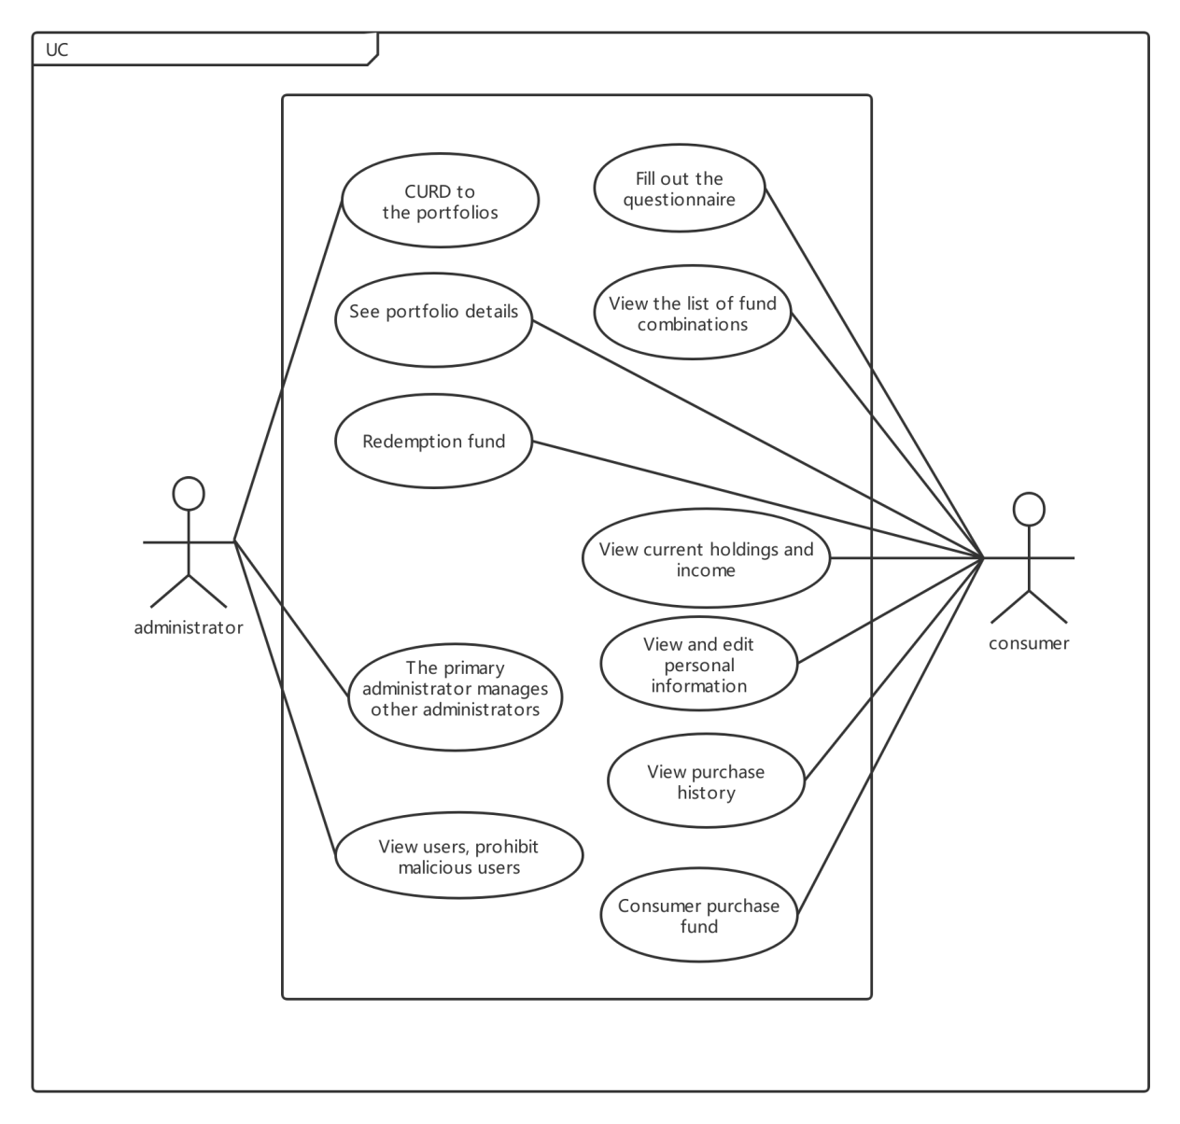

Figure 3.2.1-1 Use Case View

#### 3.2.2 Logical view

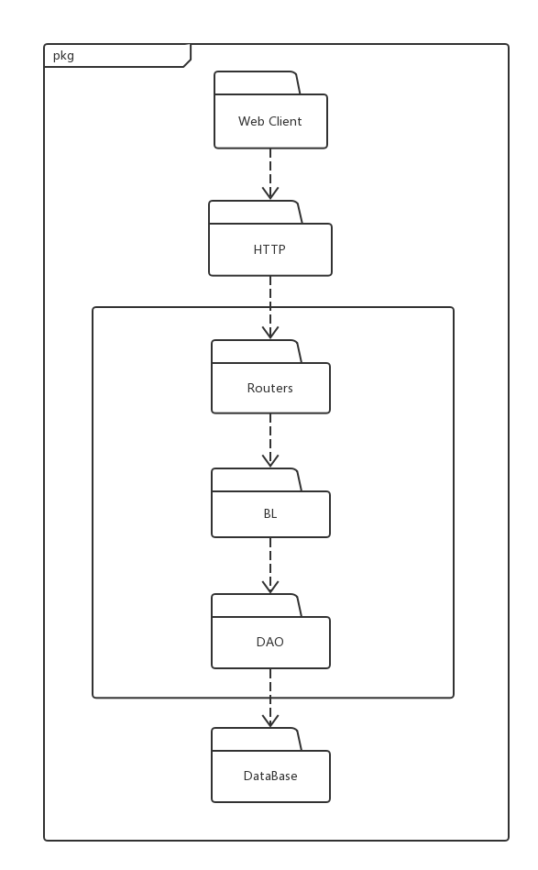 Figure 3.2.2-1 Logical View

#### 3.2.3 Development view

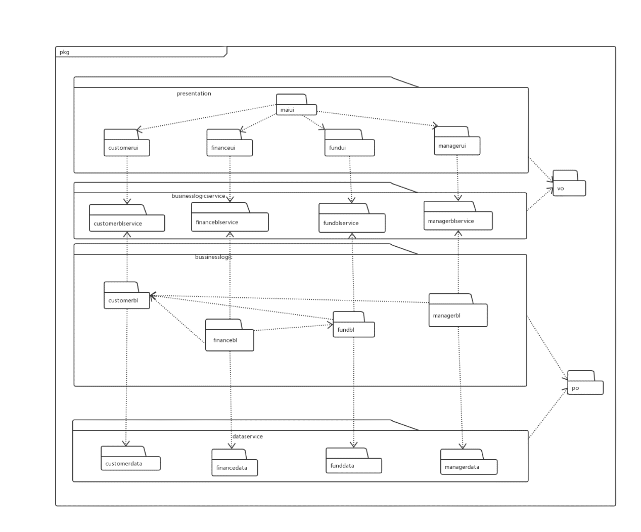Figure 3.2.3-1 Development View

#### 3.2.4 Process view

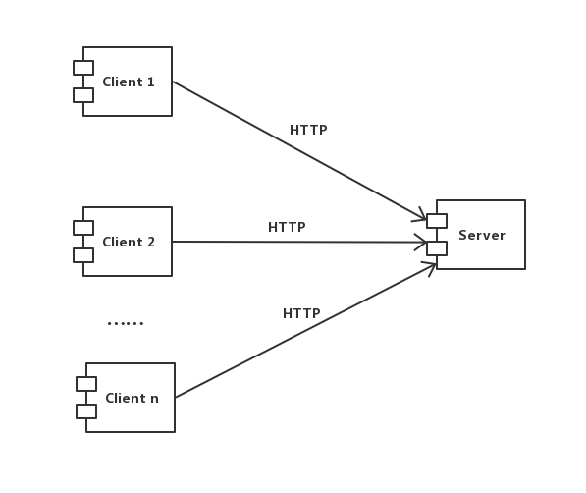Figure 3.2.4-1 Process View

#### 3.2.5 Deployment view

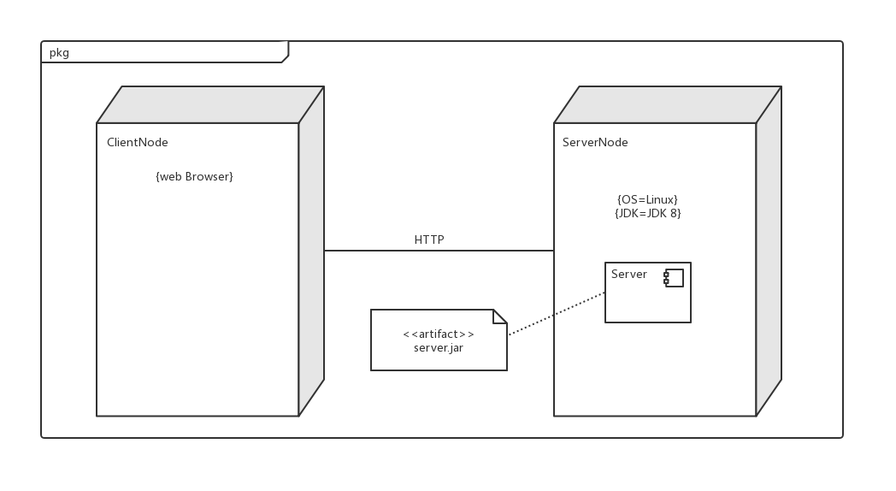

Figure 3.2.5-1 Deployment View

## 4 market analysis

### 4.1 market environment analysis

#### 4.1.1 political environment

China's financial system is subject to separate supervision, and the securities investment field is currently in charge of the China securities regulatory commission. The interim provisions on securities investment consultant business issued on October 12, 2010 and implemented on January 1, 2011 are the main regulatory legal documents.Since there are many differences between digital asset allocation and securities investment business in the normative sense, it is not appropriate to use the above documents.For the increasingly developing intelligent investment advisory market, the securities industry association released the "account management business rules (draft for comments)" and other laws and regulations to allow investment advisers to conduct account management business, and put forward the possibility of future digital asset allocation business to manage customer assets.

#### 4.1.2 Economic environment

Growing with the development of economy and the residents’ wealth, tens of thousands of money need to find good investment goals, relative to the extremely sensitive quantity and price of stocks and bonds, fund is a good investment channel. Fund on net sales, fund net worth is the total amount of its actual assets held. The quantity of you buy more quantity is little and the funds will not change. In the 14 years since the birth of the open-end fund, all public funds, including low-yield bond fund and monetary fund, the simple average annual return is 19.2%! By comparison, the Shanghai index's annualized yield over the past 14 years has been only 7%, while the average yield on government bonds has been about 3%. Meanwhile, over the past 20 years, the average annualized return on U.S. public funds has been only 2.29%! By contrast, the fund take much more dominance.

At the same time, the fund of funds (FOF) derived from funds can achieve a better risk-return ratio by optimizing asset allocation, so it has attracted more and more attention from the market. The application of FOF in the field of intelligent investment consulting not only has low cost and wide audience, but also has a high degree of investment specialization and has a good prospect.

#### 4.1.3 Social environment

With the development of the Internet, those people in eighties and nineties has gradually become the main body of investors, and consumer’s habit are also changing. The characteristics of traditional wealth management products, such as high cost and high starting point of investment, cannot meet the investment needs of most users. By optimizing asset allocation, intelligent property products can achieve a risk-return ratio that can better meet the needs of investors, thus attracting more and more attention from the market. At the same time, due to the general improvement of investment awareness and knowledge of domestic financial products. In this situation, high net worth individual investors have gradually become rational and mature since a single asset allocation is difficult to meet the needs of investors. The development of intelligent financial management can reduce the investment risk in the second time under the advantage of reducing the selection cost of investors. In addition, the regulatory policy for intelligent investment is also progressing and improving. Thus, the launch of this software not only has a low cost and a wide audience, but also has a high degree of investment specialization. It has a good market prospect and has a head start in the future wealth management market.

#### 4.1.4 technological environment

Artificial intelligence has been evolving continuously since it was proposed in 1956, with machine learning becoming one of the branches. Around 2000, deep learning became a further extension of machine learning, and the development of computer technology initiated new changes in the field of financial planning.Traditional offline channels is difficult to integrate the size of the rapid growth of data analysis, thus creating the cloud computing, big data, such as deep learning technology widely used in the field of digital asset allocation, big data, the depth of the data mining, cloud computing technology promotion and application of gradually broaden, help intelligent asset allocation by market transaction data user information data collection and analysis of user behavior analysis and forecast, in the financial markets.

### 4.2Market entry feasibility analysis

#### 4.2.1 Consumer Demand

Along with the rapid development of China's economy, people's wealth is growing quickly, and the rational allocation of assets and investment management has gradually become a hot issue that people pay close attention to.According to the "Residents' Income and Consumption Expenditure" issued by the National Bureau of Statistics: In 2013-2018, the per capita disposable income of urban residents in China increased from 26,467 yuan in 2013 to 39,521 yuan in 2018, with an average annual growth rate of 8.2%. Residents' investment and wealth management income is developing very well.On the other hand, the proportion of savings deposits to total personal investable assets has been decreasing year by year, indicating that residents' demand for wealth management is increasing while wealth is accumulated.

Figure 3per capita disposable income of urban residents in China

Data source: National Bureau of Statistics

Figure 4the proportion of savings deposits to total personal investable assets

Data source: Yiguan

At the same time, the new middle class has become the backbone of financial management, and intelligent financial management just meets their financial needs and preferences. The new middle-class group that has grown up along with the Internet is gradually becoming the main force of China's consumption, investment and wealth management, and has become the backbone of social development. The new middle class is a group of young people who are mainly engaged in mental work, have a good educational background, and have great potential in wealth. They have a natural dependence on the Internet and a strong desire to explore wealth management. And with certain financial management experience, but the relative lack of professional financial management knowledge, limited time and energy limit their financial management through traditional methods. However, this product can just solve the problem of new middle-income investment and financial management, to meet their financial needs and preferences.

According to estimates, the size of China's smart financial services market in 2016 was only 30.07 billion yuan, and by 2018 it has risen to 254.69 billion yuan, with a compound annual growth rate of 191%. In the future, driven by multiple factors such as regulatory support, the intelligent level of intelligent wealth management services will continue to increase, and large online wealth management users will also be rapidly transformed into intelligent wealth management users. The market size of intelligent wealth management services will increase rapidly. It is estimated that by 2022, the market size of China's smart financial services will reach 737.05 billion yuan.

Figure 5Market size and forecast of intelligent financial services

Data source: China industry information website

With the surge of artificial intelligence commercialization, its technology is also rapidly applied to financial business, and smart investment is regarded as the core application. According to the forecast of Kearney Management Consulting, it is estimated that by 2022, the market size of China's smart financial services will reach 5 trillion yuan. This also shows that the concept of providing asset allocation and wealth management advice for users conforms to the overall market trend and has a good market prospect.

Users have a strong demand for financial services with higher levels of intelligence and better services. However, in the context that most services cannot fully satisfy users, the smart financial services market is in urgent need of technological innovators to break the bureau and improve the intelligence level of financial services. To provide users with better and more comprehensive services, the intelligent wealth management service provided by this product greatly reduces the labor cost, thereby lowering the service threshold and cost, and has strong appeal to mass consumers and high net worth people. The further improvement of the existing smart investment system in the market can better meet the needs of consumers, so the feasibility of entering this market is high.

### 4.3 Market competition analysis

#### 4.3.1 Market competition environment analysis

In analyzing the market competition environment faced by this product, the Porter Five Force Analysis Model is used to analyze the market competition factors it faces.

**(1) Supplier's bargaining power**

For this product, the supplier mainly provides a variety of fund-related data and industry-related multiple data collection services. However, the current data is mostly for the public and there are many data collection providers, and the competition is relatively large, so the supplier's bargaining power is weak.

**(2) The buyer's bargaining power**

Users have strong demand for financial services with higher levels of intelligence and better services. However, in the context that most current services cannot fully satisfy users, the unique integrity and innovation of this product will largely meet the needs of users. The product will gain user trust and the user's bargaining power is weak.

**(3) The threat of new entrants**

In the future, in the context of supporting the integration of finance and technology and encouraging the development of artificial intelligence industry, the government's further support and promotion will enable many new financial platforms similar to the system's business to enter the market and increase competition pressure.

**(4) The threat of substitutes**

Compared with the existing intelligent investment system on the market, this product has advanced clustering and recommendation algorithms and more scientific matching algorithms. It is unique and innovative in the market, and the threat of substitutes is temporarily small. .

**(5) Competitors in the same industry**

With the gradual implementation of a series of national financial policies, more and more financial institutions and companies have launched a variety of smart wealth management products, but due to the short development time of China's smart investment market, a variety of influx into the market Smart investment products are still not mature enough to fully meet the user's existing personalized and scientific needs. At present, similar products in the same industry are less competitive, but we must remain vigilant and strive to innovate.

#### 4.3.2 analysis of competitive products.

The core of this project is the idea of asset allocation, which is comparable with the domestic intelligent investment management system in asset allocation.At present, there are mainly two types of enterprises in the domestic intelligent investment market:First, related businesses launched by traditional financial or Internet enterprises;One is innovative start-ups.

|  |  |  |  |  |
| --- | --- | --- | --- | --- |
| competing goods | Company profile | Product data | [service](C:/Program%20Files%20(x86)/Youdao/Dict/8.5.1.0/resultui/html/index.html#/javascript:;) [object](C:/Program%20Files%20(x86)/Youdao/Dict/8.5.1.0/resultui/html/index.html#/javascript:;) | [competitive](C:/Program%20Files%20(x86)/Youdao/Dict/8.5.1.0/resultui/html/index.html#/javascript:;) [advantage](C:/Program%20Files%20(x86)/Youdao/Dict/8.5.1.0/resultui/html/index.html#/javascript:;) |
| Clipper Advisor | Founded in October 2015, it is an intelligentinvestment service provider focusing on overseas asset allocation | Thetarget market is the global high net worth Chinese population | To C  To B | The "Yale model" is a reference to global asset allocation, which focuses on overseas ETFs |
| Financial rubik’s cube | Founded in December, 2014. financial products shopping guide platform | 36 krypton space phase iv project, no customer investment minimum requirements, intelligent portfolio fund purchase rate is less than 1 discount on average. | To C | Intelligent investment advisory services, tracking the latest product trends, analysis of the portfolio |
| micai | Founded in September 2014, it is an Internet finance company | The annualized rate of return is expected to be 3.52%~8.43% | To C | A. It has exclusive investment advisers;  B. Focus on domestic asset allocation;  C. The risk matching questionnaire filled out by users at the beginning of use is of high quality. |

#### 4.3.3 Product competitiveness analysis

Currently, the institutions entering the field of intelligent asset allocation are mainly divided into two categories. One is the related business launched by traditional financial or Internet enterprises; the other is innovative start-up enterprises.

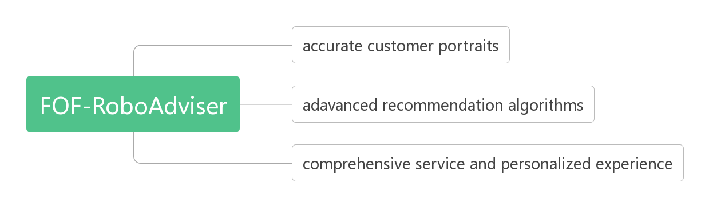

**A accurate customer portraits**

Through the collection of customer basic information, the customer fill in the questionnaire, the historical trading performance analysis, more accurate description of customer investment preferences, determine the type of customer preferences, the system has achieved a more accurate grasp of customer investment preferences.Make use of fund evaluation and user's investment preference to complete personalized matching recommendation of fund portfolio and customer.

**B advanced recommendation algorithm, matching fund portfolio with customer personalization.**

With the proliferation of user data and product data, providing personalized recommendation services for users has gradually become the focus.At present, the common intelligent investment products in the market are mostly divided into risk preference levels according to the questionnaire users fill, and different fund portfolios are recommended according to different risk preference levels.However, there is a gap between the contents of the questionnaire and the actual preferences of users, and the fund portfolio cannot be divided simply by the risk index.Therefore, for the current situation of financial products, we adopt a combination recommendation algorithm based on user clustering to provide more accurate recommendations for customers.For new users, we adopt the score weighting algorithm based on user clustering.Firstly, the questionnaire survey information of new users is used to classify new users according to the user portrait algorithm.For old users, collaborative filtering combined with score weighting based on user clustering is adopted.

**C more comprehensive service, more humane use experience.**

From the questionnaire filled by new customers to the analysis of the historical purchase records of old customers, from the fund information overview to the fund portfolio recommended by the system, this project provides customers with all the service functions that an intelligent investment platform should have, and strives for simple operation to provide customers with the best use experience.

## 5 Financial analysis

### 5.1 Financial status estimation

Based on the historical data of the industry, the relevant statistical data of relevant authorities for nearly ten years and the experience gained from related events, we use statistical methods such as statistics to estimate the relevant financial status.

Operating plan: For new users, we will reduce the consultation and management fee for the first month to expand the user group to accelerate the market promotion; the old users will charge 0.35% of the consulting management fee as the platform operating expenses; users who use the platform to reach a certain time limit can enjoy a more favorable rate.

The expected income structure is as follows:

|  |  |  |  |  |  |
| --- | --- | --- | --- | --- | --- |
|  | the first year | the second year | The third year | fourth year | fifth year |
| From new users | 300000 | 350000 | 500000 | 750000 | 1100000 |
| From old users | 0 | 240000 | 472000 | 7776000 | 1222080 |
| total | 300000 | 590000 | 972000 | 1527600 | 2322080 |

Note: The platform revenue is only from the consultation and management fee, no other income; assuming the platform user retention rate is 80% / year

The main business cost structure is as follows:

|  |  |  |  |  |  |
| --- | --- | --- | --- | --- | --- |
|  | the first year | the second year | The third year | fourth year | fifth year |
| Raw material | 150000 | 150000 | 150000 | 150000 | 150000 |
| Direct wage | 150000 | 165000 | 180000 | 220000 | 265000 |
| Depreciation of fixed assets | 15000 | 15000 | 15000 | 15000 | 15000 |
| total | 315000 | 330000 | 345000 | 385000 | 430000 |

Note: Assume that the initial fixed assets are 200,000 yuan, the expected service life is 10 years, and the residual value is 50000, the annual depreciation is (200000-50000)/10=15000 yuan.

Business tax

|  |  |  |  |  |  |
| --- | --- | --- | --- | --- | --- |
|  | the first year | the second year | The third year | fourth year | fifth year |
| total | 15000 | 29500 | 48600 | 76380 | 116104 |

Note: 5% of operating income

sales expense

|  |  |  |  |  |  |
| --- | --- | --- | --- | --- | --- |
|  | the first year | the second year | The third year | fourth year | fifth year |
| Salesperson salary | 90000 | 105000 | 150000 | 180000 | 180000 |
| advertising fee | 40000 | 40000 | 40000 | 35000 | 30000 |
| Travel expenses | 30000 | 35000 | 50000 | 60000 | 65000 |
| total | 160000 | 180000 | 240000 | 275000 | 275000 |

Management costs

|  |  |  |  |  |  |
| --- | --- | --- | --- | --- | --- |
|  | the first year | the second year | The third year | fourth year | fifth year |
| Managerial salary | 120000 | 150000 | 180000 | 230000 | 270000 |
| Wages and benefits | 5000 | 6000 | 7500 | 9500 | 11000 |
| training fees | 10000 | 10000 | 10000 | 10000 | 10000 |
| Office expenses | 10000 | 12000 | 14000 | 16000 | 18000 |
| Miscellaneous | 6000 | 6000 | 6000 | 6000 | 6000 |
| total | 151000 | 184000 | 217500 | 271500 | 315000 |

Note: Office expenses include workplace rent, loss and replacement of office supplies, etc. Miscellaneous expenses include utilities, temporary expenses, etc.

### 5.2 Expected Income Statement

Based on the above estimates, it is estimated that the company's profit and loss situation in the next 5 years is as follows:

|  |  |  |  |  |  |
| --- | --- | --- | --- | --- | --- |
|  | the first year | the second year | The third year | fourth year | fifth year |
| First, the main business income | 300000 | 590000 | 972000 | 1527600 | 2322080 |
| Less: main business cost | 315000 | 330000 | 345000 | 385000 | 430000 |
| Business tax and surcharges | 15000 | 29500 | 48600 | 76380 | 116104 |
| sales expense | 160000 | 180000 | 240000 | 275000 | 275000 |
| Management costs | 151000 | 184000 | 217500 | 271500 | 315000 |
| 2. Operating profit | -341000 | -133500 | 120900 | 519720 | 1185976 |
| Plus: Non-operating income | 0 | 0 | 0 | 0 | 0 |
| Less: Non-operating expenses | 0 | 0 | 0 | 0 | 0 |
| 3. Total profit | -341000 | -133500 | 120900 | 519720 | 1185976 |
| Less: Income tax | 0 | 0 | 30225 | 129930 | 296494 |
| 4. Net profit | 0 | 0 | 90675 | 389790 | 889482 |

### 5.3 Cash flow estimation

The cash flow generated by the company's operating activities in the next five years is expected to be as follows:

|  |  |  |  |  |  |
| --- | --- | --- | --- | --- | --- |
|  | the first year | the second year | The third year | fourth year | fifth year |
| Cash flow from operating activities | 300000 | 590000 | 972000 | 1527600 | 2322080 |
| Tax refund | 0 | 0 | 0 | 0 | 0 |
| Other inflows into cash flow | 0 | 0 | 0 | 0 | 0 |
| Total cash inflow | 300000 | 590000 | 972000 | 1527600 | 2322080 |
| Cash paid to employees for wage expenses | 365000 | 426000 | 537500 | 639500 | 726000 |
| Various taxes paid | 15000 | 29500 | 78825 | 206310 | 412598 |
| Other cash outflows related to operating activities | 246000 | 253000 | 270000 | 277000 | 279000 |
| Total cash outflow | 626000 | 708500 | 886325 | 1122810 | 1417598 |
| Net cash flow | -326000 | -118500 | 85675 | 404790 | 904482 |

### 5.4 Net present value of investment

Calculated based on the previous five years of cash flow:

After calculation, npv=278160.5519, greater than 0, so the investment project is feasible (in case the expected industry income is normal).

### 5.5 Financial risk control

In order to control the risk, we assume that the income is reduced to x (percentage) of normal income, the related expenses are the same, and assuming the relevant taxes and fees are unchanged, the expected cash flow statement is:

|  |  |  |  |  |  |
| --- | --- | --- | --- | --- | --- |
|  | the first year | the second year | The third year | fourth year | fifth year |
| Cash flow from operating activities | 300000x | 590000x | 972000x | 1527600x | 2322080x |
| Tax refund | 0 | 0 | 0 | 0 | 0 |
| Other inflows into cash flow | 0 | 0 | 0 | 0 | 0 |
| Total cash inflow | 300000 | 590000 | 972000 | 1527600 | 2322080 |
| Cash paid to employees for wage expenses | 365000 | 426000 | 537500 | 639500 | 726000 |
| Various taxes paid | 15000 | 29500 | 78825 | 206310 | 412598 |
| Other cash outflows related to operating activities | 246000 | 253000 | 270000 | 277000 | 279000 |
| Total cash outflow | 626000 | 708500 | 886325 | 1122810 | 1417598 |
| Net cash flow | 300000x-626000 | 590000x-708500 | 972000x-886325 | 1527600x-1122810 | 2322080x-1417598 |

The net present value of the investment is calculated based on the previous five-year cash flow situation:

Let NPV=0, and solve x=0.8539, that is, as long as the actual income can reach 85% of the estimated income (the industry's normal income), the NPV of the project is greater than 0, and the project can be implemented. In the actual situation, it is not difficult to achieve this goal, so we basically affirm the feasibility of the project.