

Hotel Booking App

Name:
Damian Mihai

Group:
30435

Table of Contents
Deliverable 1 3
Project Specification 3
Functional Requirements 3
Use Case Model 3
Use Cases Identification: 3
UML Use Case Diagrams 3
Supplementary Specification 3
Non-functional Requirements 3
Design Constraints 3
Glossary 3
Deliverable 2 3
Domain Model 3
Architectural Design 3
Conceptual Architecture 3
Package Design 4
Component and Deployment Diagram 4
Deliverable 3 4
Design Model 4
Dynamic Behavior 4
Class Diagram 4
Data Model 4
System Testing 4
Future Improvements 4
Conclusion 4
Bibliography 4

Deliverable 1

Project Specification

The proposed project is a Hotel Management Application designed to facilitate accommodation booking for users and efficient inventory management for administrators.

Functional Requirements
- The system will allow registered users to:
  - search for hotels by location, date, and availability.
  - book a hotel room.
  - a list of their past and active bookings.
  - manage their bookings (edit/cancel).
- The system will allow the administrator to:
  - add new hotels to the platform.
  - remove existing hotels from the platform.
  - edit existing hotels (change prices/room availability).

Use Case Model

Use Cases Identification:

Use-Case: Book Hotel Room
- Level: User Goal
- Primary Actor: Registered User
- Main success scenario: The user selects a desired hotel and dates, confirms the booking details, and submits the request. The system processes the request, deducts the room from available inventory, and displays a booking confirmation.

- Extensions:
  - Room unavailable: If the room becomes unavailable during the booking process, the system alerts the user and prompts them to select different dates or a different hotel.

Use-Case: Search Hotels
- Level: User Goal
- Primary Actor: Registered User
- Main success scenario: The user enters search criteria (city, check-in/check-out dates). The system queries the database and displays a list of available hotels matching the criteria.
- Extensions:
  - No results: If no hotels match the criteria, the system displays a "No hotels found" message and suggests broadening the search parameters.

Use-Case: Add Hotel
- Level: User Goal
- Primary Actor: Administrator
- Main success scenario: The administrator logs into the system, navigates to the dashboard, and selects "Add Hotel". They fill in the hotel details (name, address, amenities, room capacity, price) and submit. The system saves the new hotel to the database and displays a success notification.
- Extensions:
  - Invalid data: If the admin enters invalid data (negative prices or missing mandatory fields), the system highlights the errors and prevents submission until corrected.

UML Use Case Diagrams
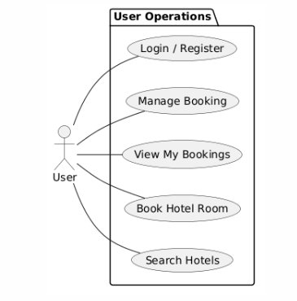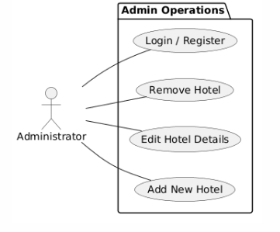

Supplementary Specification

Non-functional Requirements

Reliability (Data Consistency)
- Description: The system must ensure that once a room is booked, it is immediately marked as unavailable for those specific dates across all user sessions.
- Suitability: This is critical to prevent double-booking. Ensuring the data is synchronized and reliable maintains trust between the hotel and the guest.

Security:
- Description: All user passwords must be hashed.
- Suitability: The system handles personal information and potentially booking/payment details, making data protection a legal and ethical necessity.

Compatibility (Browser Support)
- Description: The web application must load and function correctly on the latest versions of major web browsers, specifically Google Chrome, Mozilla Firefox, Apple Safari, and Microsoft Edge.
- Suitability: Users will try to book hotels using whatever browser they have installed. Ensuring standard browser compatibility guarantees a smooth experience for the maximum number of potential guests.

Design Constraints

Architecture: The application must follow a Client-Server architecture, communicating via a RESTful API.

Database Constraint: The system must utilize a relational database (PostgreSQL) to enforce ACID compliance, which is strictly required to handle concurrent booking transactions and prevent double-booking of rooms.

Developmental Tools: The project mandates the use of Git for version control (with repositories hosted on GitHub).

Build Automation: The project must use Maven for dependency management and to automate the build process.

Glossary
Booking / Reservation: A confirmed hold on a specific hotel room for a defined date range. Validation Rule: The check-out date must always be strictly greater than the check-in date.
User: Any individual interacting with the system. Can be an unauthenticated "Guest" (only able to search) or a "Registered User" (able to book and view history).
Administrator: A staff member with elevated privileges allowed to manage the hotel inventory (add/remove/edit listings).
Inventory: The total number of available rooms a specific hotel has for a given set of dates.

Deliverable 2

Domain Model
The Hotel Booking System manages the lifecycle of hotel room reservations. The core domain concepts are:
Concept | Description
User | A customer who registers, logs in, and makes bookings. Identified by email; passwords are hashed. Has a role attribute (customer, admin).
Hotel | An establishment with a name, address, phone, and email. Owns a collection of rooms.
Room | A bookable unit within a hotel. Characterized by room number, type (SINGLE / DOUBLE / SUITE), capacity, price per night, and availability flag.
Booking | A reservation linking a User to a Room for a specific date range (check-in → check-out). Derives the number of nights and total cost.

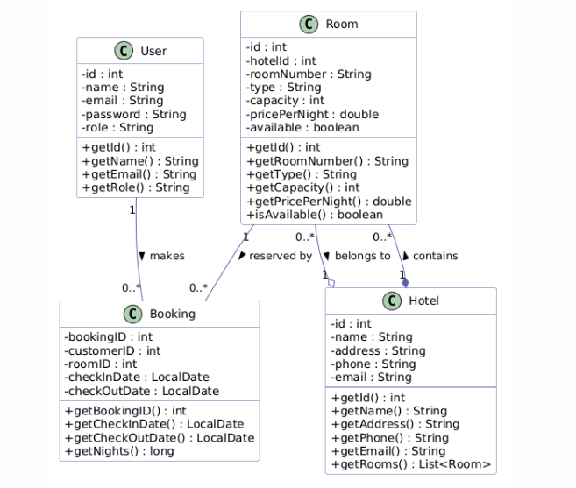
Key Domain Rules
- A check-out date must be strictly after the check-in date.
- A check-in date cannot be in the past.
- A room cannot be double-booked: overlapping date ranges for the same room are rejected.
- User emails are unique, passwords are stored as BCrypt hashes.

Architectural Design

Conceptual Architecture
The system follows a 3-Tier Architecture (Presentation – Application – Data), with a separation between a web-based frontend and a backend REST API, communicating over HTTP/JSON.
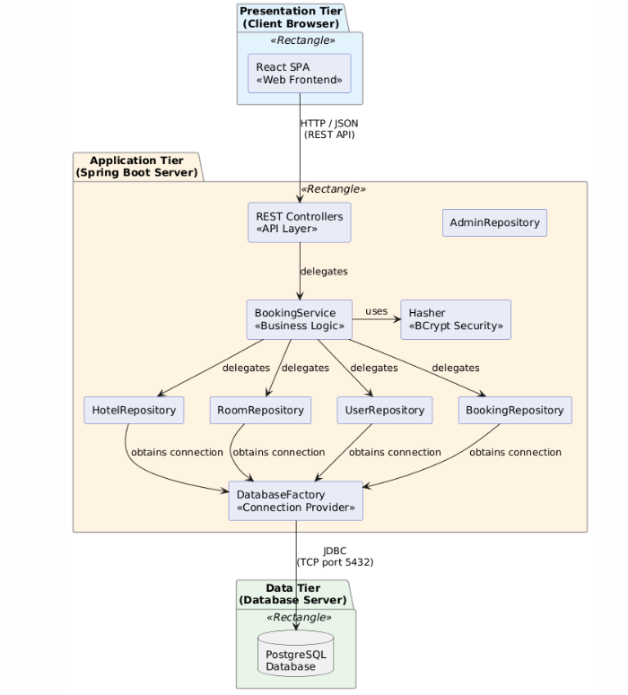

Criteria and motivation:
Deployability - Web frontend is accessible from any browser on any device — no installation required. The backend deploys as a standalone server process.
Separation of concerns - The frontend handles only rendering and user interaction. The backend (Spring Boot) handles business rules, authentication, and data access. The database handles persistence. Each tier is independently replaceable.
Scalability - The stateless REST API can be scaled behind a load balancer. The database tier can be scaled or replicated independently.

Package Design
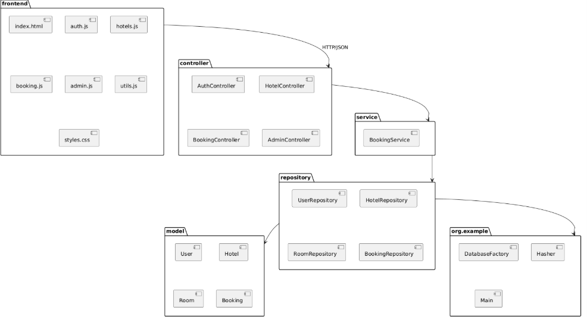

Component and Deployment Diagram

Component diagram:
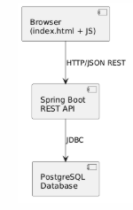

Deployment diagram:
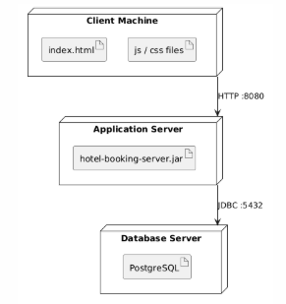

Deliverable 3

Design Model

Dynamic Behavior
User books a room: 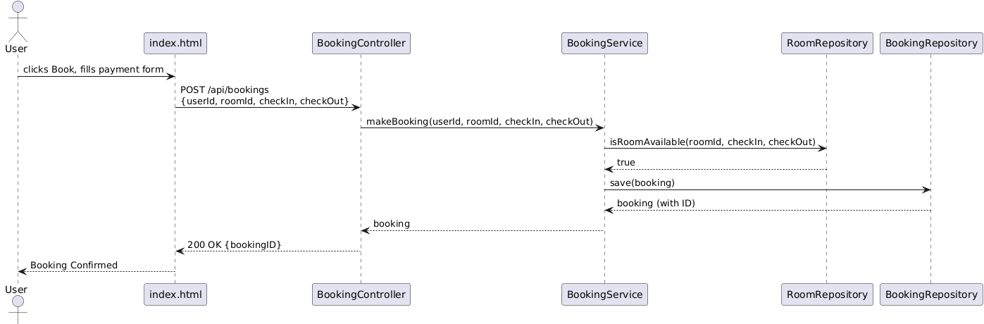

User logs in:
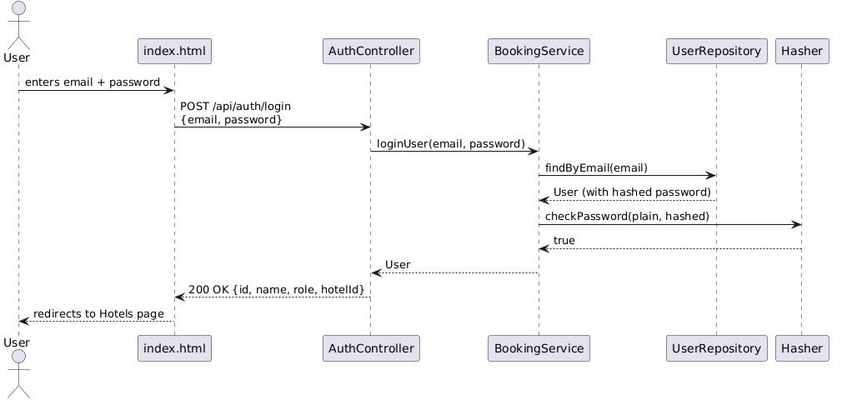

Class Diagram
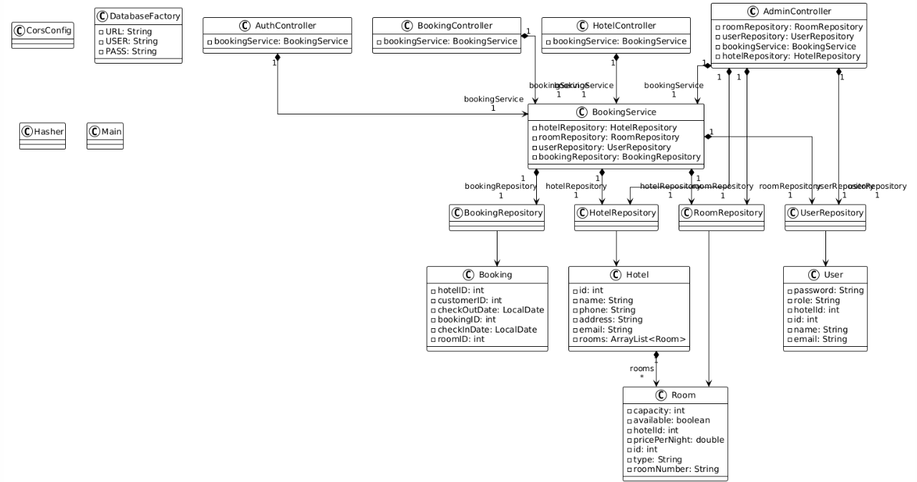
The project uses two GoF patterns:

Factory (DatabaseFactory)
The DatabaseFactory class centralizes the creation of database connections. No other class calls DriverManager.getConnection() directly — they all go through DatabaseFactory.getConnection(). This is an application of the Factory Method pattern: the object creation logic is encapsulated in one place, so if the connection details or driver ever change, only DatabaseFactory needs to be updated.

Facade (BookingService)
The BookingService class acts as a Facade over the four repositories (HotelRepository, RoomRepository, UserRepository, BookingRepository). Controllers never interact with repositories directly — they call a single, simplified interface through BookingService. This hides the complexity of coordinating multiple repositories behind one class, making the controllers simpler and the system easier to maintain.

Data Model
The system uses a PostgreSQL relational database with four tables. The users table stores registered users with hashed passwords and an optional hotel_id foreign key for admin accounts. The hotels table stores hotel information. The rooms table links each room to a hotel via hotel_id and stores type, capacity, price, and availability. The bookings table links a user to a room for a date range, with a check constraint enforcing that check_out_date > check_in_date.
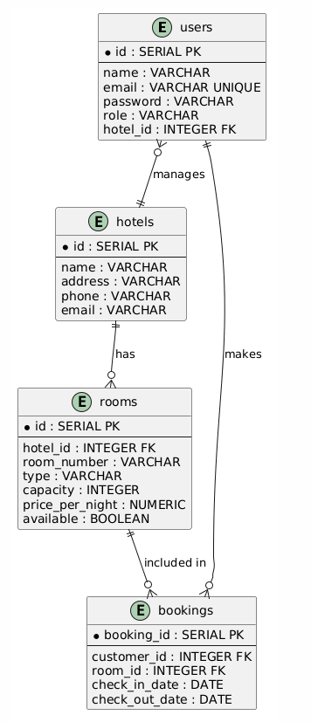

System Testing
Testing Methodology
Automated testing was implemented using JUnit 5 and Spring Boot's MockMvc framework. Tests run against the real PostgreSQL database and cover both the service layer (business logic) and the controller layer (REST endpoints).

Test Classes
Class | Layer | What it tests
AuthControllerTest | Controller | Registration, duplicate email, wrong password, correct login, password not returned in response
HotelControllerTest | Controller | Get all hotels, get by ID, invalid ID returns 404, get rooms, available rooms, missing parameters
BookingControllerTest | Controller | Valid booking, inverted dates, past dates, missing fields, double-booking prevention, get user bookings
BookingServiceTest | Service | Date validation, duplicate email, login with wrong password, hotel and room retrieval

Future Improvements
Email notifications — send booking confirmation and cancellation emails to users automatically.
Search and filtering — allow users to filter hotels by city, price range, or room type on the browse page.
Booking cancellation by user — currently only admins can cancel; users should be able to cancel their own upcoming bookings.
Payment integration — replace the mockup payment form with a real payment gateway.
Review system — allow users to leave ratings and reviews for hotels they have stayed at.
Room photos — allow admins to upload photos for individual rooms, not just the hotel card image.

Conclusion
This project successfully implements a fully functional client-server web application. The system implements a clean 3-tier architecture with a REST API backend built in Spring Boot, a PostgreSQL database, and a plain HTML/CSS/JS frontend. Role-based access control distinguishes regular users from hotel administrators, allowing hotel-specific room and booking management. Automated testing using JUnit 5 and MockMvc verified that all core flows: registration, authentication, room availability, booking creation, and double-booking prevention behave correctly.

Bibliography

