spark-submit DNA.py cross year 2009 -CSA --mCCA –mCMA

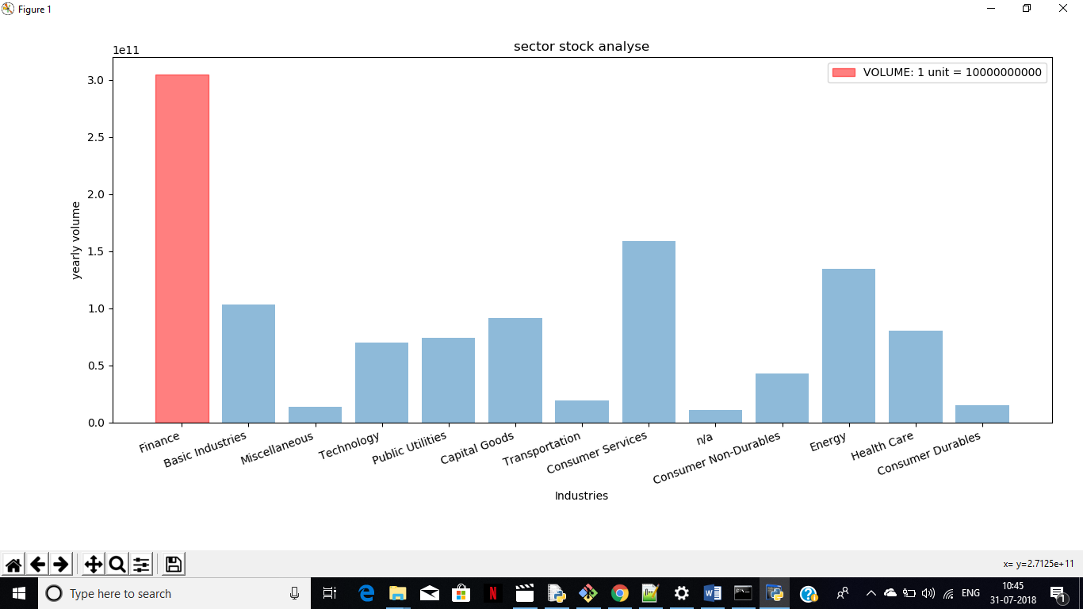

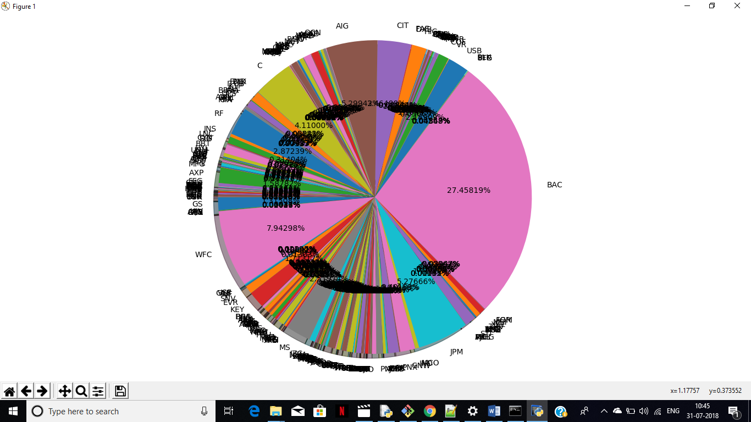

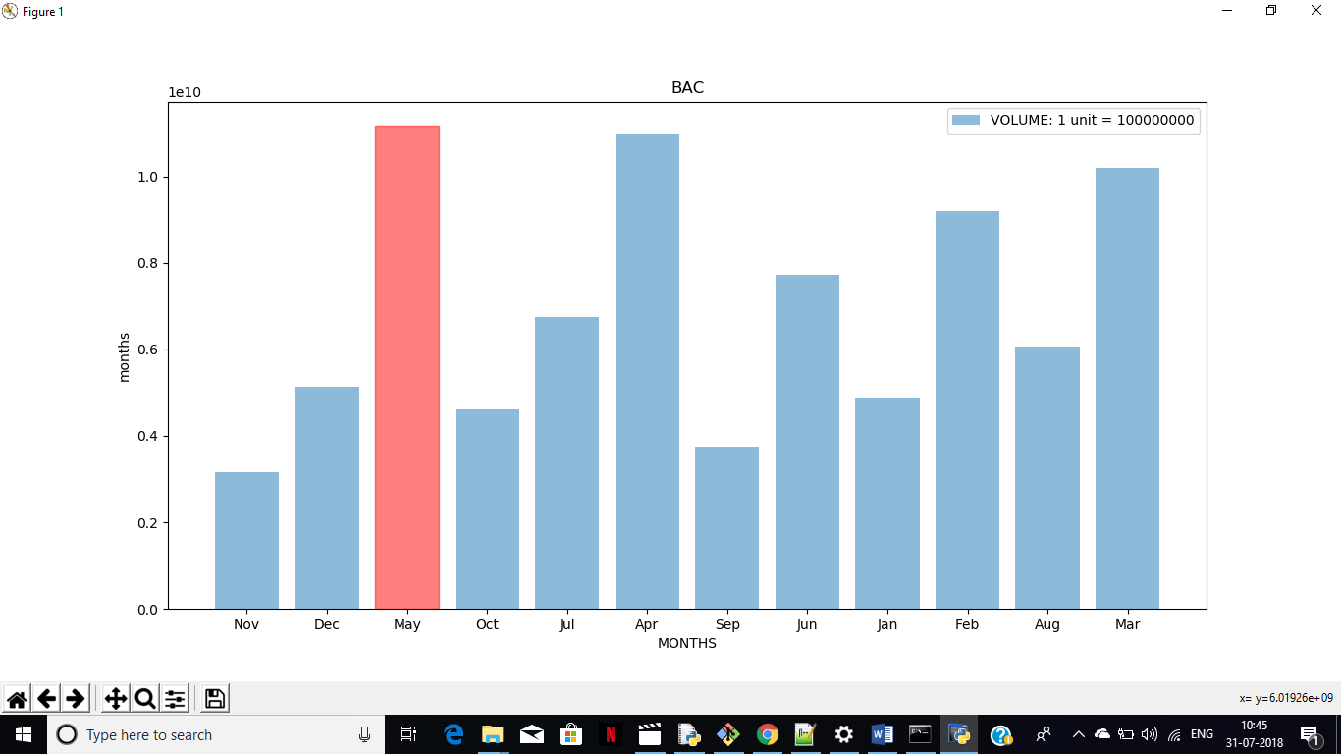

spark-submit DNA.py cross year 2010 -CSA –mCMA

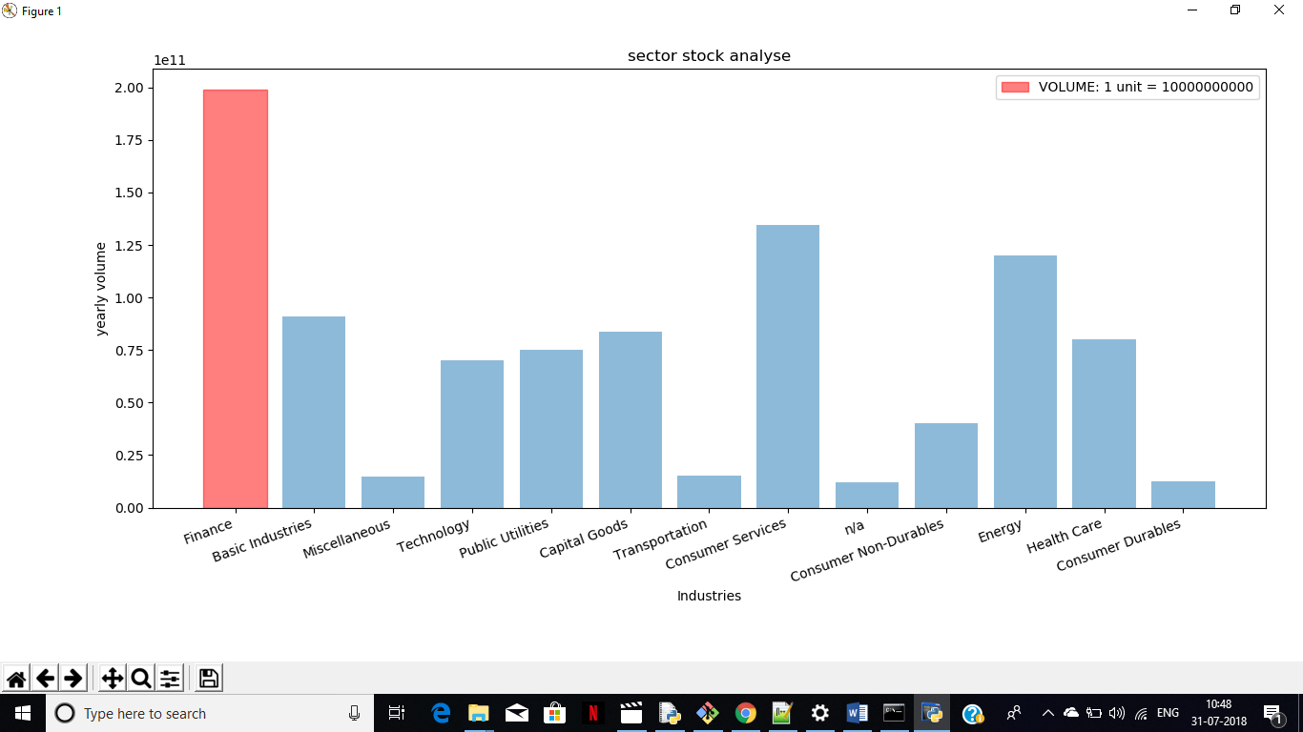

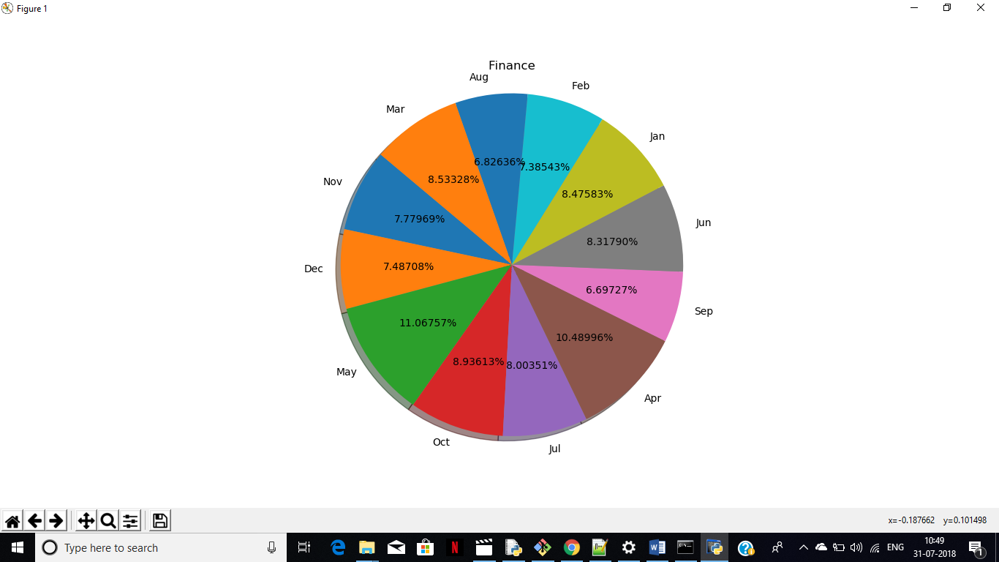

spark-submit DNA.py ohlc year 2010 Jan BAC

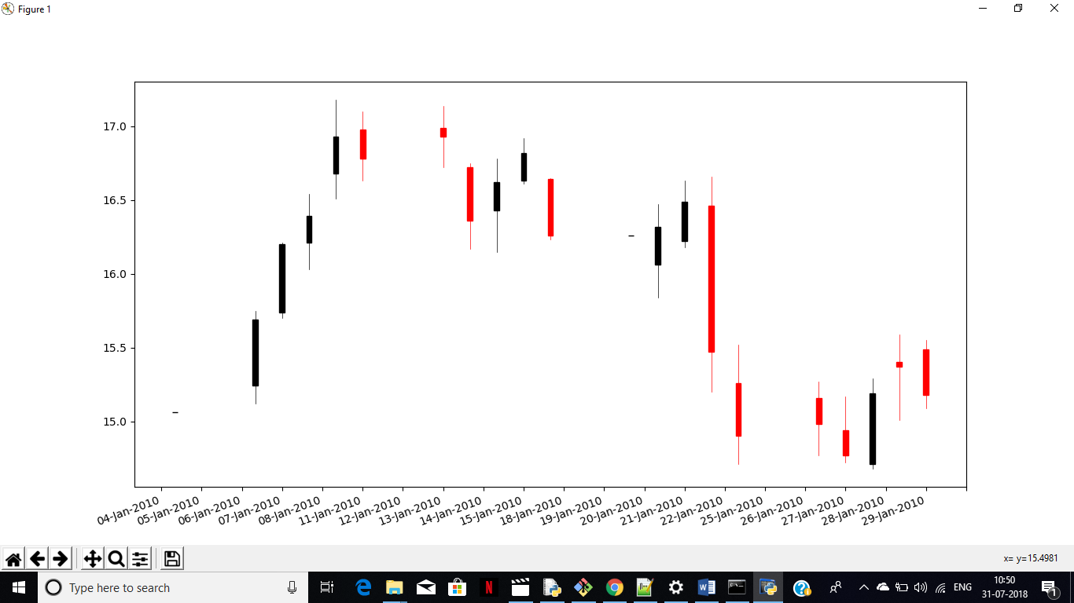

spark-submit DNA.py ohlc year 2010 BAC

