Week 1 Task Report

Python for Machine Learning & Data Preprocessing
AI Pioneers Internship (Machine Learning Internship) — Yuva Intern
Submitted by: D Niteesh Kumar

1. Objective
The objective of this task is to understand and apply the fundamentals of data preprocessing for Machine Learning using Python. This includes loading a raw dataset, handling missing values, selecting and encoding relevant features, normalizing numeric data, and performing basic exploratory data analysis (EDA) using the Pandas, NumPy, scikit-learn, and Seaborn libraries.

2. Dataset Description
The Titanic dataset was used for this task, sourced via Seaborn’s built-in dataset loader (sns.load_dataset('titanic')). It contains 891 passenger records with 15 original attributes covering demographic details (age, sex), travel details (class, fare, port of embarkation), family relationships (siblings/spouses, parents/children aboard), and the target outcome (survived). The dataset was chosen because it combines numeric, categorical, and missing data, making it well suited to demonstrate a complete preprocessing pipeline.

3. Preprocessing Steps

3.1 Loading and Initial Inspection
The dataset was loaded and inspected using df.info(), df.describe(), and df.isnull().sum() to understand column data types, distributions, and the extent of missing data before making any changes.
import pandas as pd, numpy as np, seaborn as sns
df = sns.load_dataset('titanic')
df.info()
print(df.isnull().sum())

3.2 Handling Missing Values
Inspection showed missing data concentrated in four columns. Each was handled differently depending on how much data was missing and whether the column was redundant with another:
Column | Missing Values | Action Taken
age | 177 | Filled with median age
deck | 688 | Dropped (77% missing, too sparse)
embarked | 2 | Filled with mode
embark_town | 2 | Dropped (duplicate of embarked)

Two further columns (alive, class, who, adult_male) were dropped as they directly duplicated or were trivially derived from survived, pclass, sex, and age, and would have added redundant, noisy features rather than new information.
df = df.drop(columns=['deck', 'embark_town', 'alive', 'class', 'who', 'adult_male'])
df['age'] = df['age'].fillna(df['age'].median())
df['embarked'] = df['embarked'].fillna(df['embarked'].mode()[0])
After this step, the dataset had zero missing values across all 891 rows and 9 remaining columns.

3.3 Feature Selection and Encoding
Two categorical columns required encoding before the data could be used in a model:
- sex (binary: male/female) — encoded with LabelEncoder, since a 0/1 mapping does not introduce a false ordinal relationship for a two-category feature.
- embarked (three unrelated categories: S, C, Q) — encoded with one-hot encoding (pd.get_dummies), since label-encoding three unordered categories would incorrectly imply a ranking between ports.
df = pd.get_dummies(df, columns=['embarked'], prefix='embarked')
le = LabelEncoder()
df['sex'] = le.fit_transform(df['sex']) # male=1, female=0
df['alone'] = df['alone'].astype(int)

3.4 Normalization
The numeric columns (age, fare, sibsp, parch) were standardized using scikit-learn’s StandardScaler, which rescales each feature to zero mean and unit variance. This step is important because fare and age were on very different numeric scales, and unscaled features can bias distance-based or gradient-based ML algorithms.
scaler = StandardScaler()
num_cols = ['age', 'fare', 'sibsp', 'parch']
df[num_cols] = scaler.fit_transform(df[num_cols])

4. Exploratory Data Analysis
A histogram of the scaled age distribution and a correlation heatmap across all processed features were generated to understand the data’s shape and relationships before modeling.
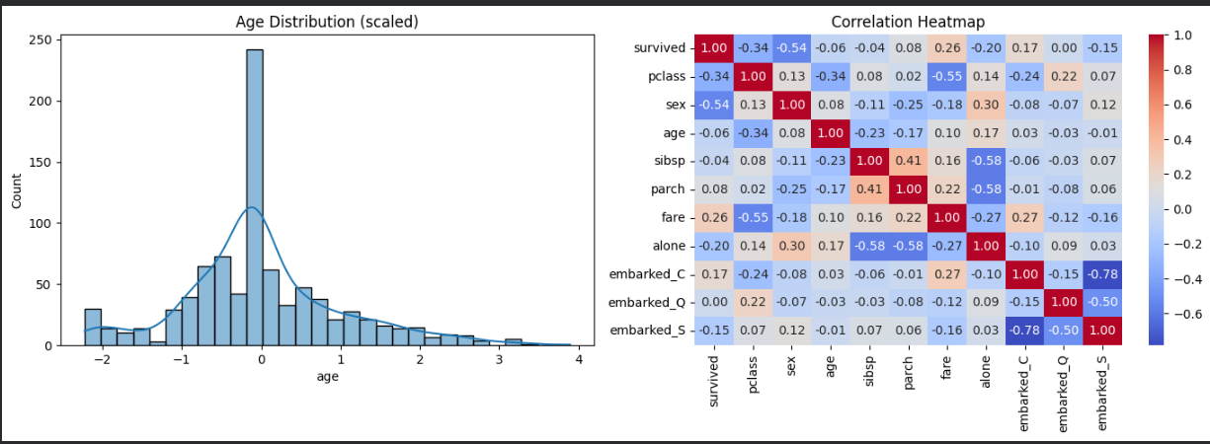
Figure 1: Age distribution (left) and correlation heatmap (right) of the processed dataset.
The heatmap shows that sex has the strongest correlation with survival (-0.54), followed by passenger class (-0.34) and fare (0.26) — consistent with the well-known historical pattern that women and higher-class, higher-fare passengers had better survival odds. sibsp and parch are moderately correlated with each other (0.41), as expected since both describe family group size.

5. Conclusion
This task walked through a complete, standard ML preprocessing pipeline on the Titanic dataset: inspecting raw data, handling missing values column-by-column with justified strategies, removing redundant features, encoding categorical variables appropriately for their cardinality, and scaling numeric features. The resulting dataset is fully numeric, has no missing values, and is ready to be used directly as input to a machine learning model. The EDA step also surfaced early insight into which features are likely to be strong predictors of survival, which will help guide feature selection in later stages of this internship.

