Week 2 Task Report

Supervised Machine Learning Models
AI Pioneers Internship (Machine Learning Internship) — Yuva Intern
Submitted by: D Niteesh Kumar

1. Objective
The objective of this task is to implement and compare multiple supervised machine learning classification algorithms — Logistic Regression, Decision Tree, Random Forest, and K-Nearest Neighbors (KNN) — by training each on the same dataset and evaluating their performance using standard classification metrics: Accuracy, Precision, Recall, and F1 Score.

2. Dataset and Preparation
This task builds directly on the Week 1 preprocessing pipeline. The cleaned, encoded, and scaled Titanic dataset (891 rows, 10 columns, zero missing values) was reused, with survived as the binary target variable and the remaining 9 columns as features. The data was split into training and test sets using an 80/20 split with stratified sampling on the target, to preserve the survived/not-survived ratio across both sets.
X = df.drop(columns=['survived'])
y = df['survived']
X_train, X_test, y_train, y_test = train_test_split(
X, y, test_size=0.2, random_state=42, stratify=y)
This produced 712 training samples and 179 test samples.

3. Models Trained
Four classification models were trained on the identical training set and evaluated on the identical held-out test set, so their performance is directly comparable:
- Logistic Regression — a linear model that estimates the probability of survival; simple, interpretable, and a good baseline.
- Decision Tree — splits the data on feature thresholds to form a tree of decision rules; captures non-linear patterns but can overfit.
- Random Forest — an ensemble of many decision trees whose predictions are averaged; generally more robust and less prone to overfitting than a single tree.
- K-Nearest Neighbors (KNN, k=5) — classifies a point based on the majority class among its 5 nearest neighbors in feature space; relies heavily on the feature scaling done in Week 1.
models = {
'Logistic Regression': LogisticRegression(max_iter=1000, random_state=42),
'Decision Tree': DecisionTreeClassifier(random_state=42),
'Random Forest': RandomForestClassifier(random_state=42),
'KNN': KNeighborsClassifier(n_neighbors=5)
}
for name, model in models.items():
model.fit(X_train, y_train)
y_pred = model.predict(X_test)

4. Results
Model | Accuracy | Precision | Recall | F1 Score
Logistic Regression | 0.8045 | 0.7833 | 0.6812 | 0.7287
Decision Tree | 0.8324 | 0.8000 | 0.7536 | 0.7761
Random Forest | 0.8101 | 0.7869 | 0.6957 | 0.7385
KNN | 0.8045 | 0.7742 | 0.6957 | 0.7328

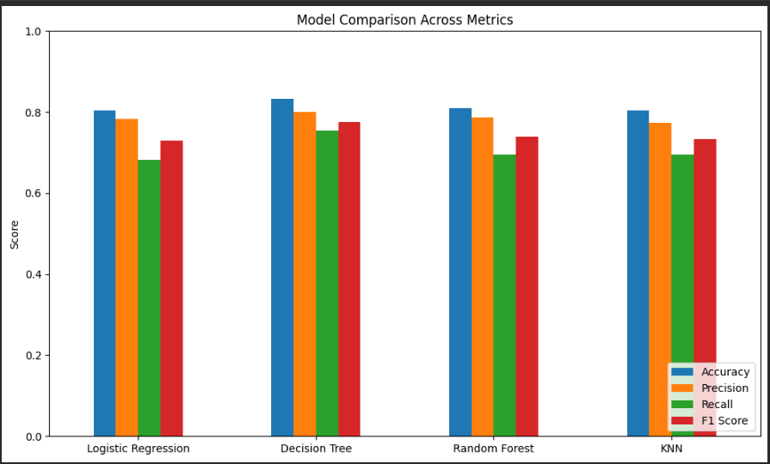
Figure 1: Accuracy, Precision, Recall, and F1 Score compared across all four models.
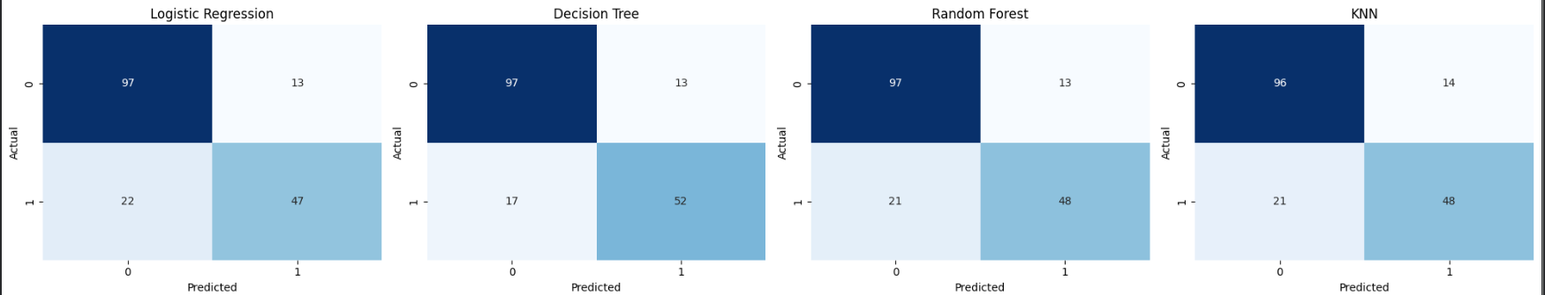
Figure 2: Confusion matrices for all four models on the test set (179 samples).

5. Analysis
The Decision Tree achieved the best score on every metric (Accuracy 0.832, F1 0.776), correctly identifying more survivors (52 true positives) than any other model while making fewer false negatives (17). Random Forest and KNN performed almost identically overall (~0.81 and ~0.80 accuracy respectively), with Logistic Regression close behind. All four models were noticeably better at identifying non-survivors than survivors, reflected in the higher false-negative counts (17–22) versus false-positive counts (13–14) across the board — consistent with the class imbalance in the original dataset (more passengers did not survive).
It is worth noting that Decision Tree outperforming Random Forest is somewhat atypical, since ensembles usually generalize better than a single tree. With a test set of only 179 samples, this gap is within the range of normal variance between models of similar strength, and would benefit from validation via k-fold cross-validation rather than a single train/test split to confirm it is a genuine effect and not sampling noise.

6. Conclusion
Four supervised classification models — Logistic Regression, Decision Tree, Random Forest, and KNN — were trained on the preprocessed Titanic dataset and evaluated using Accuracy, Precision, Recall, and F1 Score. The Decision Tree model produced the strongest results on this test split, though all four models performed comparably, in the 0.80–0.83 accuracy range. This task demonstrated the full supervised learning workflow: train/test splitting with stratification, training multiple algorithm types, and comparing them using multiple complementary metrics rather than accuracy alone, since precision and recall reveal class-specific performance that accuracy can mask.

