Week 3: Unsupervised Learning & Model Evaluation
AI Pioneers Internship – Machine Learning Internship
Submitted by: D.Niteesh Kumar
YUVA Internship Program

1. Objective
The objective of this task is to apply unsupervised machine-learning techniques to identify natural patterns in a dataset without using target labels during model training. The work compares K-Means clustering and Hierarchical Agglomerative Clustering on the Iris dataset. It also uses Principal Component Analysis (PCA) to reduce dimensionality for visualization and evaluates cluster quality with internal validation metrics.

2. Dataset Description
The Iris dataset was used for this experiment. It contains 150 flower observations, represented by four numerical measurements: sepal length, sepal width, petal length, and petal width. The dataset has three known species-setosa, versicolor, and virginica-but these labels were not supplied to either clustering algorithm during training. They are available only as contextual information for interpreting the discovered groups.

3. Methodology

Data preprocessing
The dataset was checked for missing values and then standardized with StandardScaler. Standardization gives each feature a comparable scale, preventing variables with larger numeric ranges from exerting excessive influence on distance-based clustering.

Dimensionality reduction
PCA was applied after scaling to transform the four-dimensional feature space into two principal components. The two-component representation was used for visual inspection of the cluster structure; model fitting and metric calculation were performed on the standardized four-feature data.

Clustering models
- K-Means clustering was fitted with k = 3, random_state = 42, and n_init = 10. It iteratively assigns observations to the nearest centroid and updates centroids to minimize within-cluster variation.
- Hierarchical Agglomerative Clustering was fitted with three clusters using Ward linkage. This bottom-up method begins with individual observations and successively merges groups to minimize the increase in within-cluster variance.
- The Elbow Method and silhouette analysis were calculated for k values from 2 to 7 to examine a reasonable number of K-Means clusters.
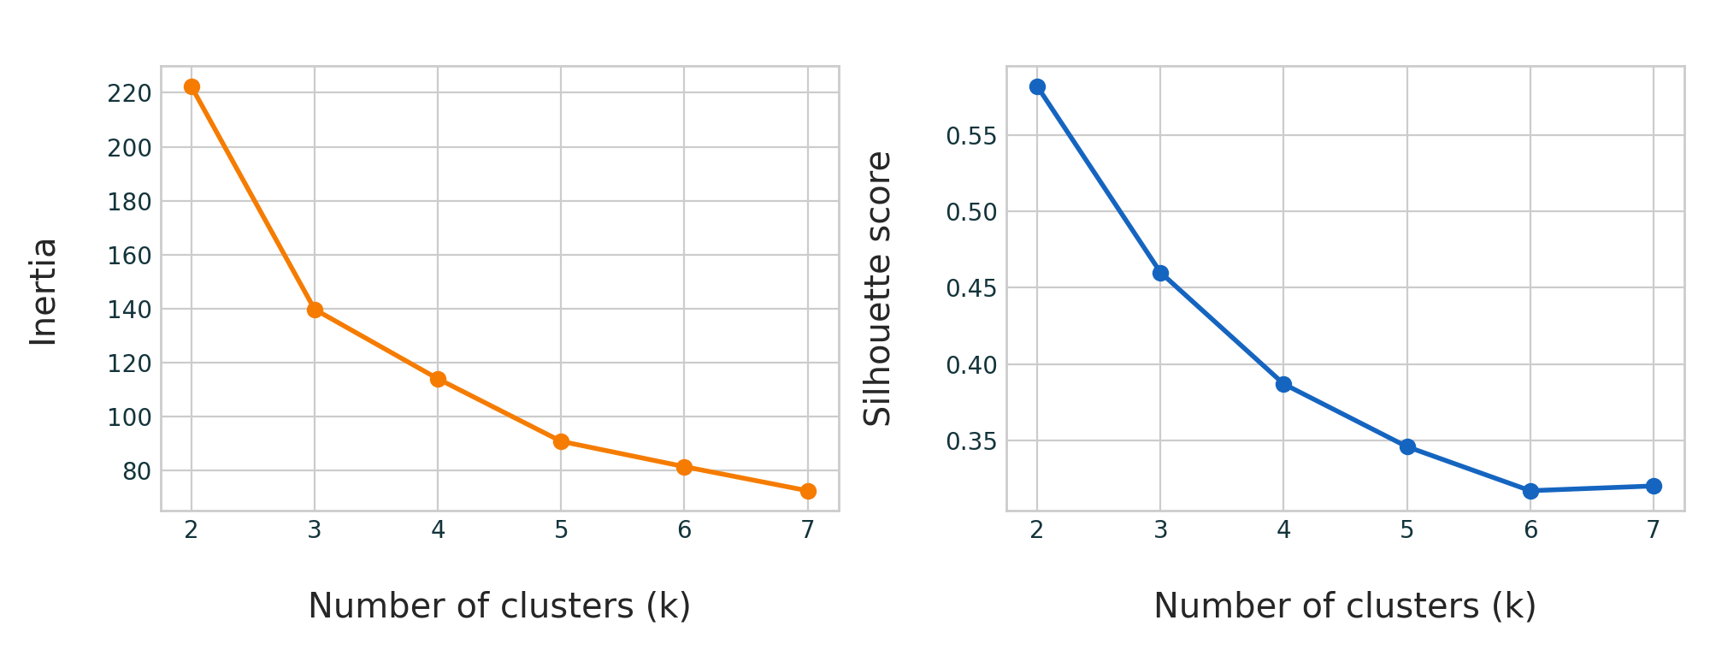
Figure 1. K-Means cluster-number assessment using inertia and silhouette score.

4. Results and Visualizations
The visualizations below show the clustering outputs projected into two PCA dimensions. The plots make it possible to inspect compactness, overlap, and separation between the groups. The dendrogram shows the successive cluster-merging structure produced by Ward linkage.
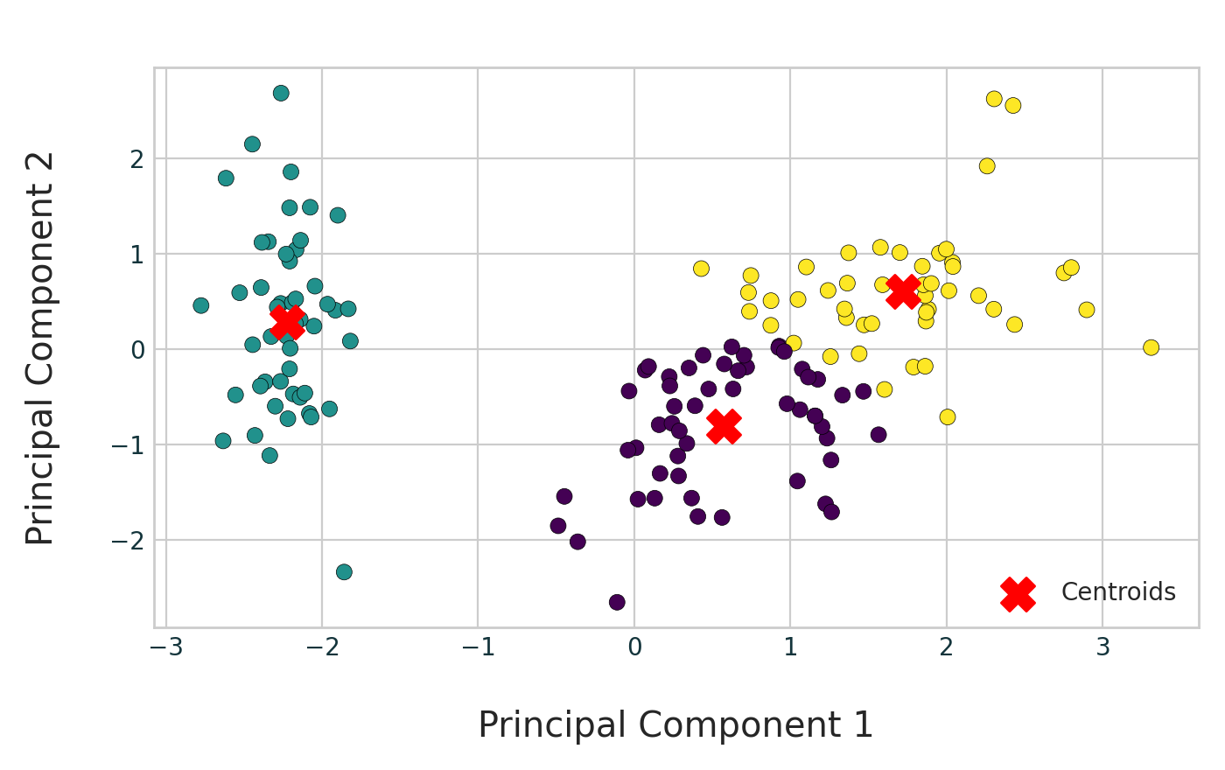
Figure 2. K-Means clustering projected into PCA space.
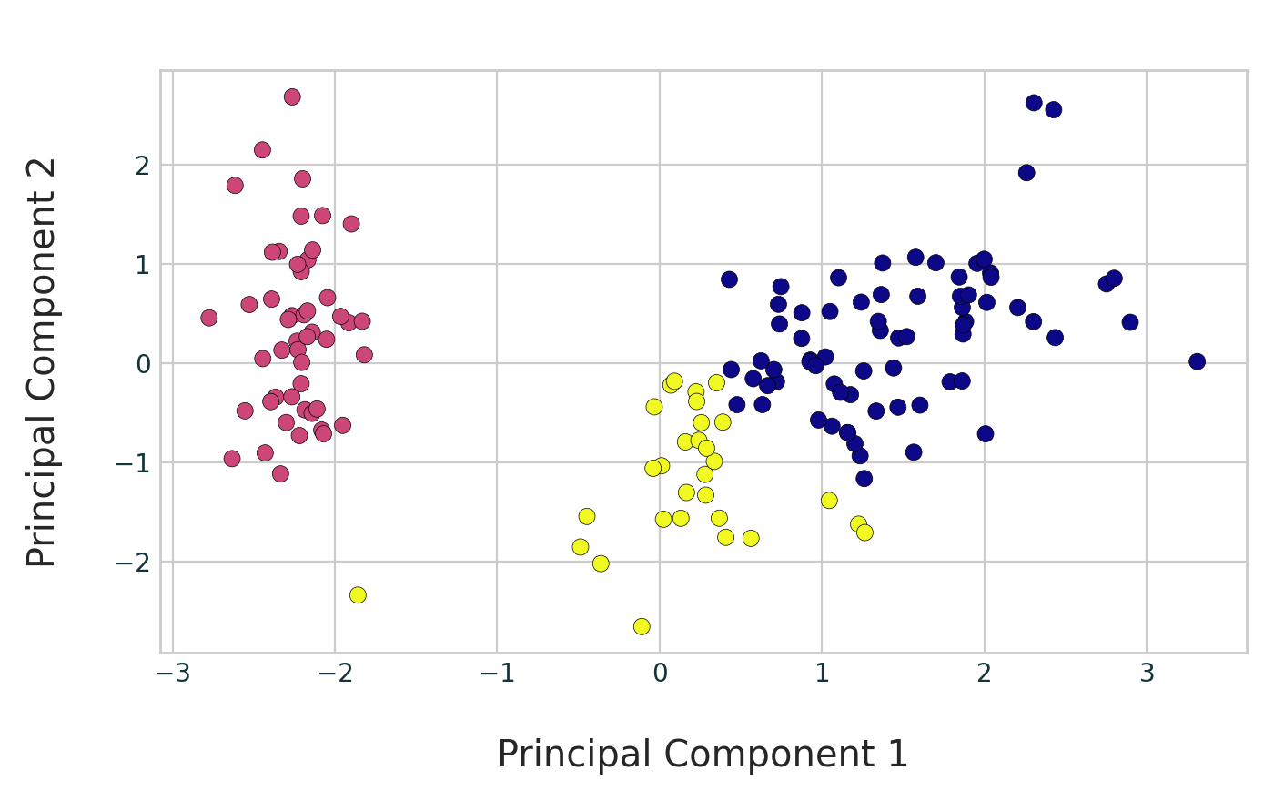
Figure 3. Hierarchical clustering projected into PCA space.
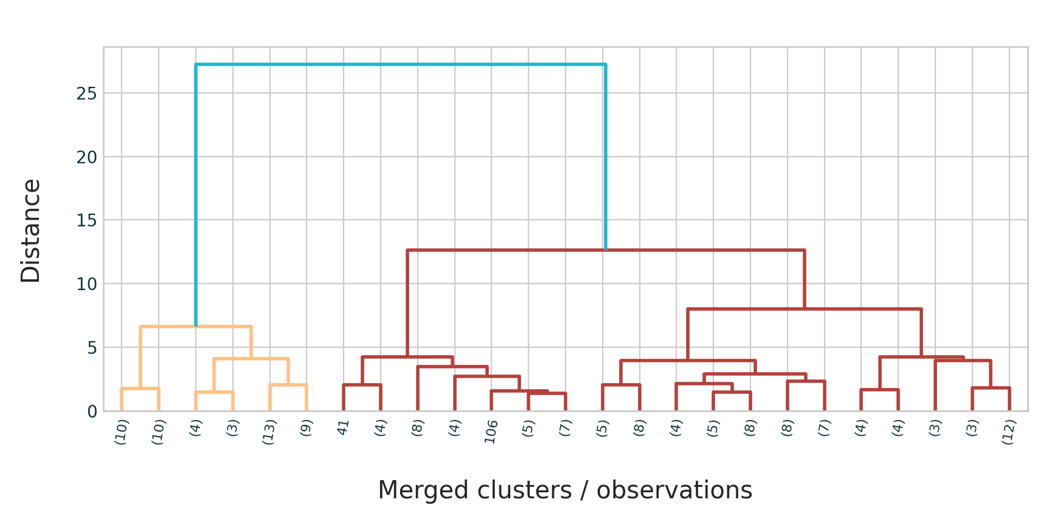
Figure 4. Ward-linkage hierarchical clustering dendrogram.

5. Model Evaluation
Three internal validation metrics were used. The Silhouette Score ranges from −1 to 1 and measures how similar each observation is to its assigned cluster compared with nearby clusters; higher values indicate clearer separation. The Davies–Bouldin Index assesses average cluster similarity, where lower values are preferred. The Calinski–Harabasz Score compares between-cluster dispersion with within-cluster dispersion, where higher values are preferred.
Model | Silhouette Score  (higher better) | Davies–Bouldin Index  (lower better) | Calinski–Harabasz Score  (higher better)
K-Means | 0.4599 | 0.8336 | 241.90
Hierarchical Clustering | 0.4467 | 0.8035 | 222.72
Table 1. Internal cluster-validation results computed on the standardized Iris features.
K-Means obtained the higher Silhouette Score (0.4599 versus 0.4467) and the higher Calinski–Harabasz Score (241.90 versus 222.72), indicating slightly stronger overall separation and cluster structure in this experiment. Hierarchical Clustering achieved the lower Davies–Bouldin Index (0.8035 versus 0.8336), which indicates a modest advantage under that metric. Since the metrics are close and do not all select the same model, the comparison should be interpreted cautiously. On balance, K-Means is selected as the preferred model because it leads on two of the three reported measures, including silhouette score.

6. Conclusion
This task demonstrated how unsupervised learning can reveal patterns without relying on class labels during training. Both K-Means and Hierarchical Clustering successfully partitioned the standardized Iris observations into three groups, and PCA made their structure easier to visualize. The evaluation shows that K-Means produced a marginally stronger clustering solution overall, although Hierarchical Clustering had a slightly better Davies–Bouldin Index. The exercise strengthened practical understanding of data scaling, dimensionality reduction, clustering algorithms, dendrogram interpretation, and internal model evaluation. Future work could test alternative linkage criteria, additional values of k, and other datasets to assess the stability of the clustering results.

7. Technologies Used
- Python
- Pandas and NumPy
- Matplotlib
- Scikit-learn
- SciPy
- Jupyter Notebook / Google Colab

8. References
1. Scikit-learn. The Iris Dataset documentation. https://scikit-learn.org/stable/auto_examples/datasets/plot_iris_dataset.html
2. Scikit-learn. Clustering documentation. https://scikit-learn.org/stable/modules/clustering.html
3. Scikit-learn. silhouette_score documentation. https://scikit-learn.org/stable/modules/generated/sklearn.metrics.silhouette_score.html

