**. JOSEPH’S COLLEGE OF ARTS & SCIENCE (AUTONOMOUS)**

**CUDDALORE-1**

**PG Department of Computer applications**

**Report on TECHXTRA 2K23**

Title of the Programme: TECHXTRA 2K23

Date : 20.09.2023

Venue : . Joseph’s college of arts & science (autonomous)

Cuddalore-1

The PG Department of Computer Applications organized an Intra-College departmental competition named "**TECHXTRA 2K24**" on 20.09.2023, from 9:30 AM to 5:00 PM. This event saw enthusia ic participation from udents of various departments of our college with the maximum participation of 150. The competition aimed to unite udents from various departments to demon rate their technical prowess, imulate innovation, and promote collaboration among young technologi s. All events provided udents with a valuable platform to present and be recognized for their exceptional technical solutions. Activities organized are ***Paper Presentation, Technical Quiz, Web Design, and Code Drive.***

.

**Organizing Secretaries**

**Invitation**

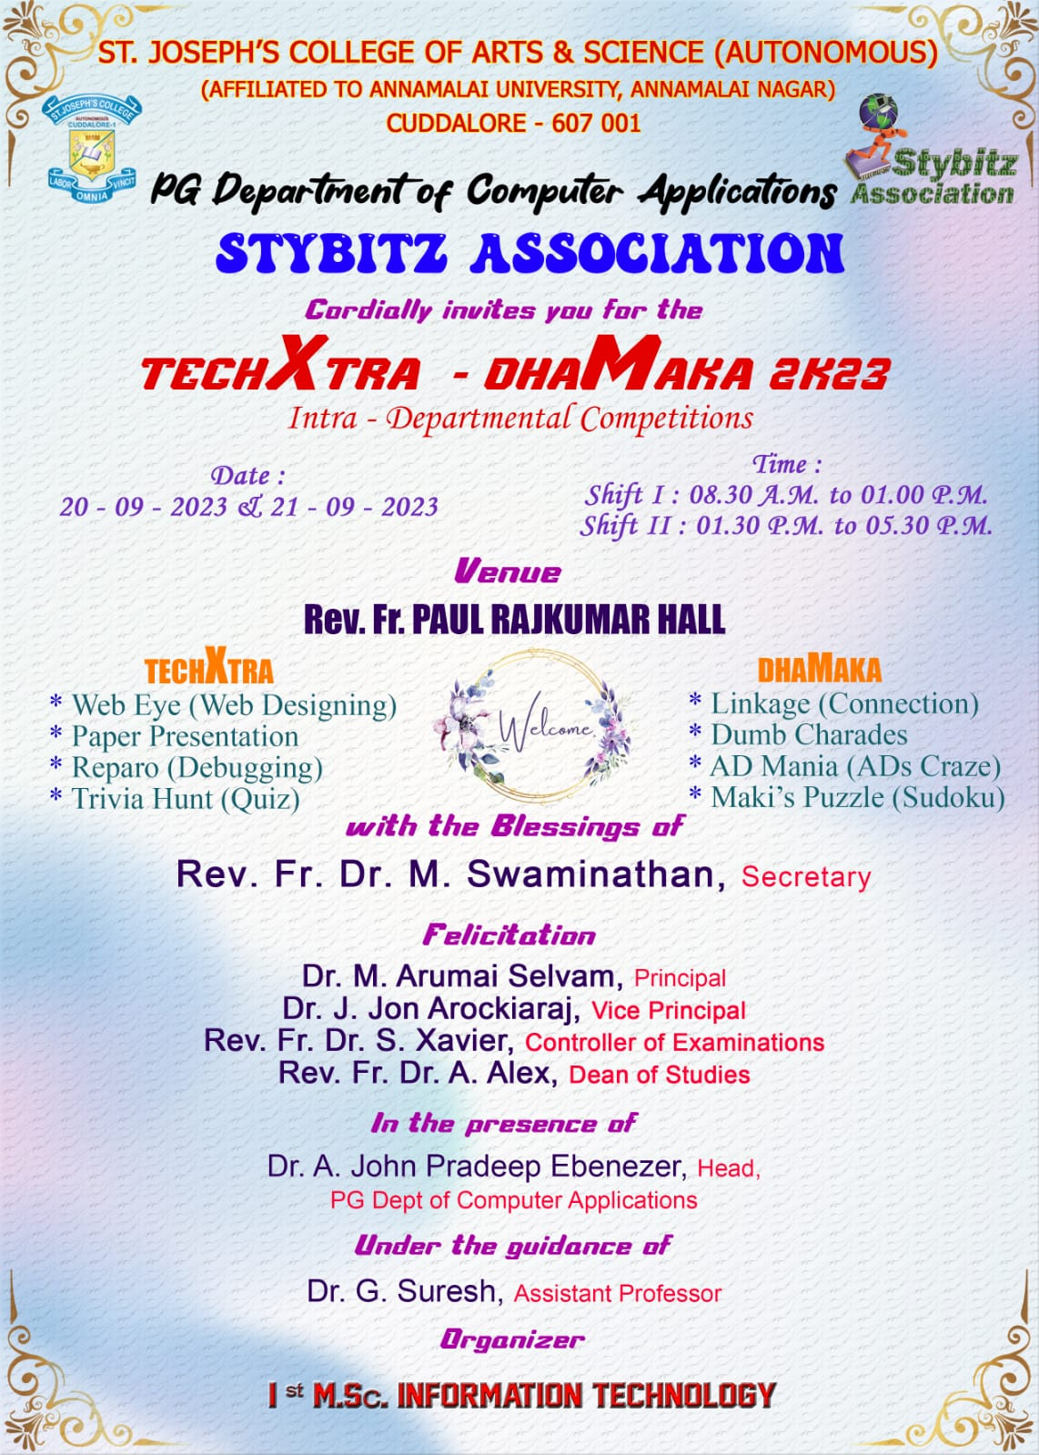

Banners

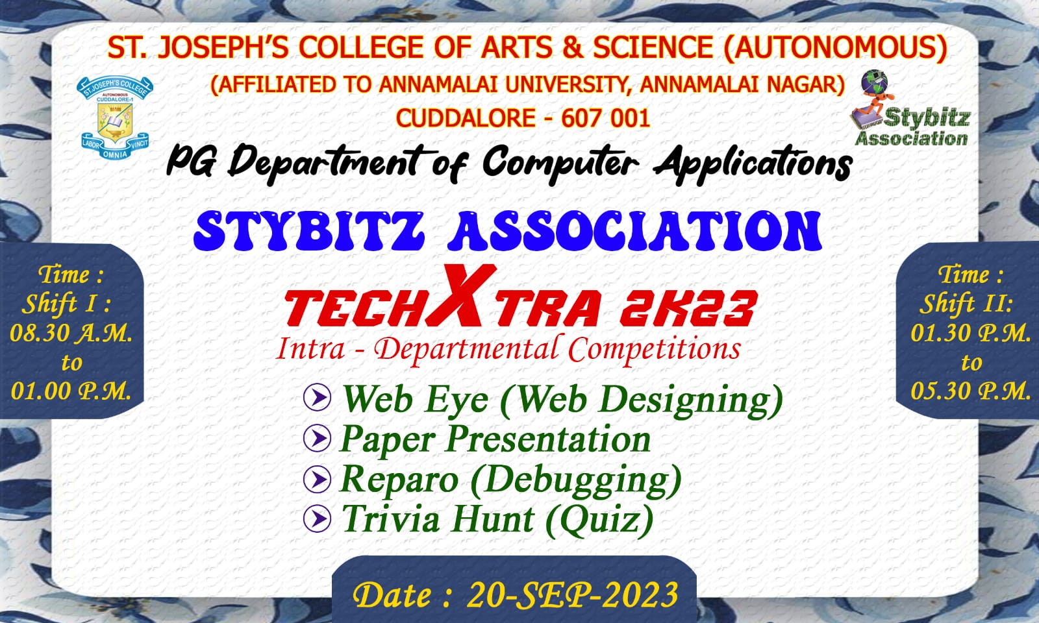

Photos

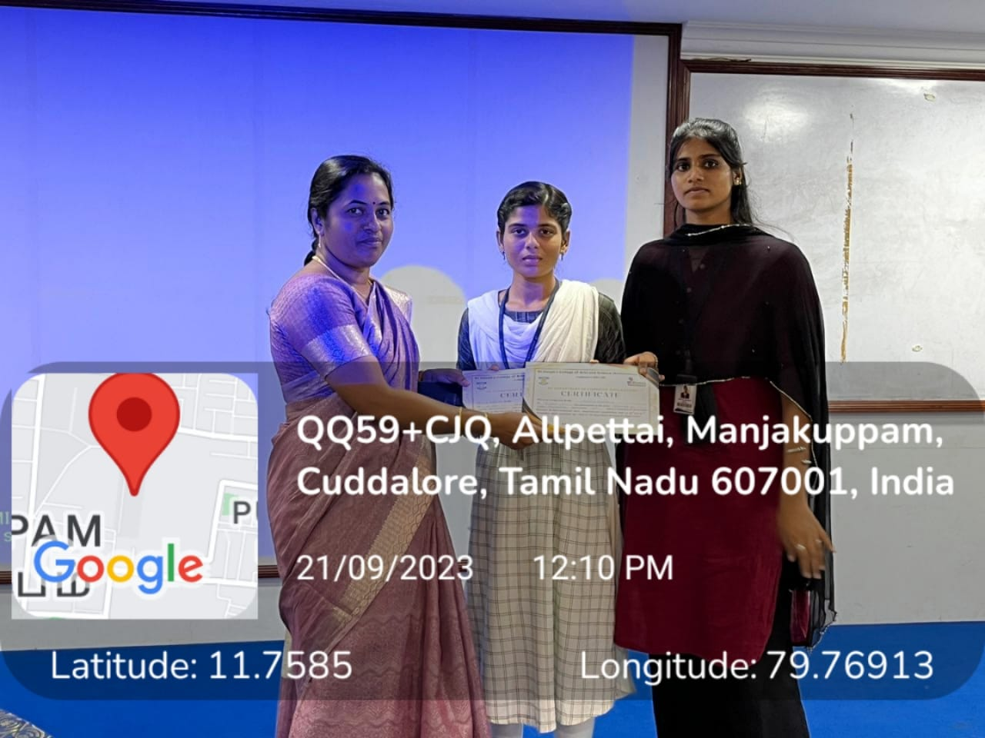

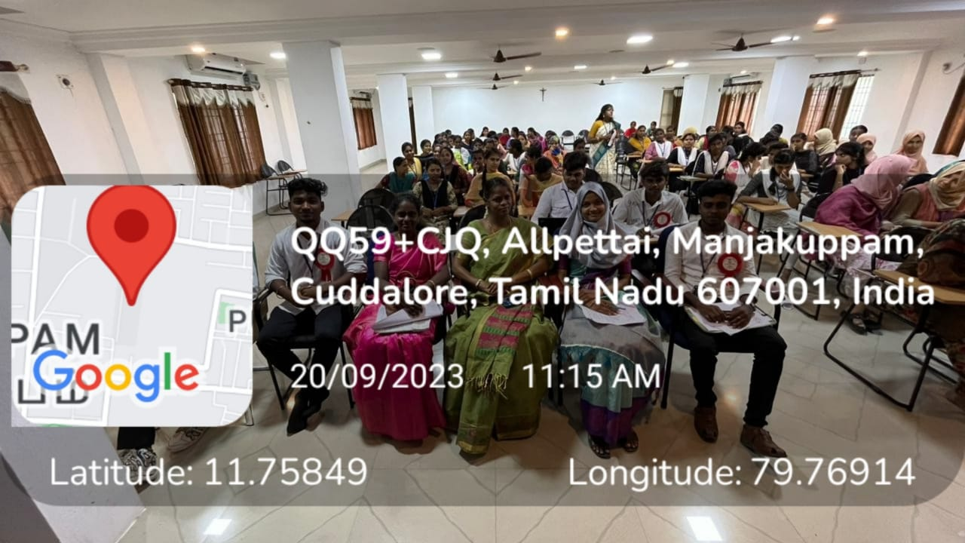

Certificate

**Participants li**

TECHXTRA (SHIFT-1)

|  |  |  |
| --- | --- | --- |
| **S.no** | **NAME** | **CLASS** |
|  | Jayakumar.G | 1 BCA-A |
|  | Emanuvel.A.R | 1 BCA-A |
|  | Akashraj.R | 1 BCA-B |
|  | Murugan.S | 1 BCA-B |
|  | Seenuvasan.R | 11 BCA-A |
|  | Rubesh Kumar.J | 11 BCA-A |
|  | Gopalakrishnan.A | 11 BCA-B |
|  | Visvasarathi.V | 11 BCA-B |
|  | Balaji.S | 111 BCA-A |
|  | Sri jaya simma nathi.V | 111 BCA-A |
|  | Feroz Khan.A | 111 BCA-B |
|  | Vishal.M | 111 BCA-B |
|  | Vijay.k | 1 BBA(CA) |
|  | Balakrishnan.P | 1 BBA(CA) |
|  | Mohamed Thaahir.M | 11 BBA(CA) |
|  | Sudharasan.V | 11 BBA(CA) |
|  | Mohammed Thoufik.T | 111 BBA(CA) |
|  | Raghul.M | 111 BBA(CA) |
|  | Arun Raj.S | 1 BCA-A |
|  | Sagaya Prajin.R | 1 BCA-A |
|  | Nithish Kumar.M | 1 BCA-B |
|  | Karthikeyan.V | 1 BCA-B |
|  | Ganesh.S.M | 11 BCA-A |
|  | Pasupathi.A | 11 BCA-A |
|  | Gokulraj.K | 11 BCA-B |
|  | Mohammed Noordeen.A | 11 BCA-B |
|  | Andrein.L | 111 BCA-A |
|  | Ravi Varma.J | 111 BCA-A |
|  | Newton Marconi.S | 111 BCA-B |
|  | Nithish Kumar.S | 111 BCA-B |
|  | Ajay.S | 111 BBA(CA) |
|  | Deepak.B | 111 BBA(CA) |
|  | Inba Thamizan.M | 1 BCA-A |
|  | Elamaran.R | 1 BCA-A |
|  | Thamizharasan.A | 1 BCA-B |
|  | Mohammed Safeek.S | 1 BCA-B |
|  | Anandha Kumar.P | 11 BCA-A |
|  | Bharath.A | 11 BCA-A |
|  | Pradhiswar Raj.K | 11 BCA-B |
|  | Vimal Raj.R | 11 BCA-B |
|  | Aijay.N | 111 BCA-A |
|  | Mohamed Basheer.Y | 111 BCA-A |
|  | Balaji.S | 111 BCA-B |
|  | Pavitharan.S | 111 BCA-B |
|  | Ugendran.J | 1 BBA(CA) |
|  | Prabakaran.U | 1 BBA(CA) |
|  | Aravinraj.M | 111 BBA(CA) |
|  | Delwins Jefforsou.D.S | 111 BBA(CA) |
|  | Samusel Mervin.M | 1 BCA-A |
|  | Bharani.S | 1 BCA-A |
|  | Vishuva Dhulasi.S | 1 BCA-B |
|  | Daniel Felix.L | 1 BCA-B |
|  | Anbuardeen.S | 11 BCA-A |
|  | Sriram.R | 11 BCA-A |
|  | Muhillan.V | 11 BCA-B |
|  | Priyadharshan.K | 11 BCA-B |
|  | Hariharan.A | 111 BCA-A |
|  | Giri Aswin.R | 111 BCA-A |
|  | Parthiban.M | 111 BCA-B |
|  | Rathinavel.S | 111 BCA-B |
|  | Senthamilzh.S | 1 BBA(CA) |
|  | Madhan Narendira.K.S | 1 BBA(CA) |
|  | Rakesh.S | 11 BBA(CA) |
|  | Naveen.M | 11 BBA(CA) |
|  | Mohammed Imran.M.A | 111 BBA(CA) |
|  | Manikandan.S | 111 BBA(CA) |
|  | Padma.P | 1 BCA-A |
|  | Shafana.H | 1 BCA-A |
|  | Madhunisha.C | 1 BCA-B |
|  | Divya.G | 1 BCA-B |
|  | Jafreena Rahima.J | 11 BCA-A |
|  | Shahin.M | 11 BCA-A |
|  | Balambika.T | 11 BCA-B |
|  | Jayashri.J | 11 BCA-B |
|  | Priyadharshana.D | 111 BCA-A |
|  | Padamashree.S | 111 BCA-A |
|  | Jocelyn Jenifer.V | 111 BCA-B |
|  | Rakshana.C | 111 BCA-B |
|  | Rabika.V | 1 BBA(CA) |
|  | Jayasri .V | 1 BBA(CA) |
|  | Nisha.A | 11 BBA(CA) |
|  | Nithiyashree.K | 11 BBA(CA) |
|  | Celine Sagayamary.J | 111 BBA(CA) |
|  | Bhuvana.M | 111 BBA(CA) |
|  | Kathija.A | 1 BCA-A |
|  | Fathimabanu.A | 1 BCA-A |
|  | Abiyagabriella A | 1 BCA-B |
|  | Athifa.S.M | 1 BCA-B |
|  | Mariyam Siddeeqa.N | 11 BCA-A |
|  | Monisha.D | 11 BCA-A |
|  | Kaviya.M | 11 BCA-B |
|  | Karthega.R | 11 BCA-B |
|  | Janani.S | 111 BCA-A |
|  | Saidha Fathima.K.F | 111 BCA-A |
|  | Aruna Devi.G | 111 BCA-B |
|  | Hema priya.L | 111 BCA-B |
|  | Sharanya.S | 1 BBA(CA) |
|  | Monika.S | 1 BBA(CA) |
|  | Pavithra.A | 11 BBA(CA) |
|  | Dhanujashree.J | 11 BBA(CA) |
|  | Swetha.K | 111 BBA(CA) |
|  | Najima.M | 111 BBA(CA) |
|  | Subashini.S | 1 BCA-A |
|  | Madhumitha.S | 1 BCA-A |
|  | Yogeshwari.M | 1 BCA-B |
|  | Anitha.M | 1 BCA-B |
|  | Keerthiga.S | 11 BCA-A |
|  | Lakshmi.S | 11 BCA-A |
|  | Shabeera Safrin.A | 11 BCA-B |
|  | Neeraja.B | 11 BCA-B |
|  | Sandhya.M | 111 BCA-A |
|  | Gajalakshmi.B | 111 BCA-A |
|  | Anitha.I | 111 BCA-B |
|  | Dhivya.S | 111 BCA-B |
|  | Kalai.M | 1 BBA(CA) |
|  | Rajeshwari.V | 1 BBA(CA) |
|  | Monishiy.H | 11 BBA(CA) |
|  | Dhasleem Banu.H | 11 BBA(CA) |
|  | Subanu.S | 111 BBA(CA) |
|  | Mugunthamala.B | 111 BBA(CA) |
|  | Hascera.S | 1 BCA-A |
|  | Juhaina.J | 1 BCA-A |
|  | Kezia Roseline.E | 1 BCA-B |
|  | Archana.V | 1 BCA-B |
|  | Sowmiya.K | 11 BCA-A |
|  | Kaviya.L | 11 BCA-A |
|  | Bharnika.G | 11 BCA-B |
|  | Durgalakshmi.A | 11 BCA-B |
|  | Harani.J | 111 BCA-A |
|  | Yamuna.M | 111 BCA-A |
|  | Dhanalakshmi .M | 111 BCA-B |
|  | Hemapriya.V | 111 BCA-B |
|  | Lakshitha.A | 1 BBA(CA) |
|  | Rekha.J | 1 BBA(CA) |
|  | Fazila Begum.A | 11 BBA(CA) |
|  | Monisha.N | 11 BBA(CA) |
|  | Hemambujavalli.B | 111 BBA(CA) |
|  | Shathya.P | 111 BBA(CA) |