# How to Test IMX390 Companding mode

<1> isp\v4l2_dev\inc\acamera_firmware_config.h:

#define HOBOT_NATIVE_WDR 1

#define SENSOR_DEFAULT_PRESET_MODE 11

<2> mipi_sif_isp_1936x1096_raw12.json

Copy to

install\test\config\mipi_sif_isp_1936x1096_raw12.json

<3> script:

ifconfig eth0 down;ifconfig eth0 hw ether 00:01:02:03:04:03; ifconfig eth0 up ; ifconfig eth0 192.168.1.03; sleep 1;mkdir -p /usr/nfslocal && cd /usr && mount 192.168.1.101:/home/fpga/share/nfsroot nfslocal -o nolock;cd /usr/nfslocal/jesse/isp; sh insert.sh;cd /usr/nfslocal/jesse/isp_andrew/install/test/bin/;export LD_LIBRARY_PATH=/usr/nfslocal/jesse/isp_andrew/install/lib/ && cd /usr/nfslocal/jesse/install/test/bin

./x2a_vio test_isp ./../config/mipi_sif_isp_1936x1096_raw12.json vio.log ./../config/sif_isp_empty_patch.json d 1 1 >/tmp/log

<4> get image:

Install/test/bin/

<5> Sensor: increase vmax of IMX390 to avoid isp_done fail issue

--- IMX390/IMX390_step3_390_4lane_1920x1080_raw12_25fps.txt

+++ IMX390_vmax/IMX390_step3_390_4lane_1920x1080_raw12_25fps.txt

-0x200d,0x11

+0x200d,0x44

<5> show image:

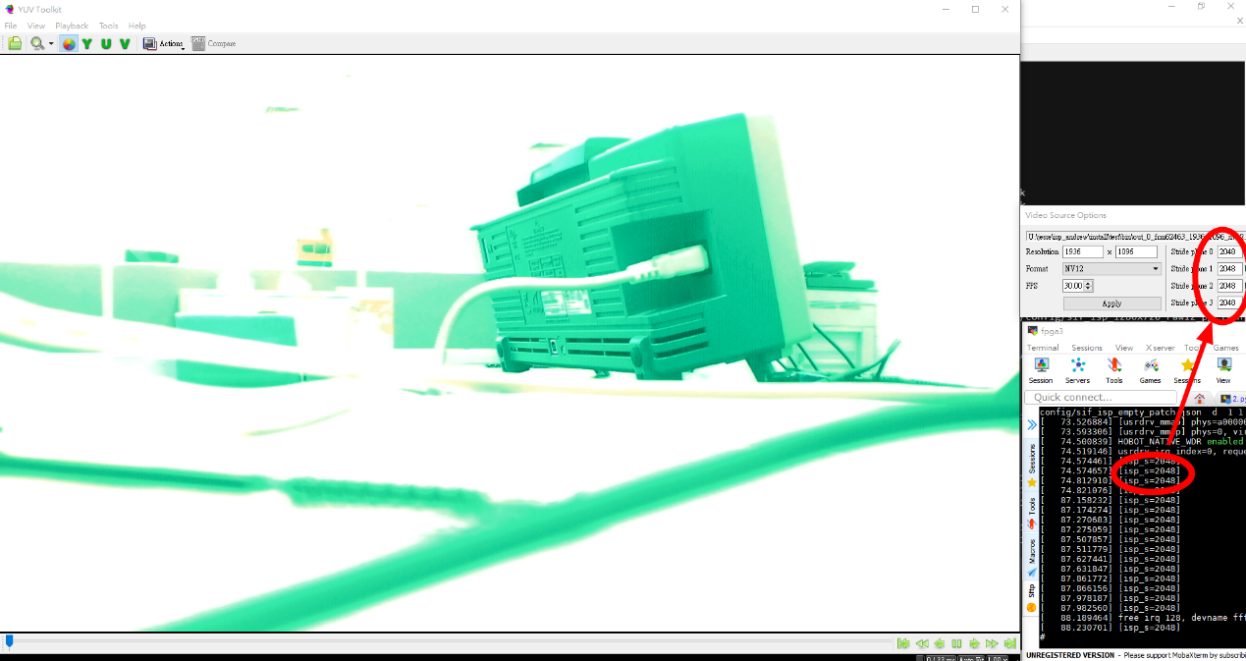

Remember to setting yuvToolkit “video source options” as 2048

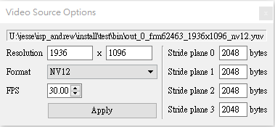

Stride size can be found in isp driver log “[isp_s=2048]”

# Companding mode的判定:

4/23與電話ARM AE: Will確認過這樣設定有打開Companding mode:

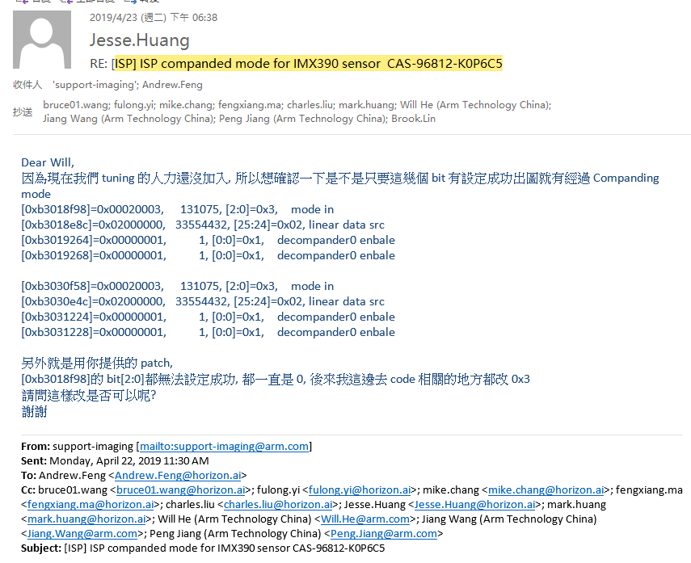

Patch 請參考isp_arm_native_wdr.rar

# Changelist:

Bitfile: x2a_0422_1852_isp.bit

Isp driver: 5cb761ac4d2acdaa6db5256fc6fc340f8eea0feb

Testbench: 5a3e6b36426780dae4f97154eafc45cd1dfa57c2