HPV Awareness Impact Analysis

Problem Statement: An interventional study to assess the level of awareness among youth regarding Human Papillomavirus (HPV) and its vaccination in District Sitapur.

# Objectives

1. Assess levels of awareness regarding HPV and its consequences.

2. Assess association between pre-test and post-test scores after teaching.

3. Determine knowledge regarding availability, schedule, and benefits.

# Data Cleaning

Raw demographic, pre-test, and post-test tables were ingested, cleaned, merged, and mapped to human-readable labels. Final dataset shape: 58 rows × 20 columns.

## Data Dictionary

|  |  |
| --- | --- |
| Variable | Description |
| Age | Age group categories |
| Gender | Biological sex |
| Place_of_Residency | Type of area where participant resides |
| Education | Highest education level attained |
| Vaccination_Status | HPV vaccination status |
| Health_Care_Access | Accessibility to healthcare services |
| Occupation_of_Parents | Occupation category of parents |
| Family_Income_per_Month | Monthly family income brackets |
| pre_test_score | Score before the educational intervention |
| post_test_score | Score after the educational intervention |
| score_improvement | Improvement in score (post - pre) |

# Exploratory Data Analysis

We examined participant demographics and score distributions.

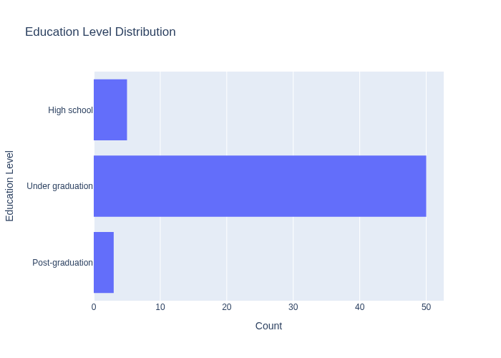

Education Distribution

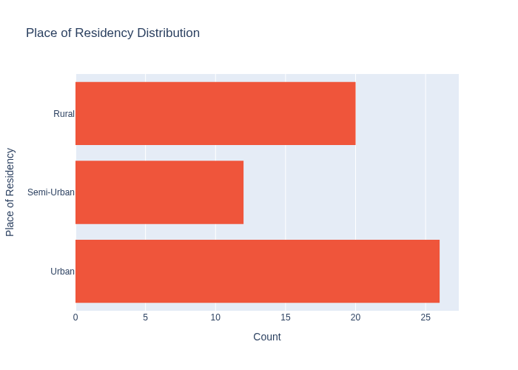

Residency Distribution

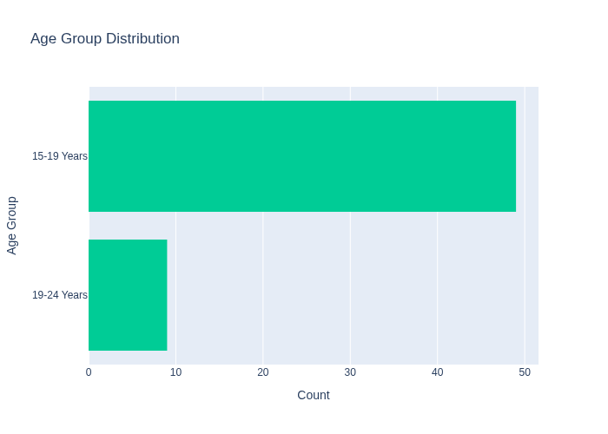

Age Group Distribution

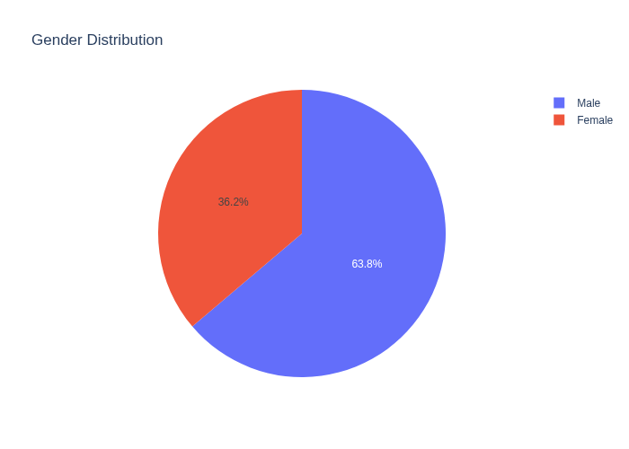

Gender Distribution

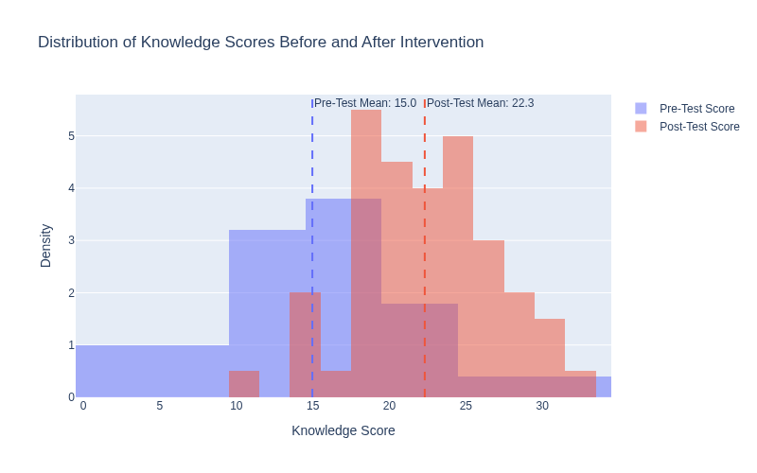

Knowledge Score Distribution

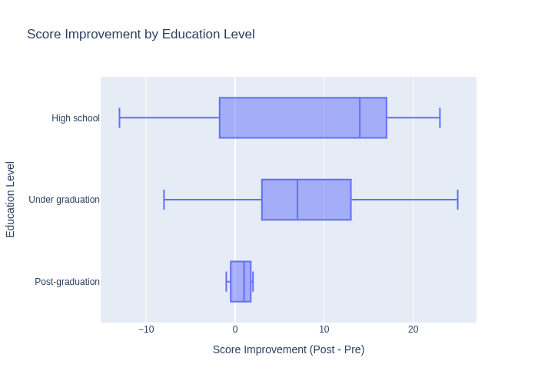

Score Improvement Education

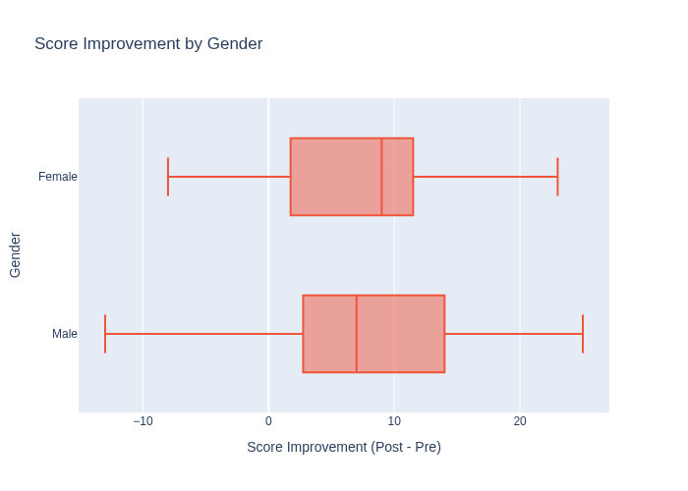

Score Improvement Gender

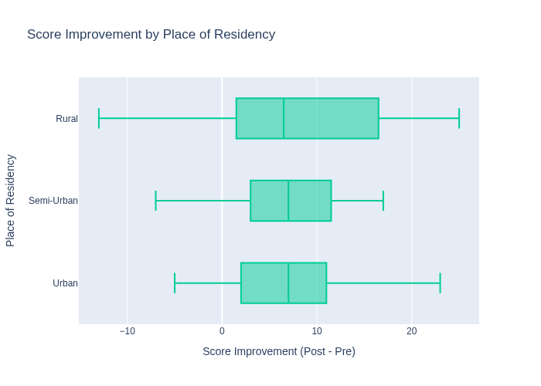

Score Improvement Residency

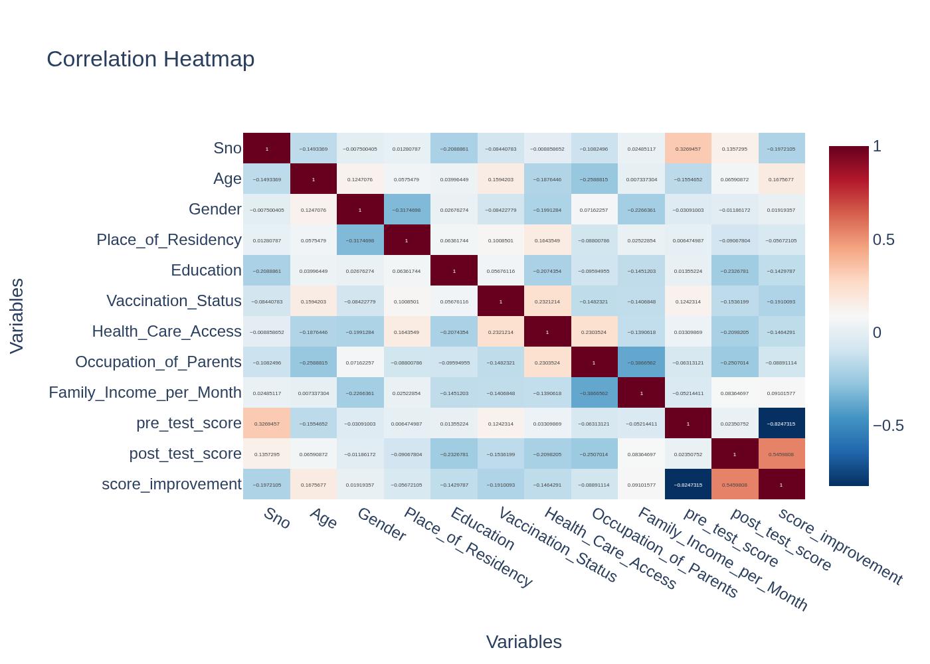

Correlation Heatmap

# Statistical Analysis

|  |  |  |  |
| --- | --- | --- | --- |
| Test | Statistic | p-value | Significance |
| Shapiro (Pre) | 0.953 | 0.024 | ★ |
| Shapiro (Post) | 0.988 | 0.819 | • |
| Paired t-test | 6.995 | 0.000 | ★ |
| Wilcoxon | 151.000 | 0.000 | ★ |
| ANOVA (Education) | 1.118 | 0.334 | • |

Cronbach's Alpha (Pre): 0.858

Cronbach's Alpha (Post): 0.736

Cohen's d: 1.28 (large effect if >0.8)

Statistical Power: 1.000

# Conclusions & Insights

• Intervention significantly improved knowledge (p<0.001, large effect size).

• Improvement strongest among undergraduates and rural groups need additional support.

• Reliability of survey instruments acceptable (Cronbach’s α > 0.7).

• Low baseline participants benefited most, demographics had minimal influence.