**Brain tumor detection from MRI images**

D Sainath Reddy

**Introduction**

1. Overview

Brain tumor identification is really challenging task in the early stages of life. But now it became advanced with various machine learning algorithms. Now a day’s issue of brain tumor automatic identification is of great interest. A tumor is the unusual growth of the tissues. A brain tumor is a number of unnecessary cells growing in the brain or central spine canal.  
It is the unrestrained progress of cancer cells in any portion of the body. In Order to detect the brain tumor of a patient, we consider the data of patients like MRI images of a patient’s brain. Here our problem is to identify whether the tumor is present in the patient's brain or not. It is very important to detect the tumors at the starting level for a healthy life of a patient.

1. Purpose

In this project, a method is introduced to detect brain tumor cancer by using Deep learning techniques. The main objective is to detect the tumor present in the brain. We are using convolution neural networks to train the model with brain MRI images.  
A web application is built which in turn is integrated with the model. The web interface will allow the user to upload an image this image is processed by deep learning model and prediction is displayed on web UI.

**Literature Survey**

1. Existing Problem

Detecting brain tumor in its early stages is not an easy task. We can’t wait for body to show the effects of tumor. Also, there is possibility of misinterpreting by a human about the presence or absence of tumor in the brain

1. Proposed Solution

We can improve the accuracy of predicting a tumor and reducing the time to detect it by building a model using CNN to detect brain tumors from MRI images. We can’t develop a software which could tell the presence of tumor because we don’t understand the logic behind it, so we develop a neural network and train it using examples such that it will recognise tumor. We use feedforward and backpropagation to calculate and minimize the loss we calculated using cross entropy

**Theoretical Analysis**

1. Block Diagram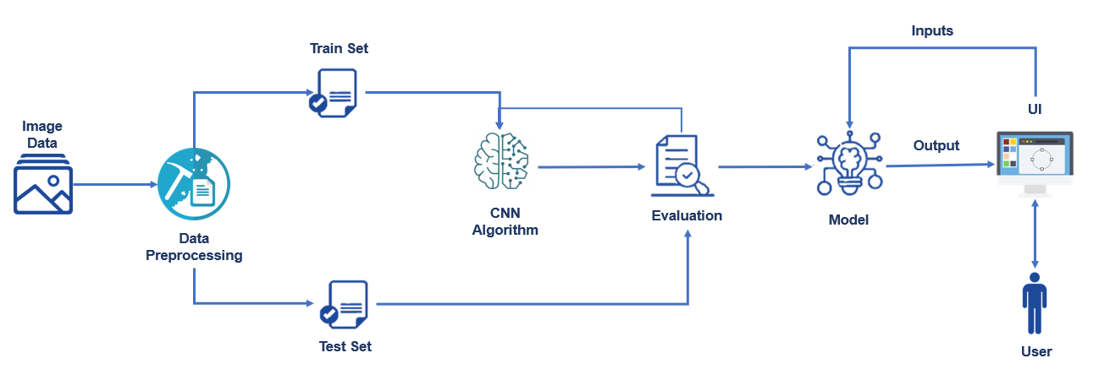
2. Hardware/Software Designing

We start building the project by doing data collection, in this step we collect datasets required to train the neural network and split data into train sets and test sets.

Then we pre-process the data by importing pre-processing libraries and configure and apply them so that we will be able to use data to train our model.

In Model Building to build the model, we follow several steps like

Importing the Model Building Libraries

Initializing the Model

Loading the pre-processed data

Adding CNN layers

Adding Dense Layers

Configure the learning process

Training and testing the model

Optimising the model

Saving the model

Then we will be building a web application which is integrated to the model we built. An UI is provided for the uses where we have to upload a picture/photo. The uploaded photo is given to the model built, and prediction is showcased on the UI.

**Experimental Investigations**

The Model developed will have more accuracy if we have datasets of bigger size and if we can train the model for more number of epochs.

**Flowchart**

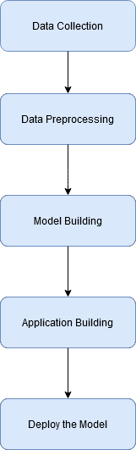

**Results**

We get a model which uses CNN to detect brain tumors from MRI Images which will have an accuracy of 86% after training it 40 times(epochs) using a train set containing 176 images belonging to 2 classes

**Advantages and Disadvantages**

Predictive modelling is beneficial compared to human judgement because predictions based on analysing data are found to be more reliable. We can improve our model accuracy if we improve the amount of data available to train and if we improve the number of times we train the model

**Applications**

The growing dependence of many companies on web applications and mobile applications has led to place increased priority on digital platform in an effort to improve the user’s overall experience. This application will help to calculate the requirements for tumor presence very easily. The benefits will be in terms of speedy, smooth and faster operations involved in diagnosing and treating brain tumors

**Conclusion**

With this application, we are helping the doctors and patients to classify the type of scan for the specific image given with the help of Neural Networks and store the patient's data.

**Future Scope**

As technology is evolving we could implement this model into a mobile application. This will result in easier diagnosis and reduce amount of time & money which goes to detect the tumor.

**Appendix**

1. Source Code

Base.html

<html lang="en">

<head>

<meta charset="UTF-8">

<meta name="viewport" content="width=device-width, initial-scale=1.0">

<meta http-equiv="X-UA-Compatible" content="ie=edge">

<title>Tumor Detection</title>

<link href="https://cdn.bootcss.com/bootstrap/4.0.0/css/bootstrap.min.css" rel="stylesheet">

<script src="https://cdn.bootcss.com/popper.js/1.12.9/umd/popper.min.js"></script>

<script src="https://cdn.bootcss.com/jquery/3.3.1/jquery.min.js"></script>

<script src="https://cdn.bootcss.com/bootstrap/4.0.0/js/bootstrap.min.js"></script>

<link href="{{ url_for('static', filename='css/main.css') }}" rel="stylesheet">

<style>

.bg-dark {

background-color: #42678c!important;

}

#result {

color: #0a1c4ed1;

}

</style>

</head>

<body>

<nav class="navbar navbar-dark bg-dark">

<div class="container">

<a class="navbar-brand" href="#">Brain Tumor Detection using MRI Images</a>

</div>

</nav>

<div class="container">

<div id="content" style="margin-top:2em">

<div class="container">

<div class="row">

<div class="col-sm-6 bd" >

<h3>Tumor Detection</h3>

<br>

<p>Brain tumor identification is really challenging task in the early stages of life. But now it became advanced with various machine learning algorithms. Now a day’s issue of brain tumor automatic identification is of great interest. A tumor is the unusual growth of the tissues. A brain tumor is a number of unnecessary cells growing in the brain or central spine canal.It is the unrestrained progress of cancer cells in any portion of the body. In Order to detect the brain tumor of a patient, we consider the data of patients like MRI images of a patient’s brain. Here our problem is to identify whether the tumor is present in the patient's brain or not. It is very important to detect the tumors at the starting level for a healthy life of a patient.</p>

<img src="https://images.medicinenet.com/images/article/main_image/what-were-your-first-signs-of-a-brain-tumor.jpg" style="height:300px"class="img-rounded" alt="Gesture">

</div>

<div class="col-sm-6">

<div>

<h4>Please upload MRI Image for Tumor Detection</h4>

<form action = "http://localhost:5000/predict" id="upload-file" method="post" enctype="multipart/form-data">

<label for="imageUpload" class="upload-label">

Upload

</label>

<input type="file" name="image" id="imageUpload" accept=".png, .jpg, .jpeg">

</form>

<div class="image-section" style="display:none;">

<div class="img-preview">

<div id="imagePreview">

</div>

</div>

<div>

<button type="button" class="btn btn-info btn-lg " id="btn-predict">Click to check for the presence of tumor</button>

</div>

</div>

<div class="loader" style="display:none;"></div>

<h3>

<span id="result"> </span>

</h3>

</div>

</div>

</div>

</div>

</div>

</div>

</body>

<footer>

<script src="{{ url_for('static', filename='js/main.js') }}" type="text/javascript"></script>

</footer>

</html>

App.py

# -*- coding: utf-8 -*-

"""

Created on Sun Dec 27 16:59:04 2020

@author: Sainath

"""

from __future__ import division, print_function

import sys

from flask import Flask,url_for,request,render_template

#request to request the image and render to render the page

import os

from werkzeug.utils import secure_filename

#this was imported only for secure_filename

app = Flask(__name__)

from tensorflow.keras.models import load_model

from keras import backend

from tensorflow.keras import backend

from tensorflow.keras.preprocessing import image

import numpy as np

#import tensorflow as tf is not working so we use

import tensorflow.compat.v1 as tf

tf.disable_v2_behavior()

global graph

graph=tf.get_default_graph()

model=load_model('mri.h5')

@app.route('/',methods=['GET'])

def index():

return render_template("base.html")

@app.route('/predict',methods=['GET','POST'])

def upload():

if request.method == 'POST':

f=request.files['image']

basepath=os.path.dirname(__file__)

#gives path of folder in which app.py is present

print('current path: ',basepath)

file_path=os.path.join(basepath,'uploads',secure_filename(f.filename))

#we are saving the image we uploaded in the uploads folder ,next we save it

#u get file path as result by addng base path ,uploads and filename

f.save(file_path)

print('joined path: ',file_path)

img=image.load_img(file_path,target_size=(64,64))

x=image.img_to_array(img)

x=np.expand_dims(x,axis=0)

with graph.as_default():

preds=model.predict_classes(x)

print(preds)

index=['No','Yes']

text='Presence of Tumor : '+index[preds[0]]

return text

if __name__=="__main__":

app.run(debug=False,threaded=False)

1. Screenshots

