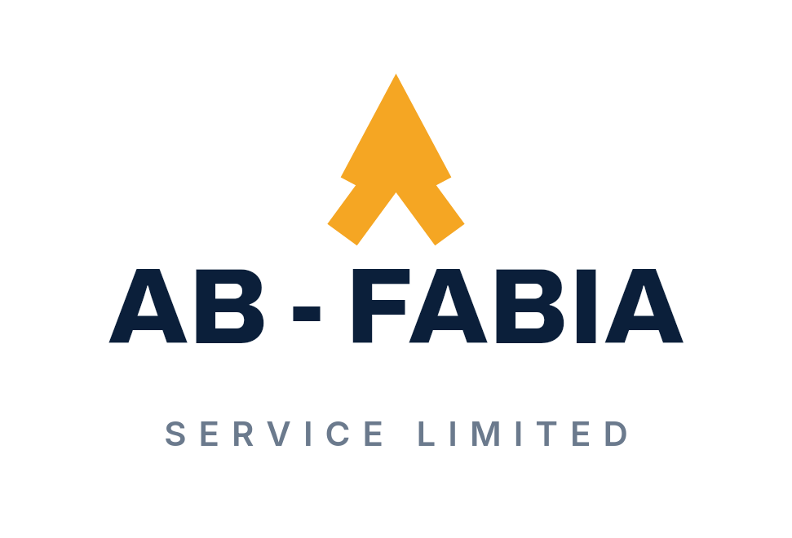
AB-FABIA SERVICE LIMITED
INTEGRATED EPC & ENERGY SERVICES
Engineering • Procurement • Construction • Energy Services
Precision. Procurement. Performance.
EST. 2002
PORT HARCOURT, RIVERS STATE, NIGERIA
CORPORATE CAPABILITY PROFILE · VERSION 1.0

CONTENTS
Tip: in Word, right-click the contents and choose "Update Field" to refresh page numbers after any edit.

01 WHO WE ARE
AB-FABIA SERVICE LIMITED is an indigenous Nigerian integrated engineering, procurement, construction and energy-services company with capabilities spanning EPC delivery, oilfield services, drilling fluids, technical product supply, civil and infrastructure works, marine services and surveying.
The company has developed from a specialist foundation in drilling-chemical procurement and oilfield technical support into a broader integrated delivery organization.
AB-FABIA combines technical expertise, procurement capability, project execution, field operations and specialist energy services to support clients across demanding industrial and infrastructure environments.
One organization · Multiple technical capabilities · Integrated delivery

Capability Overview
EPC
Engineering · Procurement · Construction · Commissioning
ENERGY
Oilfield Services · Products · Logistics
SPECIALIST TECHNICAL
Drilling Fluids · Surveying · Marine · Infrastructure
Integrated capability. Specialist expertise. Practical delivery.

02 OUR STORY
FROM SPECIALIST EXPERTISE TO INTEGRATED DELIVERY
1999 · SPECIALIST PROCUREMENT FOUNDATION
AB-FABIA's roots developed through drilling-chemical procurement and supply, including specialist support to oilfield operations, trading as AB-Fabia Services.
2002 · FORMAL INCORPORATION
AB-FABIA SERVICE LIMITED was formally incorporated in Nigeria.
DEVELOPMENT · EXPANDING TECHNICAL DEPTH
The company developed further capability in drilling fluids, mud engineering, technical chemical supply, logistics and associated field support.
CAPABILITY INTEGRATION · ENGINEERING & INFRASTRUCTURE
The organization expanded into broader engineering, construction, infrastructure, marine and surveying capabilities.
INTEGRATION · BROADER PROFESSIONAL CAPABILITY
The capabilities and professional experience associated with the former 1st Support Services organization became part of AB-FABIA's broader corporate capability.
TODAY · INTEGRATED EPC & ENERGY SERVICES
AB-FABIA brings together engineering, procurement, construction, energy services and specialist technical capability within one expanding organization.

03 OUR CAPABILITIES
AB-FABIA's capability is organized around integrated delivery rather than a flat list of disconnected services.

01 · ENGINEERING & EPC
Concept-to-commissioning technical delivery.
- Engineering & Design
- Procurement
- Project Management
- Construction
- Fabrication
- Installation
- Commissioning
- Operations & Maintenance

02 · ENERGY & OILFIELD SERVICES
Specialist fluids, products and field support.
- Drilling Fluids
- Mud Engineering
- Drilling / Completion / Workover Fluid Support
- Technical Chemical Supply
- Fluid Facilities
- Field Technical Support
- Oilfield Logistics

03 · CIVIL & INFRASTRUCTURE
Land-based construction and public infrastructure.
- Earthworks
- Roads
- Drainage
- Buildings
- Bridges
- Structural Works
- Industrial Facilities
- Water Infrastructure

04 · MARINE & WATERWAYS
Dredging and marine environment works.
- Dredging
- Piling
- Reclamation
- Canalization
- Shore Protection
- Marine Structures
- Hydrological Services

05 · SURVEYING & GEOMATICS
Field information for planning and execution.
- Topographic Surveying
- Hydrographic Surveying
- Route Surveying
- Positioning
- Related Field Survey Services

04 ENERGY & OILFIELD SERVICES
AB-FABIA combines specialist oilfield knowledge with procurement, technical support, logistics and field execution capability.

DRILLING FLUIDS & MUD ENGINEERING
Fluid formulation, technical support, mud-engineering services and field operations.

CHEMICAL SUPPLY
Drilling, completion and workover chemical products supported by technical knowledge of their application.

FLUID FACILITIES
Mud and bulk facilities, storage, mixing, filtration and related field-support infrastructure where applicable.

TECHNICAL FIELD SUPPORT
Practical technical support for demanding drilling and oilfield environments.

LOGISTICS & SUPPLY
Procurement, materials coordination, storage and operational logistics.

Supporting Facilities
Supporting infrastructure includes a mud and bulk plant at Onne, a mud laboratory with field kits and units, warehouses in Port Harcourt and associated materials-handling equipment.
Specialist technical knowledge supported by practical field capability.

05 ENGINEERING, PROCUREMENT & CONSTRUCTION
AB-FABIA integrates engineering, procurement and project execution to provide clients with coordinated delivery from concept and planning through construction, commissioning and operational support.

ENGINEERING
- Civil
- Structural
- Mechanical
- Chemical / Process
- Project Engineering
- Technical Planning

PROCUREMENT
- Materials sourcing
- Vendor coordination
- Supply-chain management
- Technical procurement
- Logistics coordination

CONSTRUCTION
- Site development
- Civil works
- Structural works
- Facilities
- Industrial construction
- Fabrication
- Installation

PROJECT DELIVERY
- Planning
- Coordination
- Supervision
- Quality control
- HSE oversight
- Commissioning
- Handover
Engineering decisions, procurement discipline and field execution working as one delivery system.

06 CIVIL, INFRASTRUCTURE & MARINE

CIVIL & INFRASTRUCTURE
- Earthworks
- Roads
- Drainage
- Water systems
- Buildings
- Bridges
- Industrial facilities
- Structural works

MARINE & WATERWAYS
- Dredging
- Piling
- Reclamation
- Canalization
- Sand stockpiling
- Shore protection
- Jetties
- Marine structures
- Hydrological services
The capability developed through the integrated technical organization allows AB-FABIA to work across land-based, industrial and marine environments.

07 SURVEYING & GEOMATICS
Surveying supports AB-FABIA's engineering, infrastructure, marine and construction activities by providing field information required for planning, design, positioning and execution.

Capabilities
- Topographic Survey
- Hydrographic Survey
- Route Survey
- Positioning
- Field Data Collection
- Engineering Survey Support

Applications
- Infrastructure
- Roads
- Marine Works
- Construction
- Site Development
- Engineering Planning

08 DRILLING FLUIDS & TECHNICAL PRODUCTS
One of AB-FABIA's major specialist strengths is its technical depth in drilling, completion and workover fluid systems.

Product Families
- Weighting Agents
- Viscosifiers & Rheology Modifiers
- Fluid-Loss Control Materials
- Lubricants
- Shale / Formation Control
- Lost-Circulation Materials
- Biocides
- Corrosion Inhibitors
- Defoamers
- Brines & Salts
- Drill-In Fluid Systems
- Completion & Workover Products
- Specialty Chemicals

Technical Documentation
Detailed product specifications, technical data and application information are available through AB-FABIA's technical and product documentation.

09 HOW WE DELIVER
01 · UNDERSTAND
Client requirement, operating environment and delivery objectives.
02 · ENGINEER
Technical assessment, planning, design and solution development.
03 · PROCURE
Materials, equipment, specialist products and supply-chain coordination.
04 · EXECUTE
Construction, installation, field operations and technical delivery.
05 · CONTROL
Project supervision, HSE, QA/QC and execution monitoring.
06 · COMMISSION
Testing, completion, handover and technical close-out.
07 · SUPPORT
Operations, maintenance and technical support where required.
AB-FABIA's integrated model reduces fragmentation between technical planning, procurement and field execution.

10 HSE, QUALITY & FIELD ASSURANCE
Safe, controlled and technically responsible execution is integral to AB-FABIA project delivery.

HSE
- Site safety
- Risk awareness
- Environmental responsibility
- Field supervision
- Operational discipline

Quality
- Technical compliance
- Inspection
- QA/QC oversight
- Specification control
- Field verification
- Supervision

Field Assurance
"Field teams maintain active project supervision and execution oversight."

Certifications & Registrations
Verified certifications and registrations are published as they are issued.

11 OUR PEOPLE
AB-FABIA's capability is built around an integrated team of experienced professionals whose combined technical, commercial and operational expertise supports project delivery.
Company capability first. People as evidence of that capability.

Executive Leadership
Ayini Basil Iyalla · Managing Director / CEO
Leads the company he established from a specialist drilling-chemical supply base in 1999. More than two decades of procurement and supply experience across oilfield operations, with an academic and chartered management background.
Edward Tamunobelem Alabo · General Manager
Drilling-fluids professional with more than two decades of senior mud-engineering experience, including roles with major international oilfield service companies. Holds degrees in industrial chemistry and project management.
David Gelsthorpe · Executive Director, Finance / Admin
Chartered accountant with more than twenty years of finance and taxation experience across the oil and gas, construction and logistics industries, serving at management and board levels.
Joyce Tawiyah · Consulting Partner
Trained drilling-fluids professional specializing in drilling and completion fluids, oilfield chemical testing and operational reliability in the Nigerian energy sector.
Dike Orji Okiwe · Operations Manager
Engineer with more than twenty years of experience across oil production, marine operations engineering, construction and project management, with qualifications in chemical, petroleum and logistics engineering.

Technical & Professional Strength
- Civil Engineering
- Structural Engineering
- Drilling Fluids & Oilfield Services
- Marine & Infrastructure
- Surveying & Geomatics
- Project Management
- Finance & Commercial
- Operations & Logistics
- HSE / QA / QC

Integrated Experience
The organization's current professional capability also incorporates relevant technical experience developed through the former 1st Support Services organization following its integration into AB-FABIA.

12 SELECTED DELIVERY EXPERIENCE
AB-FABIA's experience spans engineering, construction, oilfield technical services, chemical supply, infrastructure and related specialist delivery.

A. EPC / CONSTRUCTION
Staff Quarters, Oshie Oilfield
Client / Relationship | Oando (formerly Nigerian Agip)
Location | Oshie Oilfield
AB-FABIA Role | Construction
Scope | Design and construction of staff quarters, including civil and structural works, building services and site development to support field operations.
Date / Period | To be confirmed
Outcome | Quality staff accommodation delivered on target and on budget.

B. DRILLING / MUD ENGINEERING
Idu 1 & Idu 6, Mud Engineering Support
Client / Relationship | NAOC, in partnership with Baroid Drilling Fluids · Joint mud engineering support (70:30)
Location | Idu Oilfield, Bayelsa State
AB-FABIA Role | Mud engineering support
Scope | Joint mud engineering support with Baroid Drilling Fluids for the drilling and completion of the Idu 1 and Idu 6 wells.
Date / Period | 2003 - 2005
Outcome | Both wells drilled and completed to production readiness.

C. CHEMICAL SUPPLY / TECHNICAL SUPPORT
Drilling Chemicals Supply
Client / Relationship | Nigerian Agip Oil Company (NAOC)
Location | Niger Delta
AB-FABIA Role | Single-source procurement and supply
Scope | Major single-source procurement and supply of drilling chemicals, sustained as a trusted relationship over more than two decades.
Date / Period | Since 1999
Outcome | A supply partnership maintained with one of Nigeria’s leading operators since 1999.

Drilling Fluid Products Supply
Client / Relationship | Geo-Fluids Limited, serving Total E&P operations · Supply relationship through Geo-Fluids Limited
Location | Total E&P operations
AB-FABIA Role | Products supply
Scope | Supplied Geo-Fluids Limited, an indigenous mud engineering service company, with the products required for its operations at Total E&P.
Date / Period | 2000 - 2005
Outcome | Established AB-FABIA among the foremost indigenous mud engineering supply companies of the period.

D. INFRASTRUCTURE / MARINE
Mbiama / Akinima Road
Client / Relationship | Rivers State Government
Location | Mbiama / Akinima, Rivers State
AB-FABIA Role | Road construction
Scope | Road construction works, including earthworks, drainage, surfacing and quality control, improving access and connectivity for communities and commerce.
Date / Period | To be confirmed
Outcome | Durable road infrastructure delivered for the Rivers State Government.

13 CLIENTS & INDUSTRY RELATIONSHIPS
AB-FABIA's experience has developed through relationships across oil and gas, industrial, public-sector and infrastructure environments.

DIRECT CLIENTS
- Rivers State Government · Public-sector infrastructure
- Nigerian Agip Oil Company (NAOC) · Drilling chemical supply since 1999
- Oando · Construction, Oshie Oilfield
- Geo-Fluids Limited · Drilling fluid products supply
- Nubian Nigeria Limited · Oil and gas services

SUPPLY / TECHNICAL RELATIONSHIP
- Total E&P · Served through supply to Geo-Fluids Limited (2000 - 2005)

CONTRACTOR / PARTNER RELATIONSHIP
- Baroid Drilling Fluids · Joint mud engineering support, Idu Oilfield (2003 - 2005)
Relationships are stated as direct or through intermediaries exactly as the delivery record supports.

14 WHY AB-FABIA
01 · PROVEN INDUSTRY FOUNDATION
More than two decades of development and experience across specialist energy and engineering environments.
02 · INTEGRATED DELIVERY
Engineering, procurement, construction, technical services and project execution connected within one organization.
03 · SPECIALIST DRILLING-FLUID EXPERTISE
Deep technical capability supported by a broad drilling, completion and workover product portfolio.
04 · BROAD ENGINEERING CAPABILITY
Civil, structural, mechanical, infrastructure, marine and surveying competence.
05 · PRACTICAL FIELD EXPERIENCE
Technical capability supported by operational and site-level execution.
06 · LOCAL TECHNICAL STRENGTH
An expanding Nigerian professional and operational workforce.
07 · ADAPTABLE DELIVERY
Capability spanning specialist oilfield requirements and broader engineering, construction and infrastructure environments.

15 CORPORATE INFORMATION
Company | AB-FABIA SERVICE LIMITED
Established | 2002
Head Office | Port Harcourt, Rivers State, Nigeria
Address | Circular Road, Close 7, Block 6, Flat 4, Elekiahia Housing Estate, Port Harcourt, Rivers State, Nigeria
Core Positioning | Integrated EPC & Energy Services
Specialist Strength | Drilling Fluids & Technical Products
Registration | Registered and incorporated in Nigeria (2002).
Certifications | Verified certifications and registrations are published as they are issued.

Services
- Engineering
- Procurement
- Construction
- Energy Services
- Drilling Fluids
- Technical Products
- Civil & Infrastructure
- Marine
- Surveying & Geomatics

Contact
Phone | 0803 312 6259
Email | fabai@live.com · info@ab-fabia.com
Website | ab-fabia.com
Precision. Procurement. Performance.

