Report
This project analyzes e-commerce product data to help the business owner evaluate product performance, inventory health, and pricing effectiveness. The goal is to identify strong and weak brands and categories, spot products that are out of stock or underperforming, and recommend actions that can improve overall business performance.

- Top 10 Products by Popularity Score
Identifying the platform's highest-engagement items to optimize marketing exposure and inventory readiness.
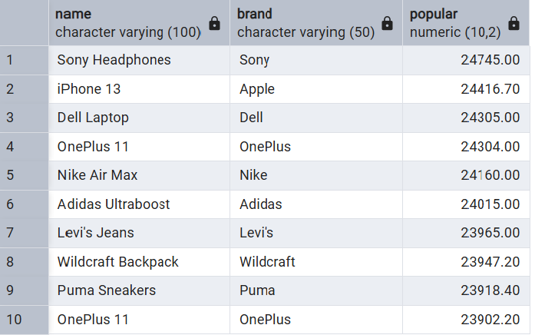

• Electronics & Apparel Dominance: Premium tech (Sony, Apple, Dell, OnePlus) and major footwear/apparel brands dominate customer interest.
• Severe Supply Risk: 8 out of the top 10 most popular products are either completely Out of Stock or on Limited Stock, signalling major potential revenue loss.
Action recommendation:
• Urgent Inventory Replenishment: Prioritize restocking Wildcraft, OnePlus, Sony, and Apple items immediately to capture unmet demand.
• Pause Ad Spend: Temporarily reduce marketing spend on the limited/out-of-stock items to prevent wasting ad budget on products customers cannot buy.

- Top 10 products by review count.
Identifying products with the highest customer engagement and post-purchase feedback volume to determine market saturation and brand loyalty.
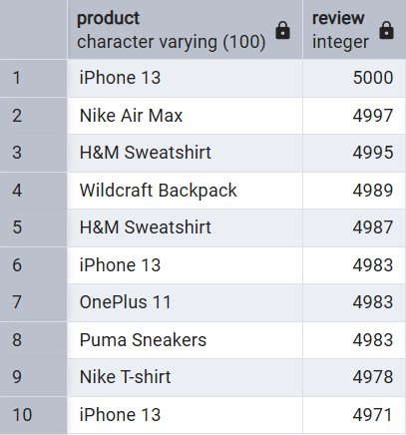
• High Engagement/Mature Products: Products like the iPhone 13 and H&M Sweatshirt appear multiple times, suggesting these are high-velocity items with a large, active user base.
• Feedback Density: The top 10 products are tightly clustered (all between 4,971 and 5,000 reviews), indicating a consistent level of high consumer interaction across these core product lines.
Action recommendation:
• Sentiment Analysis: Perform a sentiment analysis on these high-review products to identify common customer pain points or praise, which can inform future product iterations.
• Leverage Social Proof: Use these high-review counts in marketing materials (e.g., "Join 5,000+ satisfied customers") to drive conversion for newer, lower-reviewed items.

- Top 10 Products by Rating with Minimum Review Threshold
Identifying flawless, highly-rated products while filtering out single-buyer 5.0 ratings to find true customer favorites with verified social proof.
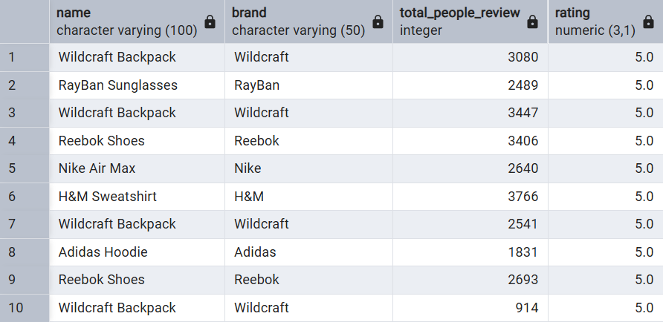
• Elite Catalysts: These are your top-tier performing products; achieving a perfect 5.0 rating with thousands of reviews indicates extreme product-market fit.
• Wildcraft Outperformance: Wildcraft backpacks dominate this elite category, but half of their top-rated variants are currently unpurchasable.
Action recommendation:
• Gold Standard Protection: Guard the stock of these exact items aggressively; they are conversion engines that guarantee high customer satisfaction.
• "Best Seller" Badging: Tag these items with exclusive web badges (e.g., "Top Rated") to capitalize on their massive, unblemished customer approval scores.

4: Brand-wise average rating, reviews, popularity, and stock distribution.
Evaluating aggregate brand performance and inventory stability across the entire platform to identify top-performing partners and chronic supply chain offenders.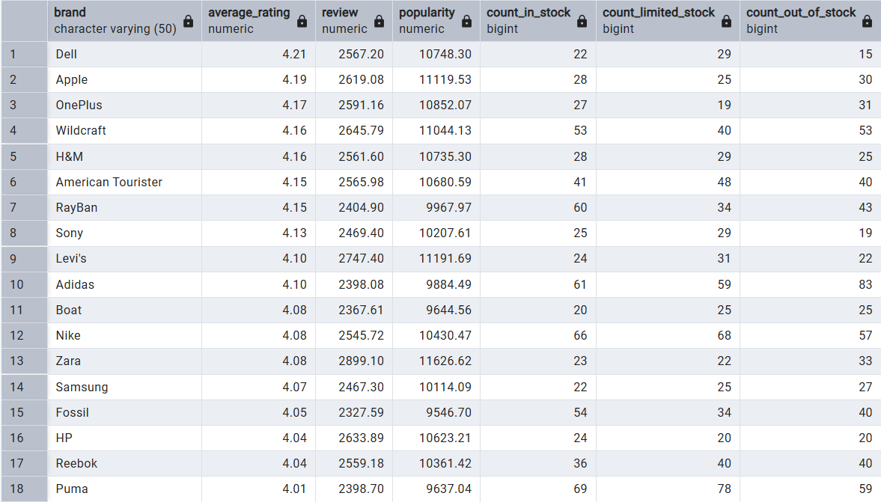
• Quality Leaders vs. High Demand: Dell holds the highest customer satisfaction (4.21), while Zara and Levi's lead the platform in consumer demand, commanding the highest average engagement and popularity scores.
• The Stockout Red Zone: Adidas (83 items out of stock) and Wildcraft (53 items out of stock) are experiencing severe operational bottlenecks, choking off high-popularity catalogs. Tech leaders Apple and OnePlus also have more items entirely out of stock than fully available.
Action recommendation:
• Supplier SLA Enforcement: Impose stricter fulfillment SLA metrics on Adidas, Wildcraft, and Apple to lower their high share of out-of-stock items.
• Capitalize on Fashion Traffic: Increase promotional focus on Zara and Levi's as they naturally generate the highest user traction and interaction metrics.

5: Category-wise average price, discount, and popularity.
Assessing macro-level performance across main product categories to evaluate pricing structures, discount distributions, and overall customer engagement.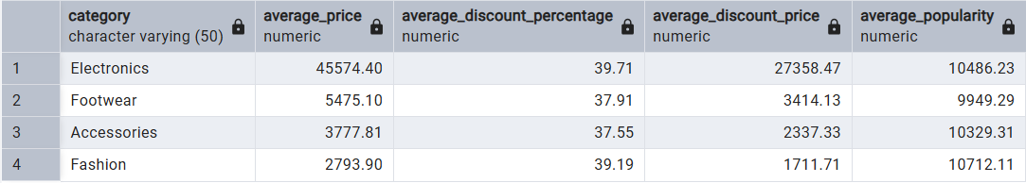
• High-Volume vs. High-Value: Fashion is the most popular category on average (10,712.11) despite having the lowest average transaction value, showing high customer interest and purchase frequency.
• Aggressive Electronics Discounting: Electronics carries the highest average price and the steepest discount percentage (~39.71%), indicating that tech sales are highly dependent on heavy promotional slashes to drive engagement.
Action recommendation:
• Optimize Fashion Margins: Since Fashion naturally pulls the highest popularity, consider slightly reducing the 39.19% average discount on trending items to recover profit margins without losing traffic.
• Bundle Accessories with Electronics: Create cross-category bundle promotions (e.g., matching a high-value electronic item with highly popular accessories) to increase the average order value (AOV).

6: Subcategory-wise product performance ranking.
Breaking down macro categories into specific subcategories to understand exactly which product types are driving the highest popularity, interaction volume, and customer satisfaction.
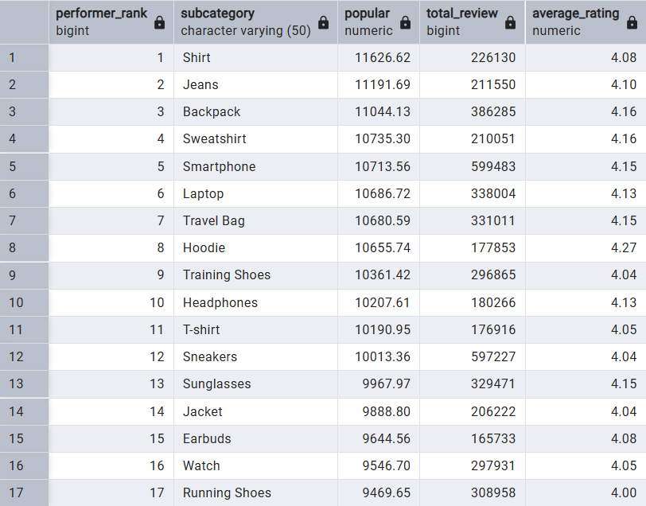
• High-Engagement Engines: Smartphone and Sneakers are massive transaction drivers, accumulating nearly 600,000 total reviews each, proving they command the highest customer purchase volumes on the platform.
• Underappreciated Superstars: Hoodie ranks 8th in popularity but holds the highest customer satisfaction score (4.27) on the chart, signaling a highly reliable product category that customers love.
• The Bottom Performers: Running Shoes sit at the bottom of the list with the lowest average rating (4.00), signaling potential quality or vendor sizing issues.
Action recommendation:
• De-risk Core Volume Subcategories: Ensure Smartphone and Sneakers subcategories have flawless user experience pipelines, as any drop in their search visibility or inventory immediately threatens the platform's core traffic.
• Audit Low-Performing Lines: Investigate individual products under the Running Shoes subcategory to identify which specific vendors are bringing down the average ratings.
7. Products with high price and low popularity
Identifying premium, expensive items that are failing to generate customer engagement or platform traffic, highlighting potential overpricing or lack of market demand.
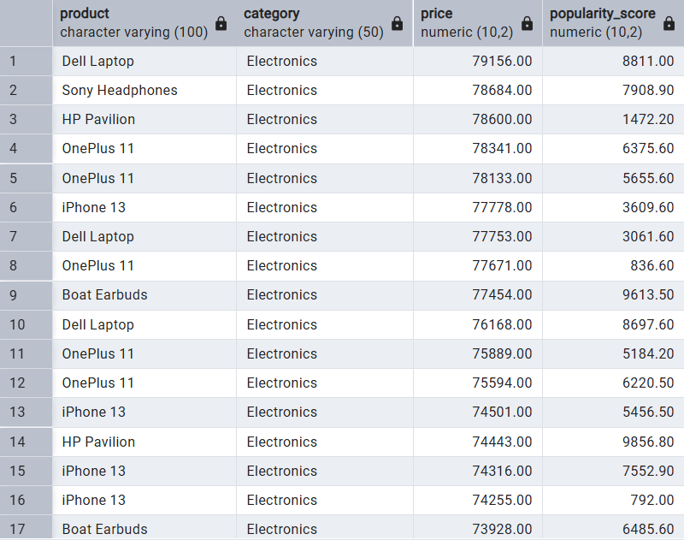
• Electronics Concentration: The list is entirely populated by Electronics, which tie up significant capital.
• Severe Outliers (Dead Stock Risk): Specific variants like the OnePlus 11 (77,671.00 with a popularity score of only 836.60) and iPhone 13 (74,255.00 with a popularity score of 792.00) are practically invisible to customers despite their premium pricing.
• Mismatched Value Perception: Typically budget-friendly subcategories like Boat Earbuds are listed at extreme premium price points (over 73,000+), resulting in lowered popularity scores relative to standard inventory.

Action recommendation:
• Implement Targeted Price Cuts: Deploy flash discounts or trade-in offers specifically for the low-popularity/high-price variants (like the low-performing HP Pavilion and OnePlus 11 listings) to liquidate stagnant inventory.
• Correct Listing Pricing Inconsistencies: Audit listings where standard brand expectations conflict with high data pricing (e.g., Boat Earbuds at premium laptop rates) to fix potential manual seller pricing errors.

8. Products with high discount but low rating.
Identifying underperforming or low-quality products that sellers are aggressively discounting (55% to 70%) to liquidate stock, risking platform reputation and high return rates.
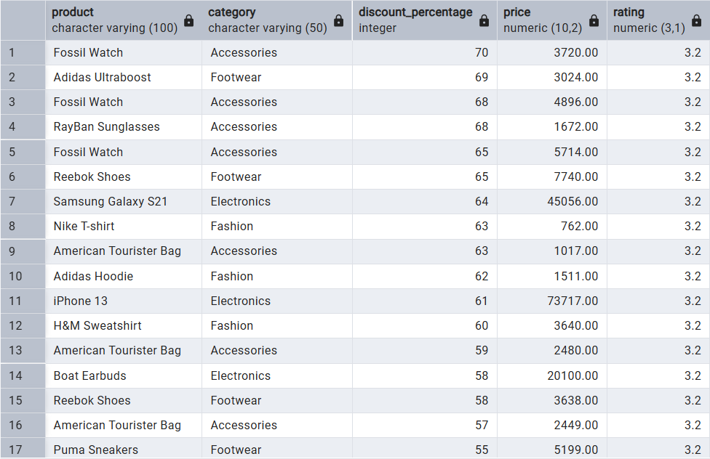
• The "Discount Trap": These products possess a flat 3.2 rating despite steep price cuts, indicating that a low price point is not enough to overcome underlying issues with product quality or fulfillment accuracy.
• Capital Exposure Risk: High-ticket electronics like the iPhone 13 (73,717.00 at 61% off) and Samsung Galaxy S21 (45,056.00 at 64% off) tied to low consumer satisfaction represent high return rates and customer frustration risks.
Action recommendation:
• Quality and Listing Audits: Pause algorithmic promotion of these items and conduct catalog quality checks to understand if the poor ratings stem from damaged inventory, sizing mismatches, or counterfeit listings.
• Transition to Clearance Badging: Relabel these specific inventory lines from standard promotional campaigns to "Clearance/As-Is" status to set appropriate consumer expectations and protect the platform's brand equity.

9. Out-of-stock products with high popularity or high reviews.
Pinpointing the highest-demand products that are currently unavailable, which represents an immediate leakage of platform revenue and a frustrating experience for high-intent shoppers.
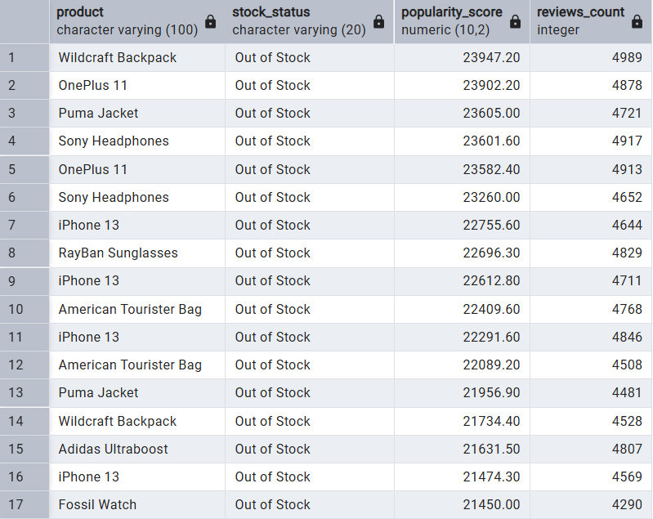
• Severe Revenue Bleed: This list features multiple entries for core items like the iPhone 13, OnePlus 11, Wildcraft Backpack, and Sony Headphones, proving that systemic stockouts are occurring across entire high-performing product lines rather than just isolated SKUs.
• High-Intent Traffic Drop-Off: Every single product here combines extreme popularity scores (>21,000$) with deep review history (>4,000$), meaning organic search traffic is landing on dead ends.
Action recommendation:
• Deploy "Notify Me" and Backorder Widgets: Immediately activate an automated email/SMS waitlist on these specific product pages to capture and retain customer intent while inventory is restored.
• Prioritize Tier-1 Replenishment Logs: Establish a priority replenishment flag in the logistics system explicitly for these 17 high-traffic items to automate emergency reorders before stock completely zeroes out.

10. Monthly product additions and trend by category.
Tracking catalog expansion trends over time to understand seller upload behavior and identify which product categories are scaling the fastest.
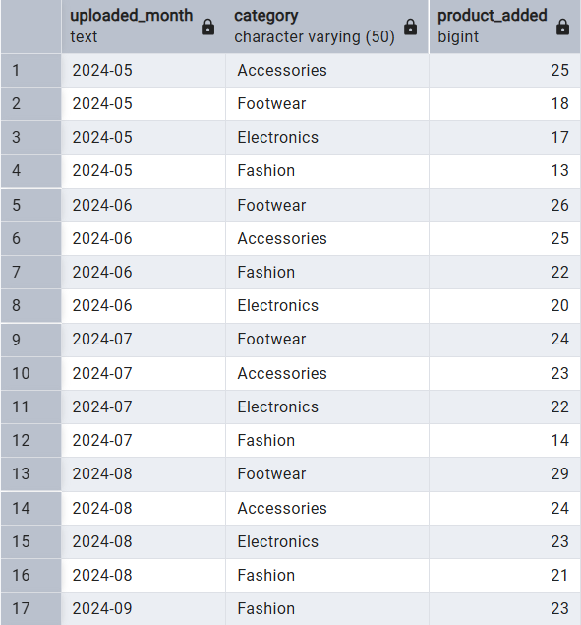
• Footwear Core Expansion: Footwear demonstrates consistent, aggressive growth, peaking with 29 new additions in August 2024, signalling strong vendor supply lines in this segment.
• Steady Accessories Baseline: Accessories maintains a stable and predictable upload rhythm, averaging around 23 to 25 items monthly from May to August.
• Laggard Fashion Slumps: Fashion updates are historically volatile, dipping significantly in July (14 additions) before seeing a recovery heading into September.
Action recommendation:
• Align Marketing Calendars with Upload Peaks: Sync high-budget promotional campaigns with known inventory influxes (e.g., scale up Footwear marketing in late August to immediately push newly listed stock).
• Incentivize Off-Season Uploads: Offer seller fee discounts or visibility boosts to Fashion vendors during historical low-upload months (like July) to stabilize catalog growth variations throughout the year.

11. Products added recently but already performing well
Identifying newly introduced catalog products that have quickly secured exceptional customer satisfaction and popularity, pointing to immediate market fit and viral potential.
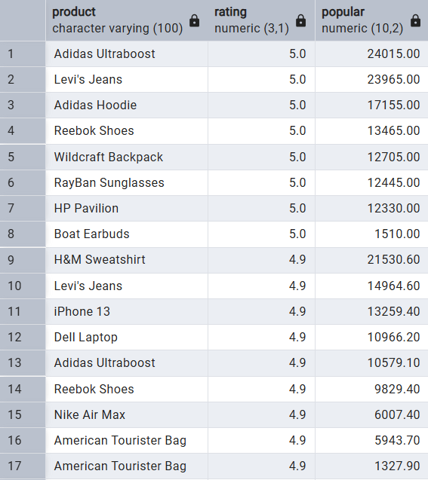
• Instant Market Fit: Products like Adidas Ultraboost and Levi's Jeans have achieved a perfect 5.0 rating alongside top-tier popularity scores shortly after launch, demonstrating massive immediate customer traction.
• High-Velocity Contenders: The presence of high-ticket items (HP Pavilion, iPhone 13) with a 4.9–5.0 rating trend indicates strong introductory momentum for premium hardware additions.
Action recommendation:
• Fast-Track Inventory Pipeline: Immediately establish dedicated reorder cycles for these fast-moving new listings to prevent stock depletion before they hit maturity.
• Amplify Through Collection Placement: Bundle these trending items into curated "New Arrivals & Fan Favorites" marketing carousels on the platform home page to maintain velocity.

12. Products with the biggest gap between price and discounted price
Isolating items undergoing the most extreme price cuts (absolute margin drops) to track margin erosion and identify heavy promo-dependent listings.
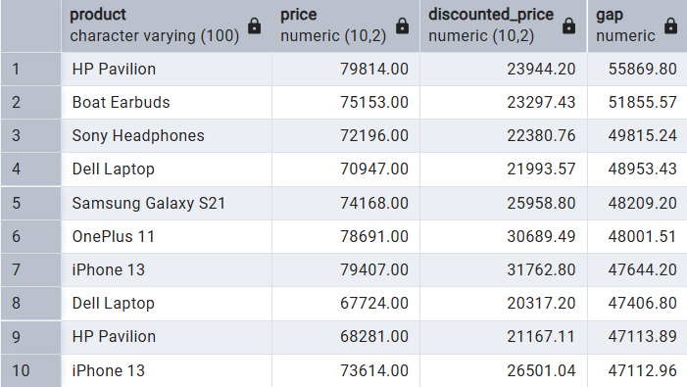
• Massive Margin Sacrifices: High-end electronics are taking absolute price cuts of over 47,000 Rs to₹55,000 Rs, signalling desperate inventory liquidation or hyper-aggressive customer acquisition loss-leaders.
• Pricing Identity Inconsistencies: Similar to Query 7, mid-tier items like Boat Earbuds are listed with inflated original baseline prices (~75,153.00 Rs) just to display a massive absolute discount gap.
Action recommendation:
• Re-evaluate Margin Health: Audit the gross profit margins for the HP Pavilion and Dell Laptop lines to ensure these huge absolute gaps aren’t causing net financial losses.
• Create a "Mega Deals" Section: Group these highest-gap items into a dedicated high-impact deal banner on the homepage to maximize high-conversion click-through rates.

13. Brands with the highest share of out-of-stock items
Isolating vendor supply chain bottlenecks by identifying which brands suffer from the highest proportional stockout rates, leading to lost customer momentum.
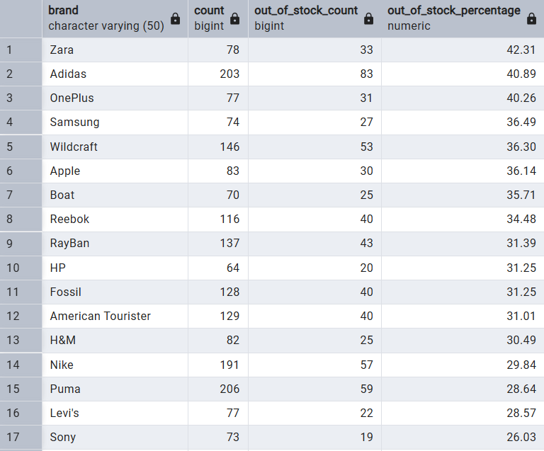
• Critical Inventory Bleed: Fast-fashion giant Zara and athletic apparel leader Adidas are severely undersupplying the platform, with over 40% of their total catalog completely unavailable for purchase.
• Tech Logistics Snags: Premium electronic manufacturers (OnePlus, Samsung, and Apple) are locking up customer wallets, with roughly 1 in every 3 products sitting on out-of-stock pages.
Action recommendation:
• Enforce Out-of-Stock Penalties/Caps: Introduce platform penalties or limit promotional visibility for vendors like Zara and Adidas if their total stockout rate remains above a 30% operational threshold.
• Automate Reorder Lead Times: Sync with OnePlus, Samsung, and Apple distribution channels to dynamically adjust procurement safety margins, accounting for longer tech-supply turn around periods.

14. Categories with the weakest average rating
Diagnosing macro-level consumer dissatisfaction by identifying which broad product categories are underperforming in quality, sizing accuracy, or performance metrics.
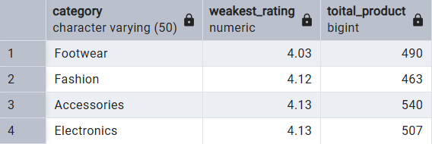
• Footwear Core Vulnerability: Footwear exhibits the most pronounced quality slump with an average rating of 4.03 across a substantial volume of 490 products, signalling systemic platform-wide issues such as structural sizing mismatches, poor material quality, or misleading product imagery.
• Narrow Quality Ceiling: Interestingly, all major categories are clustered tightly within a narrow band of 4.03 to 4.13, which means no single sector is distinctively running away as a "gold standard" for consumer satisfaction.

Action recommendation:
• Deploy Sizing Intelligence and Fit Charts: For the bottom-ranking Footwear and Fashion sectors, integrate dynamic customer feedback widgets (e.g., "Runs True to Size", "Runs Small") on product pages to actively reduce return rates driven by fit expectations.
• Filter Out Underperforming Low-Tier Vendors: Conduct an automated purge or issue performance warnings to individual sellers whose consistent sub-3.5 ratings are dragging down the macro averages of the Footwear and Fashion categories.

15. Best and worst products in each brand.
Evaluating intra-brand quality variance by juxtaposing a manufacturer's highest-rated product against their lowest-performing offering to expose brand inconsistency or manufacturing defects.
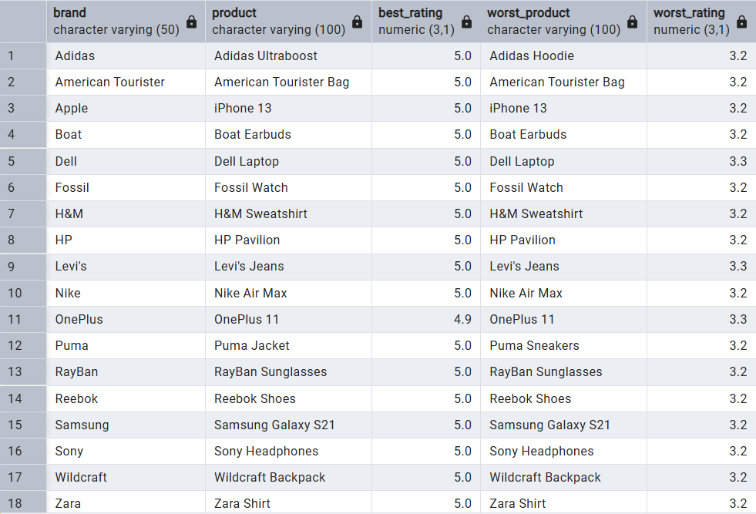
• Severe SKU-Level Quality Gaps: Brands like Apple (iPhone 13), Samsung (Galaxy S21), and Sony (Sony Headphones) show the exact same product name taking both a perfect 5.0 and a low 3.2/3.3 rating. This reveals that consumer satisfaction isn't breaking down at the brand level, but rather at the individual seller/variant level (e.g., bad batches, renewed/refurbished listings mixed with new ones, or fulfillment errors).
• Uniform Satisfaction Ceilings & Floors: Across almost every single brand listed, the best products confidently reach a ceiling of 5.0 (or 4.9 for OnePlus), while the worst bottom out consistently at a tight floor of 3.2 to 3.3.
Action recommendation:
• Isolate Variant and Seller IDs: Modify the underlying query to drill down past generic product names into specific SKU, Seller, or Condition codes (New vs Refurbished) to find exactly who is selling the 3.2-rated iPhone 13s or Galaxy S21s.
• Establish Brand Consistency Alerts: Work with major partners like Nike, Adidas, and Apple to investigate their lower-tier variants (like the Adidas Hoodie) or problematic seller channels to protect their overall brand equity on your marketplace.

Conclusion
In conclusion, this analysis highlights that the e-commerce business’s main challenge is not only identifying strong products, but also ensuring that high-demand items remain available, appropriately priced, and supported by consistent inventory planning. The findings show that several brands and categories generate strong customer interest, but stock shortages and pricing imbalances are limiting their full business potential. At the same time, some high-priced products are not performing well, which suggests the need for closer review of pricing strategy, product quality, and promotional effectiveness. Overall, the most effective business response is to prioritize restocking for high-performing products, refine pricing and discount decisions for weak listings, and focus marketing and operational support on the brands and categories that consistently deliver customer engagement and satisfaction.

