CS3235 Course Project — Requirements Document Template
Working with Large Language Models (LLMs) · Version 1.0 · September 2026

How to use this template
Every team submits one completed copy of this document before building starts. It is the agreement between your team and the instructor on what you will build, how the LLM is used, and how success will be measured.
- Make a copy; do not edit this master version.
- Replace every text in [square brackets] with your own content, then delete the brackets.
- Keep requirement IDs (FR-1, NFR-1, …) — your demo, report and viva will refer back to them.
- Be specific: numbers, model names, dataset names and dates, not adjectives like "fast" or "accurate".
- Anything you have not decided yet goes in the Open questions list at the end, not left blank.
- Cloud deployment (Section 11) is mandatory for every team.
- Suggested length: 6–10 pages. Changes after sign-off need a short note in the Change log.

1. Project overview
Field | Details
Project title | [Short, descriptive name]
Team ID | [e.g. T07]
Team members (name, roll no., role) | [Name — Roll no. — e.g. LLM/prompt lead, backend, evaluation, UI]
Faculty mentor | [Name]
Primary course module | [1 LLM foundations · 2 Agents · 3 Multimodal · 4 LLMs in software dev · 5 Advanced apps & benchmarking]
Version / date | [v0.1, DD-MM-YYYY]

Problem statement (3–5 sentences): [What problem exists, who faces it, and why current approaches fall short.]
Why an LLM? [Explain what an LLM does here that a rule-based system or classical ML model cannot. If a simpler approach would work, say why you still chose an LLM.]
One-line solution summary: ["A ___ that helps ___ to ___ by using ___."]

2. Scope and users
In scope — what the finished system will do:
- [Capability 1]
- [Capability 2]
Out of scope — what you are deliberately not building this semester:
- [e.g. mobile app, multi-language support]
Target users
User type | What they need from the system | How they will interact (chat, API, CLI, web UI)
[e.g. First-year student] | [Need] | [Interface]
[e.g. Teaching assistant] | [Need] | [Interface]

Example user scenario: [Walk through one realistic interaction step by step, from the user's input to the system's final output.]

3. Functional requirements
List each thing the system must do as one testable statement. Priority uses MoSCoW: Must, Should, Could. Aim for 6–12 requirements, at least 4 of them Must.
ID | Requirement ("The system shall…") | Priority | How it will be verified
FR-1 | The system shall accept a user question in plain English and return an answer within the chat interface. | Must | Demo + 20 test queries
FR-2 | [The system shall cite the source document for every factual answer.] | [Must] | [Manual check of 30 answers]
FR-3 | [Requirement] | [Should] | [Test / demo / metric]
FR-4 | [Requirement] | [Could] | [Test / demo / metric]

FR-1 is a filled example; replace it with your own.

4. LLM design requirements
This section shows which course concepts your project applies. Fill every row; write "Not used — because …" where a technique does not apply.
Aspect | Your choice | Justification
Base model(s) | [e.g. Llama 3.1 8B, GPT-4o-mini, Mistral 7B, a MoE model] | [Why this size / licence / cost / open vs API]
Access method | [Hosted API · local via Ollama/vLLM · Hugging Face · Colab] | [Hardware and budget constraints]
Prompting strategy | [Zero-shot · few-shot · chain-of-thought · structured JSON output] | [Why]
Retrieval (RAG) | [Yes/No — embedding model, vector store, chunk size] | [Why]
Fine-tuning | [None · LoRA/QLoRA — rank r, target layers, trainable-parameter count] | [Why prompting alone was not enough]
Agents and tools | [Single agent · multi-agent · framework: LangChain, LangGraph, CrewAI, AutoGen] | [Which tools the agent calls and why]
Protocols | [MCP / A2A, if used] | [Which servers or agents connect]
Multimodal input | [Text only · image · audio — model, e.g. LLaVA, CLIP] | [Why]
Alignment and safety | [System prompt rules, guardrails, refusal handling, constitution-style principles] | [Risks addressed]

If you fine-tune with LoRA, show the trainable-parameter calculation for one adapted weight matrix of size d × k with rank r:
Trainable parameters = r × (d + k)
[Your numbers: d = __, k = __, r = __, layers adapted = __, total = __, fraction of full model = __ %]
LLM pipeline: [Describe the LLM flow: user input → preprocessing → retrieval/tools → LLM → post-processing → output. The full system diagram goes in Section 10.]

5. Data requirements
List every dataset, document collection or API the project depends on, including test data you will build yourselves.
Dataset / source | Purpose | Size | Format | Licence / permission | Link
[e.g. Course lecture notes] | [RAG corpus] | [120 PDFs, ~3,000 pages] | [PDF] | [Internal, instructor approved] | [URL]
[Dataset 2] | [RAG corpus / fine-tuning / evaluation / few-shot] | [Size] | [Format] | [Licence] | [URL]

- Preprocessing: [Cleaning, chunking, deduplication, labelling steps.]
- Train / test separation: [How you keep evaluation data out of prompts, retrieval and fine-tuning.]
- Personal or sensitive data: [None, or how it is anonymised and stored.]

6. Non-functional requirements
Give each a measurable target. Delete rows that do not apply.
ID | Category | Requirement | Target
NFR-1 | Latency | [Time from user input to complete response] | [e.g. ≤ 5 s for 90% of queries]
NFR-2 | Cost | [API or compute spend for the whole project] | [e.g. ≤ ₹2,000 total, or free tier only]
NFR-3 | Hardware | [GPU/RAM needed to run or fine-tune] | [e.g. single T4, 16 GB VRAM]
NFR-4 | Reliability | [Behaviour when the model or an API fails] | [e.g. graceful error message, retry once]
NFR-5 | Hallucination control | [How unsupported claims are limited] | [e.g. ≤ 10% unsupported answers on test set]
NFR-6 | Safety | [Harmful, biased or off-topic output handling] | [e.g. refuses 100% of red-team prompts in test set]
NFR-7 | Privacy | [What user data is logged, stored or sent to third parties] | [Policy]
NFR-8 | Usability | [Who can use it without training] | [e.g. a new user completes the main task in < 3 min]

7. Evaluation plan and success metrics
The project succeeds if it meets the targets below on a held-out test set. Every Must requirement needs at least one metric.
Metric | What it measures | Method | Baseline | Target | Linked req.
[e.g. Exact match / F1] | [Answer correctness] | [Automatic, 100 Q&A pairs] | [Base model without RAG] | [≥ 0.70 F1] | [FR-2]
[e.g. Faithfulness] | [Answer supported by retrieved context] | [LLM-as-judge + 30 manual checks] | [Baseline] | [Target] | [NFR-5]
[e.g. Pass@1] | [Generated code runs and passes tests] | [Unit tests] | [Baseline] | [Target] | [FR-x]
[e.g. Task success rate] | [Agent completes the full task] | [20 scripted scenarios] | [Baseline] | [Target] | [FR-x]
[User rating] | [Perceived usefulness, 1–5 scale] | [5+ real users] | [—] | [≥ 4.0 average] | [NFR-8]

- Test set: [How many examples, how they were created, who labelled them.]
- Standard benchmark (if any): [e.g. a subset of MMLU, HumanEval, or a domain benchmark — and why it fits.]
- Ablation: [At least one comparison, e.g. with vs without RAG, prompt A vs prompt B, base vs LoRA-tuned.]

8. Frontend — UI/UX specifications
Item | Your specification
Framework | [e.g. React, Next.js, Streamlit, Gradio, Flutter Web]
Styling / component library | [e.g. Tailwind CSS, Material UI, shadcn/ui]
Target devices | [Desktop browser · mobile browser · both — minimum screen width]
Response display | [Streaming tokens · full response · typing indicator while waiting]
Error and empty states | [What the user sees when the model fails, times out, or returns nothing]
Accessibility | [e.g. keyboard navigation, alt text, colour contrast WCAG AA]
Design tool / wireframes link | [Figma, Excalidraw or hand-drawn scan — URL]

Screens
Screen | Purpose | Key UI elements | Linked req.
[e.g. Login] | [Authenticate user] | [Email/password form, Google sign-in] | [FR-x]
[e.g. Chat] | [Main LLM interaction] | [Message list, input box, file upload, source citations panel] | [FR-1]
[e.g. History / Settings] | [Purpose] | [Elements] | [FR-x]

User flow: [Describe or diagram the path from landing page to completing the main task, including where the user sees citations, tool calls or agent steps.]
Wireframes: [Insert one wireframe or mock-up image per main screen.]

9. Backend specifications
Item | Your specification | Version
Language | [e.g. Python 3.11, Node.js 20] | [ ]
Web framework | [e.g. FastAPI, Flask, Django, Express] | [ ]
LLM orchestration | [e.g. LangChain, LangGraph, LlamaIndex, CrewAI, AutoGen, direct SDK calls] | [ ]
Model serving | [Hosted API (OpenAI, Anthropic, Gemini, Groq) · self-hosted (vLLM, Ollama, TGI) · HF Inference Endpoint] | [ ]
Relational / document DB | [e.g. PostgreSQL, MySQL, MongoDB, Firestore — what it stores: users, chat history, logs] | [ ]
Vector DB | [e.g. pgvector, Pinecone, Qdrant, Weaviate, Chroma, FAISS — embedding model and dimension] | [ ]
Cache / queue | [e.g. Redis, Celery, none] | [ ]
File / object storage | [e.g. AWS S3, Google Cloud Storage, Azure Blob — for uploaded documents] | [ ]
Authentication | [e.g. Firebase Auth, Auth0, JWT, OAuth with Google] | [ ]
Secrets management | [How API keys are stored — never in the Git repo] | —

API endpoints
Method | Endpoint | Purpose | Request → Response | Auth
POST | [/api/chat] | [Send a user message, get LLM reply] | [{session_id, message} → {answer, sources: list}] | [Yes]
POST | [/api/documents] | [Upload a file for RAG] | [multipart file → {doc_id, status}] | [Yes]
GET | [/api/health] | [Health check for deployment] | [— → {status: ok}] | [No]

Database schema: [List main tables/collections and key fields, or insert an ER diagram.]

10. Architecture diagram
[Insert your team's system architecture diagram here. Draw it in draw.io, Excalidraw, Lucidchart or Mermaid, export as PNG, and paste it in.]
Your diagram must show:
- Every component: frontend, backend API, LLM (hosted or self-hosted), vector DB, main DB, object storage, external tools/APIs
- The cloud provider and service each component runs on (e.g. "FastAPI on Cloud Run")
- Data flow arrows for one request, numbered in order
- Where authentication and secrets sit
[ Paste your architecture diagram here ]

Reference example (a RAG chatbot) — replace with your own:
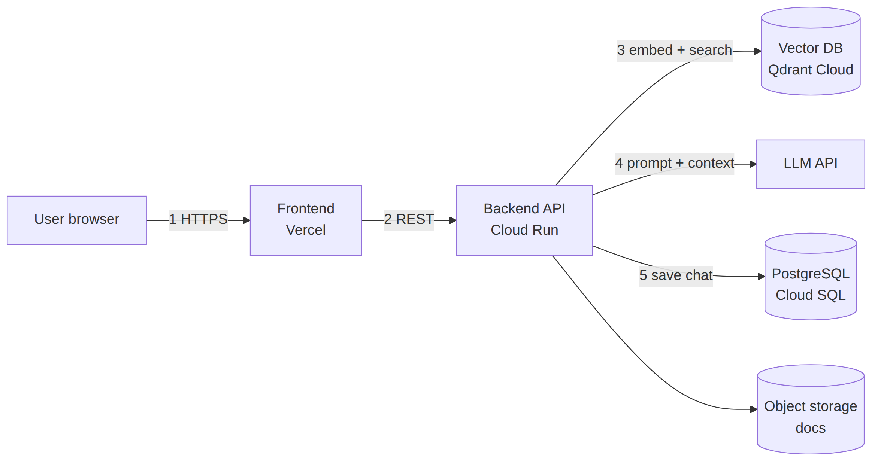
The numbers trace one chat request from the browser to the stored answer.
Component description: [One line per component: what it does and why you chose it.]

11. Cloud hosting and deployment (mandatory)
Every project must be deployed on a public cloud and reachable by a public URL for the final demo. A laptop-only or Colab-only demo does not meet this requirement.
Item | Your specification
Cloud provider | [AWS · Google Cloud · Azure · Hugging Face Spaces · Render · Railway · Vercel]
Free tier / credits used | [e.g. AWS Educate, GCP student credits, Azure for Students]
Frontend hosting | [e.g. Vercel, Netlify, S3 + CloudFront, Firebase Hosting]
Backend hosting | [e.g. Cloud Run, AWS App Runner/ECS/Lambda, Azure App Service, Render]
LLM hosting | [Hosted API · GPU instance (type, e.g. g4dn.xlarge) · HF Inference Endpoint]
Managed databases | [e.g. Cloud SQL, RDS, MongoDB Atlas, Supabase, Pinecone/Qdrant Cloud]
Containerisation | [Dockerfile(s) in repo — base image]
CI/CD | [e.g. GitHub Actions: test → build image → deploy on push to main]
Environment config & secrets | [e.g. cloud Secret Manager, environment variables — never committed]
Domain and HTTPS | [Provider URL or custom domain, TLS certificate]
Monitoring and logging (LLMOps) | [e.g. cloud logs, LangSmith, Langfuse — track latency, token usage, errors]
Estimated monthly cost | [₹ per month at demo load, and how you will stay within credits]
Public demo URL | [https://… — to be filled after deployment]

Deployment steps: [Short numbered list a TA could follow to redeploy from the repo.]
Shutdown plan: [When and how you will stop paid resources after evaluation to avoid charges.]

12. Risks and mitigation
Risk | Likelihood (L/M/H) | Impact (L/M/H) | Mitigation / fallback
[e.g. API rate limits or cost overrun] | [M] | [H] | [Switch to a local 7B model via Ollama]
[e.g. Not enough GPU for fine-tuning] | [ ] | [ ] | [QLoRA on Colab, or prompting + RAG only]
[Risk] | [ ] | [ ] | [ ]

13. Timeline and milestones
Week | Milestone | Deliverable | Owner
[1–2] | Requirements approved | This document, signed off | [Name]
[3–4] | Data ready, baseline running | Baseline results | [Name]
[5–7] | Core pipeline (RAG / agent / fine-tuning) + first cloud deployment | Working prototype | [Name]
[8–9] | Evaluation and improvement | Metrics table filled | [Name]
[10] | Final submission | Live cloud demo URL, report, code, slides | [All]

14. Final deliverables
- Source code in a public or instructor-shared GitHub repo with a README and setup steps
- Working demo on the deployed public cloud URL (5–7 minutes), plus a backup recording
- Final report with evaluation results mapped to FR/NFR IDs
- Presentation slides
- Individual contribution statement from each member

15. Open questions
- [Anything undecided, with who will resolve it and by when]

16. Change log
Date | Version | Change | Reason
[DD-MM-YYYY] | [v0.2] | [What changed] | [Why]

17. Sign-off
Role | Name | Signature | Date
Team lead
Faculty mentor

