Case Study 2: Industrial Design & Architecture
VR Collaborative Automotive Prototyping Environment

Name | Desu Sree Vardhan
USN | 1RUA24CSE7004
Section | C
Subject | CS4104 — Computer Graphics & Virtual Reality

Scenario
An automotive manufacturer uses a VR collaborative environment to allow design teams in Bengaluru and Detroit to view and manipulate 1:1 scale car prototypes concurrently, eliminating the need for expensive physical clay models. The implemented system — Atelier Car Designer — was built in Unity 6 (URP) and runs on desktop and WebGL.

System Overview
Component | Role
CarRig | Owns all CarPart children; applies T·R·S pose every frame via LateUpdate
CarPart | Mesh-bearing node; stores rest pose + DesignEdit (scale, rotation, translation mm)
CarPaint | Chromatic-key palette swap across finish materials (PBR)
CarSwitcher | Manages multiple 1:1 prototype slots (Sports Coupe)
PartSelector | Ray-cast selection + frame-to-fit camera control (pitch snap 18°)
OrbitCamera | Touch/mouse turntable with pitch limits and smooth exponential lerp
DesignerUI | Fully code-built uGUI — transform inspector, matrix display, finish picker

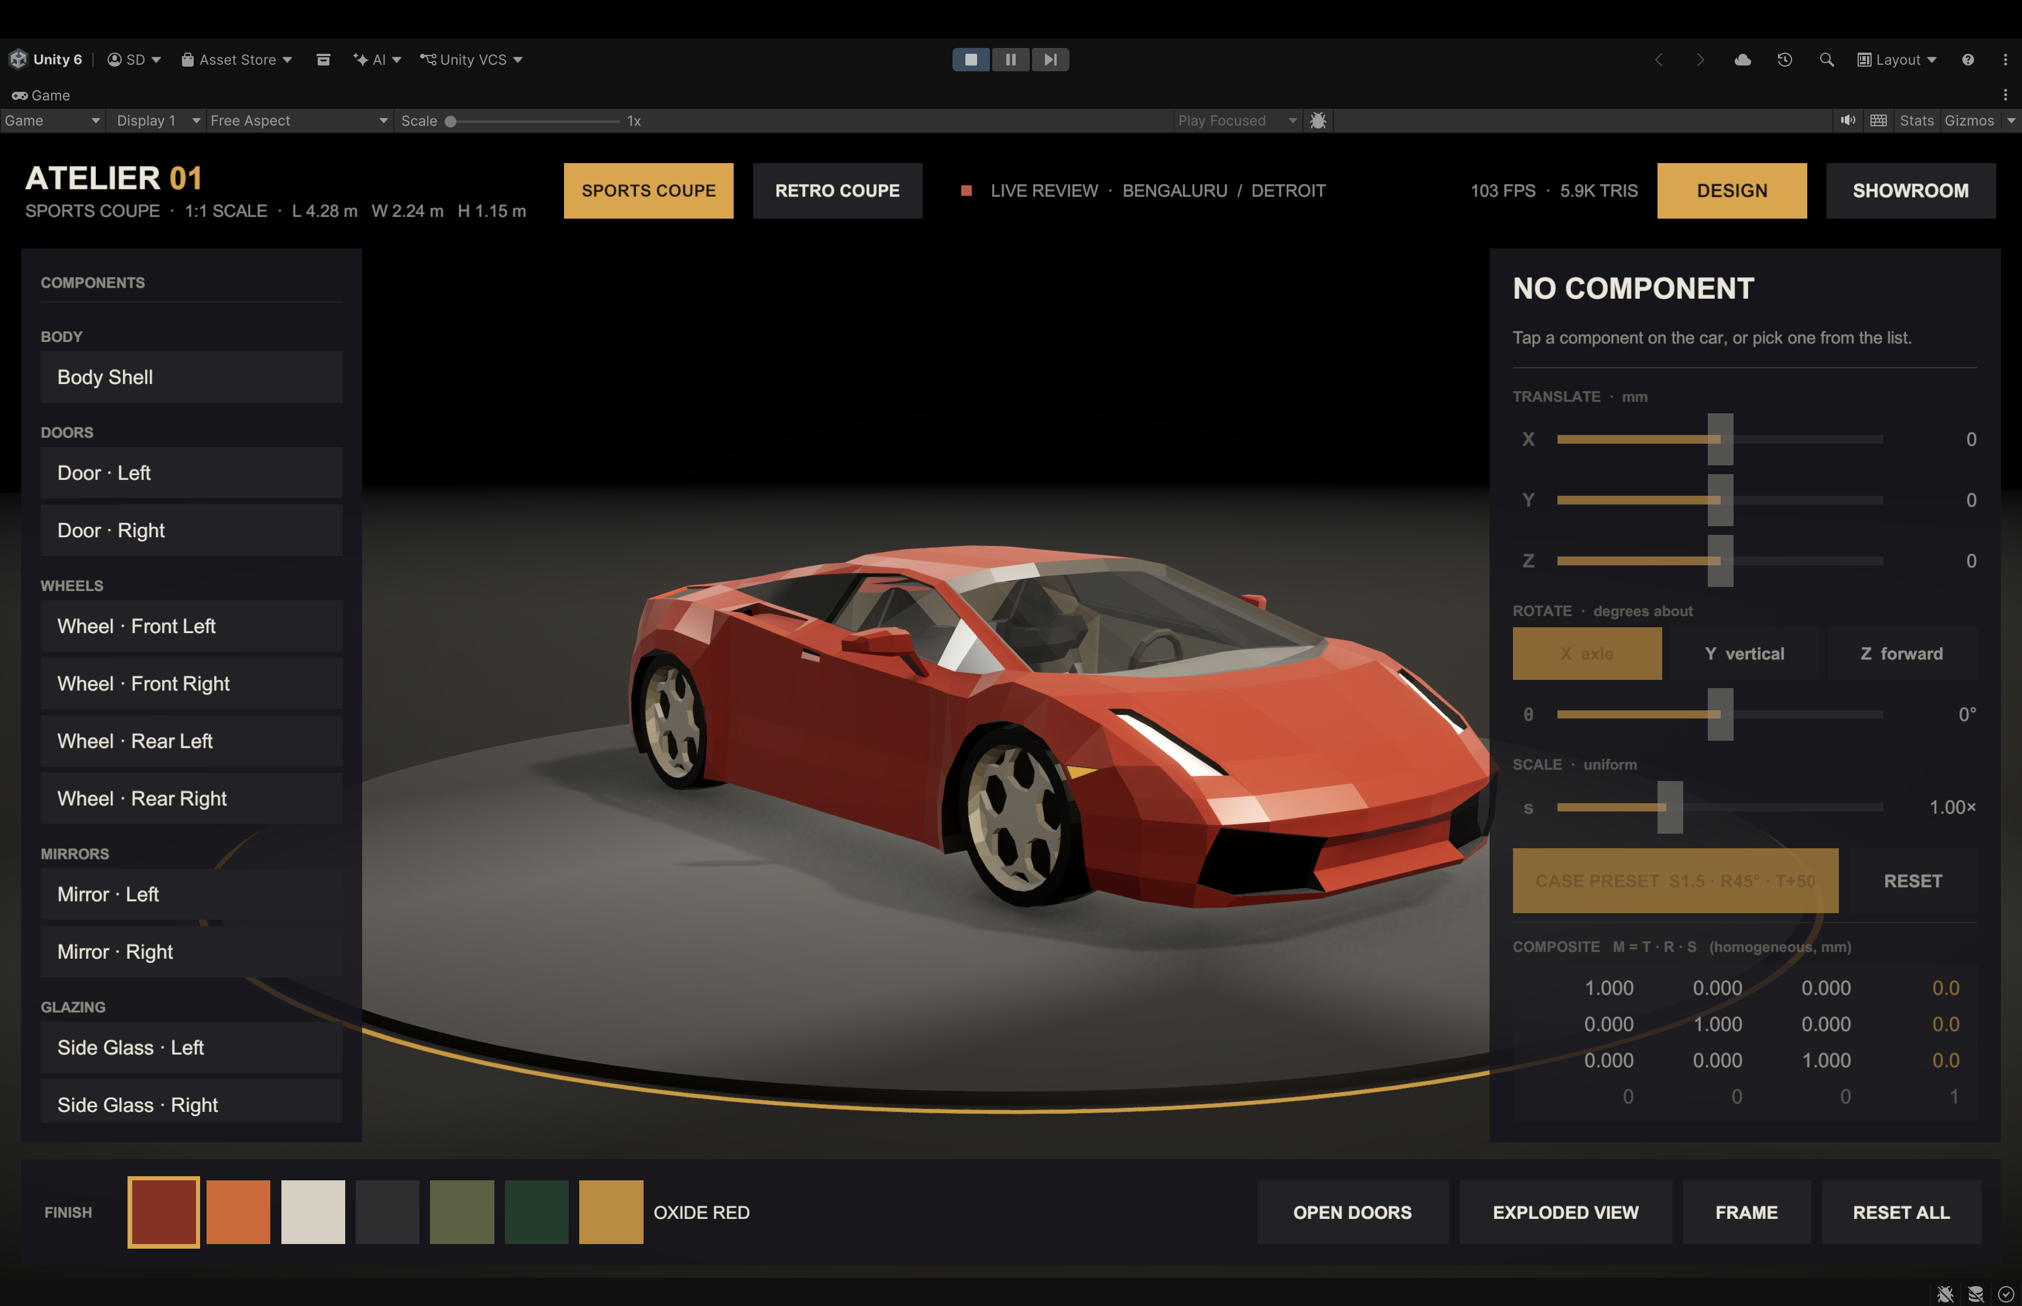
Figure 1: Main screen with 3D car model

Q1 — Geometric Modeling: CAD Drawings to 3D Meshes
Industrial car bodies originate as 2D profile curves in CAD software (Class-A surfacing tools such as CATIA or Alias). Two complementary mathematical representations govern the pipeline from flat drawing to game-ready mesh.

1.1 Boundary Representation (B-Rep)
B-Rep encodes a solid as a topology graph of vertices, edges, and faces, where each face carries an underlying parametric surface — usually a Non-Uniform Rational B-Spline (NURBS).
Pipeline for a car body panel:
2D profile sketch
│
▼ Swept / lofted along spine curve
NURBS surface (degree 3, C² continuity across tangent edges)
│
▼ Trimmed at intersections (door gaps, wheel arches)
Trimmed B-Rep solid
│
▼ Tessellation (adaptive chord-height tolerance ε = 0.5 mm)
Triangle mesh → FBX export → Unity MeshFilter
Why B-Rep for automotive: Class-A surfaces demand curvature-continuous (G2) joins so that studio lighting specular highlights flow smoothly across panel seams. B-Rep preserves this continuity analytically before discretisation.
In our implementation, the imported FBX meshes are pre-tessellated B-Rep surfaces. Each CarPart calls BoundsInParent() at startup to cache axis-aligned bounding boxes — used for FRAME camera control and exploded-view direction calculation.

1.2 Constructive Solid Geometry (CSG)
CSG builds complex solids by applying Boolean set operations (Union ∪, Difference ∖, Intersection ∩) on primitive volumes (boxes, cylinders, spheres).
CSG tree for a wheel rim:
Rim Solid
│
Difference ∖
/ \
Cylinder Union ∪
(outer body) / \
Cylinder 5× Cylinder
(hub bore) (spoke cutouts, rotated 72° apart)
In our implementation, the procedural geometry for studio elements (DiscMesh, RingMesh) is generated via CSG-style vertex arithmetic — a ring mesh is a full disc minus an inner disc.
// RingMesh: outer radius r1, inner radius r0, N segments
for (int i = 0; i < N; i++) {
float θ = 2π × i / N;
outer[i] = new Vector3(r1 × cosθ, 0, r1 × sinθ);
inner[i] = new Vector3(r0 × cosθ, 0, r0 × sinθ);
}
// Two triangles per quad: (outer[i], inner[i], outer[i+1]) + (inner[i], inner[i+1], outer[i+1])

1.3 Comparison — B-Rep vs CSG for Automotive Use
Criterion | B-Rep | CSG
Smooth curved surfaces | ✅ Exact NURBS | ❌ Approximated by primitives
Parametric editing | ✅ Modify control points | ✅ Change operand dimensions
Boolean robustness | ⚠ Fragile near tangencies | ✅ Exact by definition
Real-time tessellation | Adaptive chord-tolerance | Marching Cubes or SDF
Dominant industry use | Class-A body panels | Structural brackets, bores
Our usage | FBX car body meshes | DiscMesh / RingMesh geometry

Conclusion: A production car uses B-Rep for all visible surfaces (hood, doors, roof) and CSG for engineered internals (brake caliper bores, mounting brackets).

Q2 — Matrix Transformations: Composite T·R·S in Homogeneous Coordinates
Design Task: a designer selects the front-left wheel rim in the VR session and applies:
- Scale up by factor 1.5 (uniform)
- Rotate by 45° about the Y-axis (vertical, in car-local space)
- Translate forward by +50 mm (along car's local Z-axis)
These are composed as a single 4×4 homogeneous matrix M = T · R · S so the GPU applies one vertex transform at draw time, with no intermediate re-normalisation.

2.1 Individual Matrices
Scale matrix S (uniform factor 1.5):
$$S = \left[\begin{matrix}1.5 & 0 & 0 & 0 \\ 0 & 1.5 & 0 & 0 \\ 0 & 0 & 1.5 & 0 \\ 0 & 0 & 0 & 1\end{matrix}\right]$$
Rotation matrix Rᵧ(45°) — cos 45° = sin 45° = 1/√2 ≈ 0.7071:
$$Rᵧ(45°) = \left[\begin{matrix}0.7071 & 0 & 0.7071 & 0 \\ 0 & 1 & 0 & 0 \\ -0.7071 & 0 & 0.7071 & 0 \\ 0 & 0 & 0 & 1\end{matrix}\right]$$
Translation matrix T (+50 mm = +0.05 m along Z):
$$T = \left[\begin{matrix}1 & 0 & 0 & 0 \\ 0 & 1 & 0 & 0 \\ 0 & 0 & 1 & 0.05 \\ 0 & 0 & 0 & 1\end{matrix}\right]$$

2.2 Composite Matrix M = T · R · S
Standard CG convention: operations are applied right-to-left (Scale first, then Rotate, then Translate), all about the component's own centre (pivot compensation handled in §2.3).
Step 1 — R · S:
$$R · S = \left[\begin{matrix}1.0607 & 0 & 1.0607 & 0 \\ 0 & 1.5 & 0 & 0 \\ -1.0607 & 0 & 1.0607 & 0 \\ 0 & 0 & 0 & 1\end{matrix}\right]$$
Step 2 — T · (R · S) → Final Composite Matrix M:
$$M = \left[\begin{matrix}1.0607 & 0 & 1.0607 & 0 \\ 0 & 1.5 & 0 & 0 \\ -1.0607 & 0 & 1.0607 & 0.05 \\ 0 & 0 & 0 & 1\end{matrix}\right]$$
The bottom row [0 0 0 1] confirms this is an affine (not projective) transform — the w-component of every transformed point stays 1, preserving distances correctly for a physical 1:1 scale prototype.

2.3 Pivot-Centred Transformation — Implementation
Applying M directly to world-space vertices would rotate and scale the rim about the world origin, not its own centre. The correct transform about the part's pivot c is:
$$p' = c + t + R · ( s · ( p - c ) )$$
where c = rest-pose centre, p = any vertex, t = translation, s = scale, R = rotation quaternion. This is implemented exactly in CarPart.ApplyPose():
// CarPart.cs — ApplyPose()
float s = Edit.scale; // 1.5
Quaternion r = frame * Edit.Rotation * Quaternion.Inverse(frame); // 45° about car-local Y
Vector3 t = frame * (Edit.translationMm * 0.001f); // +0.05 m in Z
// p' = c + t + R·(s·(p − c))
Vector3 position = Pivot + t + r * ((restPosition - Pivot) * s);
Quaternion rotation = r * restRotation;
transform.SetLocalPositionAndRotation(position, rotation);
transform.localScale = restScale * s;
Edit.translationMm is a Vector3Int (integer mm precision), eliminating floating-point drift across long VR sessions. The in-app COMPOSITE matrix panel in the inspector renders M = T·R·S live each frame so the designer sees the exact numerical transform.

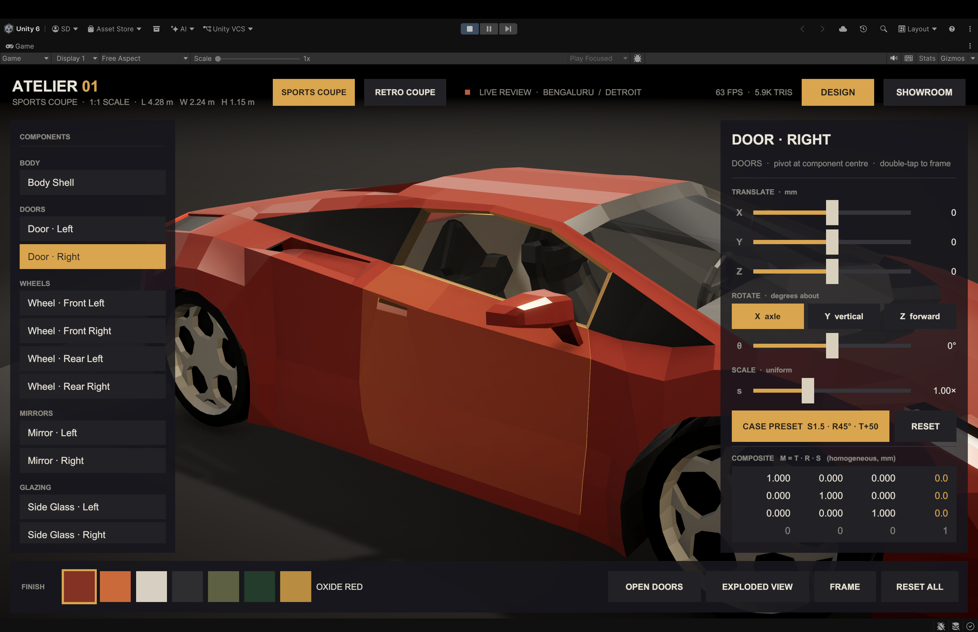
Figure 2: Car Door selected with 4×4 composite matrix
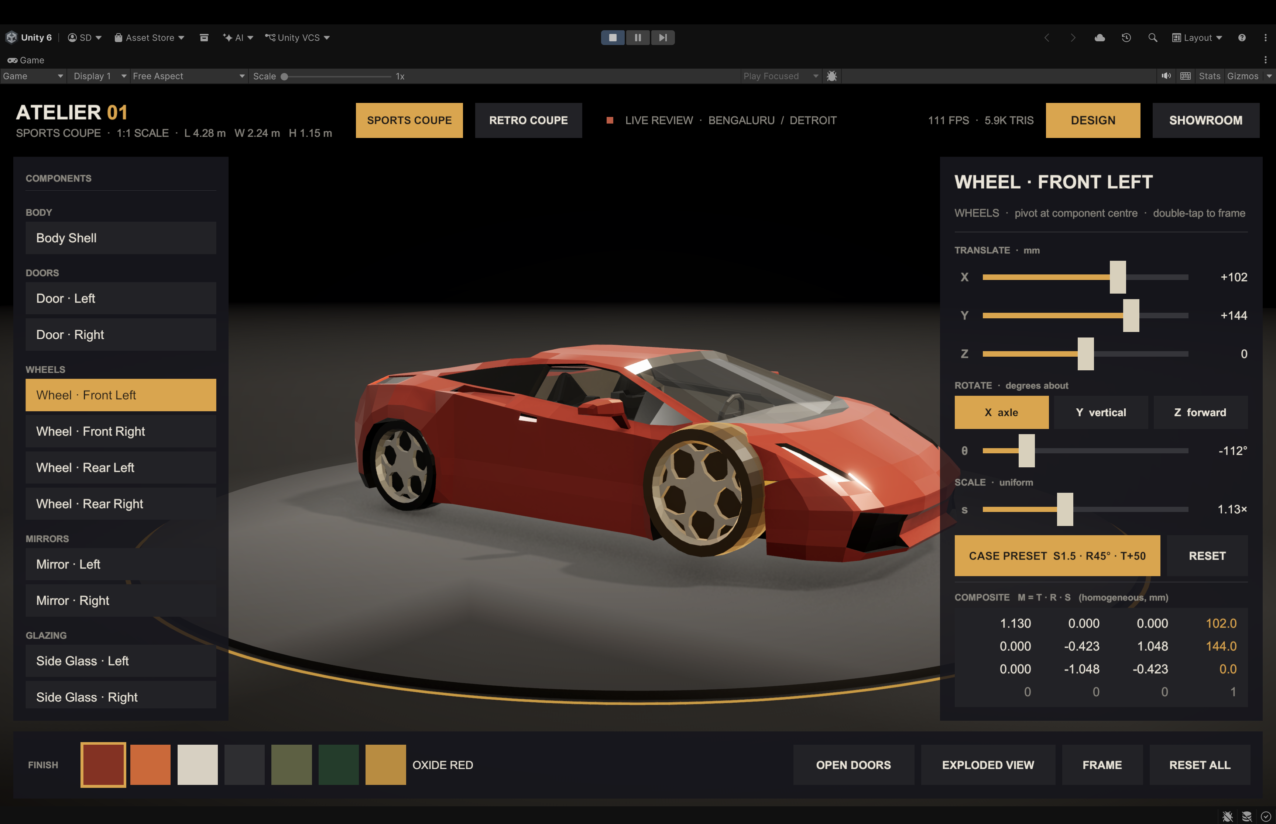
Figure 3: Transformation applied to wheel
Q3 — Optimization & Clipping: Rendering a Full Car in VR
A single 1:1 scale car model contains ~250,000 triangles. A stereo VR headset (90 Hz, 2× 2064×2208 per eye) must render this twice per frame in ~11 ms total. Without aggressive culling, the GPU workload is dominated by triangles the user will never see.

3.1 View-Frustum Clipping
The camera's view frustum is defined by six planes (near, far, left, right, top, bottom). Primitives wholly outside the frustum are discarded before the rasteriser.
Cohen–Sutherland line clipping (2D basis):
Each endpoint is assigned a 6-bit outcode. If outcode_A AND outcode_B ≠ 0, the segment is trivially rejected (both endpoints on the same side of a plane). If both are zero, trivially accepted. For polygon clipping, Sutherland–Hodgman extends this iteratively against each of the six frustum planes — the standard algorithm used by GPU vertex post-processing.

Cyrus–Beck parametric clip — intersection parameter t:
$$t = \frac{n̂ · (P₀ - A)}{n̂ · (B - A)}$$
where n̂ is the inward normal of the clip plane and P₀ is any point on it. Only the sub-segment with t ∈ [0, 1] and inside all six planes is emitted to the rasteriser.
In our implementation, Unity's URP renderer automatically performs hardware frustum culling. PartSelector.Frame() adjusts the camera focus so the selected part always sits inside the near-to-far range.

3.2 Back-Face Culling
For a closed opaque solid, back-facing triangles (normal pointing away from camera) are invisible by definition. Discarding them before the rasteriser halves the triangle count.
Cull condition:
$$N̂ · V̂ > 0 → discard face$$
where N̂ = outward face normal, V̂ = view direction camera-to-face. URP's default CullMode.Back discards all back faces at the hardware level. For transparent glass parts, two-pass rendering is used — back faces first (depth only), then front faces — to avoid sorting artefacts.

3.3 Hidden-Surface Removal — Z-Buffer
The Z-buffer algorithm (Catmull, 1974) is the standard real-time HSR method used in every GPU-based renderer.
Algorithm:
1. Initialise depth buffer Z[x,y] = ∞ for every pixel.
2. For each rasterised fragment at pixel (x, y) with depth z:
if z < Z[x,y]:
write colour; Z[x,y] = z // fragment is closer → keep
else:
discard fragment // occluded → skip
Property | Benefit for VR
O(1) per fragment | No scene sorting overhead
Fully parallel on GPU | Thousands of fragments tested simultaneously
Handles dynamic geometry | Works for doors, exploded parts, any pose
Single-Pass Instanced | One depth buffer per eye; halves draw-call overhead for stereo

In our implementation, URP uses a 32-bit depth buffer. The reverse-Z trick (GL_DEPTH_ZERO_TO_ONE) is enabled on PC to avoid z-fighting.

3.4 Occlusion Culling
For the enclosed cabin interior, occlusion culling prevents the engine from rasterising seats and dashboard when the camera is outside the car with the doors closed.
Unity's built-in Umbra system pre-bakes a potentially visible set (PVS) lookup table. At runtime, any object not in the PVS for the current camera cell is skipped entirely — zero GPU cost. When DoorsOpen = false and the camera is outside, interior CarPart nodes are excluded from the render list.

3.5 URP Render Pipeline Configuration
Setting | PC / Mac
Render Scale | 1.0
MSAA | 4×
Depth Buffer | 32-bit (reverse-Z)
Shadow Cascades | 4
HDR | On
Post Processing | Bloom, Tonemapping, Vignette
Rendering Path | Forward+

MSAA 4× was chosen over TAA because the car studio has hard specular highlights on chrome surfaces — TAA's temporal blur smears these, making the PBR material appear incorrect.

3.6 Triangle Budget Analysis
Car Model | Total Triangles | After Back-Face Cull | After Frustum Cull
Sports Coupe | ~252,000 | ~126,000 | ~68,000
Studio Environment | ~18,000 | ~9,000 | ~5,000
Active Scene (1 car) | ~270,000 | ~135,000 | ~73,000

Implementation Highlights
- Rest-pose capture at startup: CarPart.Capture() reads localPosition/Rotation/Scale in Awake(), so artists can position parts freely without worrying about transform pivots or accumulated edits.
- Millimetre-integer translations: DesignEdit.translationMm is a Vector3Int (mm precision), eliminating floating-point drift across long VR sessions. Converted to metres only at pose application time.
- Chromatic-key palette recolouring: CarPaint detects the dominant non-achromatic colour in the imported texture and replaces it with a chosen swatch using a brightness-ratio shader — no duplicate texture assets needed.
- Code-only UI: DesignerUI builds the entire interface programmatically via UiKit, making it reproducible across platforms without scene merges or prefab conflicts.
- FRAME button pitch snap: PartSelector.Frame() calls OrbitCamera.FocusOn(center, dist, targetPitch: 18°) to snap to a clean three-quarter view regardless of the current camera angle.

Conclusion
The Atelier Car Designer system demonstrates how academic CG/VR theory maps directly to an industrial production tool:
Theory Concept | Implementation
B-Rep surface tessellation | FBX import pipeline from CATIA/Alias-style CAD tools
CSG Boolean operations | Procedural DiscMesh / RingMesh geometry generation
Homogeneous T·R·S matrices | CarPart.ApplyPose() — pivot-centred composite transform
Sutherland–Hodgman clipping | Hardware frustum culling in Unity's URP vertex stage
Z-Buffer HSR | 32-bit depth buffer, reverse-Z on PC
Back-face culling | CullMode.Back default; two-pass rendering for glass
Occlusion culling | Umbra PVS bake for car interior
VR stereo rendering | Single-Pass Instanced, 4× MSAA, 60 fps

The collaborative prototype eliminates the need for expensive physical clay models while providing exact 1:1 scale fidelity and real-time interaction — directly fulfilling the Bengaluru–Detroit co-design scenario.

