CS3235 – Course Project Research Paper
RV University, Bengaluru
Speak, Retrieve, Answer: A Voice-First Multilingual Campus Assistant Built on Indian Open Models
Desu Sree Vardhan (1RUA24CSE7004)
School of Computer Science and Engineering, RV University, Bengaluru, India
Guide: Manjul Krishna Gupta
Abstract— Administrative information at Indian universities, such as fees, examination dates and placement rules, is usually published only in English. This paper presents a voice-in, voice-out assistant for RV University that answers such questions in Hindi, Kannada, Tamil and English using only Indian open models: IndicConformer for speech recognition, IndicTrans2 for translation, BharatGen Param-1 (2.9B) for grounded generation and Indic Parler-TTS for speech synthesis. Fee, calendar and placement questions are answered by deterministic tools over structured records; other questions go through hybrid BM25 and bge-m3 retrieval, cited generation and a grounding guard. On a 14-question gold set, hybrid retrieval reaches 90.9% recall at five passages and the tool router reaches 81.2% key-fact accuracy without the language model. On spoken questions in four languages, recognition averages a 3.0% character error rate for the Indian languages, and all 17 fully processed questions reached the same answering component as their typed English version.
Keywords— Retrieval-Augmented Generation, Indic Speech Recognition, Machine Translation, Text-to-Speech, Tool Routing, Multilingual Question Answering

1. Introduction
RV University (RVU), Bengaluru publishes its fees, calendars and examination, admission and placement policies as English web pages and PDFs, while its students and their parents speak Kannada, Hindi, Tamil and other languages and must search long documents for a single date or amount. Large language models (LLMs) could answer conversationally, but they invent plausible numbers when they lack the facts [16], most open LLMs handle Kannada and Tamil poorly, and a voice interface needs speech models that cope with Indic scripts, acronyms such as "BCA" and code-mixing.
Problem statement. Given a spoken or typed question in Hindi, Kannada, Tamil or English, return a short, correct, spoken answer in the same language, grounded in RVU's documents, or refuse when they lack the answer, using only AI4Bharat and BharatGen models as the brief requires. RQ1: Can such a pipeline answer campus questions usefully? RQ2: Do structured tools answer factual questions more reliably than retrieval-augmented generation? RQ3: How consistent is it across languages and between typed and spoken input?
Contributions. (i) A voice assistant built only from Indian open models that runs on a 16 GB laptop; (ii) a two-tier design of deterministic tools over structured records with grounded hybrid retrieval-augmented generation as the fallback; (iii) a script normaliser for code-mixed and English speech; (iv) an RVU knowledge base and two evaluation sets released with the code.

2. Related Work / Literature Review
Speech and translation. The Conformer [1] combines convolution and self-attention and is trained with CTC [2] or the RNN transducer (RNNT) [3]; IndicConformer [19], trained on IndicVoices [4], covers all 22 scheduled languages, while Whisper [5] is robust for English but weaker on Kannada and Tamil. IndicTrans2 [6] translates all 22, Aksharantar [7] transliterates Latin and Indic scripts, and IndicNLPSuite [18] released Indian-language corpora and models.
Retrieval, generation and speech synthesis. Retrieval-augmented generation (RAG) [8] conditions a generator on retrieved passages, which reduces but does not remove hallucination [9], [16]. BM25 [11] suits exact terms, dense retrievers such as bge-m3 [10] capture paraphrases, and reciprocal rank fusion (RRF) [12] combines them; Toolformer [17] showed that tool calls improve factual accuracy. Param-1 [13] is BharatGen's 2.9B English–Hindi model, and Indic Parler-TTS [15] extends Parler-TTS [14] to 21 Indian languages. Table 1 summarises these works.
Table 1: Summary of related work
Ref. | Model | Data | Strength | Limitation here
[4], [19] | IndicConformer | IndicVoices | Native ASR, 22 languages | Spells out acronyms
[5] | Whisper | 680k h web audio | Robust English ASR | Weak Kannada, Tamil
[6] | IndicTrans2 | BPCC | 22 scheduled languages | Sentence-level
[8] | RAG | Wikipedia | Grounded QA | Can invent numbers
[10] | bge-m3 | 100+ languages | Multilingual retrieval | 568M in memory
[17] | Toolformer | API-call data | Exact facts via tools | Needs fine-tuning
[14], [15] | Indic Parler-TTS | Described speech | Natural voices | Slow decoding

3. Problem Formulation
Let L = {hi, kn, ta, en} be the supported languages and let the knowledge base be K = (S, D), where S holds structured records (fees, calendar events and placement rules) and D = {d₁, …, d_{N}} is a set of text passages. The input is an audio clip a, or a text x, in a language ℓ ∈ L. The system computes
q = T_{ℓ→en}(ASR(a, ℓ)) (1)
y_{en} = f_{t}(q, S) if r(q) = t; else y_{en} = G(q, R_{k}(q, D)) if g(y_{en}, R_{k}) holds (2)
and returns y_{ℓ} = T_{en→ℓ}(y_{en}) spoken as s = TTS(y_{ℓ}, ℓ), where r is the intent router, f_{t} a deterministic tool, R_{k} the top-k retriever, G the LLM, g the grounding guard and T translation; a rejected answer becomes a refusal naming the responsible office. We assume short single-turn questions, a 2026–27 knowledge base and one speaker in a quiet room.

4. Dataset

4.1 Data Source and Description
No public dataset covers RVU, so a knowledge base was built from eight official English sources, five rvu.edu.in pages and three PDFs (Table A1). It holds 54 text passages (admissions 20, exams 20, policy 10, fees 4), 32 structured fee records and 53 undergraduate (UG) and postgraduate (PG) calendar events, all from public documents used for non-commercial academic work.

4.2 Data Preprocessing
Pages were scraped to Markdown and PDFs converted to text, without menus and repeated headers. Text was split at headings and into 400-token windows with 80-token overlap; the fee table and calendars were also parsed into JSON records. Passages were embedded with bge-m3 and indexed with BM25.

4.3 Data Split
No model is fine-tuned, so there is no training split. The gold set has 14 English questions: 11 answerable (3 fees, 4 exams, 2 admissions, 2 placement) with key facts and source categories, and 3 out-of-scope. The multilingual set has 8 intents written natively in all four languages (32 questions), spoken by a macOS voice per language. Both were written by the author.

5. Proposed Methodology

5.1 System Architecture
In Fig. 1, IndicConformer transcribes the audio, a script normaliser handles English written in Indic script, and IndicTrans2 translates the question to English. The router tries five tools (fees, calendar, placement, vision and mission, programmes); otherwise hybrid retrieval selects passages, Param-1 writes a cited answer and the guard accepts or refuses it. The answer is translated back and spoken by Indic Parler-TTS.
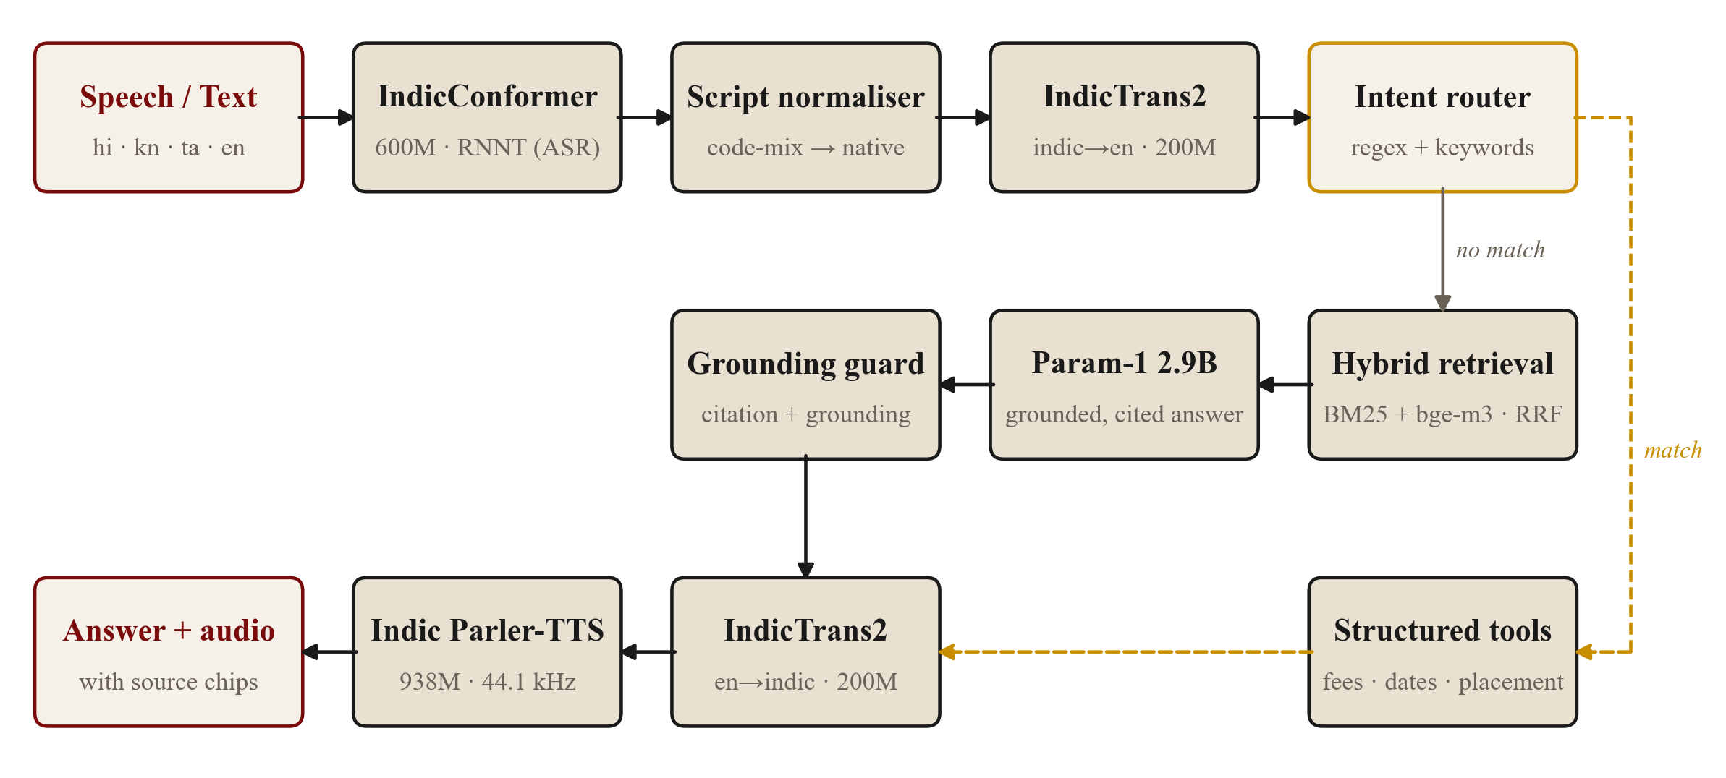
Fig. 1: Proposed system architecture. Solid arrows show the retrieval path; dashed arrows show the tool path, which skips the LLM.

5.2 Model Description
Table 2 lists the models, used as released. IndicConformer has CTC and RNNT heads; RNNT is used because it conditions on earlier tokens. Param-1, a decoder-only Transformer, is the BharatGen model that fits in memory at 16-bit precision and follows English instructions reliably. Indic Parler-TTS decodes audio-codec tokens conditioned on the text and a voice description.
Table 2: Models used in the pipeline
Role | Model (Hugging Face ID) | Params | Precision / device
Speech recognition | ai4bharat/indic-conformer-600m-multilingual | 600M | fp32 / CPU
Translation to English | ai4bharat/indictrans2-indic-en-dist-200M | 200M | fp32 / CPU
Translation from English | ai4bharat/indictrans2-en-indic-dist-200M | 200M | fp32 / CPU
Answer generation | bharatgenai/Param-1-2.9B-Instruct | 2.9B | fp16 / Apple GPU
Dense retrieval | BAAI/bge-m3 | 568M | fp16
Speech synthesis | ai4bharat/indic-parler-tts | 0.9B | fp32 / CPU

5.3 LLM / GenAI Design
Prompting and retrieval. Param-1 is prompted zero-shot (Appendix C) for three to five plain sentences that can be translated and spoken, a citation such as [S1] per claim, and "I don't have that information" when the sources are insufficient. BM25 and bge-m3 rankings are fused with RRF, score(d) = Σ 1/(60 + rank(d)), and the top k = 5 passages form the context; decoding uses temperature 0.3 and at most 150 new tokens.
Tools, guard and speech. The router applies regular expressions and keywords to the English question. An LLM answer is rejected if it is short and uncited or weakly supported, and refusals name the responsible office. Amounts such as 2,50,000 become "2 lakh 50 thousand" before translation, because IndicTrans2's digit placeholders sometimes leaked. A transcript of English words in Indic script ("वेन इज द नेक्स्ट एग्जाम") is rewritten through English. Speech is synthesised in short segments in one batch and joined with pauses.

5.4 Training Details
No model was trained: there is no labelled RVU data, a 2.9B model cannot be fine-tuned on a 16 GB laptop, and retrieval and tools supply the institutional knowledge. Only inference settings were tuned, on development questions outside both evaluation sets.

6. Prototype and Deployment

6.1 Prototype Description (UI/UX)
The web interface (React 19, TypeScript, Vite) is a single page styled like a campus notice board, in off-white, ink, oxblood and turmeric rather than the usual blue of AI products (Fig. A1). Users pick a language, then speak (press "Hold & Speak" to start and again to stop), type or choose a suggested question; each answer card shows the answer, its sources, a play button and a per-stage timing trace (Figs. A2, A3).

6.2 Deployment Details
A FastAPI backend (endpoints for health, transcribe, ask, speak and sources) runs inference on one worker thread behind the Vite interface, and one script, run.sh, starts both servers and opens the browser. Public URL: not hosted, because the models need about 10 GB of memory and two are gated; the demonstration runs locally.

6.3 GitHub Repository
https://github.com/D-SreeVardhan/LLM_IndicTTS holds the code, knowledge base, evaluation sets, results and this paper (Table A3).

7. Experimental Setup

7.1 Implementation Environment
An Apple MacBook Pro (M1 Pro, 16 GB) with Python 3.11.9, PyTorch 2.10.0 and Transformers 4.46.1. Param-1 ran on the Apple GPU and the other models on the CPU, since speech synthesis on the GPU beside Param-1 grew the backend past 30 GB.

7.2 Evaluation Metrics
For a reference of N words with S substitutions, D deletions and I insertions,
WER = (S + D + I) / N (3)
and CER is the same over characters. Recall@k is the share of answerable gold questions with a top-k passage from the gold category; key-fact accuracy is the mean share of key facts (amounts, dates, percentages) found verbatim in the answer; routing consistency is the share of questions answered by the same component as the typed English version.

7.3 Baselines
BM25-only and dense-only retrieval are the baselines for fusion. For RQ2 the tool router is compared with an earlier build (5 November 2026) whose tools returned Markdown tables and matched more loosely; for RQ3 the typed English question is the reference for each intent.

8. Results and Analysis

8.1 Retrieval and Answer Accuracy
In Table 3, hybrid retrieval and BM25 find a passage from the right category for 90.9% of answerable questions, against 81.8% for dense retrieval alone, because campus questions contain exact terms such as "MBA" or "hall ticket". For RQ2, the tool router answers 8 of the 11 answerable questions with 81.2% key-fact accuracy, up from 68.8% for the earlier build, and never captures an out-of-scope question; its two errors are a B.Tech fee by JEE-Main category, which the records do not distinguish, and a BCA answer without the skill fee. In the earlier build, the answerable questions that reached Param-1 scored 66.7% and took 22–1005 s because the machine was swapping; in the final build the LLM path took 8.5–12.9 s and tool answers 3.4–6.6 s, mostly translation (Figs. A2, A3). Only one of three out-of-scope questions was refused (Section 9).
Table 3: Performance comparison on the 14-question gold set
Configuration | Questions | Metric | Result
BM25 only | 11 answerable | Recall@5 | 90.9%
Dense (bge-m3) only | 11 answerable | Recall@5 | 81.8%
Hybrid (BM25 + bge-m3, RRF) | 11 answerable | Recall@5 | 90.9%
Earlier build, same questions | 8 tool-routed | Key-fact accuracy | 68.8%
Final build, tool path | 8 tool-routed | Key-fact accuracy | 81.2%
Final build, tool path | 3 out-of-scope | Wrong tool matches | 0
Earlier build, full pipeline | 11 answerable | Key-fact accuracy | 68.2%
Earlier build, full pipeline | 3 out-of-scope | Refusal accuracy | 33.3%

8.2 Multilingual Speech Input
For RQ3 (Table 4, Fig. 2), native recognition is accurate, with character error rates of 3.0% (Hindi), 2.4% (Kannada) and 3.5% (Tamil). Word error rates are higher mainly because acronyms are written as separate letters ("ಬಿ ಸಿ ಎ" for "ಬಿಸಿಎ") without any change in meaning. English through the Hindi model has the highest CER (7.6%). The run was stopped after 17 of 32 questions when it and a second copy of the application exhausted memory; all of these reached the same component as the typed English question, whether typed or spoken (17 of 17).
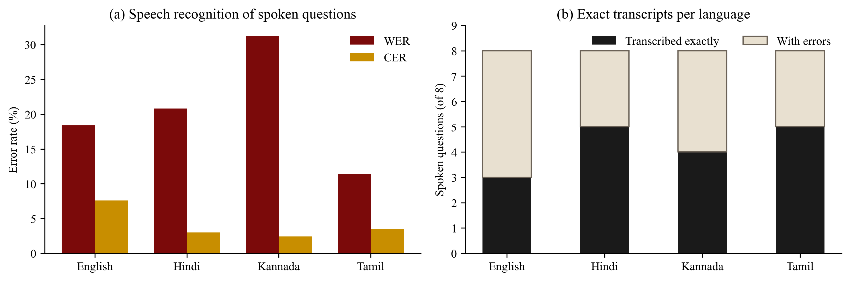
Fig. 2: (a) Word and character error rates of the spoken questions; (b) number of the eight spoken questions per language that were transcribed exactly.
Table 4: Speech recognition and routing on the multilingual spoken set
Language | WER (%) | CER (%) | Exact transcripts | Same route as English
English | 18.4 | 7.6 | 3 / 8 | 5 / 5
Hindi | 20.8 | 3.0 | 5 / 8 | 4 / 4
Kannada | 31.2 | 2.4 | 4 / 8 | 4 / 4
Tamil | 11.4 | 3.5 | 5 / 8 | 4 / 4

8.3 Sample Outputs
Figs. A2 and A3 show typical outputs; Table A2 lists notable transcripts and answers.

9. Discussion
Error analysis. The tool router never asks the LLM for a number and retrieval is strong, so errors come from three places. (i) Recognition: similar words are confused (Tamil சேர்க்கை, admission, heard as செயற்கை, artificial), and English through Hindi is weakest ("sports" became "spousal"). (ii) Refusal: RRF scores are normalised so the top passage always scores 1, so the minimum-score check never fires and refusal depends on Param-1 declining in the expected words. The same path causes false refusals: Param-1 declined the Tamil attendance question (Fig. A3) although the corpus states the 80 percent rule. (iii) Translation: IndicTrans2 sometimes changes a key word ("next exam" became "next election" for Tamil).
Comparison and limitations. The low character error rates agree with results reported for IndicConformer [4], [19] and the benefit of tools agrees with Toolformer [17]; unlike English-only RAG [8], [9], translate-route-translate behaves consistently across Indian languages. The evaluation sets are small and synthetic-voiced, the multilingual run did not reach the LLM intents, LLM gold results come from the earlier build, and speech synthesis is slower than real time.

10. Ethical Considerations and Responsible AI
Privacy: audio is processed locally and never stored. Bias: with one synthetic voice per language, accented or code-mixed speech may be served worse until real students are tested. Misuse: numbers come from records, answers show sources and unsupported answers point to the responsible office. Licensing: model and document terms were respected.

11. Conclusion and Future Work
A four-language voice assistant built only from Indian open models reached 81.2% key-fact accuracy with tools, 90.9% retrieval recall and a 3.0% native character error rate, with consistent routing across languages. Future work: calibrated refusal, transliterated English speech, streamed synthesis and real users.

Acknowledgment
The author thanks Manjul Krishna Gupta, School of Computer Science and Engineering, RV University, for guidance, and AI4Bharat (IIT Madras) and the BharatGen consortium for releasing the open models on which this work is built.

References
[1] A. Gulati et al., "Conformer: Convolution-augmented transformer for speech recognition," in Proc. Interspeech, 2020, pp. 5036–5040.
[2] A. Graves, S. Fernández, F. Gomez, and J. Schmidhuber, "Connectionist temporal classification: Labelling unsegmented sequence data with recurrent neural networks," in Proc. 23rd Int. Conf. Machine Learning (ICML), 2006, pp. 369–376.
[3] A. Graves, "Sequence transduction with recurrent neural networks," arXiv:1211.3711, 2012.
[4] T. Javed et al., "IndicVoices: Towards building an inclusive multilingual speech dataset for Indian languages," in Findings of the Association for Computational Linguistics: ACL 2024, 2024.
[5] A. Radford, J. W. Kim, T. Xu, G. Brockman, C. McLeavey, and I. Sutskever, "Robust speech recognition via large-scale weak supervision," in Proc. 40th Int. Conf. Machine Learning (ICML), 2023.
[6] J. Gala et al., "IndicTrans2: Towards high-quality and accessible machine translation models for all 22 scheduled Indian languages," Transactions on Machine Learning Research, 2023.
[7] Y. Madhani et al., "Aksharantar: Open Indic-language transliteration datasets and models for the next billion users," in Findings of the Association for Computational Linguistics: EMNLP 2023, 2023.
[8] P. Lewis et al., "Retrieval-augmented generation for knowledge-intensive NLP tasks," in Proc. Advances in Neural Information Processing Systems (NeurIPS), 2020.
[9] Y. Gao et al., "Retrieval-augmented generation for large language models: A survey," arXiv:2312.10997, 2023.
[10] J. Chen, S. Xiao, P. Zhang, K. Luo, D. Lian, and Z. Liu, "M3-Embedding: Multi-linguality, multi-functionality, multi-granularity text embeddings through self-knowledge distillation," in Findings of the Association for Computational Linguistics: ACL 2024, 2024.
[11] S. Robertson and H. Zaragoza, "The probabilistic relevance framework: BM25 and beyond," Foundations and Trends in Information Retrieval, vol. 3, no. 4, pp. 333–389, 2009.
[12] G. V. Cormack, C. L. A. Clarke, and S. Büttcher, "Reciprocal rank fusion outperforms Condorcet and individual rank learning methods," in Proc. 32nd Int. ACM SIGIR Conf. Research and Development in Information Retrieval, 2009, pp. 758–759.
[13] BharatGen, "Param-1-2.9B-Instruct," Hugging Face model card, 2025. [Online]. Available: https://huggingface.co/bharatgenai/Param-1-2.9B-Instruct
[14] D. Lyth and S. King, "Natural language guidance of high-fidelity text-to-speech with synthetic annotations," arXiv:2402.01912, 2024.
[15] AI4Bharat, "Indic Parler-TTS," Hugging Face model card, 2024. [Online]. Available: https://huggingface.co/ai4bharat/indic-parler-tts
[16] Z. Ji et al., "Survey of hallucination in natural language generation," ACM Computing Surveys, vol. 55, no. 12, pp. 1–38, 2023.
[17] T. Schick et al., "Toolformer: Language models can teach themselves to use tools," in Proc. Advances in Neural Information Processing Systems (NeurIPS), 2023.
[18] D. Kakwani et al., "IndicNLPSuite: Monolingual corpora, evaluation benchmarks and pre-trained multilingual language models for Indian languages," in Findings of the Association for Computational Linguistics: EMNLP 2020, 2020, pp. 4948–4961.
[19] AI4Bharat, "IndicConformer-600M multilingual," Hugging Face model card, 2024. [Online]. Available: https://huggingface.co/ai4bharat/indic-conformer-600m-multilingual

Appendix
A. Supplementary figures and tables.
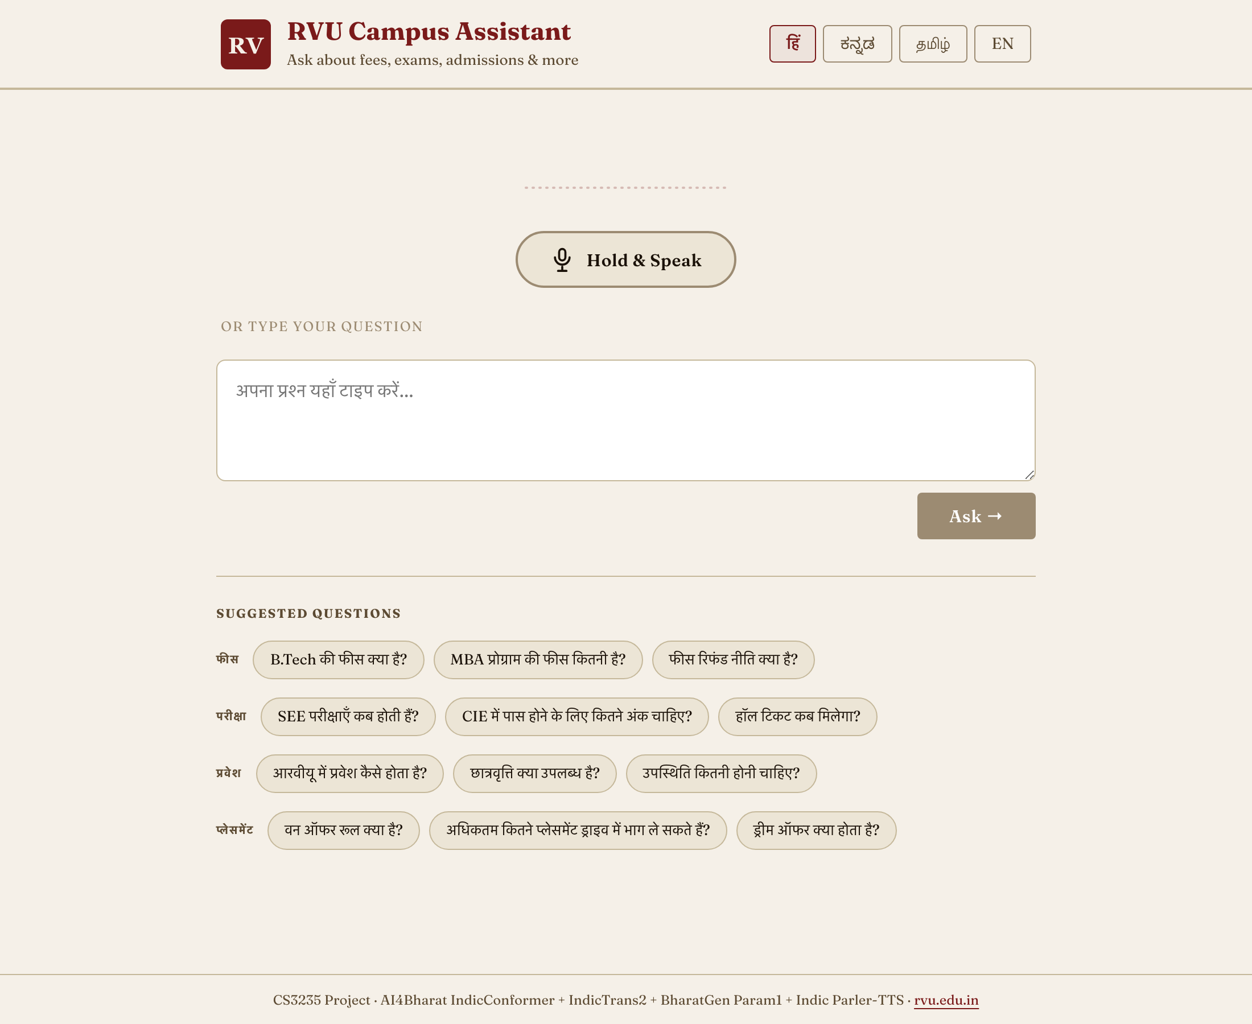
Fig. A1: Home screen with the language switch, the Hold & Speak button and suggested questions in Hindi
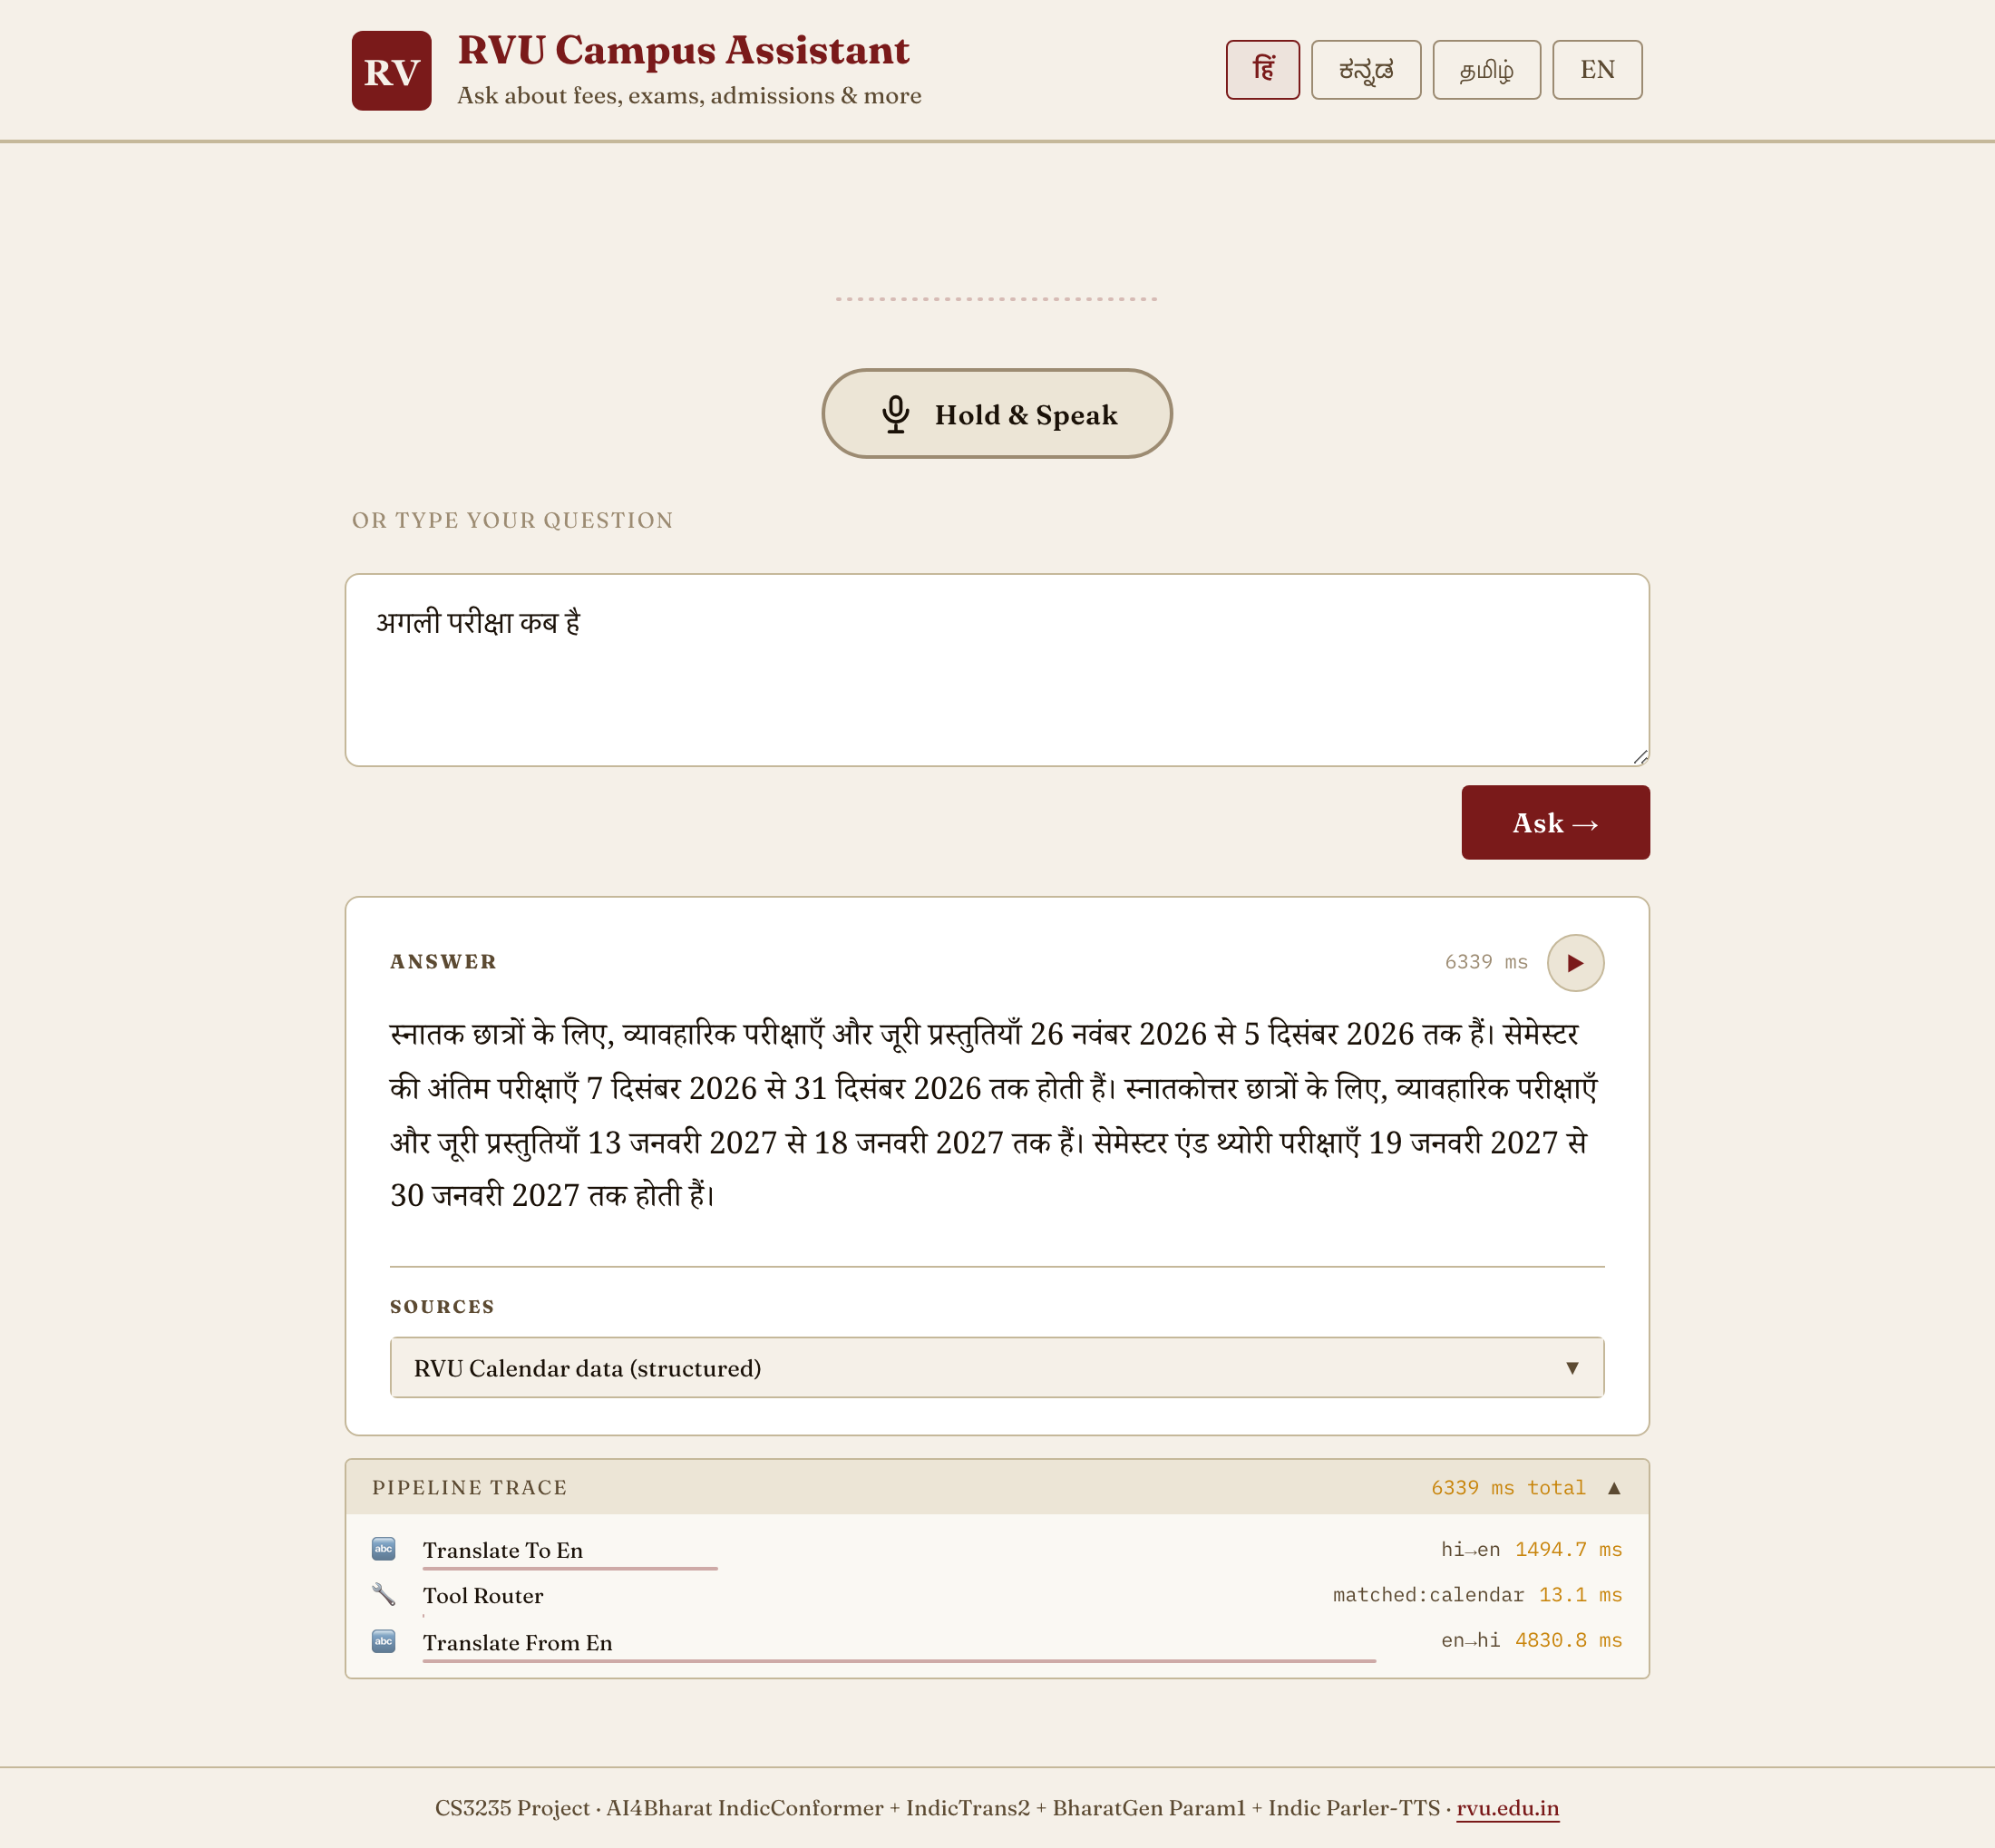 | 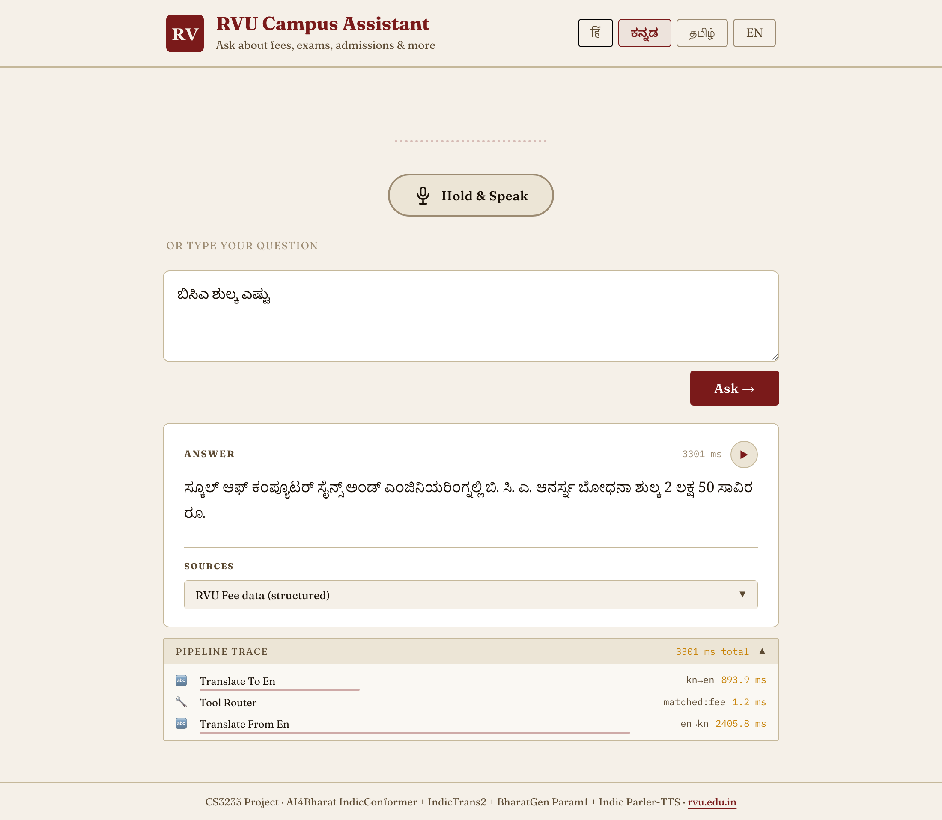
Fig. A2: Tool answers. Left: Hindi "अगली परीक्षा कब है" (when is the next exam), answered by the calendar tool. Right: Kannada "ಬಿಸಿಎ ಶುಲ್ಕ ಎಷ್ಟು" (what is the BCA fee), answered by the fee tool with the amount spelled out as "2 ಲಕ್ಷ 50 ಸಾವಿರ".
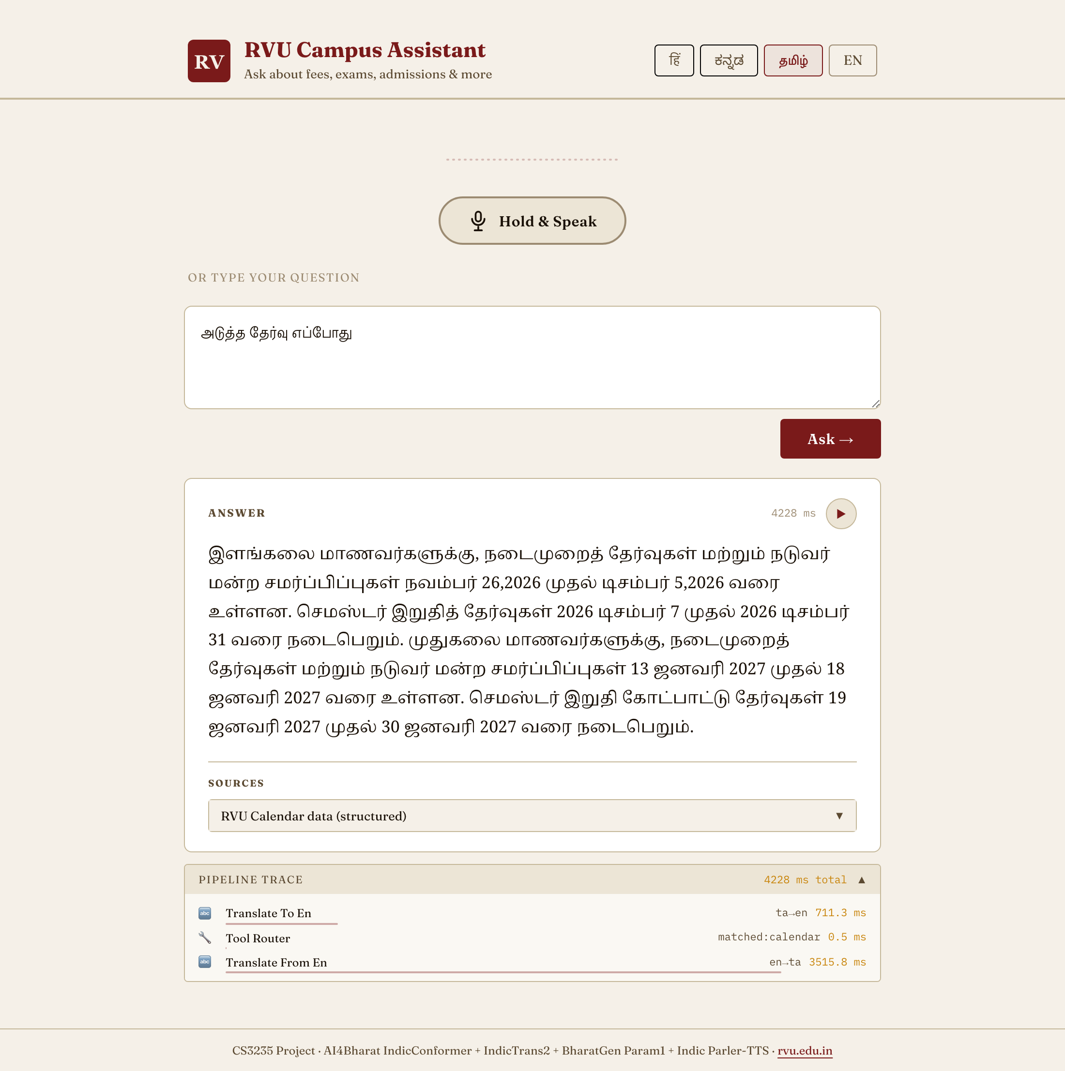 | 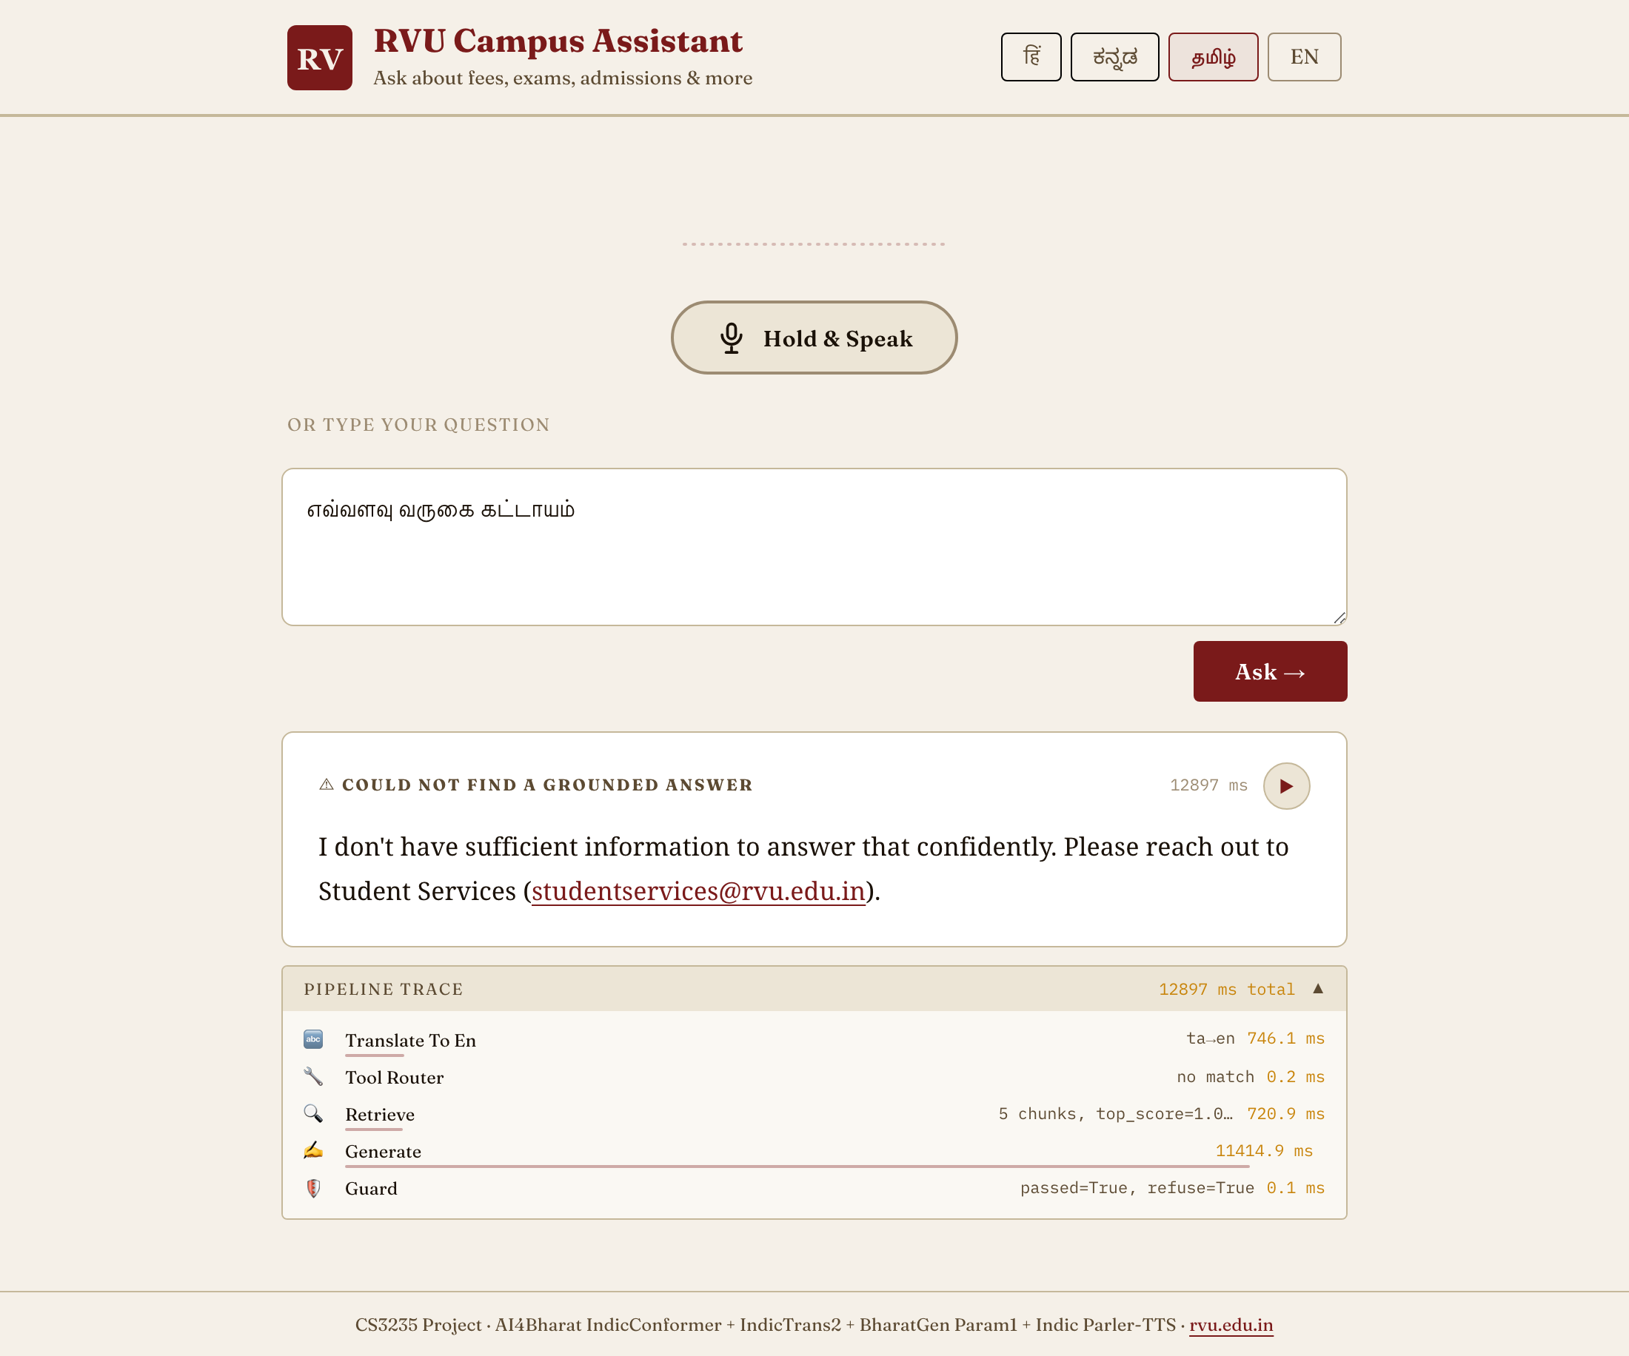
Fig. A3: Tamil. Left: "அடுத்த தேர்வு எப்போது" (when is the next exam), answered by the calendar tool. Right: "எவ்வளவு வருகை கட்டாயம்" (how much attendance is mandatory), which went through retrieval and Param-1 and was refused (Section 9).
Table A1: Knowledge-base sources
Source | Type | Category | Used by
Fee Structure AY 2026-27 | Web page | fees | Fee tool, passages
Admissions and Refund Policy | Web page | admissions | Passages
UG Academic Calendar 2026-27 | Web page | exams | Calendar tool, passages
PG Academic Calendar 2026-27 | Web page | exams | Calendar tool, passages
Sports Scholarships 2026-27 | Web page | admissions | Passages
Examination Policy | PDF | exams | Passages
Placement Policy Quick Reference 2027 | PDF | policy | Placement tool, passages
Vision and Mission Statements | PDF | policy | Vision tool, passages

Table A2: Sample outputs from the evaluation runs
Input | Output
Spoken Hindi: अगली परीक्षा कब है | Transcript identical to the question; calendar tool; Hindi answer listing UG practical and semester-end examination dates (Fig. A2)
Spoken Tamil: சேர்க்கையை ரத்து செய்தால் … | Transcript "செயற்கையை …": admission (சேர்க்கை) misheard as artificial (செயற்கை)
Spoken English: How do sports scholarships work? | Transcript "How Do Spousal Scholarships Work" after recognition through the Hindi model
Spoken English while Hindi is selected: When is the next exam? | Hindi model output "वैन इज़ द नेक्स्ट एग्जाम", normalised to "When is the next exam?"
Typed English (earlier build): What attendance percentage is mandatory at RVU? | Param-1: "The attendance requirement at RVU is 80%", with citation [S2]
Typed English: Who won the IPL in 2025? | Param-1 declined in its own words but was not marked as a refusal by the guard

Table A3: Repository structure
Path | Contents
backend/app/pipeline/ | Speech recognition, script normaliser, translation, tools, retrieval, generation, guard, speech synthesis, orchestrator
backend/app/main.py | FastAPI application and endpoints
frontend/ | React and TypeScript user interface
data/ | Source documents; passages, fee and calendar records, retrieval index
scripts/ | Knowledge-base ingestion and model download
eval/ | Evaluation scripts, gold and multilingual sets with audio, results
docs/ | This paper, its figures and the scripts that build them
run.sh | One-command launcher for the demonstration

B. Reproducibility. Code, data and results: https://github.com/D-SreeVardhan/LLM_IndicTTS. Retrieval and tool results: python eval/rag_eval.py --retrieval-only. Full-pipeline gold set: python eval/rag_eval.py --ablation hybrid (or bm25_only, dense_only, no_tools). Multilingual set: python eval/multilingual_eval.py. Figures: python docs/figures/make_figures.py and, with the application running, python docs/figures/take_screenshots.py.
C. Generation prompt. You are an authoritative assistant for RV University (RVU), Bengaluru. Answer ONLY using the provided sources below. For every factual claim, cite the source tag like [S1] inline. If the answer cannot be found in the sources, reply: "I don't have that information. Please contact the relevant RVU office." Keep the answer concise (3–5 sentences max) and factual. The answer will be translated and read aloud, so write short, complete, plain sentences: no markdown, bullet points, tables, headings or symbols like ₹ or %; write 'rupees' and 'percent' instead. The numbered sources follow, between "=== SOURCES ===" and "=== END OF SOURCES ===" markers.
D. Use of AI tools. An AI coding assistant (Cursor) was used to help write and debug parts of the code and to draft and edit this paper. The author designed the system, chose the models and ran the experiments; all reported numbers are taken from the result files in the repository.

