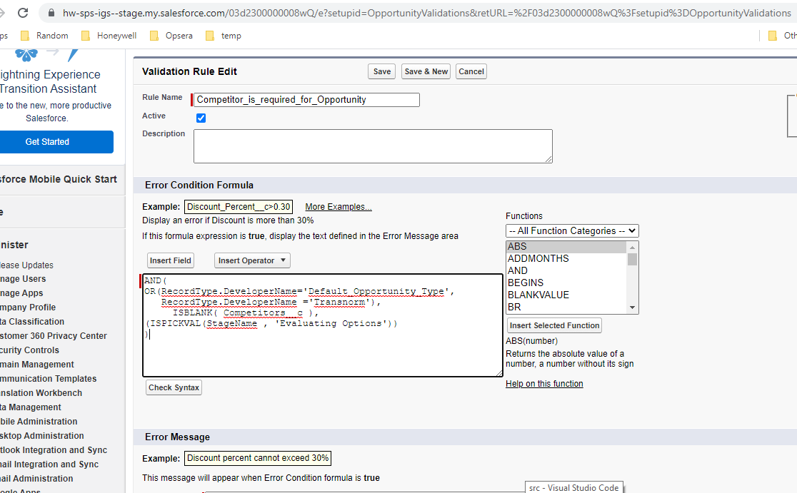

https://itbitbucket.honeywell.com/projects/SFDC/repos/sfdc_igs/pull-requests/21/diff#src/objects/Opportunity/validationRules/Competitor_is_required_for_Opportunity.validationRule-meta.xml
Run 9
610a7f2acd9bc7353548ee81

