**BANK LOAN REPORT QUERY DOCUMENT**

1. **BANK LOAN REPORT | SUMMARY**

**KPI’s:**

**1. Total Loan Applications**

SELECT COUNT(id) AS Total_Loan_Applications FROM bank_loan_data;



**2. MTD Loan Applications**

SELECT COUNT(id) AS MTD_Total_Loan_Applications FROM bank_loan_data

WHERE MONTH(issue_date) = 12 AND YEAR(issue_date) = 2021;



**3. PMTD Loan Applications**  
SELECT COUNT(id) AS PMTD_Total_Loan_Applications FROM bank_loan_data

WHERE MONTH(issue_date) = 11 AND YEAR(issue_date) = 2021;



**4. Total Funded Amount**

SELECT SUM(loan_amount) AS Total_Funded_Amount FROM bank_loan_data;



**5. MTD Total Funded Amount**

SELECT SUM(loan_amount) AS MTD_Total_Funded_Amount FROM bank_loan_data

WHERE MONTH(issue_date) = 12 AND YEAR(issue_date) = 2021;



**6. PMTD Total Funded Amount**

SELECT SUM(loan_amount) AS Total_Funded_Amount FROM bank_loan_data

WHERE MONTH(issue_date) = 11 AND YEAR(issue_date) = 2021;



**7. Total Amount Received**

SELECT SUM(total_payment) AS Total_Amount_Received FROM bank_loan_data;



**8. MTD Total Amount Received**

SELECT SUM(total_payment) AS MTD_Total_Amount_ Received FROM bank_loan_data

WHERE MONTH(issue_date) = 12 AND YEAR(issue_date) = 2021;



**9. PMTD Total Amount Received**

SELECT SUM(total_payment) AS PMTDTotal_Amount_ Received FROM bank_loan_data

WHERE MONTH(issue_date) = 11 AND YEAR(issue_date) = 2021;

**10. Average Interest Rate**

SELECT ROUND(AVG(int_rate), 4) * 100 AS Avg_Interest_Rate FROM bank_loan_data;



**11. MTD Average Interest**

SELECT ROUND(AVG(int_rate), 4) * 100 AS MTD_Avg_Interest_Rate FROM bank_loan_data

WHERE MONTH(issue_date) = 12 AND YEAR(issue_date) = 2021;



**12. PMTD Average Interest**

SELECT ROUND(AVG(int_rate), 4) * 100 AS PMTD_Avg_Interest_Rate FROM bank_loan_data

WHERE MONTH(issue_date) = 11 AND YEAR(issue_date) = 2021;



**13. Avg DTI**

SELECT ROUND(AVG(dti), 4) * 100 AS Avg_DTI FROM bank_loan_data;



**14. MTD Avg DTI**

SELECT ROUND(AVG(dti), 4) * 100 AS MTD_Avg_DTI FROM bank_loan_data

WHERE MONTH(issue_date) = 12 AND YEAR(issue_date) = 2021;



**15. PMTD Avg DTI**

SELECT ROUND(AVG(dti), 4) * 100 AS PMTD_Avg_DTI FROM bank_loan_data

WHERE MONTH(issue_date) = 12 AND YEAR(issue_date) = 2021;



**GOOD LOAN ISSUED**

**1. Good Loan Percentage**

SELECT

(COUNT(CASE WHEN loan_status = 'Fully Paid' OR loan_status = 'Current' THEN id END) * 100) /

COUNT(id) AS Good_Loan_Percentage

FROM bank_loan_data;

**2. Good Loan Applications**

SELECT COUNT(id) AS Good_Loan_Applications FROM bank_loan_data

WHERE loan_status = 'Fully Paid' OR loan_status = 'Current';



**3. Good Loan Funded Amount**

SELECT SUM(loan_amount) AS Good_Loan_Funded_Amount FROM bank_loan_data

WHERE loan_status = 'Fully Paid' OR loan_status = 'Current';

**4. Good Loan Total Received Amount**

SELECT SUM(total_payment) AS Good_Loan_Total _Received_Amount FROM bank_loan_data

WHERE loan_status = 'Fully Paid' OR loan_status = 'Current';

**BAD LOAN ISSUED**

**1. Bad Loan Percentage**

SELECT

(COUNT(CASE WHEN loan_status = 'Charged Off' THEN id END) * 100) /

COUNT(id) AS Bad_Loan_Percentage

FROM bank_loan_data;



**2. Bad Loan Applications**

SELECT COUNT(id) AS Bad_Loan_Applications FROM bank_loan_data

WHERE loan_status = 'Charged Off';



**3. Bad Loan Funded Amount**

SELECT SUM(loan_amount) AS Bad_Loan_Funded_amount FROM bank_loan_data

WHERE loan_status = 'Charged Off';



**4. Bad Loan Total Received Amount**

SELECT SUM(total_payment) AS Bad_Loan_Total_Received_Amount FROM bank_loan_data

WHERE loan_status = 'Charged Off';



**LOAN STATUS**

SELECT

loan_status,

COUNT(id) AS Total_Loan_Applications,

SUM(total_payment) AS Total_Amount_Received,

SUM(loan_amount) AS Total_Funded_Amount,

AVG(int_rate * 100) AS Interest_Rate,

AVG(dti * 100) AS DTI

FROM

bank_loan_data

GROUP BY

loan_status;

SELECT

loan_status,

SUM(total_payment) AS MTD_Total_Amount_Received,

SUM(loan_amount) AS PMTD_Total_Funded_Amount

FROM bank_loan_data

WHERE MONTH(issue_date) = 12

GROUP BY loan_status;

1. **BANK LOAN REPORT | OVERVIEW**

**1. MONTH**

SELECT

MONTH(issue_date) AS Month_Munber,

DATENAME(MONTH, issue_date) AS Month_name,

COUNT(id) AS Total_Loan_Applications,

SUM(loan_amount) AS Total_Funded_Amount,

SUM(total_payment) AS Total_Amount_Received

FROM bank_loan_data

GROUP BY MONTH(issue_date), DATENAME(MONTH, issue_date)

ORDER BY MONTH(issue_date); --COUNT(id) DESC

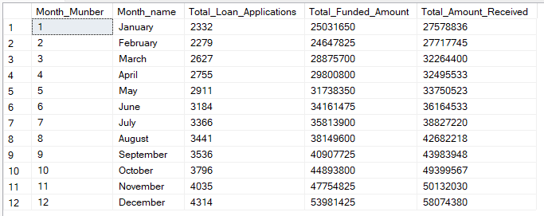

**2. STATE**

SELECT

address_state AS State,

COUNT(id) AS Total_Loan_Applications,

SUM(loan_amount) AS Total_Funded_Amount,

SUM(total_payment) AS Total_Amount_Received

FROM bank_loan_data

GROUP BY address_state

ORDER BY address_state; --COUNT(id) DESC

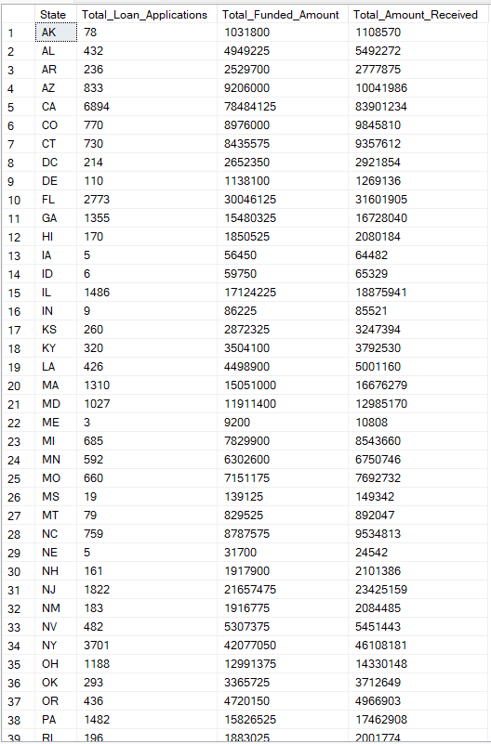

**3. TERM**

SELECT

term AS Term,

COUNT(id) AS Total_Loan_Applications,

SUM(loan_amount) AS Total_Funded_Amount,

SUM(total_payment) AS Total_Amount_Received

FROM bank_loan_data

GROUP BY term

ORDER BY term; --COUNT(id) DESC

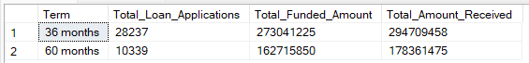

**4. EMPLOYEE LENGTH**

SELECT

emp_length AS Employee_Length,

COUNT(id) AS Total_Loan_Applications,

SUM(loan_amount) AS Total_Funded_Amount,

SUM(total_payment) AS Total_Amount_Received

FROM bank_loan_data

GROUP BY emp_length

ORDER BY emp_length; --COUNT(id) DESC;

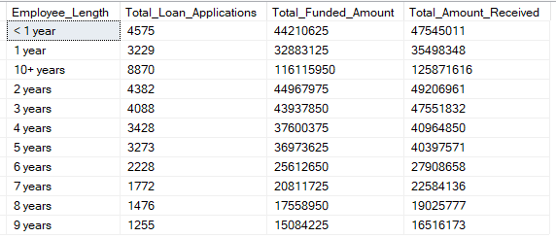

**5. PURPOSE**

SELECT

purpose AS PURPOSE,

COUNT(id) AS Total_Loan_Applications,

SUM(loan_amount) AS Total_Funded_Amount,

SUM(total_payment) AS Total_Amount_Received

FROM bank_loan_data

GROUP BY purpose

ORDER BY purpose; --COUNT(id) DESC

**6. HOME OWNERSHIP**

SELECT

home_ownership AS Home_Ownership,

COUNT(id) AS Total_Loan_Applications,

SUM(loan_amount) AS Total_Funded_Amount,

SUM(total_payment) AS Total_Amount_Received

FROM bank_loan_data

GROUP BY home_ownership

ORDER BY home_ownership; --COUNT(id) DESC

*Note: We have applied multiple Filters on all the dashboards. You can check the results for the filters as well by modifying the query and comparing the results.*

*For e.g*

*See the results when we hit the Grade A in the filters for dashboards.*

SELECT

home_ownership,

COUNT(id) AS Total_Loan_Applications,

SUM(loan_amount) AS Total_Funded_Amount,

SUM(total_payment) AS Total_Amount_Received

FROM bank_loan_data

WHERE grade = 'A' AND address_state = 'CA'

GROUP BY home_ownership

ORDER BY home_ownership; --COUNT(id) DESC