We will extract the information ( the question and answers from the scanned form) and present it in a beautiful UI, we will also make the fields editable so that if we feel there is an error or something has not been caught it can be edited before the next steps

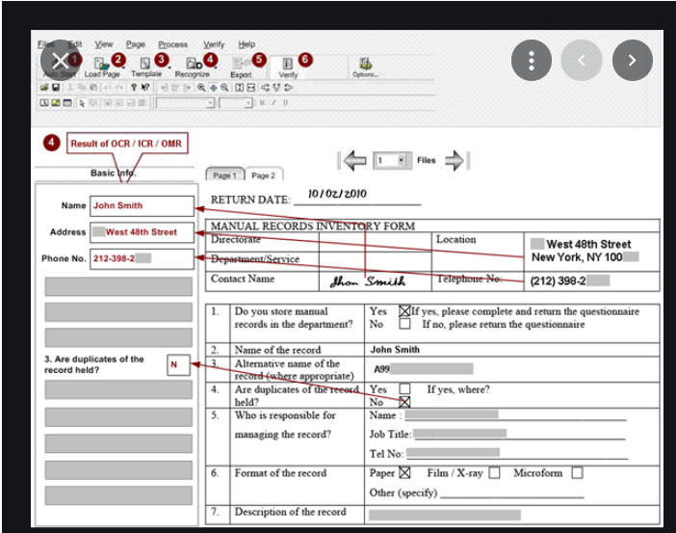

Perform sentiment analysis for review forms

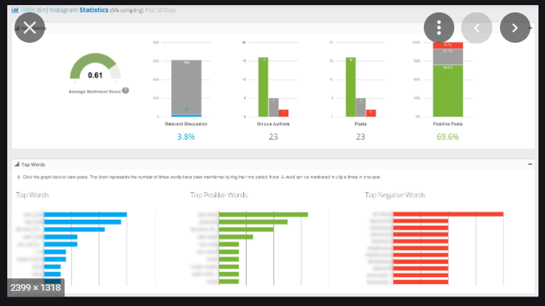

Overall Sentiment analysis based on demographic, age, sex, etc presented in UI