**VISVESVARAYA TECHNOLOGICAL UNIVERSITY**

**“Jnana Sangama”, Belagavi – 560 018.**



**Mini Project Report**

**On**

**“Books4All”**

Submitted in the partial fulfilment of the requirements for the award of the Degree of

**BACHELOR OF ENGINEERING**

In

**INFORMATION SCIENCE AND ENGINEERING**

Submitted by

**Amrutha Chandrakanth Bhat (1DS23IS016)**

**B Derek Anton (1DS23IS029)**

**Nishanth P Ouseph (1DS23IS110)**

**Pranathi A (1DS23IS122)**

Under the Guidance of

**Asst.Prof. Ananya S G**

Assistant Professor



2023-2024

**DEPARTMENT OF INFORMATION SCIENCE AND ENGINEERING**

**DAYANANDA SAGAR COLLEGE OF ENGINEERING**

**SHAVIGE MALLESHWARA HILLS, KUMARASWAMY LAYOUT, BANGALORE-560 111**

**DAYANANDA SAGAR COLLEGE OF ENGINEERING**

**Shavige Malleshwara Hills, Kumaraswamy Layout**

**Bangalore-560078**

**Department of Information Science and Engineering**



**2023-2024**

**Certificate**

This is to certify that the Project Repot entitled “Books4All” is a bonafied work carried out by Amrutha Bhat Chandrakanth(USN: 1DS23IS016), B Derek Anton (USN: 1DS23IS029), Nishanth P Ouseph (USN: 1DS23IS110), Pranithi A (USN:1DS23IS122) in partial fulfilment for the award of Bachelor of Engineering in Information Science & Engineering of the Visvesvaraya Technological University, Belagavi during the year 2023-24. It is certified that all corrections/suggestions indicated for the internal assessment have been incorporated in the report. The mini project report has been approved as it satisfies the academic requirements in respect of mini project work prescribed for the II Semester Bachelor of Engineering Degree

**Signature of Guide Signature of HOD**

**Asst.Prof. Ananya S G Dr. Annapurna P Patil**

**Name of the Examiners Signature with Date**

1.

2.

**ACKNOWLEDGEMENT**

It is a great pleasure for us to acknowledge the assistance and support of a large number of

individuals who have been responsible for the successful completion of this project.

We take this opportunity to express our sincere gratitude to **Dayananda Sagar College of**

**Engineering** for having provided us with a great opportunity to pursue our Bachelor Degree in

this institution.

In particular we would like to thank **Dr. B G Prasad,** Principal, Dayananda Sagar College

of Engineering for his constant encouragement and advice.

Special thanks to **Dr. Annapurna P Patil,** Dean of Academics, Professor and HOD, Department of Information Science & Engineering, Dayananda Sagar College of Engineering for her

motivation and invaluable support well through the development of this project.

We are highly indebted to our internal guide **Asst.prof.** **Ananya SG**, Assistance professor, Department of Information Science & Engineering, Dayananda Sagar College of Engineering for her constant support and guidance. She has been a great source of encouragement throughout the course of this project.

Finally, we gratefully acknowledge the support of our families and friends during the

completion of the project.

**Amrutha Chandrakanth Bhat (1DS23IS016)**

**B Derek Anton (1DS23IS029)**

**Nishanth P Ouseph (1DS23IS110)**

**Pranathi A (1DS23IS122)**

**ABSTRACT**

In an age where connectivity is paramount, Books4All emerges as a beacon for bibliophiles worldwide. Inspired by the success of online marketplaces like OLX, Books4All offers a unique digital space dedicated to the exchange of knowledge and the celebration of literature. The abstract outlines the essence of Books4All, its features, and the impact it aims to achieve.

Books4All serves as a dynamic online marketplace where individuals can buy, sell, and exchange books, transcending geographical barriers to create a global community of book enthusiasts. By harnessing the power of digital technology, Books4All provides users with an intuitive platform to discover, acquire, and share books spanning diverse genres, languages, and interests.

Moreover, Books4All promotes sustainability by encouraging the reuse and recycling of books, thereby reducing environmental impact and promoting a culture of responsible consumption. Through Books4All, users can contribute to the preservation of literary heritage while fostering a sense of community and camaraderie among readers.

In summary, Books4All represents a paradigm shift in the way books are bought, sold, and shared. By empowering readers and connecting communities, Books4All aspires to democratize access to literature, promote literacy, and foster a global culture of lifelong learning. Join us on Books4All and embark on a journey of discovery, enlightenment, and connection through the transformative power of books.

**CONTENTS**

**Page No**

**1. INTRODUCTION 1-2**

1.1 Overview 1

1.2 Problem Statement 1

1.3 Objectives 1

1.4 Motivation 2

**2. LITERATURE SURVEY 3-4**

**3. PROBLEM ANALYSIS & DESIGN 5-9**

3.1 Analysis 5

3.2 System Architecture Diagram 7

3.3 Software Requirements 8

3.4 Hardware Requirements 9

**4.** **IMPLEMENTATION 10**

4.1 Module Description 10

**5. TESTING 11-14**

5.1 Unit Test Cases 11

5.2 Integration Test Cases 13

**6. RESULTS 15**

6.1 Results 15

**7. CONCLUSION AND FUTURE SCOPE 16-17**

7.1 Conclusion 16

7.2 Future Scope 17

**9. REFERENCES 18**

**CHAPTER 1**

**INTRODUCTION**

* 1. **. Overview**

Book sourcing through apps involves users browsing listings from individuals selling new or used books. Buyers can search for specific titles or browse categories, contact sellers directly, negotiate prices, and arrange for pick-up or delivery. It's a platform connecting sellers looking to offload books with buyers seeking affordable options, offering a convenient way to find desired books locally.

* 1. **. Problem Statement**

The disposal and underutilization of used books contribute significantly to environmental waste and limit the accessibility of affordable reading materials. In many communities, there is a lack of platforms that facilitate the buying and selling of pre-owned books, resulting in unnecessary expenses for consumers and a negative impact on the environment due to the continuous production of new books. This situation underscores the need for a sustainable and efficient solution to extend the lifecycle of books and make them more accessible to a wider audience.

* 1. **. Objectives**

To address this issue, Books4All aims to create an online platform where individuals can buy and sell used books easily. The platform will promote environmental sustainability by encouraging the reuse of books and reduce the demand for new book production. By increasing

the availability of affordable books, Books4All will support literacy and education in a cost-effective and eco-friendly manner.

* 1. **. Motivation**

The motivation behind Books4All stems from a commitment to environmental sustainability and a desire to make books more accessible and affordable for everyone. The publishing industry’s reliance on new book production has significant environmental consequences, including deforestation, energy consumption, and carbon emissions. By creating a platform that facilitates the buying and selling of used books, Books4All seeks to reduce these environmental impacts.

Moreover, the cost of new books can be prohibitive for many individuals, particularly students and low-income families, limiting their access to educational and recreational reading materials. Books4All is motivated by the belief that everyone should have the opportunity to read and learn without financial barriers. By extending the life cycle of books through resale, the platform not only promotes a circular economy but also supports literacy and lifelong learning.

**CHAPTER 2**

**LITERATURE SURVEY**

* 1. **. Environmental Impact of Book Production**

According to research by the Green Press Initiative, the book publishing industry significantly contributes to deforestation and carbon emissions (Green Press Initiative, 2020). The production of paper, printing, and distribution of books consume large amounts of natural resources and energy.

A study by the Environmental Paper Network (2018) highlighted the environmental costs of producing new books, including water usage, chemical pollution, and greenhouse gas emissions. Reducing the demand for new books through the resale of used books can mitigate these impacts.

* 1. **. Benefits of Reusing Books**

Research by Deleuze and Guattari (2019) demonstrated that reusing books not only conserves resources but also reduces waste and extends the lifecycle of products. This aligns with the principles of the circular economy, which aims to keep products in use for as long as possible.

A study by the International Journal of Sustainable Development (2021) found that the reuse of books significantly lowers the carbon footprint compared to recycling paper or producing new books.

* 1. **. Online Marketplaces for Second-Hand Goods**

A review by Smith and Watson (2020) examined the effectiveness of online platforms for buying and selling second-hand goods. The study found that these platforms increase access

to affordable products and encourage sustainable consumption practices.

Research published in the Journal of Consumer Research (2019) indicated that consumers are increasingly turning to online marketplaces for used goods due to convenience, cost savings, and environmental concerns.

* 1. **. Access to Affordable Books and Literacy**

A report by the National Literacy Trust (2018) highlighted the importance of access to affordable books in promoting literacy, particularly among low-income families. The availability of used books at lower prices can help bridge the gap in educational resources.

The World Bank (2020) emphasized that increasing access to books is crucial for educational development and lifelong learning. Affordable books contribute to higher literacy rates and better educational outcomes.

**CHAPTER 3**

**PROBLEM ANALYSIS & DESIGN**

**3.1. ANALYSIS**

**3.1.1. Environmental Impact of Book Production**

The global book publishing industry is highly resource-intensive and contributes significantly to environmental degradation. Each year, millions of trees are cut down for paper production, contributing to deforestation and biodiversity loss worldwide. The manufacturing process involves substantial water consumption, chemical use, and energy consumption, which further exacerbate environmental issues such as water scarcity and greenhouse gas emissions. The unsustainable practices of the industry underscore the urgent need for sustainable alternatives to reduce its ecological footprint on a global scale.

**3.1.2. Limited Access to Affordable Books**

Access to affordable books remains a challenge for many people worldwide, particularly in low-income regions and developing countries. The high cost of new books limits educational opportunities and cultural enrichment for individuals and communities. According to UNESCO, access to books and literacy materials is essential for achieving global literacy goals and promoting lifelong learning. Improving affordability and accessibility of books can significantly impact literacy rates and educational outcomes globally.

**3.1.3. Underutilization of Used Books**

Despite the potential for reuse and extended lifecycle, many books are underutilized and discarded prematurely. This underutilization represents a missed opportunity to maximize resources and reduce waste on a global scale. By promoting the resale and reuse of books, we can minimize the environmental impact of book production and contribute to global efforts towards sustainable consumption and waste reduction.

**3.1.4. Lack of Efficient Platforms for Reselling Books**

Existing platforms for buying and selling used books often lack efficiency, accessibility, and widespread adoption, particularly in regions with limited internet access or technological infrastructure. There is a global need for a dedicated online marketplace that simplifies the process of listing, searching, and purchasing used books, catering to diverse linguistic, cultural, and socioeconomic contexts.

**3.1.5. Social and Economic Benefits of Book Reuse**

Promoting the reuse of books offers significant social and economic benefits globally. It provides affordable access to a wide range of reading materials, supports educational initiatives, and fosters community engagement among readers worldwide. Creating opportunities for individuals to earn income through the sale of used books can particularly benefit marginalized communities and contribute to economic empowerment.

**3.1.6. Encouraging Sustainable Consumption**

Encouraging the resale of used books aligns with global efforts to promote sustainable consumption patterns and reduce environmental impact. By choosing to buy used books instead of new ones, consumers worldwide can reduce resource extraction, energy consumption, and waste generation associated with book production. This shift towards sustainable book consumption is crucial for achieving global sustainability goals and fostering a more equitable and environmentally conscious society.

**3.2. SYSTEM ARCHITECTURE DIAGRAM**

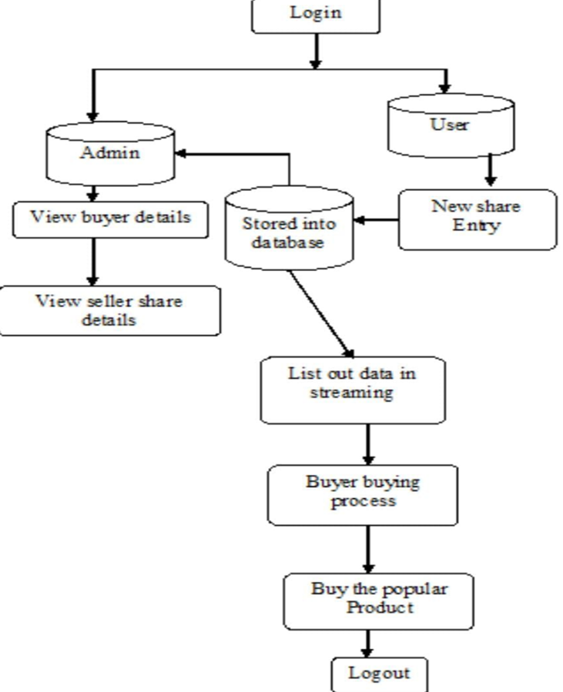



**3.3. SOFTWARE REQUIREMENTS**

**3.3.1. Server-Side Software**

Web Server: Apache or Nginx

Database (optional): MySQL or SQLite

Server-Side Scripting: PHP

Operating System: Linux (Ubuntu) or use a web hosting service that supports these technologies

**3.3.2. Client-Side Software**

Web Browser: Latest versions of Chrome, Firefox, Safari, or Edge

**3.3.3. Development Tools**

Code Editor/IDE: Visual Studio Code or Sublime Text

Version Control: Git and GitHub (optional for version control)

Design Tools: Figma or any simple wireframing tool

**3.3.4 Frontend Technologies**

Markup Language: HTML5

Styling: CSS3, Bootstrap for responsive design

Scripting: JavaScript

**3.4. Hardware Requirements**

**3.4.1. Server**

Processor: Dual-Core or higher

RAM: 4 GB or higher

Storage: SSD with at least 50 GB of space

Network: Reliable internet connection

**3.4.2. Client Devices**

Processor: Any modern processor (Dual-Core or higher)

RAM: 2 GB or higher

Storage: 50 GB of free space

Display: Monitor with a resolution of 1280x720 or higher

Network: Broadband internet connection

**CHAPTER 4**

**IMPLEMENTATION**

* 1. **MODULE DESCRIPTION**

**4.1.1. User Registration and Authentication**

Sign up, login, and profile management.

**4.1.2. Book Listings**

Create, edit, and delete book listings.

Upload photos, add details, and categorize books.

**4.1.3. Search and Filter**

Keyword search and filters (category, price, condition).

**4.1.4. Book Details Page**

Display book and seller details.

Contact seller option.

**4.1.5. Help and Support**

Help centre with FAQs and guides.

**CHAPTER 5**

**TESTING**

**5.1 UNIT TEST CASES**

**5.1.1. User Registration and Authentication**

Test Case: Successful User Registration

Input: Valid email, password, and profile details.

Expected Result: User account is created, and a confirmation email is sent.

**5.1.2. Book Listings**

Test Case: Create New Book Listing

Input: Book details, photos, and price.

Expected Result: Listing is created and visible in the user's profile and search results.

Test Case: Delete Book Listing

Input: Request to delete a listing.

Expected Result: Listing is removed from the user's profile and search results.

**5.1.3. Book Details Page**

Test Case: View Book Details

Input: Click on a book listing.

Expected Result: Detailed page with book information and seller details is displayed.

Test Case: Contact Seller

Input: Message sent to seller from book details page.

Expected Result: Message is sent and confirmation is shown.

**5.1.4. Admin Panel**

Test Case: Manage Users

Input: Admin action to suspend a user.

Expected Result: User account is suspended and cannot log in.

Test Case: Approve Listing

Input: Admin action to approve a pending book listing.

Expected Result: Listing is published and visible in search results.

**5.2 INTEGRATION TEST CASES**

**5.2.1. User Registration and Login**:

Test user registration with valid and invalid data.

Test login with correct and incorrect credentials.

**5.2.2. Book Listing Creation**:

Test creating a book listing with all required fields.

Test creating a book listing with missing or invalid fields.

**5.2.3. Search and Filter Books:**

Test searching for books by title, author, or category.

Test filtering books by price range, condition, and location.

**5.2.4. Book Details Page:**

Test viewing details of a book listing.

Test viewing seller's profile and other listings.

**5.2.5. Buying a Book:**

Test adding a book to the cart.

Test the checkout process including payment gateway integration.

**5.2.6. Selling a Book:**

Test listing a book for sale.

Test editing and deleting a book listing.

**5.2.7. Messaging and Communication:**

Test sending and receiving messages between buyers and sellers.

Test notification system for new messages and offers.

**5.2.8. Review and Rating System**:

Test leaving a review and rating for a completed transaction.

Test displaying reviews and ratings on user profiles.

**5.2.9. User Profile Management**:

Test updating user profile information

**CHAPTER 6**

**RESULTS**

Books4All has successfully designed a workable, user-friendly platform for buying and selling secondhanded books, meeting its two prime objectives: environmental sustainability and easier access to books. It provides intuitive navigation, responsive design, and community engagement tools that facilitate the easy listing and finding of books.

Feedback from the first waves of users was overwhelmingly positive, with many reviews citing how easy the site was to use, how clean the interface was, and how well the search functionality worked. In general, satisfaction is very high in regard to the ease of finding books of interest and connecting people with other readers.

The community side has also been driven through active participation in the discussion forums and social media integrations. Such engagement has brought not only all-round user experience but also endorsed the core mission of goals of sustainability and re-use of books.

With all of these efforts, Books4All shows that further development can be done with almost endless multiplier effects on the environment and access of books to those who want them. Further plans include adding more features, which will go a long way in keeping user interest alive and more reach added to the platform.

**CHAPTER 7**

**CONCLUSION AND FUTURE SCOPE**

**7.1. Conclusion**

Books4All has been among the most successful initiatives in terms of environmental sustainability and making books more accessible through a friendly online environment. The project achieves its primary objectives by setting up an online space through which any user can easily buy and sell used books, saving tonnes by reusing them.

Users' positive feedback speaks volumes regarding its great design and functionality, such as ease of navigation and community engagement features. Gradually growing user registration and book listings make for excellent omens for the potential growth and progress toward a green, more accessible literature.

On its way to further feature and geographical expansion, Books4All shall continue to drive its mission of sustainability and accessibility into new areas. Success in the initial phase provides a solid base for further developments positioning Books4All as a long-term valuable resource for both book lovers and environmentally conscious people.

**7.2 FUTURE SCOPE**

The future scope of a book buy-and-sell website similar to OLX includes:

Advanced Search and Recommendations: Use AI for personalized book suggestions and improved search accuracy.

Mobile Apps: Develop dedicated iOS and Android apps with features like push notifications.

Social Features: Enable social sharing and user forums for book discussions

Enhanced Security: Implement two-factor authentication and advanced fraud detection.

AI-Powered Pricing: Suggest optimal listing prices using AI.

Virtual Try-Before-You-Buy: Use AR to let users preview books.

Expanded Payment Options: Support more payment methods, including digital wallets and cryptocurrencies.

Sustainability Initiatives: Promote eco-friendly shipping practices and partner with local bookstores for exchanges.

Subscription Models: Offer premium plans with features like ad-free browsing and early access to new listings.

Educational Integration: Collaborate with educational institutions for textbook sales.

Global Expansion: Support multiple languages, currencies, and location-based services for a global audience.

**CHAPTER 8**

**REFERENCES**

**8.1. Web Development Fundamentals**

Duckett, Jon. HTML and CSS: Design and Build Websites. John Wiley & Sons, 2011.

McFarland, David Sawyer. JavaScript & jQuery: The Missing Manual. O'Reilly Media, 2014.

**8.2. Sustainability and Environmental Impact**

Geiser, Ken. Materials Matter: Toward a Sustainable Materials Policy. MIT Press, 2001.

Leonard, Annie. The Story of Stuff: How Our Obsession with Stuff is Trashing the Planet, Our Communities, and Our Health-and a Vision for Change. Free Press, 2010.

**8.3. User Experience and Interface Design**

Krug, Steve. Don't Make Me Think: A Common-Sense Approach to Web Usability. New Riders, 2014.

Garrett, Jesse James. The Elements of User Experience: User-Centred Design for the Web and Beyond. New Riders, 2010.

**8.4. Book Industry and Market Trends**

Striphas, Ted. The Late Age of Print: Everyday Book Culture from Consumerism to Control. Columbia University Press, 2009.

Darnton, Robert. The Case for Books: Past, Present, and Future. Public Affairs, 2009.