LIST OF COMPONENTS:  
  
1: Arduino UNO

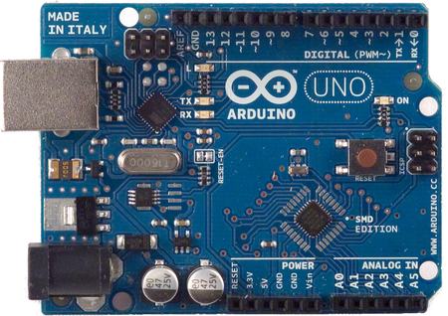

2: H-Bridge L298  
  
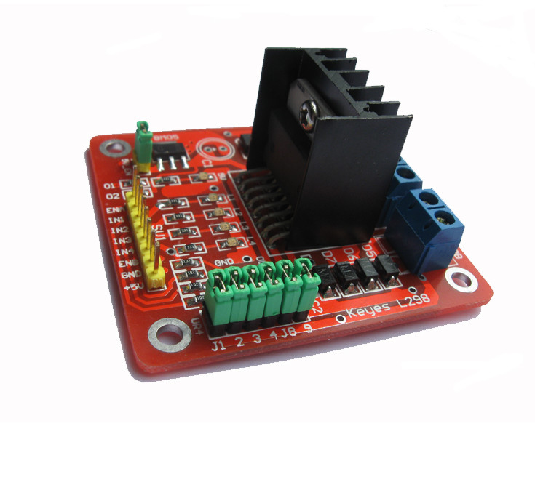

3: 2200 mAh Battery  
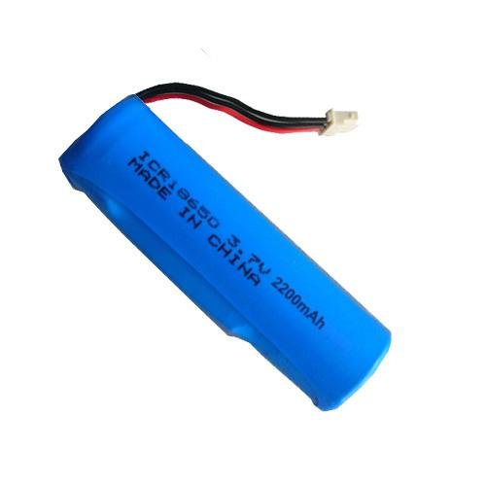  
  
  
4: Caster wheel  
  
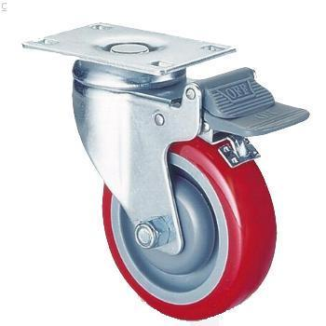  
  
5: Robot Mount  
  
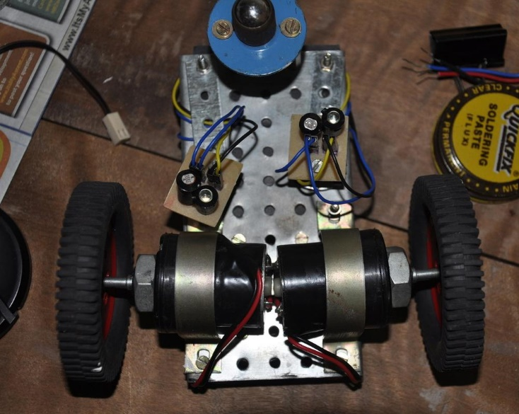

6: 2 DC motors  
  
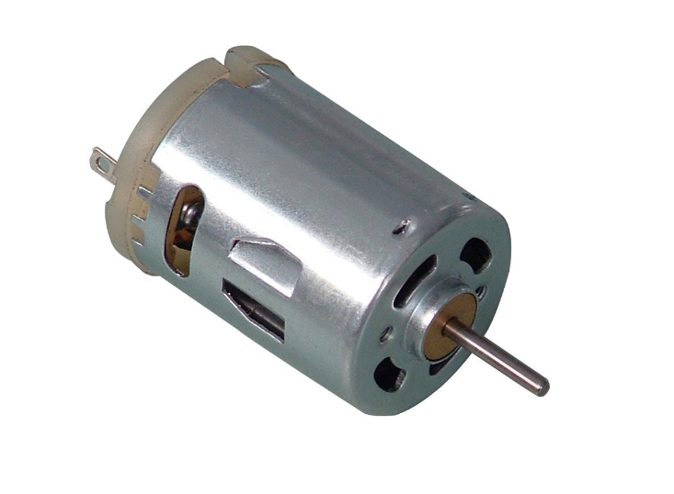  
  
7: 1 Servo motor  
  
[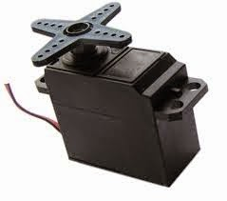](http://3.bp.blogspot.com/-be-D2xbU-Ig/VRgQZST5zdI/AAAAAAAAAD8/pZLP58HFtLk/s1600/download.jpg)  
  
8:  Wheels  
  
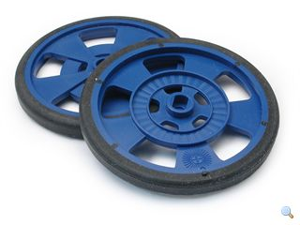

WORKING:

We'll be given a list of shapes by our mentor and we'll write the Arduino codes for the given shapes accordingly so that our robot is able to draw a rangoli of that shape taking care of where to and where not to drop the rangoli powder.

Also we'll ensure that the robot does not smudge the rangoli when it is moving.

INITIAL APPROACH:

1. First of all, we'll start by making a well-functional robot which is able to move according to the given shapes.
2. Our next milestone would be to attach a powder dropping device which is controlled by a servo motor. This device would control the powder-dropping process.
3. Our last aim would be to ensure that the robot does not smudge the already drawn figure when it is drawing overlapping figures.

TOOLS AND SOFTWARES USED:

1. Arduino IDE
2. Soldering kit

PICTURES

[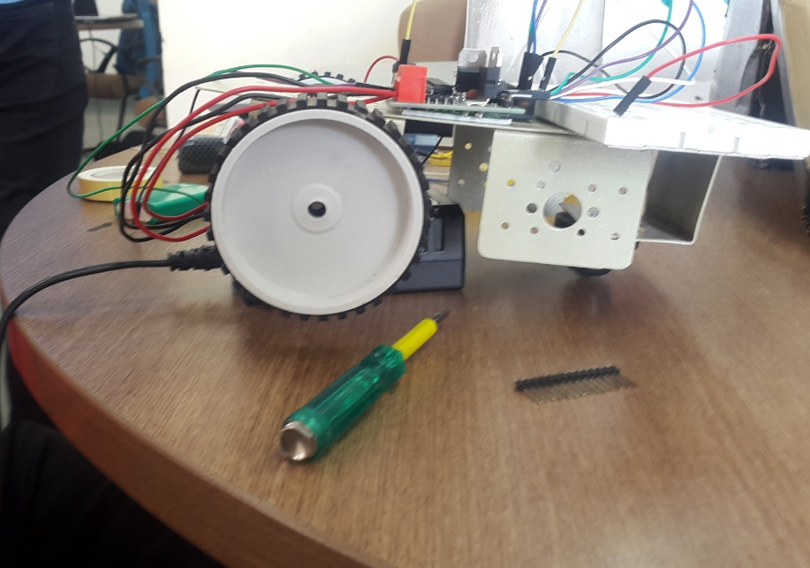](http://1.bp.blogspot.com/-4q0VZByLoMo/VUND-t-SyrI/AAAAAAAAAFI/JhsRH-3gfSU/s1600/upload.png)

LESSONS LEARNT

1) We learnt how to use a lipo battery properly.  
2) We learnt how an h bridge works and how to use an h bridge properly.  
3) We learnt to deal with problems related to the arduino getting overheated  
4) We learnt the basic functioning of a basic arduino program,

CHALLENGES FACED

1) Firstly, the h bridge refused to work properly,  
2) Then it would work properly with one motor but would get overheated when both the wheels  
would be connected to the arduino.  
3) Unfortunately, our arduino stopped working at the last moment.  
4)Calibrating the bot with respect to different surfaces.  
  
PRACTICAL USAGE

1) On a large scale the bot could be used to make the boundaries of racing tracks.  
2) The bot could also be used as an aid to teaching in pre-school where it could serve as  
an interactive and fun way to learn shapes, alphabets and serve as an extremely effective tool for visual learning.  
3) A more sophisticated version of the bot could also be used as an effective tool for interior decoration.  
  
MILESTONES ACHIEVED

1)We succeeded in making the h bridge work.  
2)We also succeeded in integrating the software with the hardware on a small scale.  
  
REFERENCES:

1. <https://www.youtube.com/watch?v=W8Rcg6lYPcU>
2. <https://www.youtube.com/watch?v=f0ASGn7V-E8>
3. http://www.arduino.cc/en/Main/ArduinoBoardUno
4. http://www.arduino.cc/en/Tutorial/HomePage