Remarks
1. Removing print statement, can save time and makes sure the cycle doesnt break. Since we are dealing with ms [improvement could be done]
2. Sleep mode is disconnecting BLE (both light and deep). Sleep used only when both BLE not asking and sensor not sending
3. Mutex is used to safeguard buffer [FREERTOS] 2 TASKS - SensorTask, BLETask
4. N is default 10, can be changed later
5. And so is buffer size
6. LPN pin operates as per sensor needed to work or not , if yes HIGH, no then low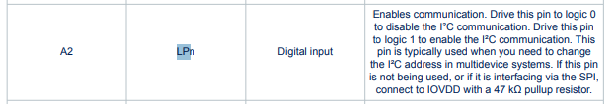
7. STOP and START are not clear in the assignment, So I used startSampling and stopSampling for sensor to work or not and startBLE and stopBLE for bluetooth to send data or not
8. When startBLE starts, ring buffer values will be sent and buffer slowly empties
9. If Buffer overfilled, overwrites old data as the data here is not critical. Different use case different methods
10. I havent changed the buffer size when the sampling rate changes. I put constant for simplicity
sYSTEM ALSO DEPENDS ON PREVIOUS STATE
Control
1. startSampling
2. stopSampling
3. startBLE
4. stopBLE
5. Setrate:10
6. Clear
For the sensor -
For this assignment lets just do 1 capture per every 50ms. (given fixed sampling rate is 20Hz)
If it takes more than 50ms, lets drop. (it wont usually wont according to the settings or configurations we choose. But if ToF is greater than yeah )

Okay, according to assignment, ring buffer stores last N seconds
1 second = 1000ms = 50 * 20 ms = 50ms * 20 = 20 Samples per second ( if we capture one data value per every 50ms)
Buffer size for N seconds = 20N
8×8 array = 64 values
Each value = 4 bytes = 64 × 4 = 256 bytes per sample
20 samples per second = 256 × 20 = 5120 bytes ( approx 5 KB per second)
For N seconds: Buffer size = 256 × 20 × N = 5120 × N bytes
To read from sensor, use this github page to get real time values from sensor,
https://github.com/stm32duino/VL53L8CX

11. Using nrfConnect, below are the attached pictures
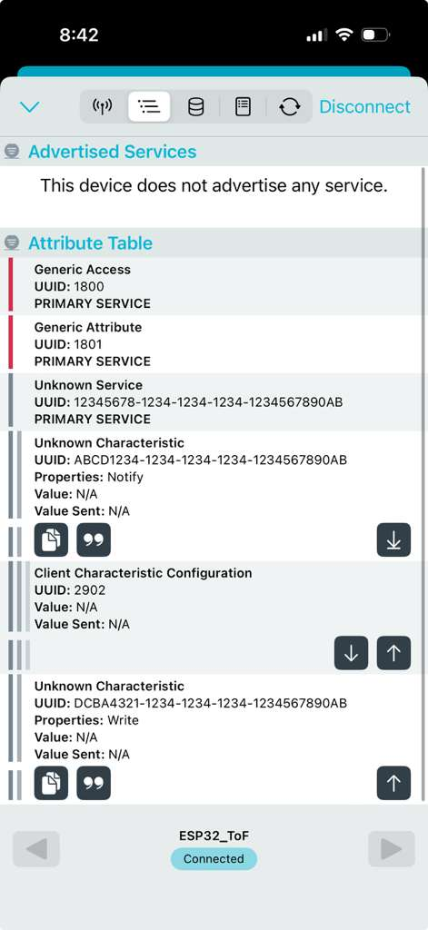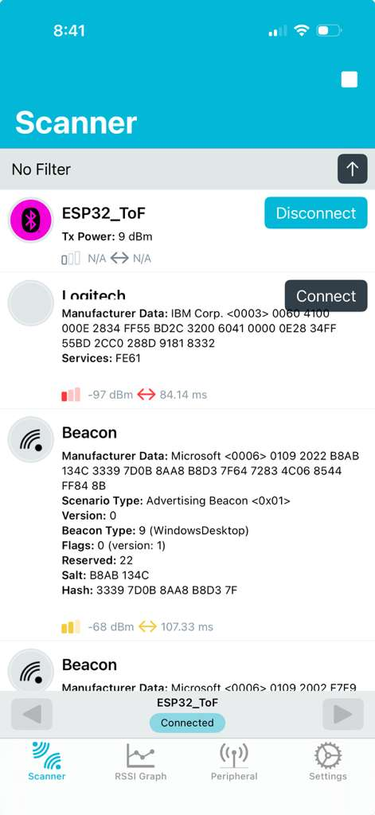

Normal startSampling = 1 and NO ble . JUST READ AND STORE . OVERFILL -> OVERWRITE

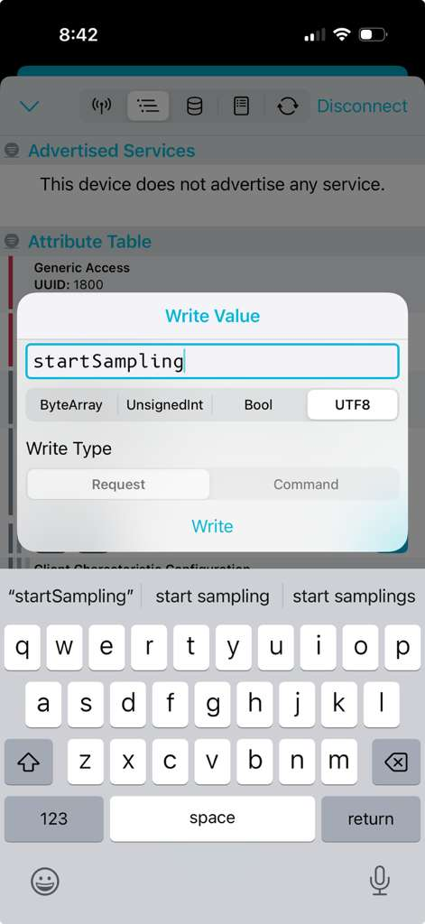

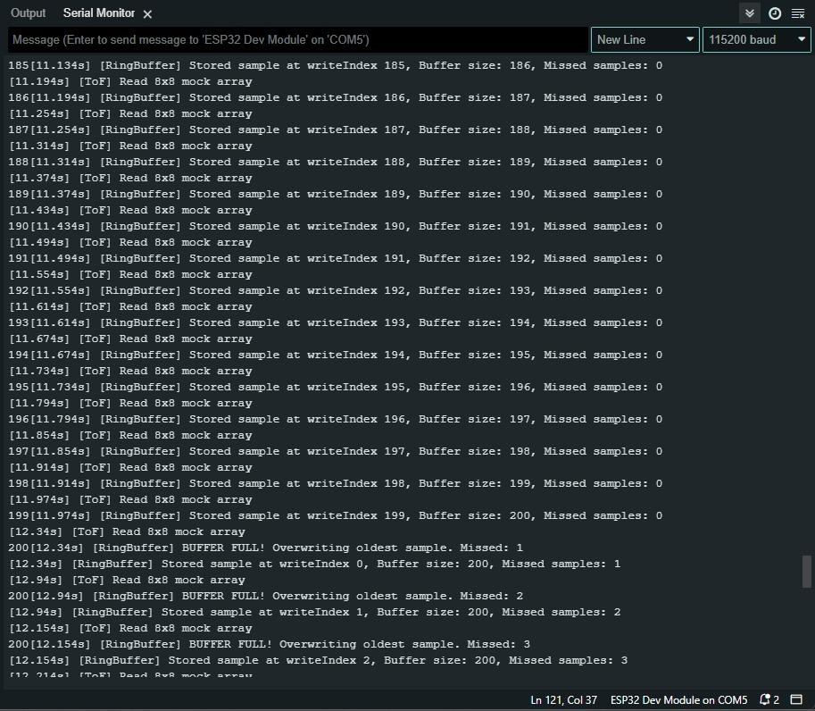

stopSampling and no BLE
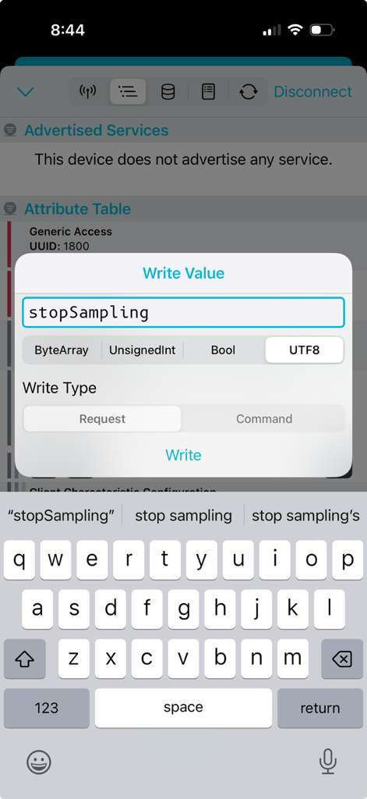
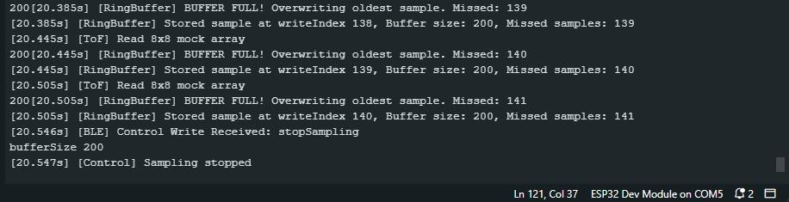

startBLE AND startSampling
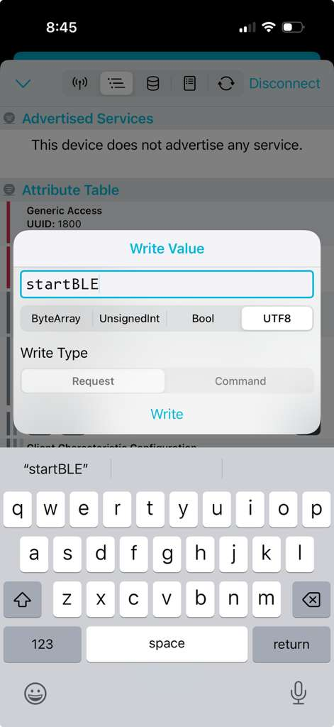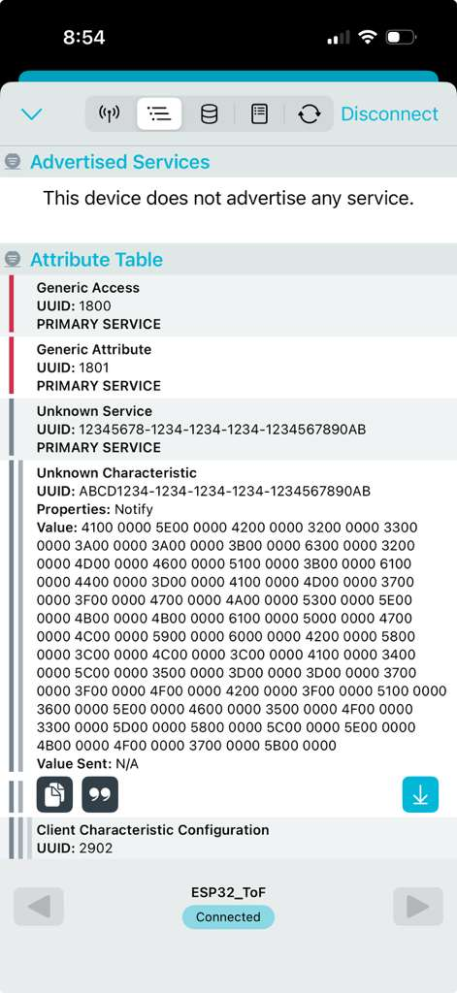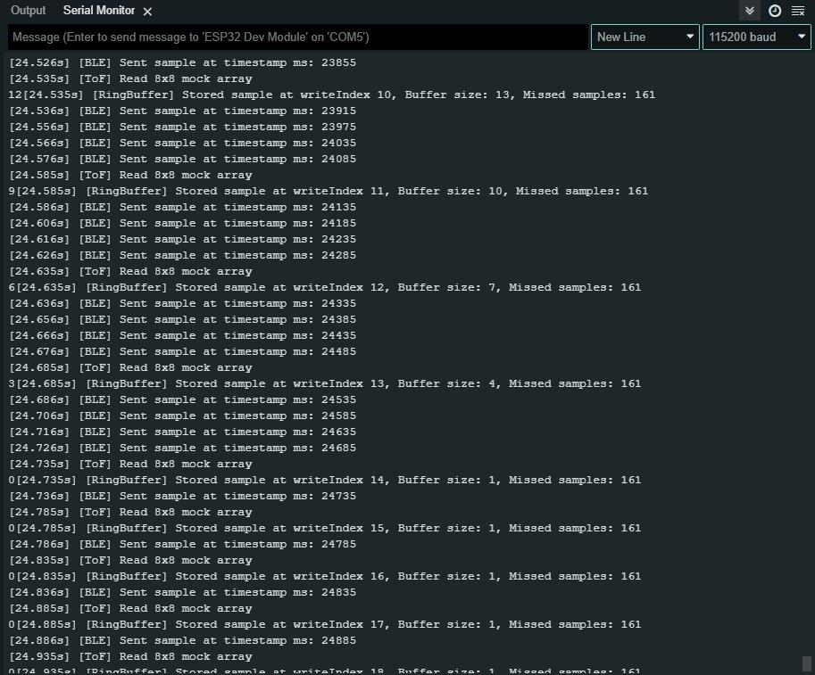

stopBLE. Back to normal
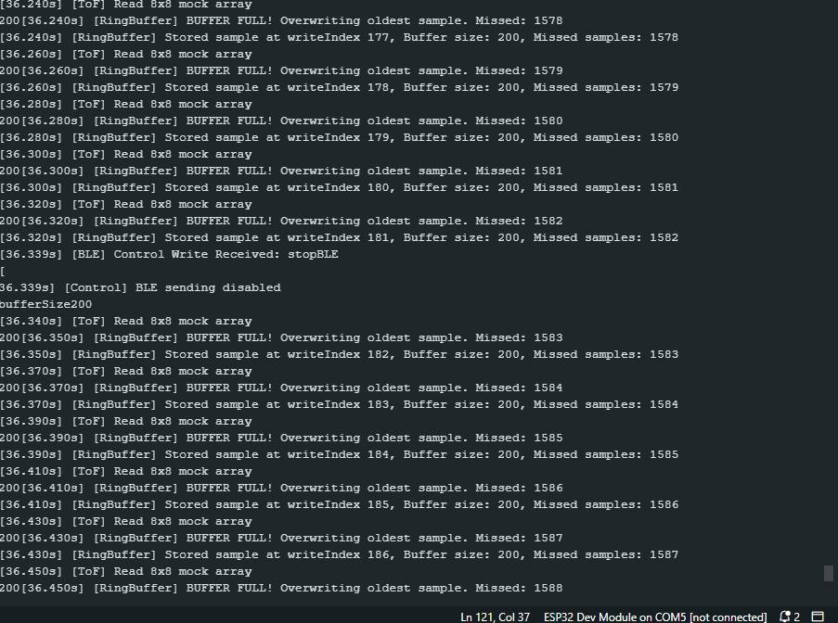

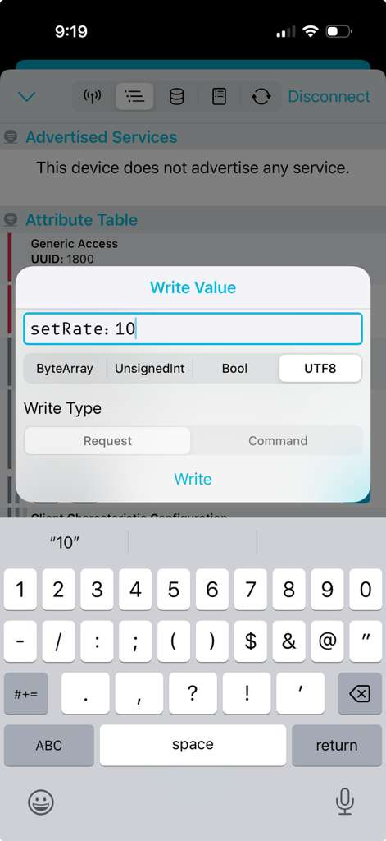
Clear
